Clinical Immunology Network – Canada
Canadian Inborn Errors of Immunity National Registry Steering Committee
Terms of Reference
The Canadian Inborn Errors (IEI) of Immunity National Registry has been developed to better define the landscape of IEI in Canada, with the aim to serve as the foundation for future epidemiological and clinical studies. The registry will provide real-world data on clinical characteristics, genetic defects, treatments, and quality of life in adult and pediatric participants with IEI. Data will serve as a strategic method to optimize patient care through identifying areas of strength and weakness in IEI diagnosis and management, guiding development of educational programs, informing Canadian public health authorities, and serving as an essential tool for patient advocacy. The registry is an initiative of the Clinical Immunology Network – Canada and will partner with other IEI registries, including the United States Immunodeficiency Network (USIDNET) and the European Society for ImmunoDeficiencies (ESID) Registry.
Description of Steering Committee
- Purpose: The Canadian Inborn Errors of Immunity National (CIEIN) Registry Steering Committee works collaboratively with the Clinical Immunology Network – Canada (CINC), and with CINC partners and key stakeholder groups to provide oversight to develop and support an integrated, national approach to deliver and continuously improve the registry for Canadians with immune disorders. The committee will develop the registry, obtain and administer funding, direct research projects and administer the use of information held within the registry database.
Functions:
- Guide development and continuous improvement of the registry.
- Develop and regularly review policies, standards, regulatory requirements, and guidelines for the registry.
- Develop and maintain policies and procedures for data usage.
- Obtain and administer funding for the registry.
- Ensure that regular evaluations of future fundings are developed and conducted.
- Develop processes and criteria for research projects including authorship guidelines. Authorship refers to all publications, including abstracts, poster presentation, manuscripts etc.
- Identify, prioritize, and develop research initiatives utilizing registry data.
- Support research initiatives focusing on engaging practitioners in clinical immunology with the goal of building a foundation of real-world data characterizing IEI in Canada.
- Communicate knowledge transfer to members, partners, and stakeholder groups across Canada and internationally.
- Establish partnerships with academic institutions, government agencies, other registries, and industry and regularly evaluate CIEIN Registry partnerships.

- Reporting Relationships: The CIEIN Registry Steering Committee reports to CINC and stakeholders. The Committee will work collaboratively with partner patient organizations, government agencies and industry. Members of the committee are expected to bring the perspective of and regularly report on registry expansion and research activities for their areas of expertise.

- Structure:
- Meetings will occur at a minimum quarterly, and dates shall be set in advance by the committee co-chairs
- Meetings will occur virtually.
- Committee co-chairs will organize meeting dates, set agendas, facilitate meetings, and distribute meeting minutes.
- A minimum of 50% and 5 Steering Committee members must agree to pass a motion or make a group decision.
- External individuals such as experts in the field or representatives from patient advocacy groups may be invited to meetings on an ad hoc basis with prior approval from the co-chairs.
- Sub-committees or working groups may be formed and required to meet at the discretion of the co-chairs.
- Co-chairs:
- Co-chairs will be elected by the Steering Committee to serve a 4-year term. Co-chairs may extend the term for a maximum of a second term.
- Co-chair terms will be staggered by 2-years such that one co-chair will be elected every 2 years.
- Co-chairs may be self-nominated or nominated by other members of the Steering Committee.
- Co-chairs must serve on the Steering Committee for a minimum of 2 years prior to being eligible for nomination as co-chair.
- Nominations for Steering Committee co-chairs must be approved by the CINC Executive Committee.
- Elections for Co-chairs will be held every 2 years with all members of the Steering Committee eligible to vote. Elections are not required if only one candidate application is received.
- Voting on co-chairs will be confidential. Votes will be collected and summarized by the existing co-chairs unless the co-chairs are also nominated.
- Majority of members voting shall govern with a minimum of 50%, and at least 5 voting members.
- Co-chairs must be members in good standing of CINC.
- Co-chairs will be named as lead for CIEINR and the contact information will documented and available on CIEINR website
- Co-chairs will complete declarations of conflicts of interests every 2 years
Co-Chair responsibilities:
- Organize meeting dates, set agendas, facilitate meetings, and distribute meeting minutes.
- Attend a minimum of 75% of meetings and vote in a minimum of 75% of decisions.
- Provide leadership in the development, maintenance, and improvement of the registry.
- Ensure the registry meets all ethical, legal, funding, and regulatory requirements.
- Oversee management of the registry budget and provide leadership to obtain registry funding.
- Facilitate collaborations and relationships with key partners such as funders, government agencies, partner registries, patient advocacy groups and other stakeholders.
- Provide leadership regarding research priorities, progress on research initiatives, and publication guidelines.
- Monitor contributions of Steering Committee members and make recommendation to the Steering Committee for addition or removal of Committee members.
- Act as a liaison with the CINC Executive Committee.
- Suggest and approve formation of sub-committees as required.
- Ensure the guiding principles are upheld by the Steering Committee.
- CIEINR Co-chairs can make recommendations to the Steering Committee about the addition or removal of Committee members.
  - Co-chairs may recommend removal of members who are not significantly contributing or are not following the guiding principles. The Steering Committee must vote on removal of any members.
- CIEINR Co-chairs can suggest and approve the formation of sub-committees as required.

- Steering Committee:
- Steering Committee members will serve a minimum 2-year term. Terms may be extended at the discretion of the Steering Committee with no limit on the number of terms served.
- Steering Committee membership shall include a broad representation of Clinical Immunologists and associated research staff from across Canada. The Steering Committee shall strive to have representation from multiple provinces, and from both pediatrics and adult immunology.
- The minimum number of Steering Committee members is 7 and maximum is 15.
- The Steering Committee will include a member from the central site, the University of Calgary and Dalhousie University
- All Steering Committee members must be members in good standing of CINC.
- Additions to the Steering Committee membership must be approved by the Steering Committee.
- If a Steering Committee member is taking a leave from work (eg parental leave, medical leave, sabbatical), another representative may be appointed to the Steering Committee for the duration of the leave, at the discretion of the Committee.
- Steering committee will complete declarations of conflicts of interests every 2 years

Membership responsibilities:
- Attend a minimum of 60% of Committee meetings.
- Steering committee members will lead or co-lead finance, quality assurance, scientific review, or diversity/equity/inclusion roles
- If members are unable to attend sufficient committee meetings, they must obtain co-chair approval to continue their membership and demonstrate meaningful contributions to the Steering Committee in other ways (e.g., supporting funding applications, research initiatives, or knowledge transfer). Alternatively, members may request co-chair approval to temporarily pause their participation in meetings.
- Open the CIEIN Registry at their site and actively recruit participants.
- Contribute to further development and improvement of the registry.
- With direction from the co-chairs, contribute to fostering collaboration opportunities, contribute to agenda items and invite guests to meetings on an ad hoc basis.
- Contribute to funding applications, research projects and other registry activities on an ad hoc basis. Dependent on ongoing Steering Committee activities, co-chairs will determine what constitutes acceptable contribution for Committee members. In general, a Committee member should contribute to a minimum of 50% of ongoing Committee activities.
- Contribute to sub-committees on an ad hoc basis.

Steering Committee Roles
- Steering Committee members will serve in these specified roles for a minimum 2-year term. Terms may be extended at the discretion of the Steering Committee with no limit on the number of terms served.
- Roles may be self-nominated or nominated by other members of the Steering Committee.

Role Descriptions
- Treasurer (Minimum of 1 Individual Required):
  - Provides oversight of the financial sustainability of the consortium.
  - Manages and identifies funding opportunities.
  - Assists in the development and management of budgets.
- Quality Assurance Lead (Minimum of 1 Individual Required):
  - Oversees the quality assurance of procedures and policies, including the Terms of Reference (ToR), consortium agreements, and confidentiality agreements.
  - Supports the assessment and monitoring of data quality.
- Scientific Review Committee Leads (3 Individuals Required):
  - Evaluate and present external data requests to the committee.
  - Review and approve publications to ensure compliance with CIEINR requirements.
  - Conduct a comprehensive review of disease-specific variables within Case Report Forms (CRFs) every five years.
- Diversity, Equity, and Inclusion (DEI) Lead (Minimum of 1 Individual Required):
  - Oversees strategies to enhance patient engagement.
  - Promotes diversity, equity, and inclusion principles, ensuring alignment with the goals of patient and family advocacy groups in communications and publications.

Project Manager
- The Project Manager will be appointed by the Co-Chairs in the role of Clinical Research Assistant or associate.
- The Project Manager will be affiliated with the University of Calgary, as the CIEINR REDCap database is hosted through the University of Calgary.
- The Project Manager will be responsible for the day-to-day management of CIEINR and will adhere to all CIEINR policies and procedures.
- The Project Manager will serve as the CIEINR IT expert and domain expert in collaboration with the University of Calgary, managing user access, intellectual property (IP) protection, and exploitation matters in partnership with the Co-Chairs.
- The Project Manager will be responsible for managing project timelines, milestones, deliverables, reports, budgets, communications, and the registry website.
- The Project Manager will oversee data quality, data security, and collaborate with the Quality Assurance Lead to support quality assurance activities.
- The Project Manager will coordinate participation in, and training on CIEINR policies and procedures.
- The Project Manager is expected to attend at least 75% of Steering Committee meetings.
- The Project Manager will serve in a non-voting capacity on the Steering Committee.

Figure 1: CIEINR organizational chart describing the roles and responsibilities of each role involved in the CIEINR and outside collaborators.
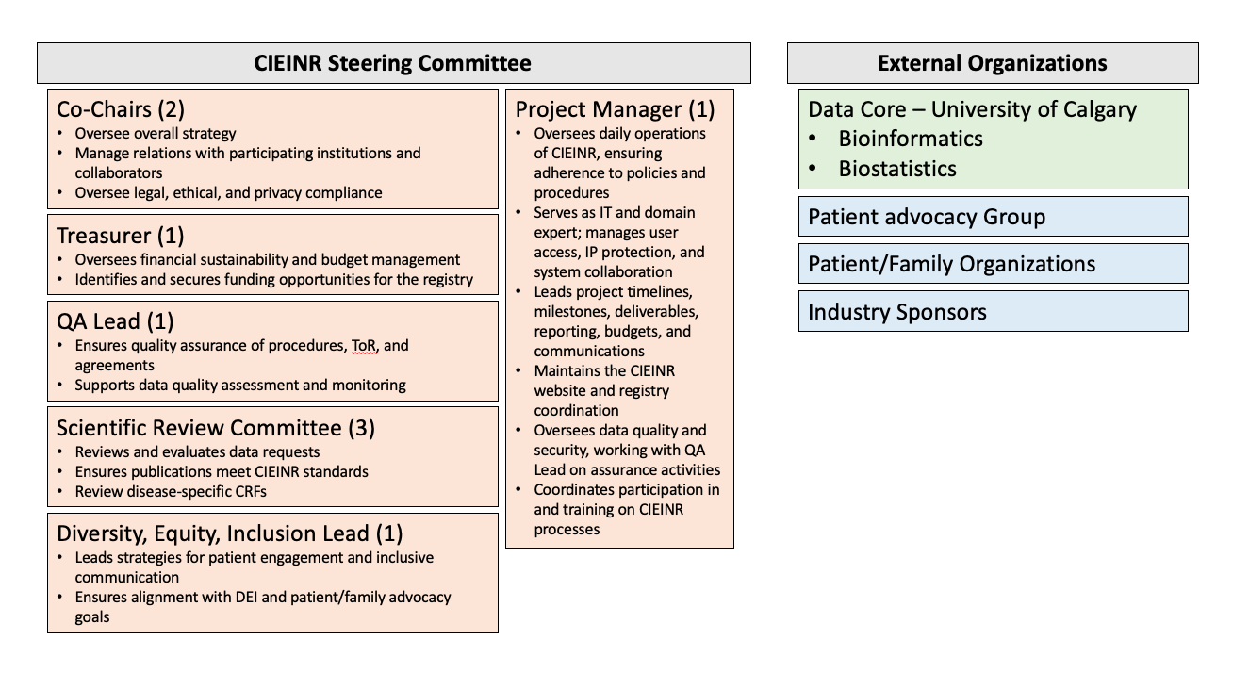

Figure 2: Decision making Governance Structure of the CIEINR:

- Guidelines for research initiatives:
- The Steering Committee will develop and regularly review policies, standards, and guidelines for research initiatives.
- The Steering Committee must approve all research initiatives. The Steering Committee will develop and regularly update procedures for proposing and approving research initiatives.
- The Steering Committee will determine research priorities. Research initiatives will be approved based on registry priorities and ability to allocate adequate resources to the project.
- All research initiatives will be expected to have appropriate ethical approvals and legal contracts and meet regulatory obligations as required by the participating institutions, registry, and other participating partners.
- The Steering Committee will regularly evaluate progress of research initiatives.

- Authorship Guidelines:
  - All publications, including abstracts, manuscripts, media submissions, etc must be approved by the Steering Committee.
  - Authorship shall be discussed by the Steering Committee at the initiation of a project. The Steering Committee must agree to any changes in authorship once the project has been initiated.
  - First and second authors will be researchers who have conceived of the research idea and contributed most to data analysis and manuscript preparation. First authorship may be shared by 2 researchers at the discretion of the Steering Committee. First authorship is generally denoted to more junior members of the research team who contribute most significantly to the work.
  - Senior author(s) will be the researcher(s) who conceived of the research idea and study design and supervised the project. Senior authorship may be shared by 2 researchers at the discretion of the Steering Committee. Senior authorship is generally denoted to the most experienced/expert member of the research team who contributed to conception and design of the project and supervised the work.
  - Corresponding author will be the researcher who conceived of the research idea and contributed most to the project, and who has the expertise and availability to respond to queries.
  - Subsequent authors will be members who have contributed significantly to the research project/data analysis/manuscript publication, followed by one author from each site contributing participant data in order of number of participants included from that site. If sites have contributed a significant number of participants, those sites may be offered 2 co-authors at the discretion of the Steering Committee.
  - Non-Steering Committee members, eg statisticians, non-member collaborators, etc may be included as authors at the discretion of the Steering Committee. The Steering Committee will determine order of authorship dependent upon the contribution of the non-member to the project.
  - Co-Chairs will be listed as co-authors on all registry publications. This will constitute the active co-chairs at the time of submission of publications.
  - All Steering Committee members will be included as authors if Committee membership responsibilities, as determined by the Steering Committee, are met. If not represented as authors as above, members will be listed following authors from sites submitting participant data.
  - Research staff and trainees may be included as authors if they have significantly participated in data analysis and manuscript publication.
  - Authorship must meet the ICMJE criteria for authors and authorship guidelines for the specific journals. As per the ICMJE criteria, contributors not meeting the criteria but who have contributed to the manuscript in some way should be acknowledged.
  - If the above results in more authors than is allowable by the journal, the Steering Committee will discuss which authors have contributed most to the project and who will be included. If allowable by the journal, ‘the CIEIN Registry’ may be listed as an author with remaining authors footnoted.
  - CINC must be acknowledged in all publications.
  - In funding applications, if a steering committee member is the lead of the application, their name will be mentioned as Co-PI, together with the Co-Chair(s), and the Steering Committee members contributing to the application will be co-investigators (i.e. edited and approved the application)

Guiding Principles:
- Mutual respect: Committee members will respect meeting times and come prepared. All members will be given the opportunity to express their opinion. Listening doesn’t confer agreement and all opinions will be heard.
- Acknowledgement of differences: Committee members will honour different values and beliefs as diversity of view improves the quality of work.
- Build on strengths: Committee members will focus on strengths, capitalizing on what we have that works and working together to identify and support opportunities for improvement.
- Strive for the best: Processes and outcomes will be evaluated and celebrated with a goal of improving the CIEIN Registry and learning from achievements.
- Decision making: Members will seek consensus when making decisions whenever possible, acknowledging that they can live with and support a specific decision even though it may not be their preferred solution and they can give permission for a decision to proceed even though the decision may not be unanimous. If necessary, members will allow or request the co-chairs to call a vote to make a decision. Members agree that if a vote is required, the decision is made based on a minimum 50% vote majority with a minimum of 5 voting committee members.

Effective Date:
This Terms of Reference document was approved and made effective on ______________ at ________________

