# Image analysis of embryos captured by confocal imaging

The pipeline provided in this project perform segmentation based on the Per Object Ellipsefit (POE) algorithm implemented to detect objects in images of early embryos captured by confocal scanning microscopy, as illustrated below. The purpose of the pipeline is to enable systematic image analyses to evaluate mammalian embryos produced *in vitro* (or *in vivo*). At this date, embryos produced and stained with fluorophores to detect nuclei, lipids and apoptotic cells (using TUNEL) can be included. Endpoints assessed are; identification and volume of separate objects (nuclei/lipids) and overlap between fluorophores (TUNEL + nuclei stain). This allow investigation of endpoints such as:

* Cell count in blastocysts (amount of nuclei)
* Lipid droplet count in blastocysts (amount of lipid droplets)
* Lipid droplet volume (average lipid droplet volume and estimation of total lipid volume in each embryo)

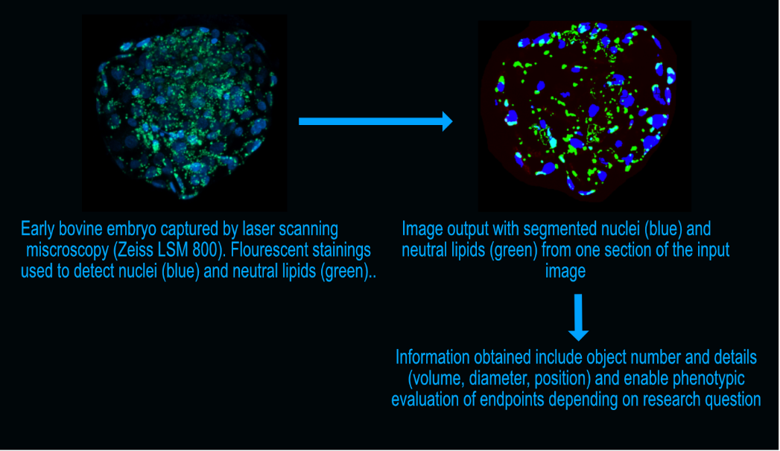

In the original Per Object Ellipsefit (POE), a threshold is set to optimize the ellipse fit of an object, given that it fulfils the input criteria (minimum and maximum diameter). The segmentation method has been developed as a 2D version but is also available in 3D. A drawback with this method arise when brighter objects are touching darker objects. The threshold might then be optimized for the brighter object and may therefore not include the darker object at all. To overcome this challenge, an iterative version of the POE was developed. After the segmentation, the resulting mask are kept as a “seed” (containing the segmented objects but eroded two pixels). After this, the segmented objects are masked from the raw image by turning all identified voxels in objects black. The segmentation will then be repeated on the raw image and the mask will be merged with the previously segmented objects while the “seed” is merged with the previous “seed” image. These steps will be repeated until no more objects are segmented. The objects in the resulting merged mask can then be separated using the 3D Watershed Split function in ImageJ (the combined mask: input, the combined “seed”: seed). The nuclei and the lipids are then segmented by applying a global grey-level threshold based on object size (SizeIntervalPrecision_) and subsequent watershed function (3D Watershed split function).

Object number and specifics (volume, position) are collected. Objects identified in two channels (such as an apoptotic nucleus which will be labelled both as a nucleus and apoptotic) can be identified to separately detect nuclei positive for apoptotic label.

# Acknowledgements

This project has support from the Nils Lagerlöfs fund (KSLA GFS2021-0031) and the BioImage Informatics Facility, a unit of the National Bioinformatics Infrastructure Sweden NBIS, with funding from SciLifeLab, National Microscopy Infrastructure NMI (VR-RFI 2019-00217), and the Chan-Zuckerberg Initiative.