SOFTWARE ENGINEERING PROJECT
ProHealth Online Pharmacy System
Deliverable 2: Diagrams and Mock-ups (Systems Analysis and Design Phases)
Institution | Strathmore University
Unit | Software Engineering
Group name | [Insert group name]
Date | 21 October 2026

Group members
# | Member name | Reg. No.
1 | [Name] | [Reg. No.]
2 | [Name] | [Reg. No.]
3 | [Name] | [Reg. No.]

1. Introduction
This document is our second deliverable. It turns the requirements from Deliverable 1 into a design for ProHealth, an online pharmacy where customers browse medicines, order them, upload prescriptions and pay with M-Pesa, while pharmacy staff manage stock, prescriptions and orders from an admin panel.
It contains the six items the guidelines ask for:
Item | Tool | Where in this document
Flow chart | draw.io | Section 2
Use case diagram | draw.io | Section 3
Class diagram | draw.io | Section 4
E-R diagram | draw.io | Section 5
Database schema | draw.io (page 5) and written tables | Section 6
User interface mock-ups (customer and admin) | Figma | Section 7

The diagrams are drawn small enough to fit a page, so for the finest detail zoom in or open the editable files. Editable draw.io file: ProHealth_Deliverable2_Diagrams.drawio. Figma file: [paste Figma link here].

2. Flow Chart
The flow chart follows the system's main transaction, a customer placing and paying for an order, from login to completion. It includes the two checks that set a pharmacy apart from an ordinary shop: the prescription check and the M-Pesa payment check.
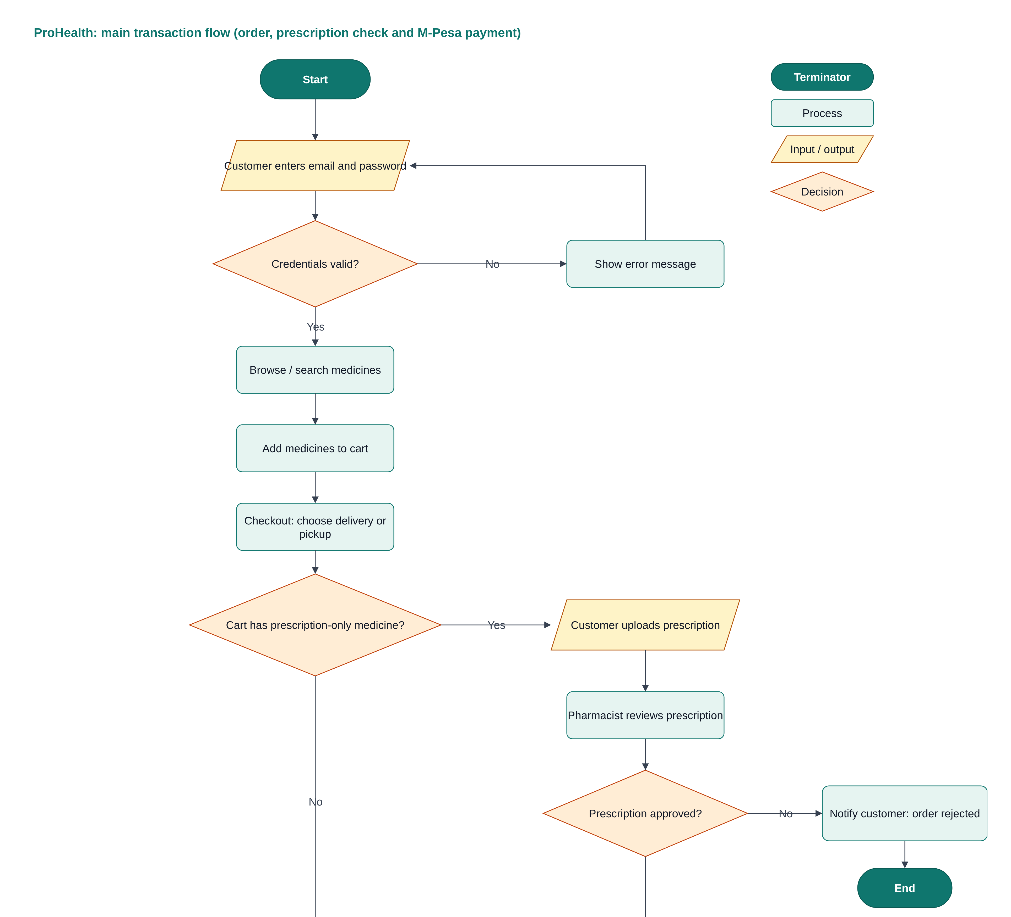
Figure 1a: Main transaction flow, part 1 (login, cart, checkout and prescription check). Continues on the next page.
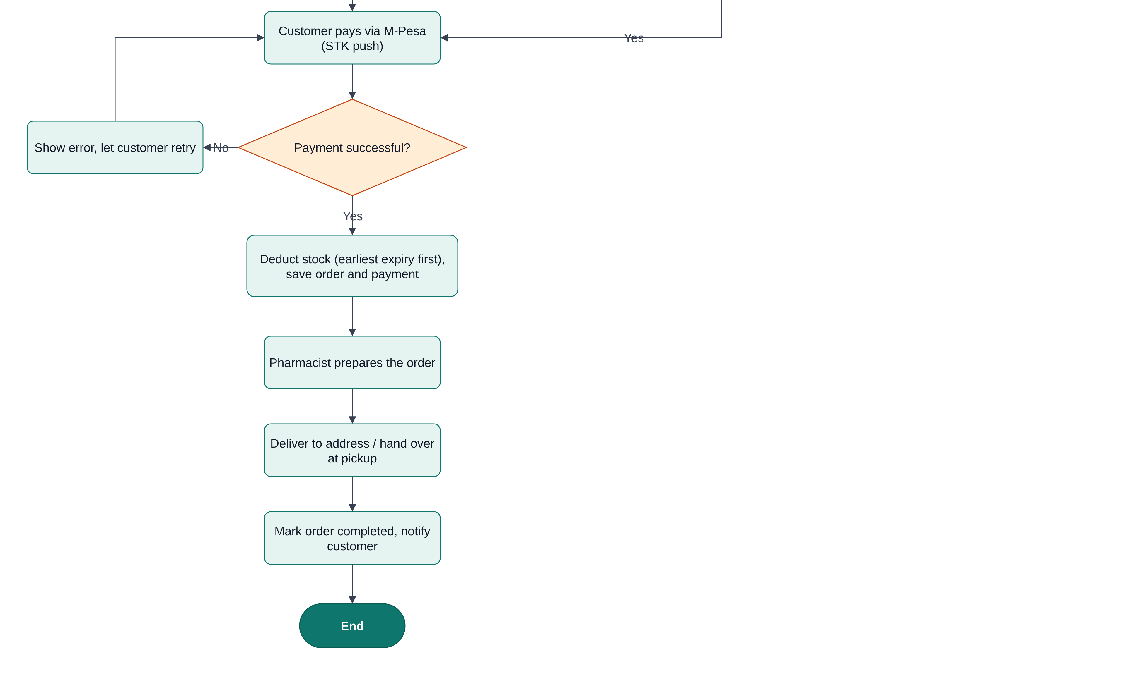
Figure 1b: Main transaction flow, part 2 (M-Pesa payment, stock update and fulfilment).
- Login: A failed login shows an error and returns to the login step.
- Prescription check: only carts containing a prescription-only medicine go through the pharmacist's review; a rejected prescription ends the order.
- Payment and stock: a failed payment lets the customer retry; stock is deducted only after payment succeeds, taking the batch that expires first.

3. Use Case Diagram
There are four actors. The system boundary holds the 16 use cases.  Customer: registers, logs in, browses and searches, manages the cart, places and pays for orders, uploads prescriptions and tracks orders.  Pharmacist: verifies prescriptions, processes and fulfils orders, manages stock and suppliers, and generates reports.  Administrator: manages users, medicines and categories, generates reports and views audit logs.  M-Pesa (Daraja API): external system that receives the payment request and confirms payment.  Place order includes Pay with M-Pesa. Upload prescription extends Place order, but only when the cart has a prescription-only medicine. | 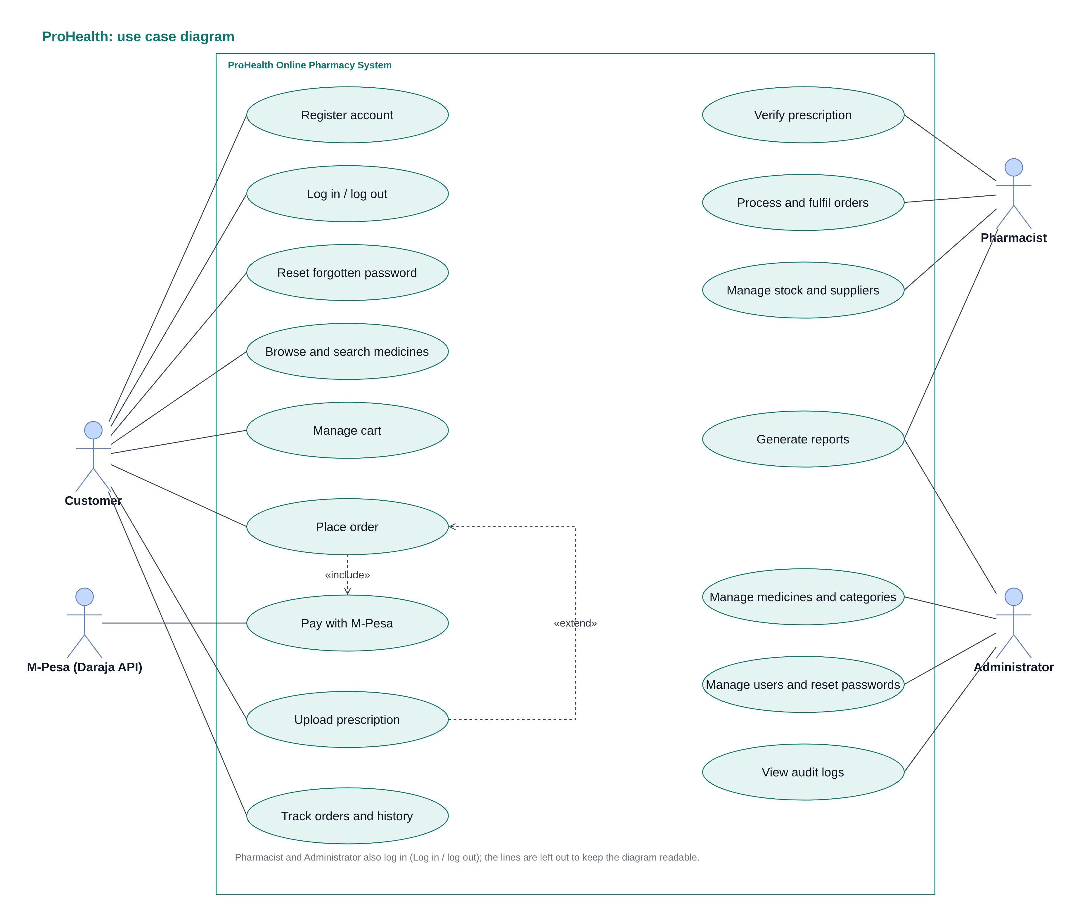  Figure 2: Use case diagram for ProHealth.

4. Class Diagram
The class diagram shows the 15 classes the system is built from. User is an abstract class with Customer, Pharmacist and Administrator as subclasses. The ordering classes (Order, OrderItem, Payment) connect customers to the catalogue classes (Medicine, Category, StockBatch, Supplier). Numbers on the lines give the multiplicity, for example one Customer places 0..* Orders.
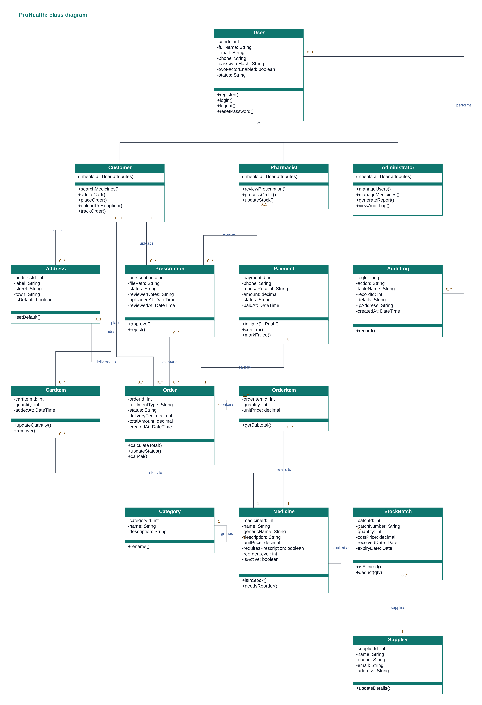
Figure 3: Class diagram. Attributes are private (-) and operations public (+).

5. Entity-Relationship (E-R) Diagram
The E-R diagram uses crow's foot notation. It has 14 entities. Primary keys are marked PK and foreign keys FK. A circle on a line means the link is optional, and a three-pronged end means "many".
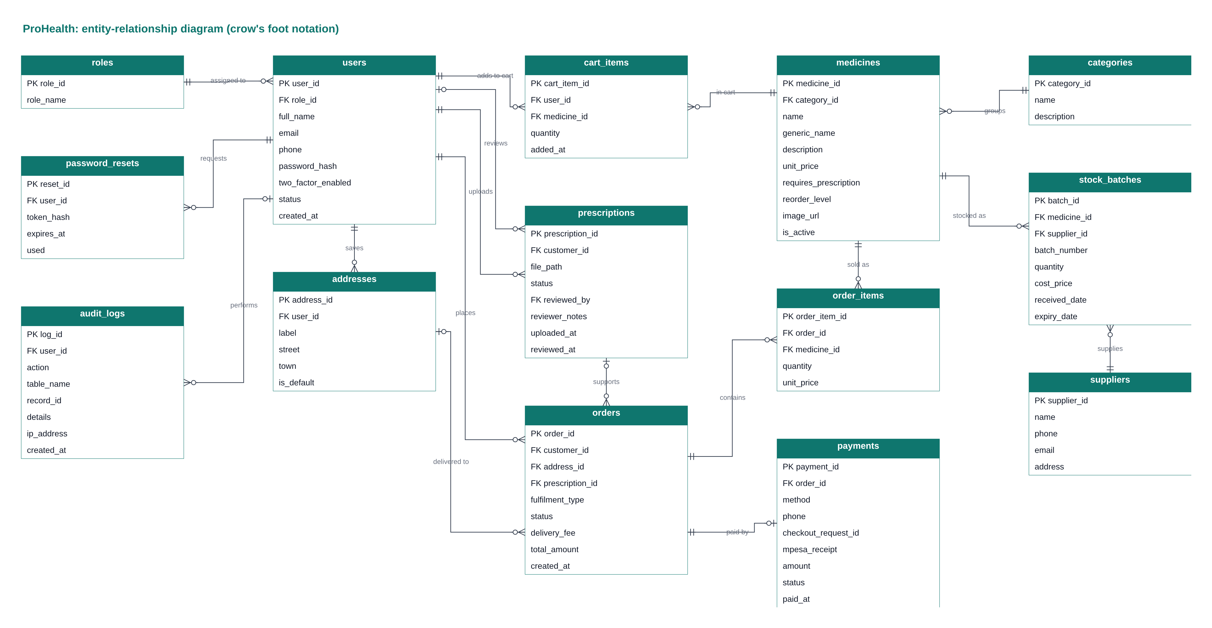
Figure 4: E-R diagram. The relationships are listed in Table 1.

Relationships and cardinalities
Table 1 lists every relationship, read from the parent table to the child table. The foreign key sits in the child table. "Optional" means the foreign key may be empty.
Parent | Child | Relationship | Cardinality | Foreign key (in child) | Link
roles | users | assigned to | 1 : M | role_id | Required
users | password_resets | requests | 1 : M | user_id | Required
users | audit_logs | performs | 1 : M | user_id | Optional
users | addresses | saves | 1 : M | user_id | Required
users | cart_items | adds to cart | 1 : M | user_id | Required
users | prescriptions | uploads | 1 : M | customer_id | Required
users | prescriptions | reviews | 1 : M | reviewed_by | Optional
users | orders | places | 1 : M | customer_id | Required
addresses | orders | delivered to | 1 : M | address_id | Optional
prescriptions | orders | supports | 1 : M | prescription_id | Optional
orders | order_items | contains | 1 : M | order_id | Required
orders | payments | paid by | 1 : 1 | order_id | Required
medicines | order_items | sold as | 1 : M | medicine_id | Required
medicines | cart_items | in cart | 1 : M | medicine_id | Required
categories | medicines | groups | 1 : M | category_id | Required
medicines | stock_batches | stocked as | 1 : M | medicine_id | Required
suppliers | stock_batches | supplies | 1 : M | supplier_id | Required
Table 1: Relationships and cardinalities.

6. Database Schema
The schema is what we will use to create the database. The same design is also drawn in the draw.io file (page 5) and written as an SQL script, prohealth_schema.sql.
Database name | prohealth_db
DBMS | MySQL 8, InnoDB engine, utf8mb4 character set
Tables | 14
Naming | Lower-case snake_case; plural table names; primary key named <table>_id

Normalisation and integrity
- First normal form: every attribute holds one value. Repeating groups are in their own tables: order_items for the lines of an order and cart_items for the cart.
- Second and third normal form: every non-key attribute depends on its table's key and nothing else. Roles, categories, suppliers and addresses are separate tables, so no detail is stored twice.
- Price history: order_items.unit_price and orders.total_amount keep the values at the time of sale, on purpose, so old orders do not change when a price changes.
- Stock batches: stock is held per batch (stock_batches) so each batch has its own quantity, supplier and expiry date. This allows low-stock and near-expiry alerts and selling the earliest-expiring batch first.
- Integrity rules: foreign keys link every child row to a parent. Check rules stop negative stock and zero quantities. Unique rules cover email, role name, category name, one batch number per medicine, one cart line per medicine per user, and one payment per order.
- Security: passwords are stored only as hashes. Password-reset tokens are stored as hashes with an expiry time. audit_logs records who did what, and when.

Table definitions

roles
Column | Data type | Key | Constraints
role_id | INT | PK | Auto increment
role_name | VARCHAR(30) |  | Required; Unique

users
Column | Data type | Key | Constraints
user_id | INT | PK | Auto increment
role_id | INT | FK | Required; References roles.role_id
full_name | VARCHAR(100) |  | Required
email | VARCHAR(120) |  | Required; Unique
phone | VARCHAR(15) |  | Required
password_hash | VARCHAR(255) |  | Required
two_factor_enabled | TINYINT(1) |  | Required; Default 0
status | ENUM('active','suspended') |  | Required; Default 'active'
created_at | DATETIME |  | Required; Default current time

password_resets
Column | Data type | Key | Constraints
reset_id | INT | PK | Auto increment
user_id | INT | FK | Required; References users.user_id
token_hash | VARCHAR(255) |  | Required
expires_at | DATETIME |  | Required
used | TINYINT(1) |  | Required; Default 0

addresses
Column | Data type | Key | Constraints
address_id | INT | PK | Auto increment
user_id | INT | FK | Required; References users.user_id
label | VARCHAR(30) |  | Required
street | VARCHAR(150) |  | Required
town | VARCHAR(60) |  | Required
is_default | TINYINT(1) |  | Required; Default 0

categories
Column | Data type | Key | Constraints
category_id | INT | PK | Auto increment
name | VARCHAR(60) |  | Required; Unique
description | VARCHAR(255) |  | Optional (NULL)

suppliers
Column | Data type | Key | Constraints
supplier_id | INT | PK | Auto increment
name | VARCHAR(100) |  | Required
phone | VARCHAR(15) |  | Required
email | VARCHAR(120) |  | Optional (NULL)
address | VARCHAR(150) |  | Optional (NULL)

medicines
Column | Data type | Key | Constraints
medicine_id | INT | PK | Auto increment
category_id | INT | FK | Required; References categories.category_id
name | VARCHAR(120) |  | Required
generic_name | VARCHAR(120) |  | Optional (NULL)
description | TEXT |  | Optional (NULL)
unit_price | DECIMAL(10,2) |  | Required; Check: unit_price >= 0
requires_prescription | TINYINT(1) |  | Required; Default 0
reorder_level | INT |  | Required; Default 10
image_url | VARCHAR(255) |  | Optional (NULL)
is_active | TINYINT(1) |  | Required; Default 1

stock_batches
Column | Data type | Key | Constraints
batch_id | INT | PK | Auto increment
medicine_id | INT | FK | Required; References medicines.medicine_id
supplier_id | INT | FK | Required; References suppliers.supplier_id
batch_number | VARCHAR(40) |  | Required
quantity | INT |  | Required; Check: quantity >= 0
cost_price | DECIMAL(10,2) |  | Required
received_date | DATE |  | Required
expiry_date | DATE |  | Required
(composite) |  | UQ | Unique together: medicine_id, batch_number

cart_items
Column | Data type | Key | Constraints
cart_item_id | INT | PK | Auto increment
user_id | INT | FK | Required; References users.user_id
medicine_id | INT | FK | Required; References medicines.medicine_id
quantity | INT |  | Required; Check: quantity > 0
added_at | DATETIME |  | Required; Default current time
(composite) |  | UQ | Unique together: user_id, medicine_id

prescriptions
Column | Data type | Key | Constraints
prescription_id | INT | PK | Auto increment
customer_id | INT | FK | Required; References users.user_id
file_path | VARCHAR(255) |  | Required
status | ENUM('pending','approved','rejected') |  | Required; Default 'pending'
reviewed_by | INT | FK | Optional (NULL); References users.user_id
reviewer_notes | VARCHAR(255) |  | Optional (NULL)
uploaded_at | DATETIME |  | Required; Default current time
reviewed_at | DATETIME |  | Optional (NULL)

orders
Column | Data type | Key | Constraints
order_id | INT | PK | Auto increment
customer_id | INT | FK | Required; References users.user_id
address_id | INT | FK | Optional (NULL); References addresses.address_id
prescription_id | INT | FK | Optional (NULL); References prescriptions.prescription_id
fulfilment_type | ENUM('delivery','pickup') |  | Required
status | ENUM('pending','paid','processing','ready','completed','cancelled') |  | Required; Default 'pending'
delivery_fee | DECIMAL(10,2) |  | Required; Default 0
total_amount | DECIMAL(10,2) |  | Required
created_at | DATETIME |  | Required; Default current time

order_items
Column | Data type | Key | Constraints
order_item_id | INT | PK | Auto increment
order_id | INT | FK | Required; References orders.order_id
medicine_id | INT | FK | Required; References medicines.medicine_id
quantity | INT |  | Required; Check: quantity > 0
unit_price | DECIMAL(10,2) |  | Required

payments
Column | Data type | Key | Constraints
payment_id | INT | PK | Auto increment
order_id | INT | FK | Required; Unique; References orders.order_id
method | ENUM('mpesa') |  | Required; Default 'mpesa'
phone | VARCHAR(15) |  | Required
checkout_request_id | VARCHAR(60) |  | Optional (NULL)
mpesa_receipt | VARCHAR(20) |  | Optional (NULL); Unique
amount | DECIMAL(10,2) |  | Required
status | ENUM('pending','success','failed') |  | Required; Default 'pending'
paid_at | DATETIME |  | Optional (NULL)

audit_logs
Column | Data type | Key | Constraints
log_id | BIGINT | PK | Auto increment
user_id | INT | FK | Optional (NULL); References users.user_id
action | VARCHAR(60) |  | Required
table_name | VARCHAR(60) |  | Optional (NULL)
record_id | INT |  | Optional (NULL)
details | TEXT |  | Optional (NULL)
ip_address | VARCHAR(45) |  | Optional (NULL)
created_at | DATETIME |  | Required; Default current time

7. User Interface Mock-ups
The mock-ups were designed in Figma as desktop screens (1440 by 900) in one consistent style: the same header, buttons, input fields, status chips and tables are used on every screen. The customer front-end uses a white top bar and the admin panel uses a dark sidebar. The pages that follow show four customer screens (C1 to C4) and six admin panel screens (A1 to A6).

Design basics
Colour | Name and code | Used for
 | Primary teal #0F766E | Buttons, links, active menu item
 | Dark teal #0B3B38 | Admin sidebar
 | Light teal #E6F4F1 | Highlights, selected rows
 | Ink #111827 | Main text
 | Grey #6B7280 | Secondary text
 | Success green #16A34A | In stock, completed
 | Warning amber #F59E0B | Low stock, expiring, pending
 | Danger red #DC2626 | Errors, delete, rejected
Table 2: Colour palette. Font: Inter. Corners are rounded; status is always shown with a coloured chip plus a word, never colour alone.

Screen C1: Log in and register
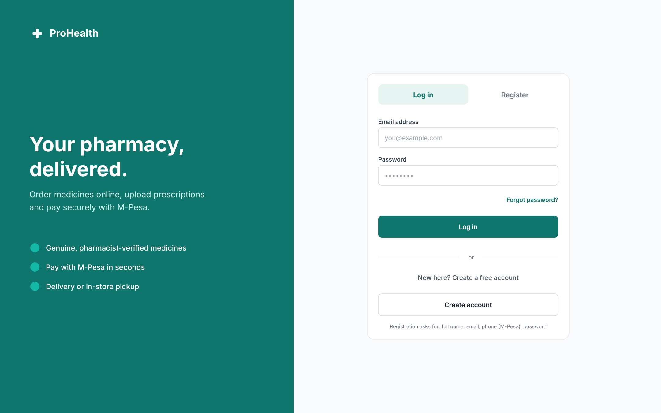
One card with Log in and Register tabs, a "Forgot password?" link and a short sign-up form (full name, email, M-Pesa phone number, password).

Screen C2: Medicine catalogue
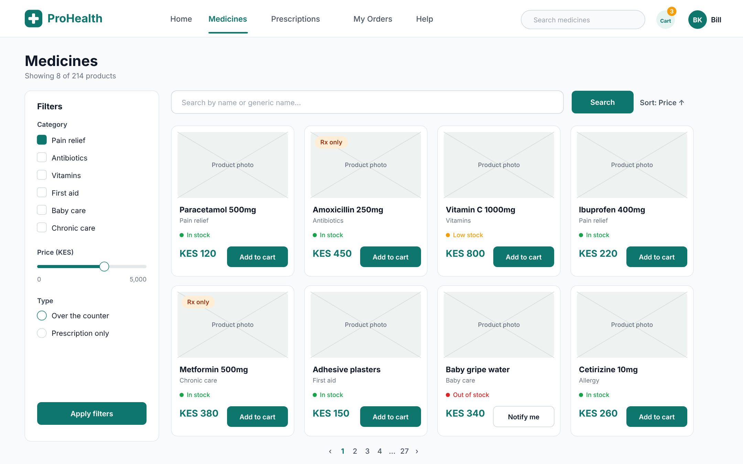
Search and sort, filters by category, price and type, and product cards that show the Rx badge, stock status, price and an Add to cart button.

Screen C3: Cart and checkout
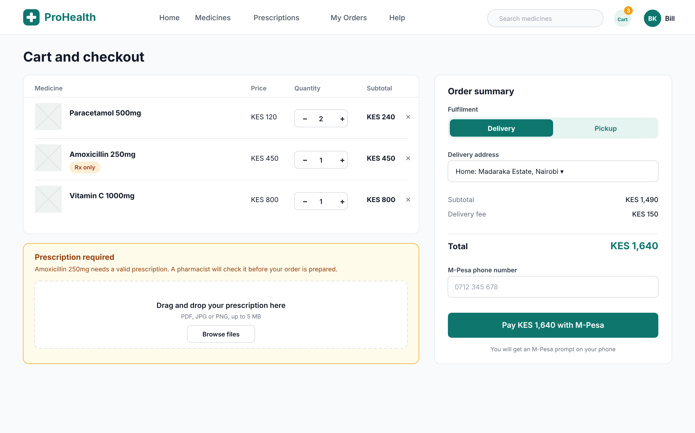
Quantity steppers, a prescription upload box that appears only because the cart has a prescription-only item, a delivery or pickup choice, and M-Pesa payment.

Screen C4: My orders and tracking
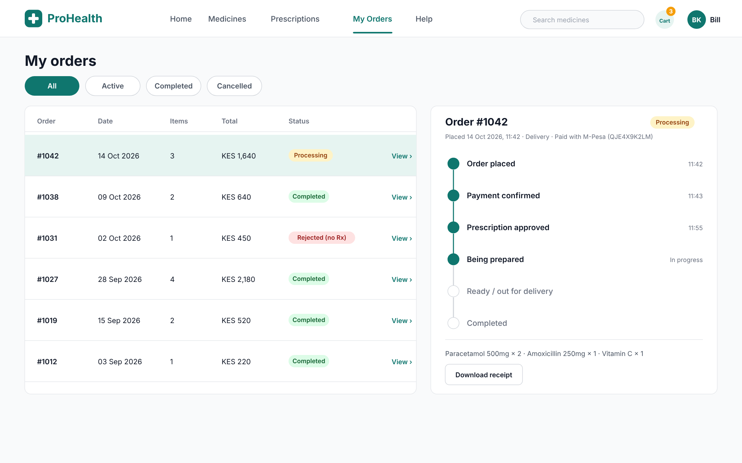
Order list with filter tabs and status chips, and a timeline of the selected order from placed to completed, with a receipt download.

Screen A1: Staff login with two-factor authentication
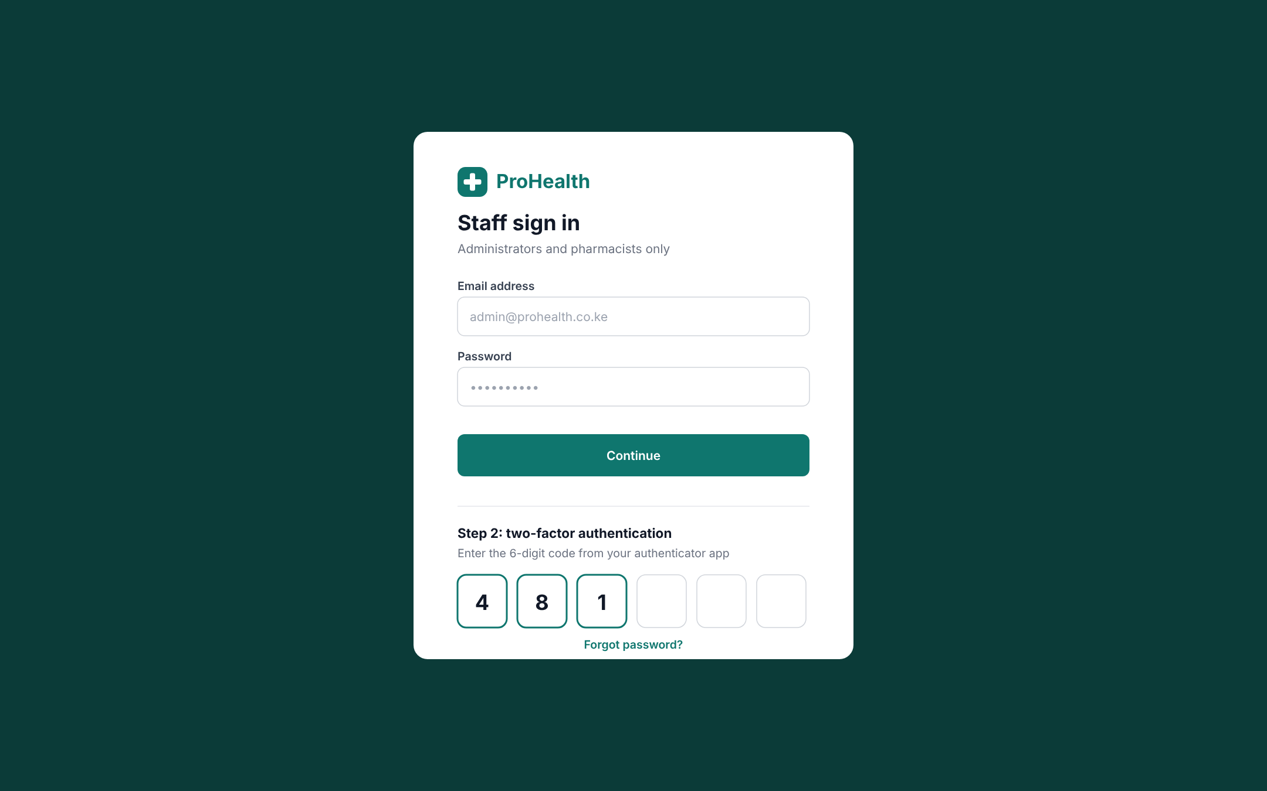
Email and password first, then a 6-digit code from an authenticator app.

Screen A2: Dashboard
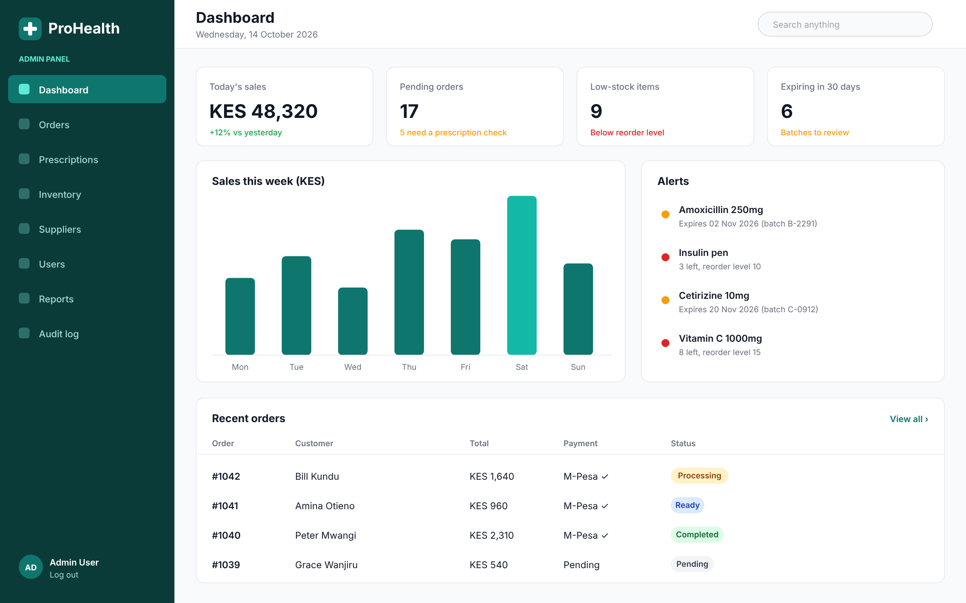
Key figures (sales, pending orders, low stock, expiring batches), a weekly sales chart, alerts and the latest orders.

Screen A3: Inventory management
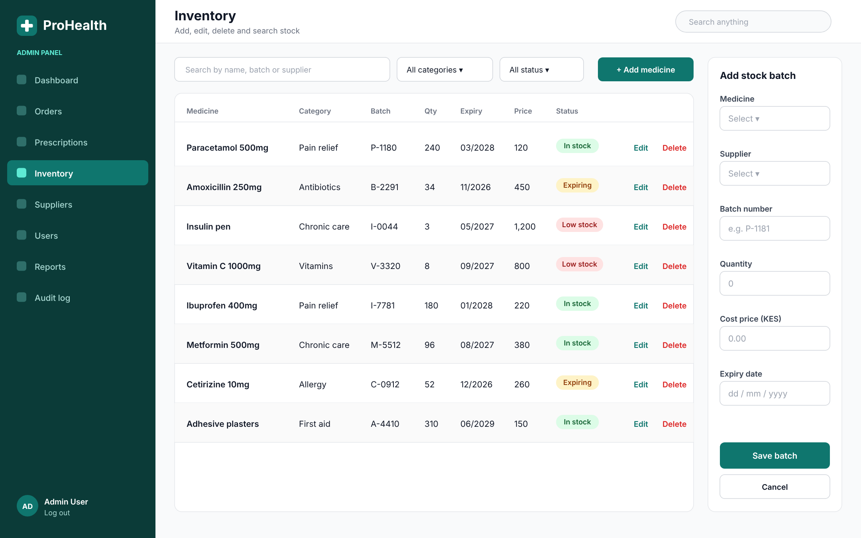
Search and filters, a stock table with status chips and Edit and Delete actions, and a side form to add a stock batch.

Screen A4: Prescription review
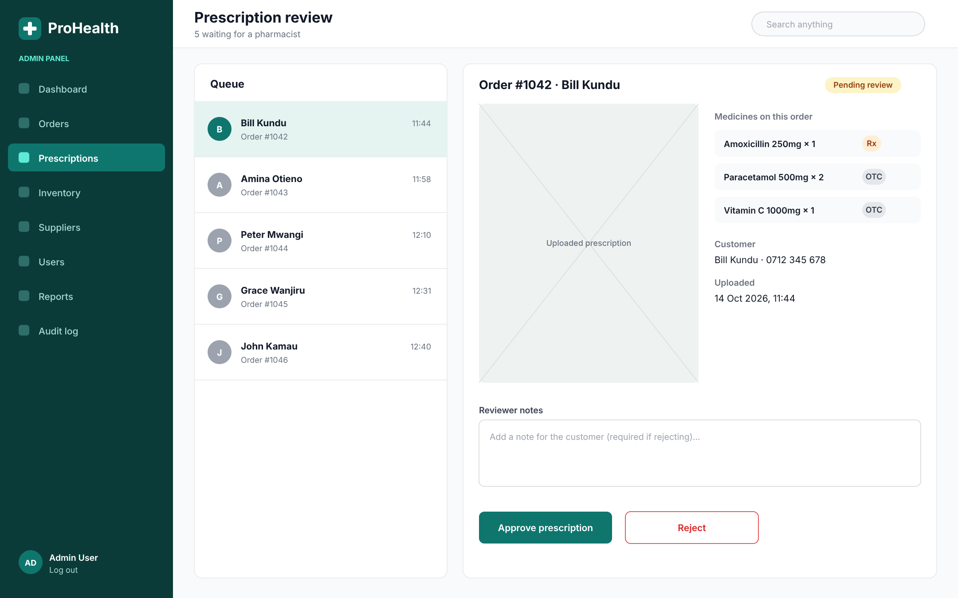
A queue of waiting prescriptions, the uploaded image, the medicines ordered, reviewer notes, and Approve and Reject buttons.

Screen A5: Reports
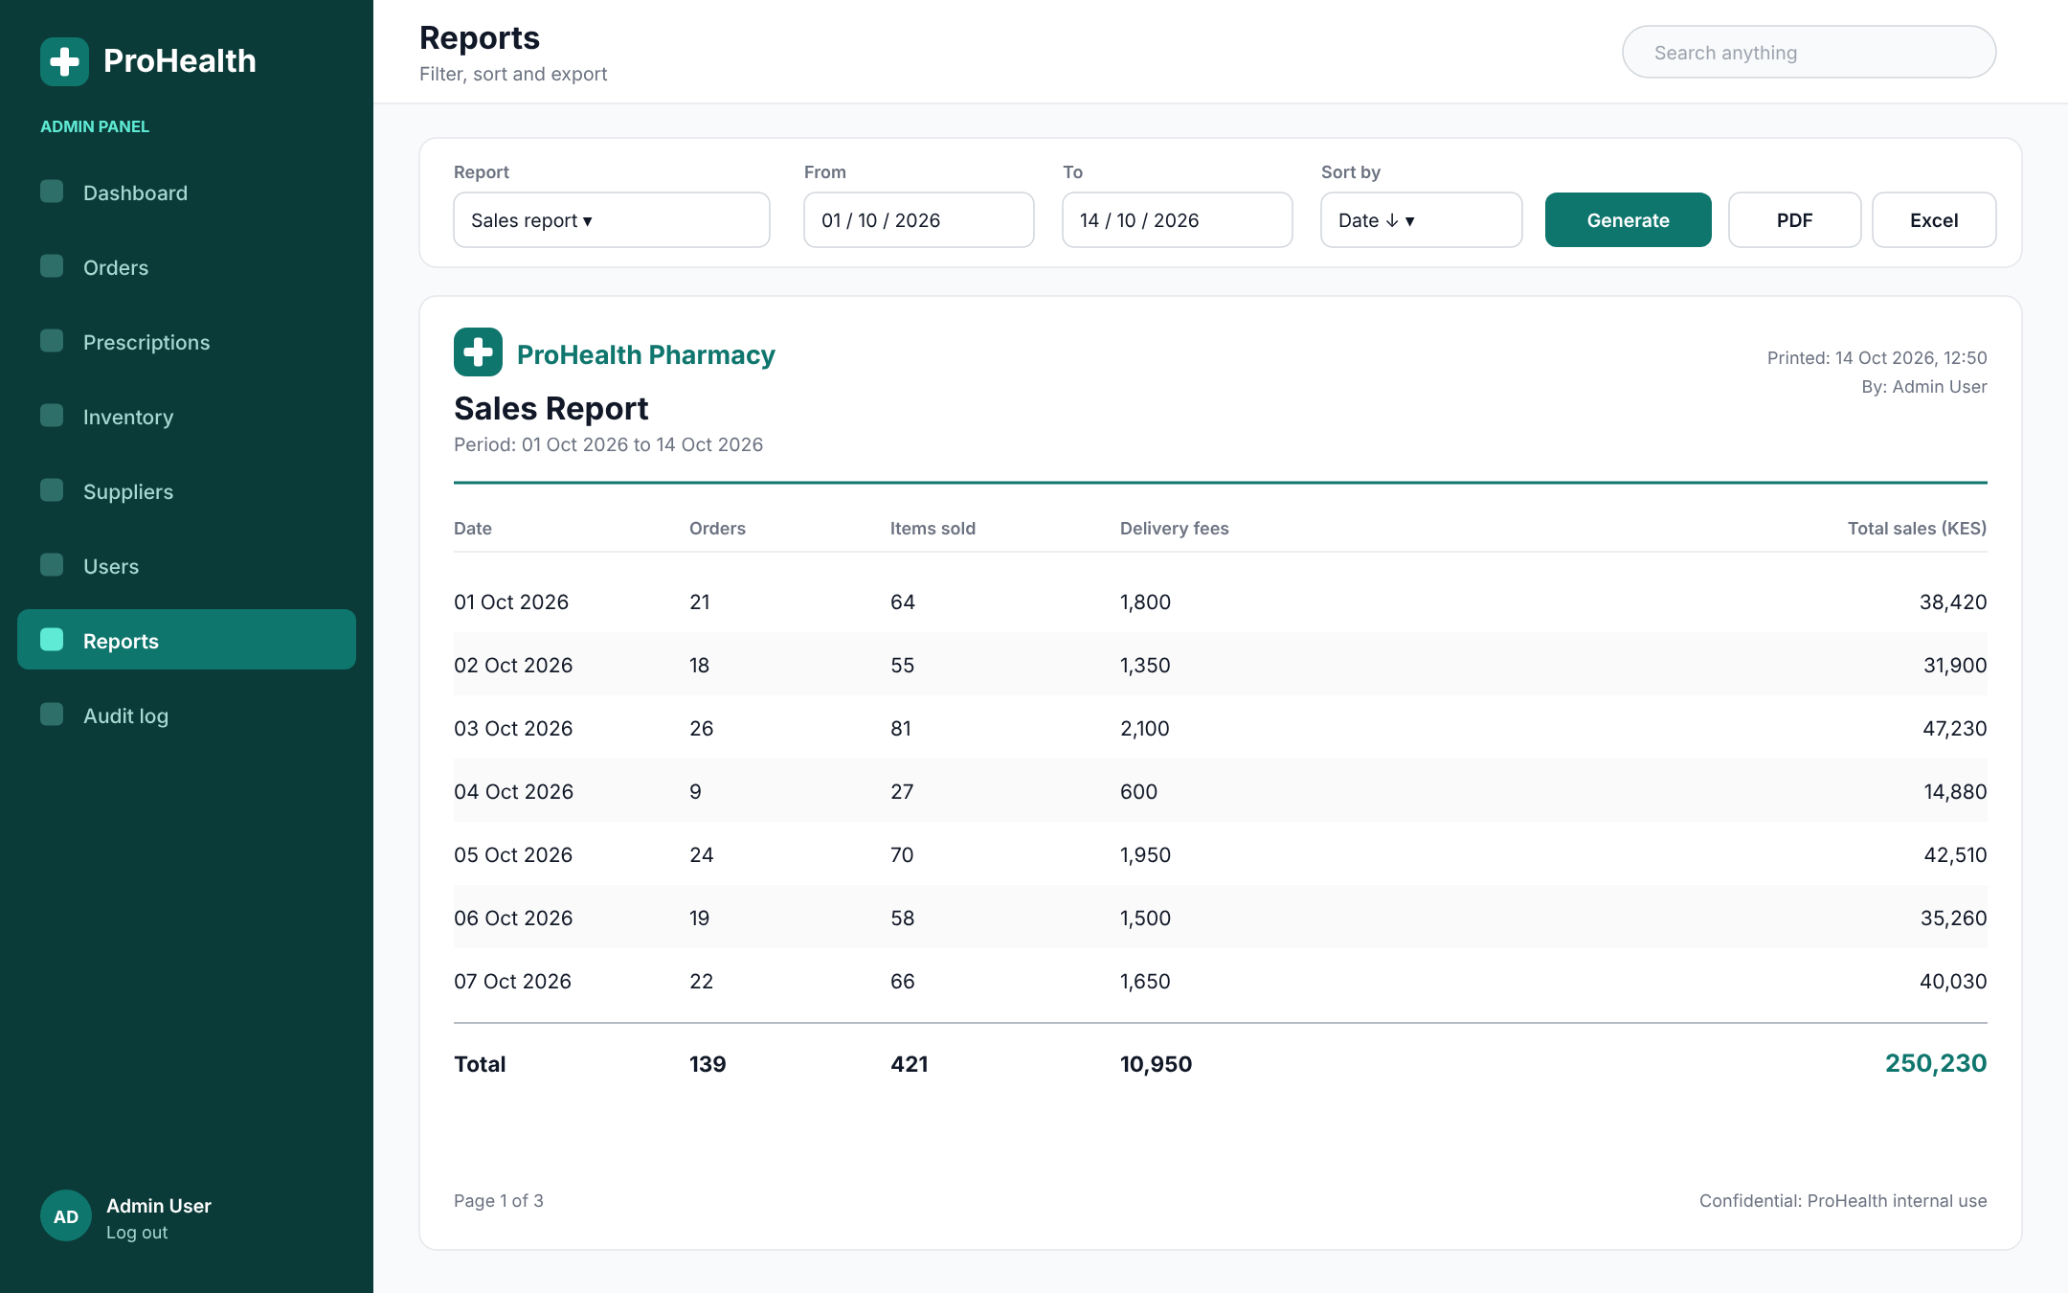
Choose report type, dates and sort order, then view and export. The report layout carries the logo, company name and print date.

Screen A6: User management
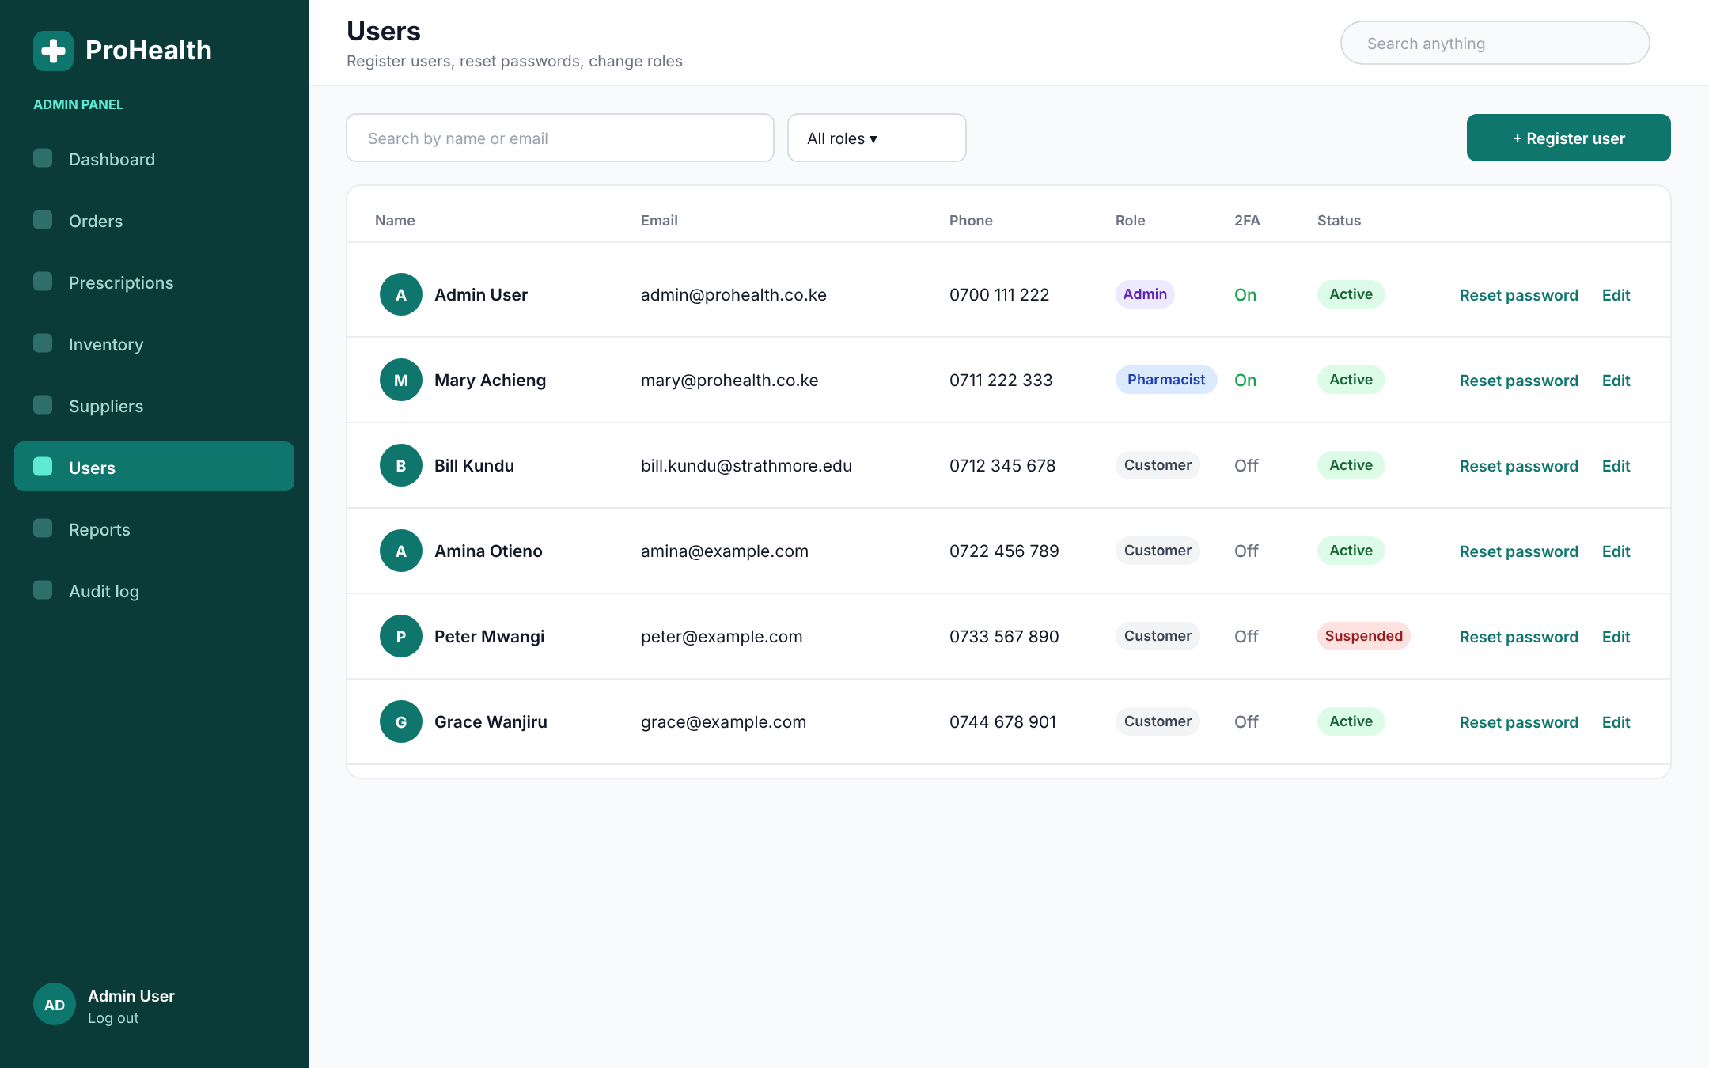
Register users, reset passwords, change roles, see two-factor status, and suspend accounts.

