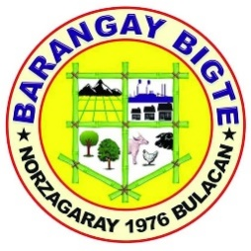

REPUBLIC OF THE PHILIPPINES
PROVINCE OF BULACAN
MUNICIPALITY OF NORZAGARAY
BARANGAY BIGTE

OFFICE OF THE PUNONG BARANGAY
CERTIFICATION

To Whom It May Concern:

This is to certify that Mr/Mrs. {{first_name}} {{middle_name}} {{last_name}}, {{citizenship}}, {{gender}}, {{civil_status}} and a resident of Sitio {{address}}, is currently working as {{job_position}} since {{start_of_work}} and continues to be engaged in said occupation to date.
.
She earns an estimated monthly income of {{amount_in_words}} pesos (php {{monthly_income}})

This certification is issued upon the request for whatever legal purpose it may serve , particularly for submission to PAG- IBIG Fund.

Issued this {{date_issued}} at Barangay Bigte, Norzagaray, Bulacan.

ROSEMARIE M. CAPA
PUNONG BARANGAY

