
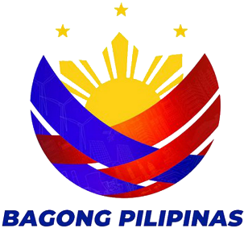
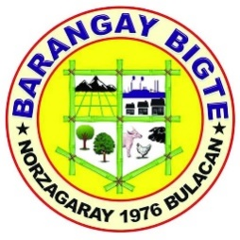
REPUBLIC OF THE PHILIPPINES
PROVINCE OF BULACAN
MUNICIPALITY OF NORZAGARAY
BARANGAY BIGTE

BARANGAY CLEARANCE

TO WHOM IT MAY CONCERN:

This is to certify that the person whose name, picture and signature appearing herein has requested a CLEARANCE from this office and the result(s) is/are listed below

First Name | : {{first_name}}
Middle Name | : {{middle_name}}
Last Name | : {{last_name}}
Address | : {{address}}
Birthdate | : {{birth_date}}
Place of Birth | : {{birth_place}}
Gender | : {{gender}}
Citizenship | : {{citizenship}}
Civil Status | : {{civil_status}}
Date Issued | : {{date_issued}}
Valid Until | : {{expiration}}
Purpose | : LOCAL EMPLOYMENT
REMARKS: | NO RECORD ON FILE.

APPLICANT SIGNATURE
ROSEMARIE M. CAPA
PUNONG BARANGAY

NOT VALID WITHOUT OFFICIAL SEAL

