
REPUBLIC OF THE PHILIPPINES PROVINCE OF BULACAN MUNICIPALITY OF NORZAGARAY

BARANGAY BIGTE

OFFICE OF THE PUNONG BARANGAY
BARANGAY BUSINESS CLEARANCE
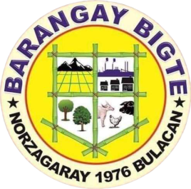

TO WHOM IT MAY CONCERN:

Clearance is hereby granted to {{prefix}}. {{first_name}} {{middle_name}} {{last_name}} of {{address}}. to manage and operate {{business_name}} located of {{location}} effective today {{month_day}} up to {{expiration}}.

This Clearance is granted subject to the condition that all existing laws or ordinances, rules and regulations governing the business are properly observed and will comply all the necessary requirements imposed by the municipality government, but if it causes any dispute, complaint or problem to anyone at any time this Clearance is automatically nullified and void;

This clearance is not valid without the necessary fees as provided by laws or ordinances. This clearance is subject to revocation anytime when the interest of the public requires & violation of any Barangay Ordinances.

{{first_name}} {{middle_name}} {{last_name}} ROSEMARIE M. CAPA
Signature/Applicant Punong Barangay

OR NO.: 0851403
Res> Cert. No. 03715053
Issued at: BIGTE, NORZAGARAY, BULACAN
Issued on: {{date_issued}} VALID UNTIL: {{expiration}} ONLY

Remarks : Not Valid As a Permit
This clearance is only a requirement to apply for Mayor’s permit

NOT VALID WITHOUT OFFICIAL SEAL

Baltazar St. Barangay Bigte, Norzagaray, Bulacan
0997-732-2787
Barangaybigte@yahoo.co.uk

