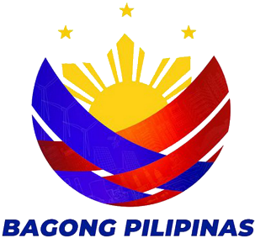
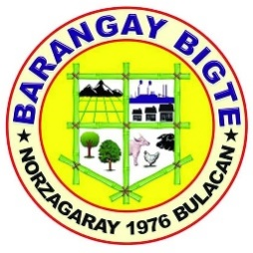


REPUBLIKA NG PILIPINAS

LALAWIGAN NG BULAKAN

MUNISIPALIDAD NG NORZAGARAY
BARANGAY BIGTE

CERTIFICATE OF INDIGENCY

TO WHOM IT MAY CONCERN:

THIS IS TO CERTIFY that {{first_name}} {{middle_name}} {{last_name}}, of legal age, residents of Sitio {{address}} belongs to one of many indigent families of this barangay. The income of this family is barely enough to meet day to day needs.
This certification is being issued upon the request of {{first_name}} {{middle_name}} {{last_name}} to apply for {{purpose}}.
Issued this {{date_issued}} at Bigte, Norzagaray , Bulacan.

ROSEMARIE M. CAPA
Punong Barangay

NOT VALID WITHOUT OFFICIAL SEAL

