
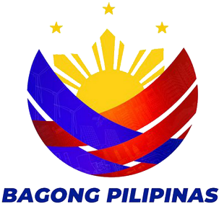
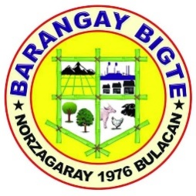

REPUBLIKA NG PILIPINAS

LALAWIGAN NG BULAKAN

MUNISIPALIDAD NG NORZAGARAY
BARANGAY BIGTE

C E R T I F I C A T I O N

TO WHOM: {{para_kay}}
{{position}}
{{hall_address}}

THIS IS TO CERTIFY that {{first_name}} {{middle_name}} {{last_name}}, of legal age, residents of Sitio {{address}} belongs to one of many indigent families of this barangay. The income of this family is barely enough to meet day to day needs.
This certification is being issued upon the request of {{first_name}} {{middle_name}} {{last_name}} to apply for {{purpose}}.
Issued this {{date_issued}} at Bigte, Norzagaray , Bulacan.

LAGDA NG MAYKAHILINGAN

ROSEMARIE M. CAPA
Punong Barangay

TOMAS R. POLICARPIO
Barangay Administrator

NOT VALID WITHOUT OFFICIAL SEAL

