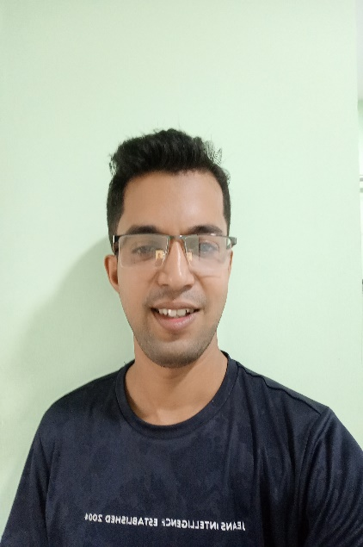

**BIKASH** DASH

­

FULL STACK DEVELOPER

**CONTACT**

+91 9937090484

[tobikashdash@gmail.com](mailto:tobikashdash@gmail.com)

<https://www.linkedin.com/in/tobikash-dash/>

https://bikash-dash.github.io/

**PROFESSIONAL EXPERIENCE**

I have been developing Web Applications for 7+ years by using various technologies like .PHP, Angular, React and Node. Involved in all the Phases of App Development From Analysis to Integration Testing. Good at agile methodology. Please go further to see why and how I may be the one you need to hire.

**PROFILE**

**Lead Software developer  
Sadyogi Technology Services Pvt Ltd,** 2016**– 2019**  
**→ Foodzo.in** [**Link**](https://www.foodzo.in/)

[**Link**](https://www.foodzo.in/)

Foodzo is an online food ordering platform in Bhubaneswar. Foodzo brings over 300 menu items to your doorstep. Free home delivery. We offer an efficient and professional service from ordering, delivery, presentation and to the quality of food

* Role:    Software Development
* Tech:   CakePhp, mysql, ccavenue

**REFERENCE**

**Nisar Ansari**  
Designation: Senior Administrator  
Company Name: Defraudit IT solutions. Location: hyderabad  
phone:+91 7097808320

**HOBBY**

Travelling

Blogging

Reading Books

Photography

**→ planforhealth** [**Link**](https://app.planforhealth.com/)

Our platform allows you to offer your patients a compelling alternative to dental insurance that raises your standard of care and team performance.

* Role:    Software Development
* Tech:   React, GraphQL, PostgresDB, NodeJS, Google Identity, Paypal, Clearent Payment Gateway.

**Software developer  
Defraudit IT solutions,** 2019**– Present**  
**→ Pearly Plan Link**

Pearly is a membership program solution to launch, manage, and grow in-house dental membership program.

* Role:    Software Development
* Tech:  React, Gatsby, GraphQL, PostgresDB, NodeJS, Google Identity, Paypal, Clearent Payment Gateway.

**MY SKILLS**

**REACT**

**REDUX**

**GRAPHQL**

**PRISMA**

**LARAVEL**

**CAKEPHP**

**TYPESCRIPT**

**MATERIAL UI**

**TAILWIND CSS**

**+2 Science**  
Bhairaba Mahavidyalaya - 2008– 2009

**Matriculation**  
Panchayat High School - 2007

**EDUCATION**

**GNIIT - Software Engineering.**Niit - 2011 – 2014  
NIIT, Bhubaneswar, Odisha

**Bachelor of Science information Technology**  
Kuvempu University - 2010– 2013   
Kuvempu University, Karnataka,

**Bachelor of Science information Technology**  
Kuvempu University - 2010– 2013   
Kuvempu University, Karnataka,

**Software developer  
maastrix solutions pvt. ltd, 2014 – 2015**  
**→ Dezmembraripenet** [**Link**](http://www.dezmembraripenet.ro/)

Dezmembraripenet is a one stop shop for all auto repairs and automotive parts at reasonable costs. Automotive parts are manufactured with highest specification and quality for Korean made vehicles’ is an e-commerce site for automobile parts like oil seals , air filters

* Role:    Software Development
* Tech:   CorePhp, MySQL, Facebook Login,.

**→ manchesteroaksremodeling** [**Link**](http://www.manchesteroaksremodeling.com/)

Looking for budget-friendly basement, kitchen or bathroom remodeling service in Atlanta? We are trusted for our flexibility &amp; on-time delivery of quality work

* Role:    Software Development
* Tech:   Laravel, MySQL