## **STEP-1: Install the latest Java version**

Find the latest Java JDK in the given folder. Now you should be able to install the last Java JDK by opening this file.

**Step-2: Install the latest Eclipse version**  
Find the latest Eclipse (64 bit) version in the given folder. Now you should be able to install the last Eclipse software by opening this file.

## **Step-3: Install OpenCV 3.x under Windows**

Find opencv 3.3.3 file in the given folder. Open it by clicking on the same and unzip it into any disk on your PC.

Now the only two things that you will need are: the opencv-3xx.jar file located at \opencv\build\java and the opencv_java3xx.dll library located at \opencv\build\java\x64 (for 64-bit systems) or \opencv\build\java\x86 (for 32-bit systems). The 3xx suffix of each file is a shortcut for the current OpenCV version, e.g., it will be 300 for OpenCV 3.0 and 330 for OpenCV 3.3.

## **Step-4: Set up OpenCV for Java in Eclipse**

Open Eclipse and select a workspace of your choice. Create a User Library, ready to be used on all your next projects: go to Window > Preferences....

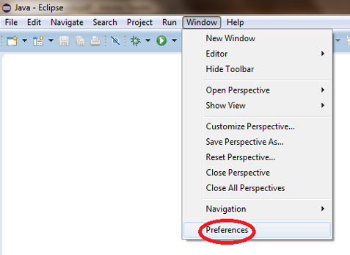

From the menu navigate under Java > Build Path > User Libraries and choose New.... Enter a name for the library (e.g., opencv) and select the newly created user library. Choose Add External JARs..., browse to select opencv-3xx.jar from your computer. After adding the jar, extend it, select Native library location and press Edit....

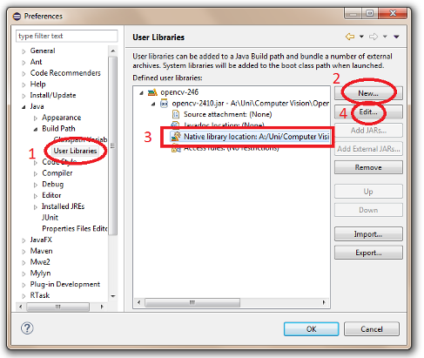

Select External Folder... and browse to select the folder containing the OpenCV libraries (e.g., C:\opencv\build\java\x64 under Windows).

**Step-5: Create new Java Project and add OpenCV libraries**

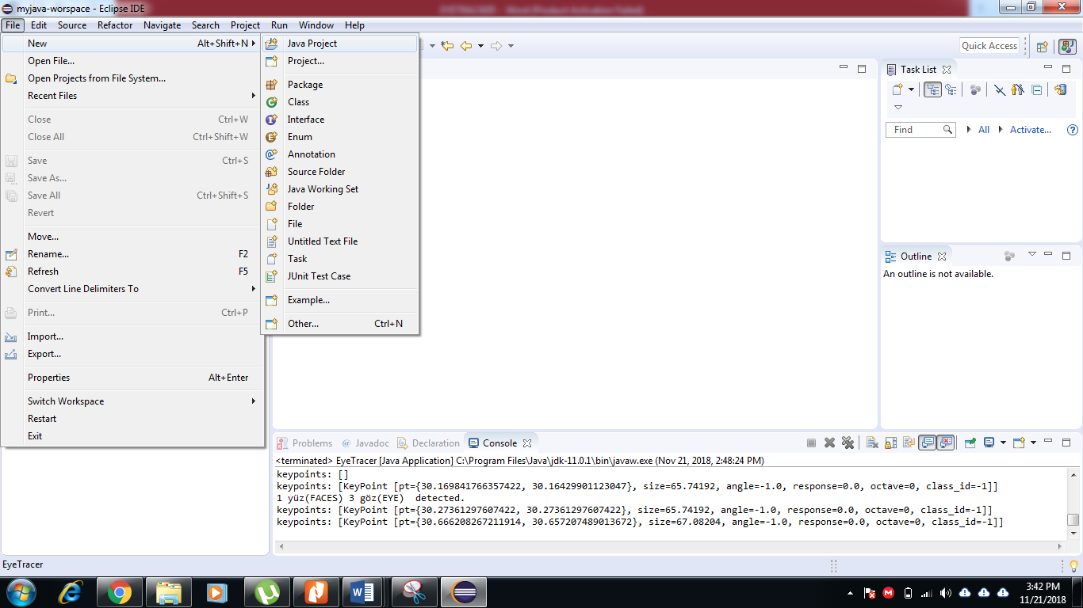

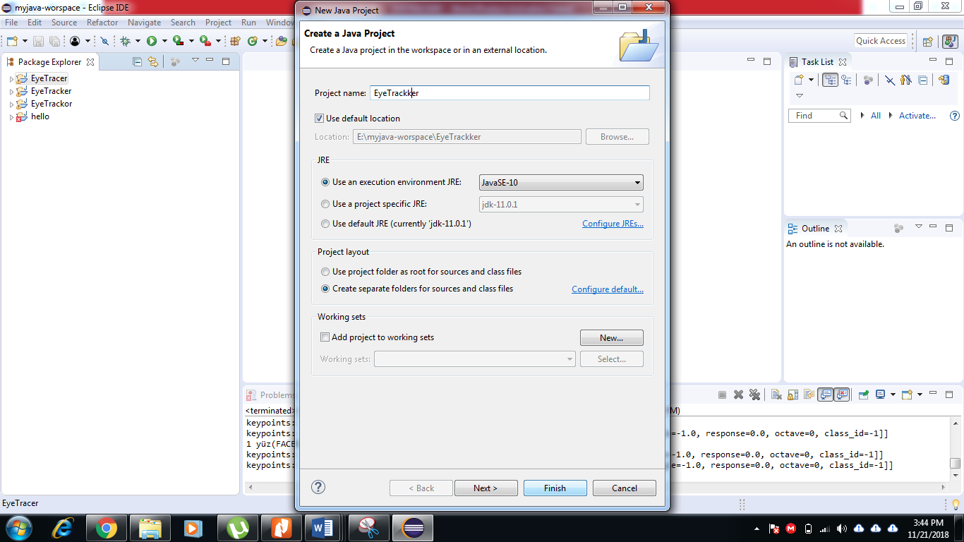

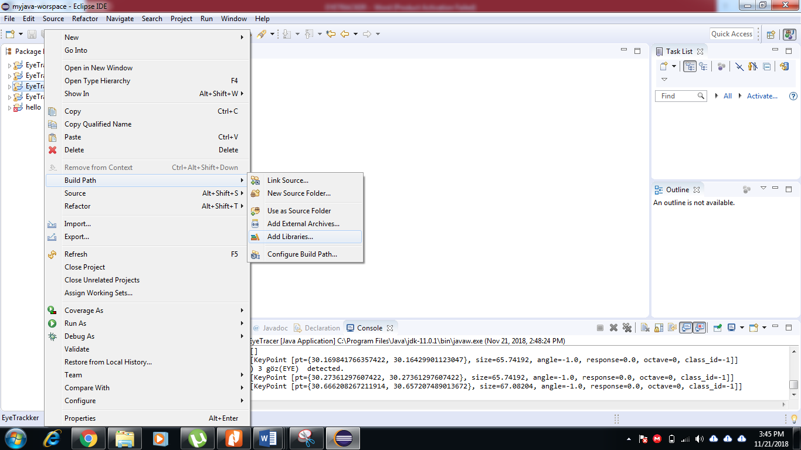

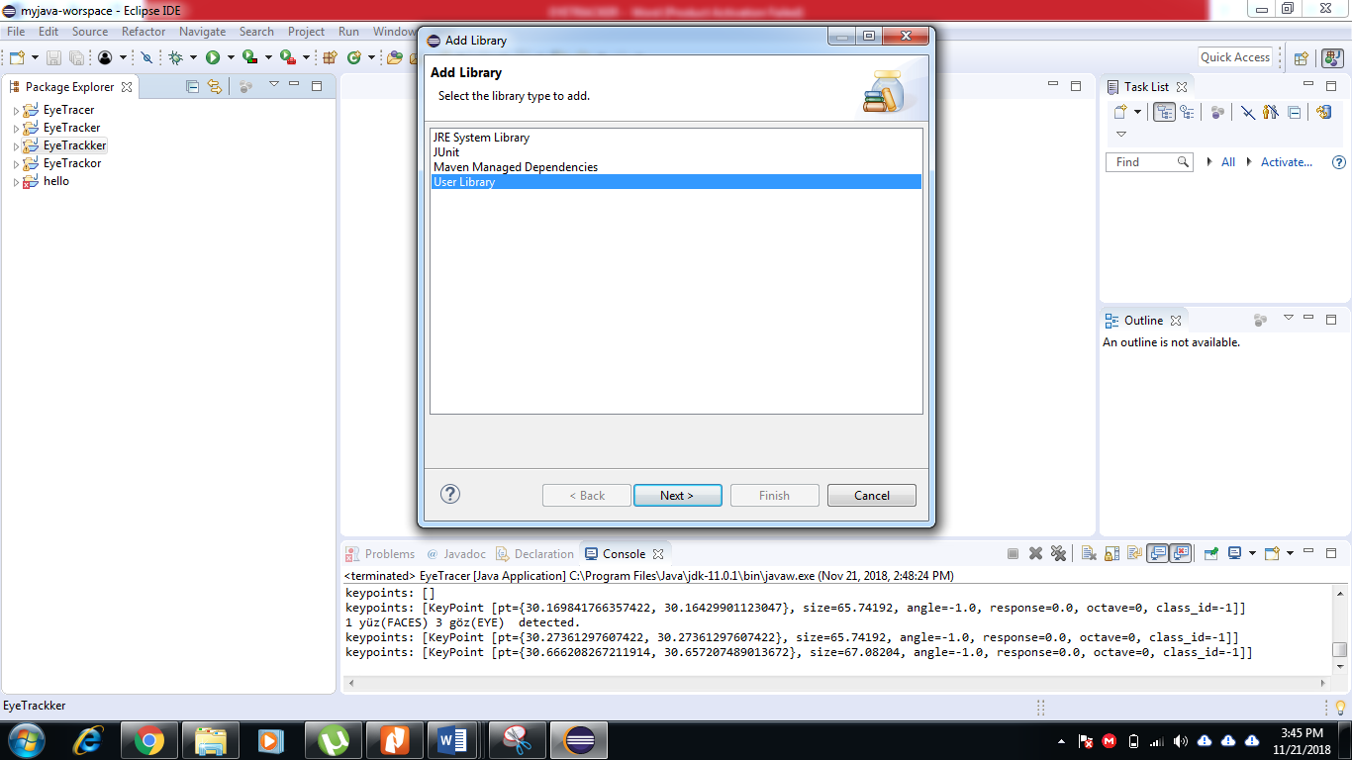

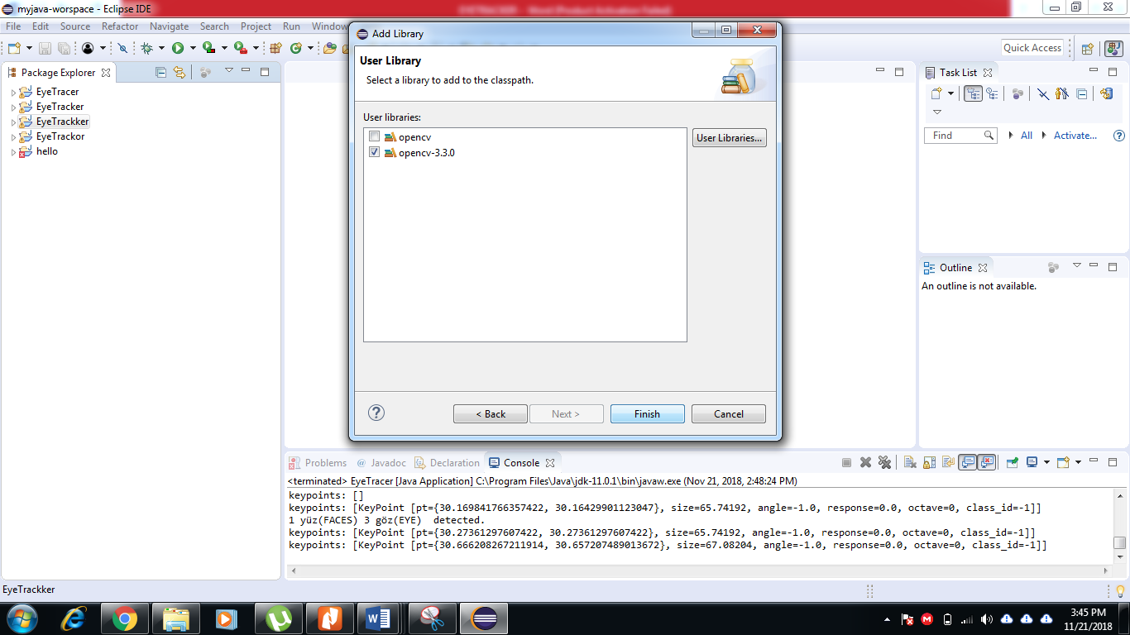

Now click on finish and opencv libraries are added to project.

**Step-5: Add EyeTracer.java file to src default package by drag and drop from folder.**

**Do check location of xml and txt files in given java folder and modify according to your set up and run the program. Now you are ready to track face, eye and pupil.**

**Thanks.**