DART-SCHOOL-LAB
TEAM
222013795 : ZINARYIZA Billy Charmant
223003227 : MUGISHA Phillipe

Screenshot for each question

Lab Questions
Part 1: Functions
Q1: Write a Dart function named `welcomeMessage` that prints a welcome message for the school system.
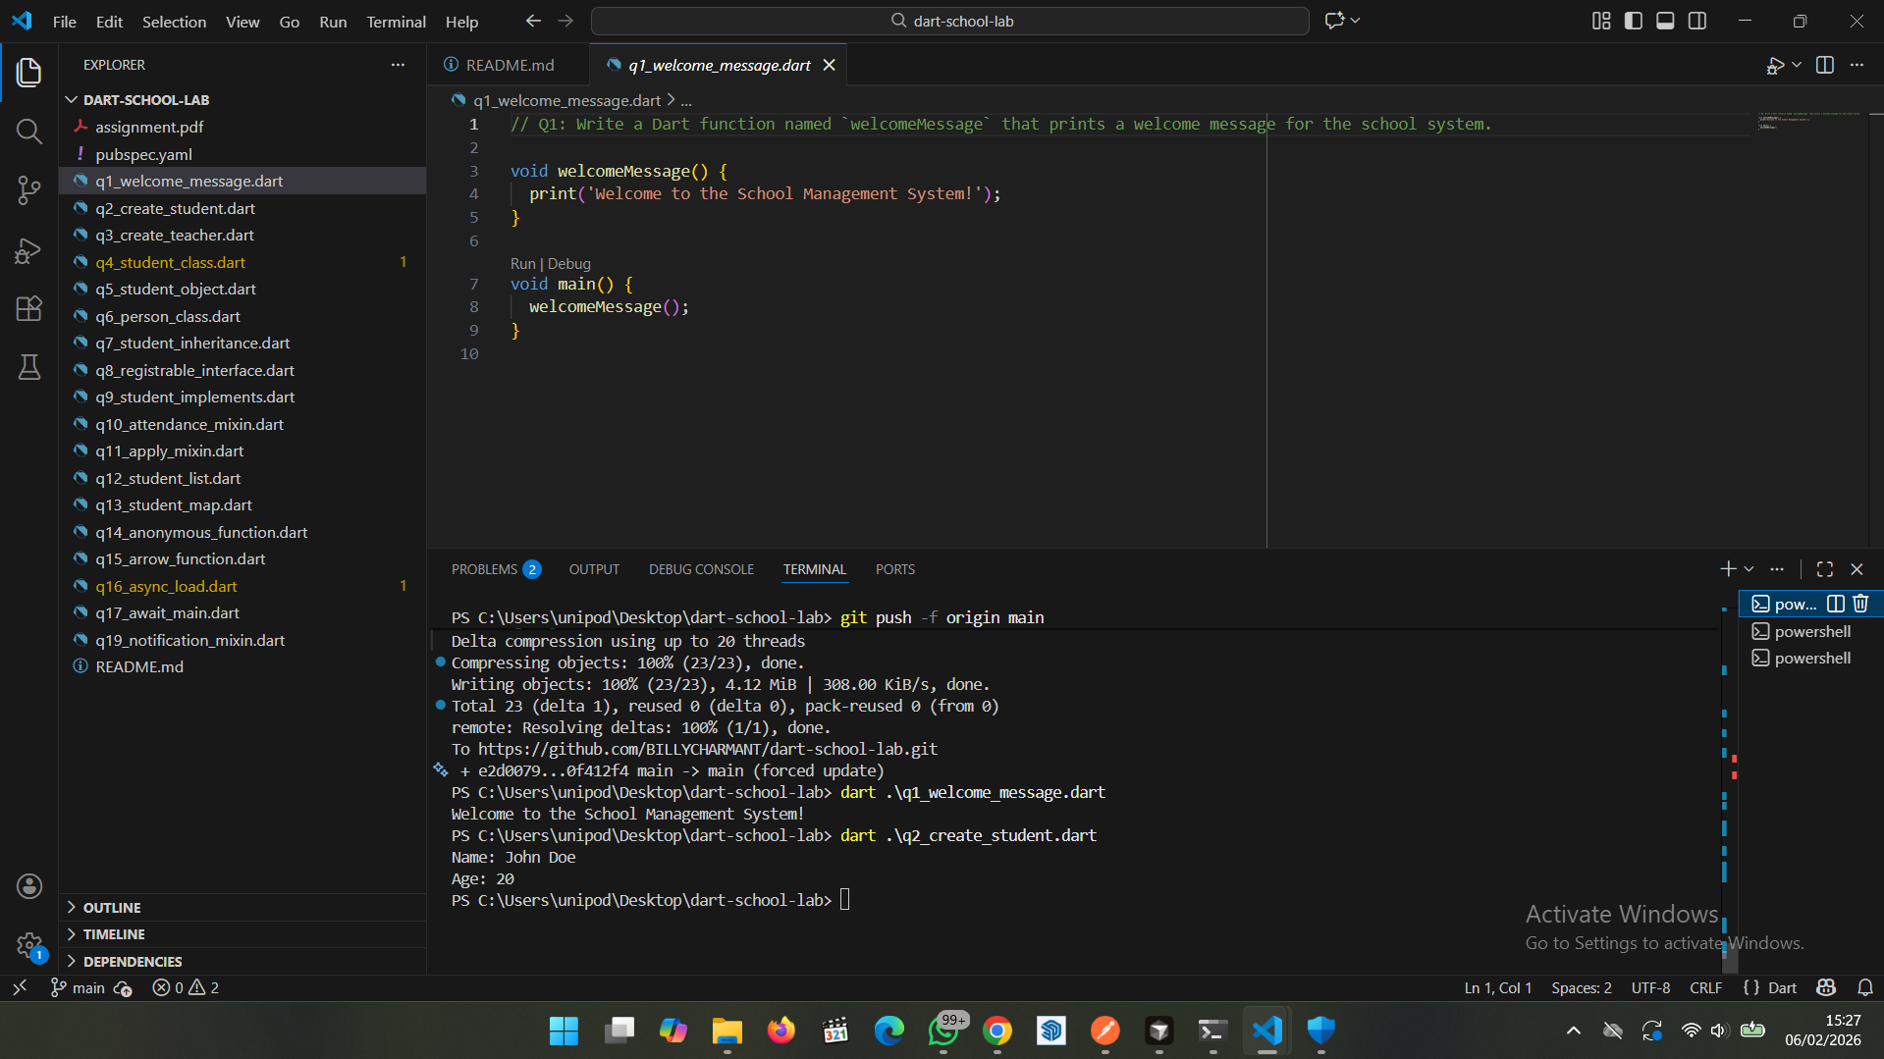
Q2: Write a function named `createStudent` that uses named parameters (`name` and `age`) and prints the student details.
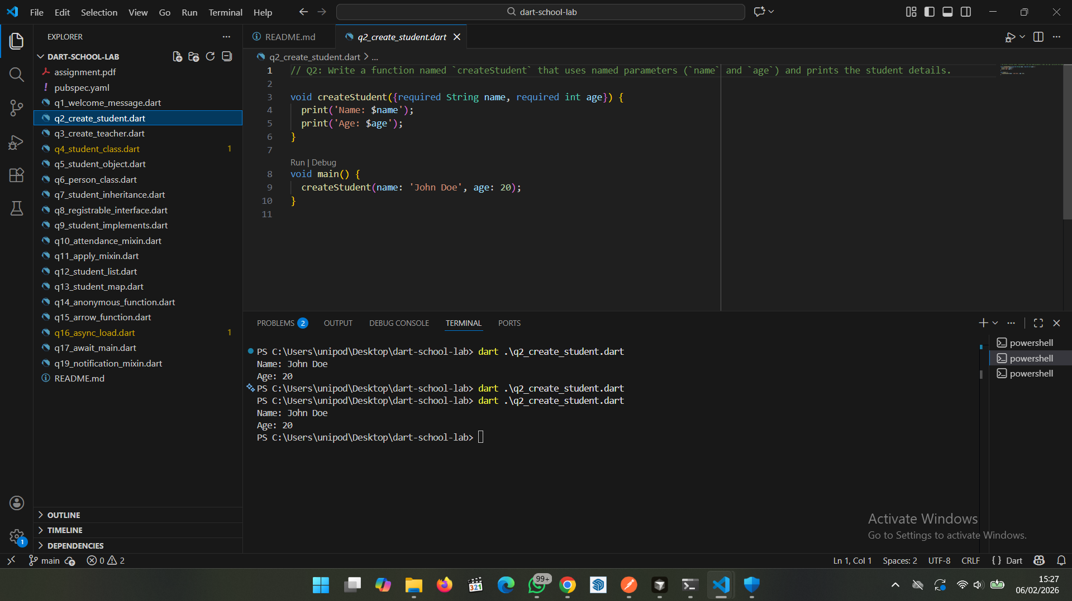
Q3: Write a function named `createTeacher` with one required parameter `name` and one optional parameter `subject`. If subject is not provided, print 'Subject not assigned'.
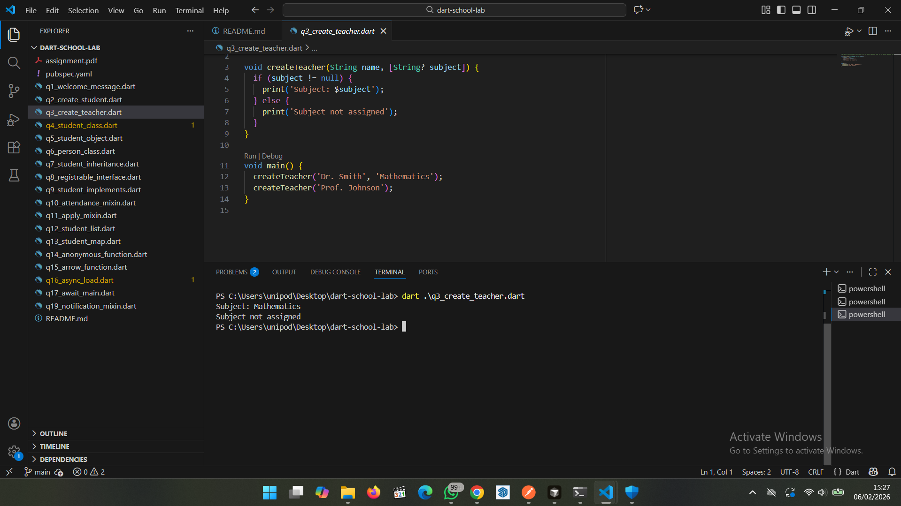

Part 2: Constructors and Classes
Q4: Create a class named `Student` with `name` and `age`, and a constructor to initialize these values.

Q5: Create an object of `Student` and print the student’s name and age.
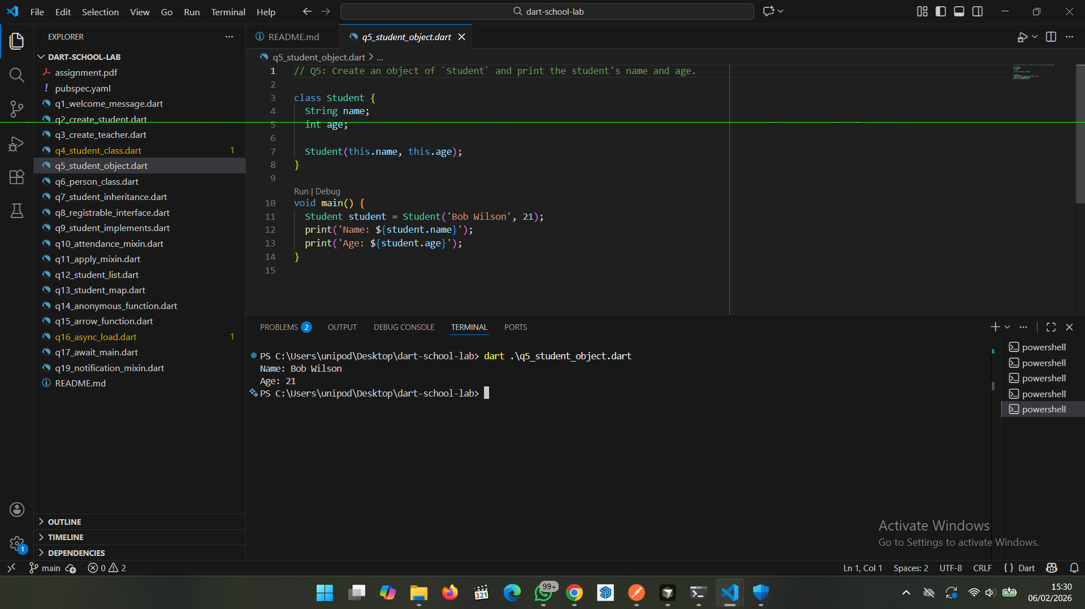

Part 3: Inheritance
Q6: Create a class `Person` with a variable `name` and a function `introduce()` that prints the name.
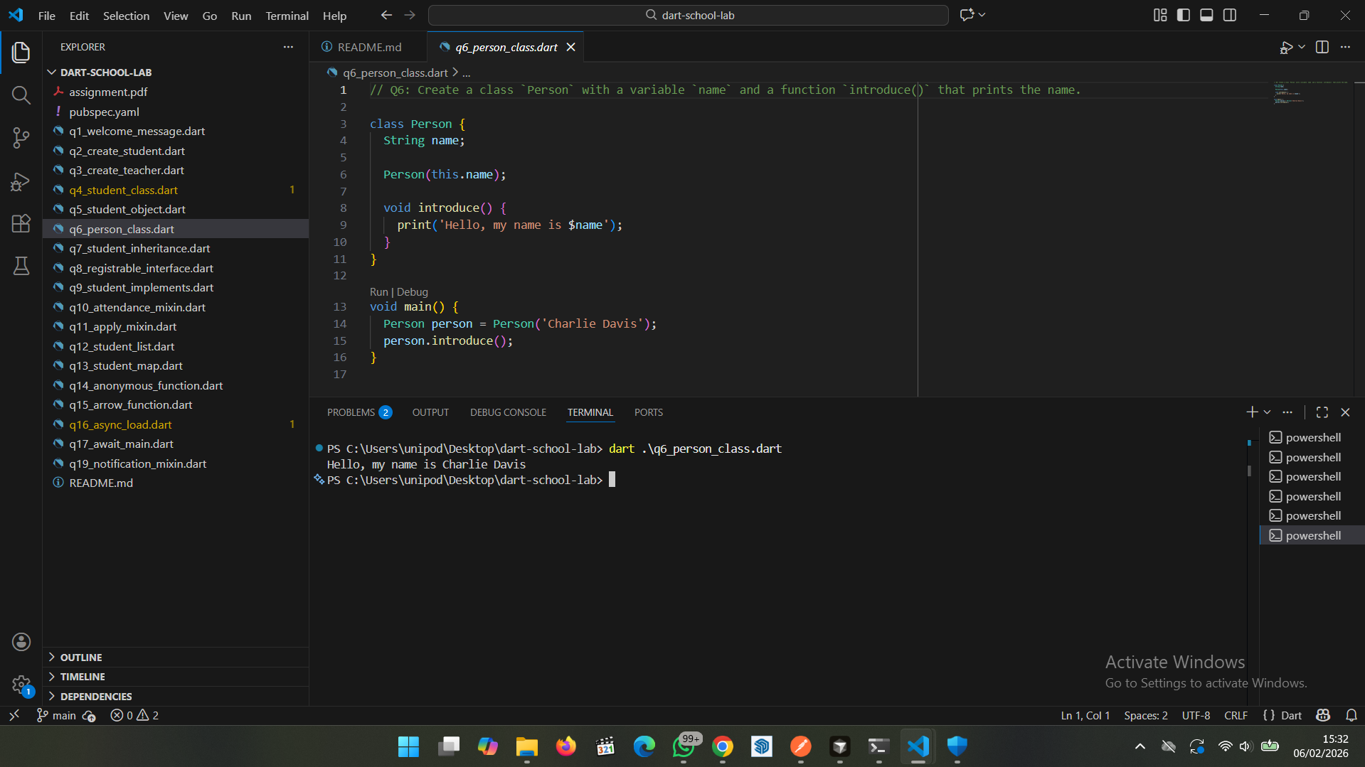

Q7: Make `Student` inherit from `Person` and call `introduce()` from a `Student` object.
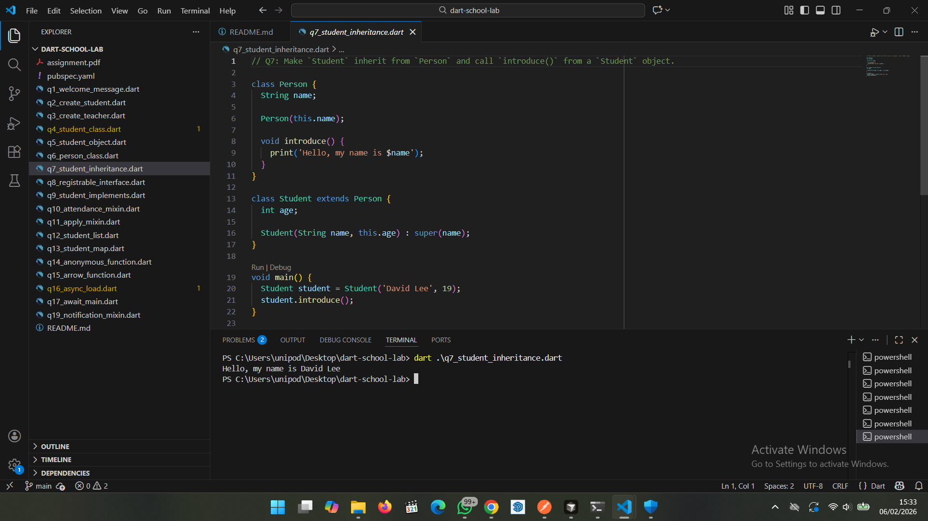

Part 4: Interfaces

Q8: Create an abstract class `Registrable` with a function `registerCourse(String courseName)`.

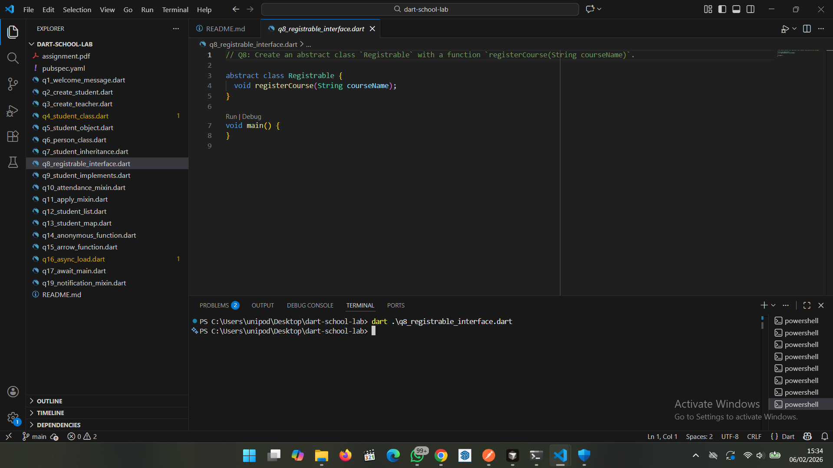

Q9: Make `Student` implement `Registrable` and implement `registerCourse` to print the student name and course.
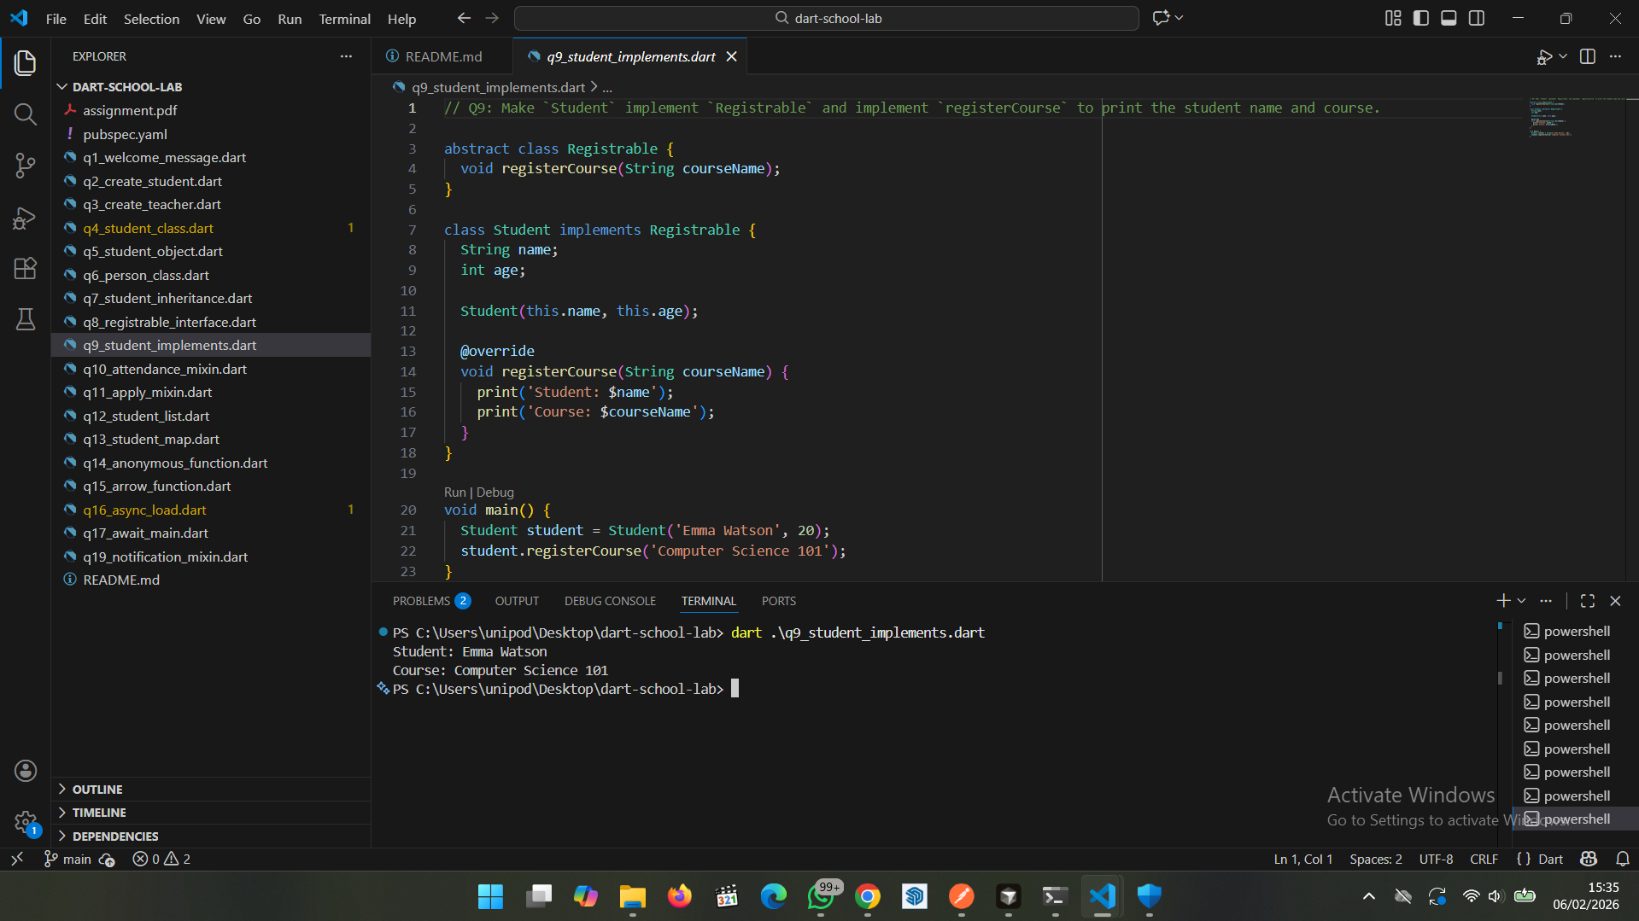

Part 5: Mixins

Q10: Create a mixin `AttendanceMixin` that stores an attendance counter and has a function `markAttendance()` to increase attendance.
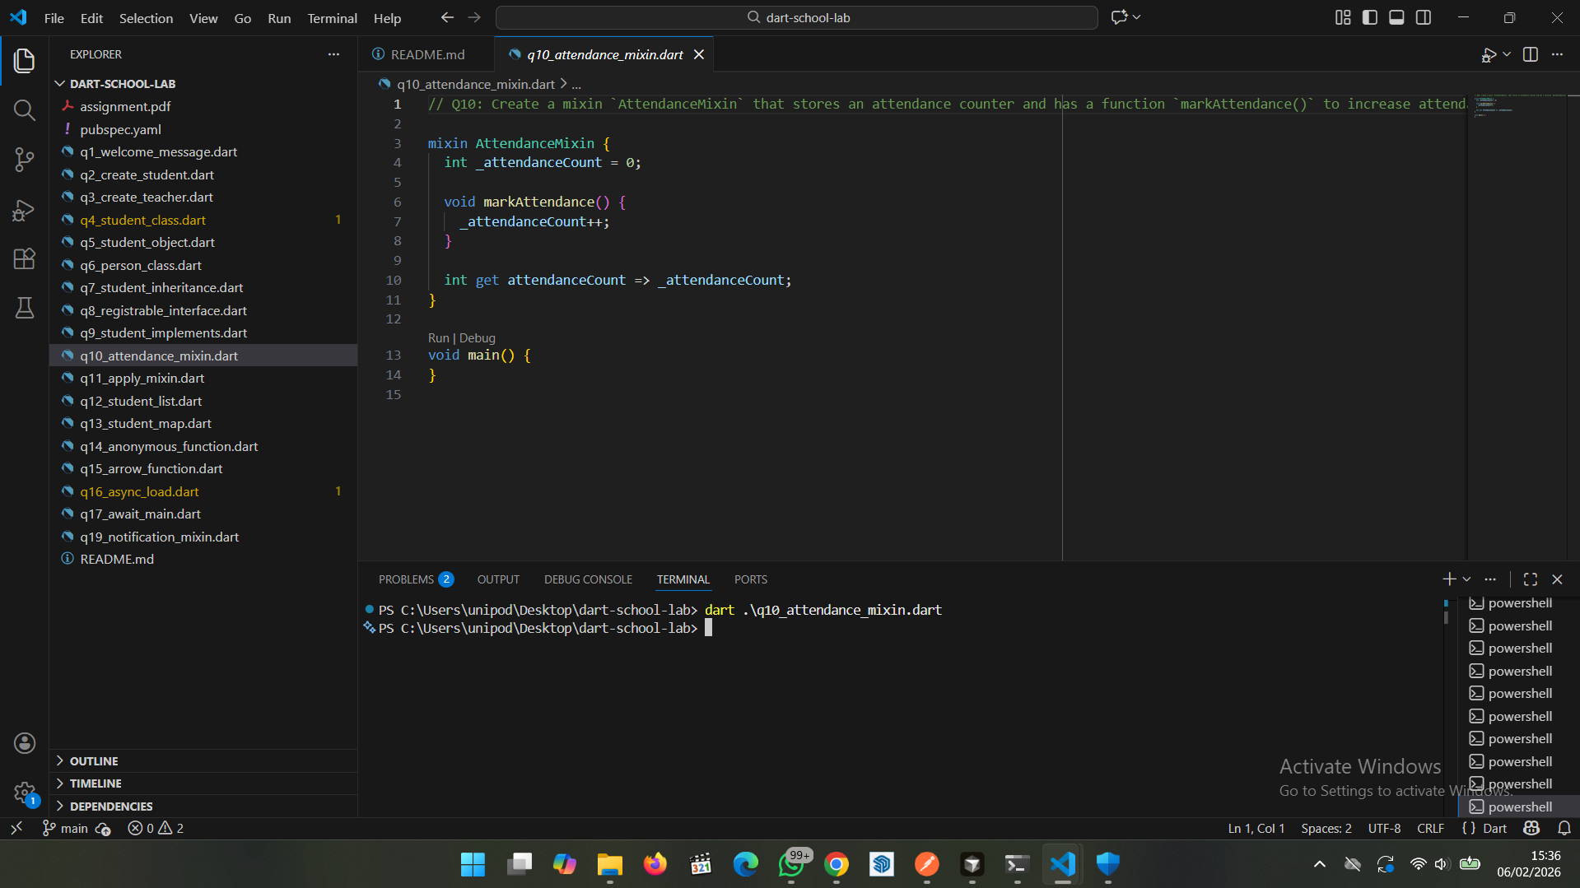

Q11: Apply `AttendanceMixin` to `Student`. Mark attendance 3 times and print the attendance.
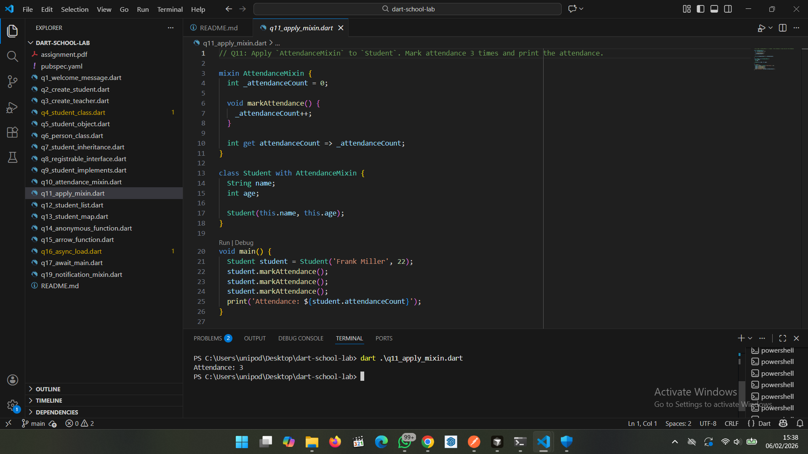

Part 6: Collections

Q12: Create a List storing multiple `Student` objects. Add 3 students.

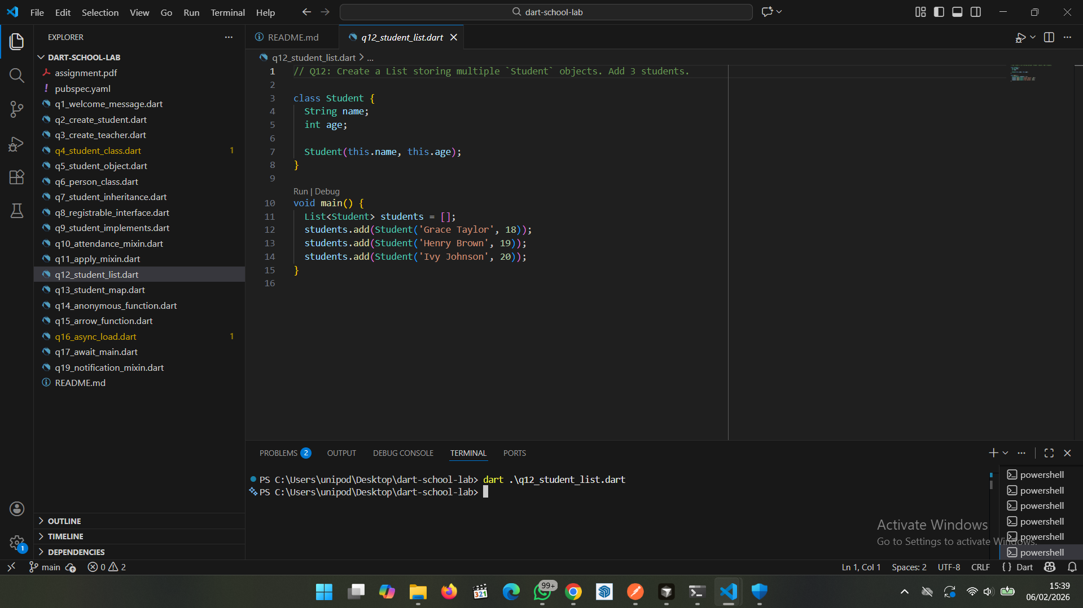

Q13: Create a Map where the key is student ID and value is a `Student`. Print all student names.

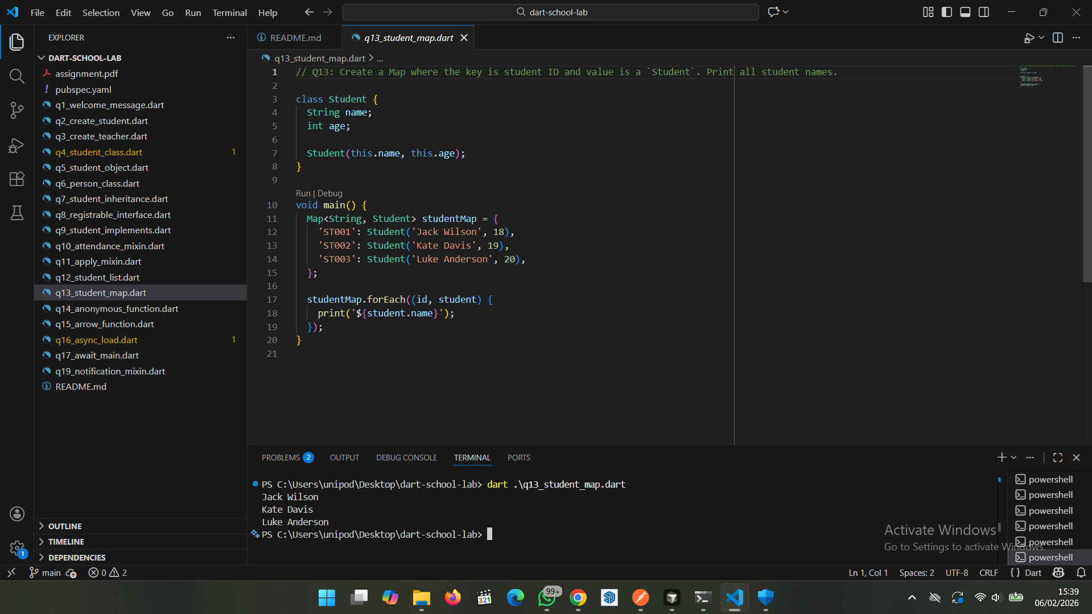

Part 7: Anonymous and Arrow Functions

Q14: Use an anonymous function to print all student names from the list.

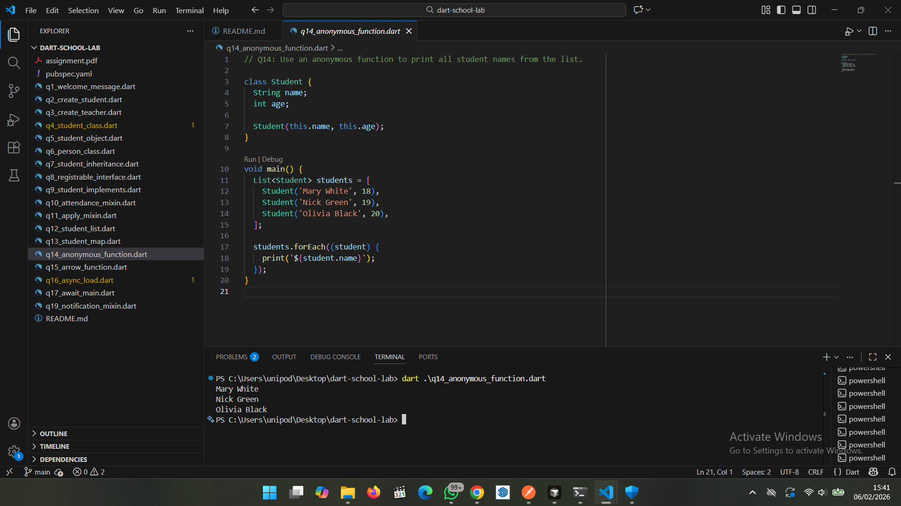

Q15: Write an arrow function that takes a student name and prints a greeting message.

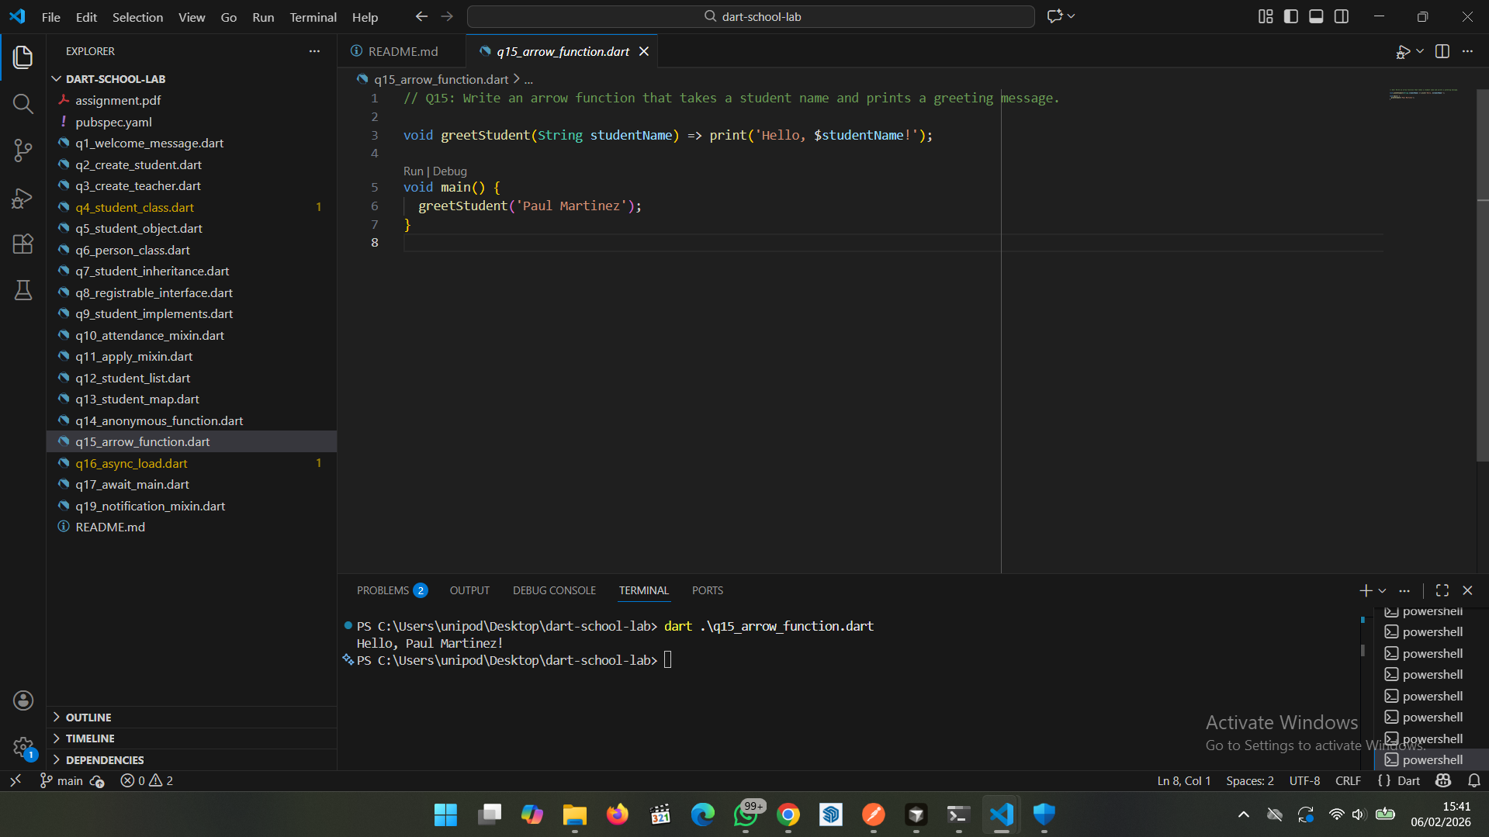

Part 8: Asynchronous Programming

Q16: Write an async function `loadStudents()` that waits 2 seconds and returns the list of students.

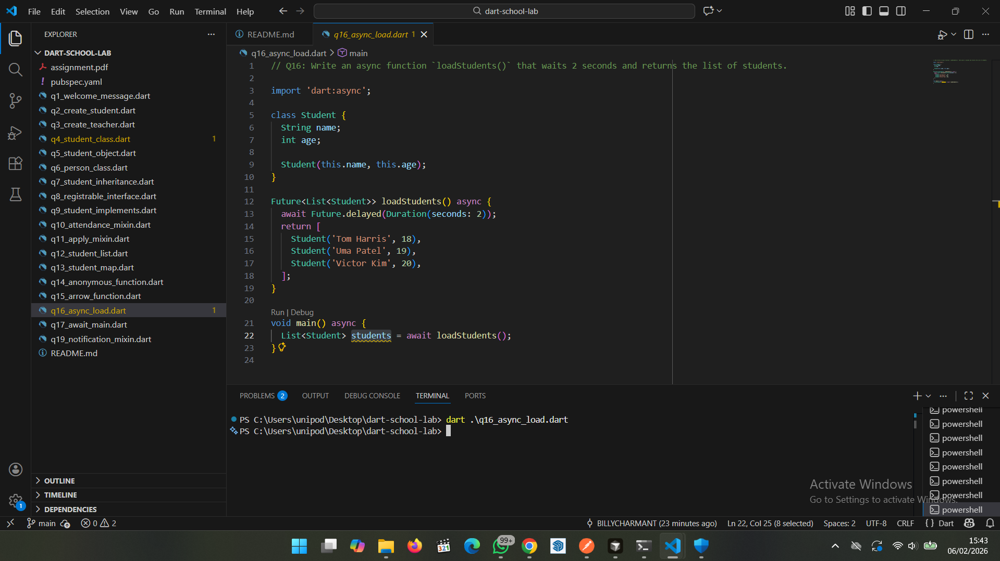

Q17: In main(), call `loadStudents()`, use await, and print the number of students loaded.

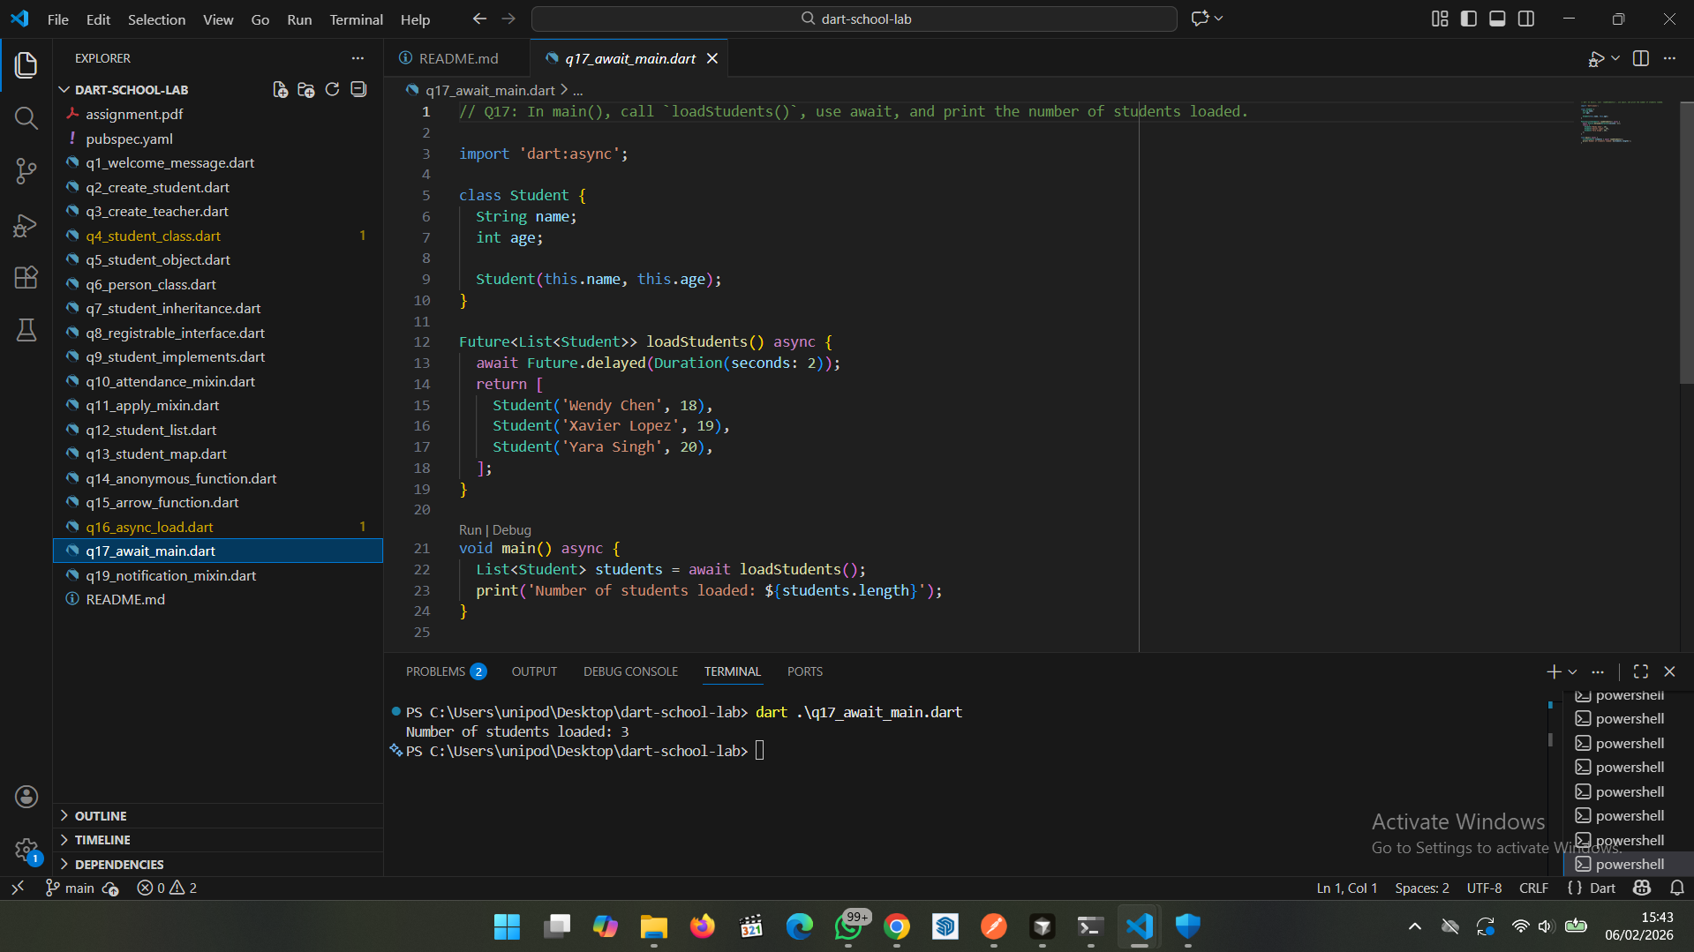

Q19: Create a new mixin `NotificationMixin` that prints a message when a student is registered to a course. Apply it to `Student`.

