

ERODE SENGUNTHAR
ENGINEERING COLLEGE
(APPROVED BY AICTE, NEW DELHI & PERMANENTLY AFFILIATED TO ANNA UNIVERSITY, CHENNAI
ACCREDITED BY NBA, NEW DELHI, NAAC WITH GRADE “A” & IE(I) KOLKATA )
PERUNDURAI , ERODE - 638057.
An Autonomous Institution

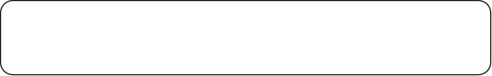
BONAFIDE

CERTIFICATE

Register No.…………………………………...
Certified that is the Bonafide Record of Work Done

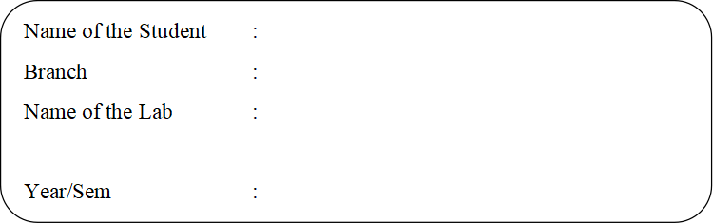

Faculty Incharge Head of the Department

Submitted for the Odd Semester Practical
Held on ………………………………...

Internal Examiner External Examiner

INDEX

S.NO | DATE | NAME OF THE EXPERIMENT | PAGE NO | MARKS | FACULTY SIGN
1. |  | Solving Xor Problem Using DNN
2. |  | Character Recognition Using CNN
3. |  | Face Recognition Using CNN
4. |  | Text Generation Using RNN
5. |  | Sentiment Analysis Using LSTM
6. |  | Parts Of Speech Tagging Using Sequence To Sequence Architecture
7. |  | Machine Translation Using Encoder- Decoder Model
8. |  | Image Augmentation Using GAN
EX.NO: - 1 SOLVING XOR PROBLEM USING DNN
DATE: -
AIM:
The aim of this procedure is to solve the XOR problem using a Deep Neural Network (DNN) in Python.
PROCEDURE:
- Import the necessary libraries
- Prepare the dataset
- Create the DNN model
- Compile the model
- Train the model
- Test the model
- Print the predictions
PROGRAM:
#1.Import the necessary libraries: import numpy as np from keras.models import Sequential from keras.layers import Dense
X= np.array([[0, 0],[0, 1], [1,0],[1, 1]]) #Define the corresponding output labels y = np.array([[0], [1], [1], [0]]) #3.Create the DNN model: #Create a Sequential model model = Sequential() #Add layers to the model model.add(Dense(4,input_dim=2,activation=’relu’)) model.add(Dense(1, activation=’sigmoid’))
# Compile the model model.compile(loss=’binary_crossentropy’,optimizer=’adam’,metrics=[‘accuracy’])
#4. Train the model:
model.fit(X,y,epochs=1000)
#5. Test the model:
# Predict outputs for the input dataset predictions = model.predict(X) rounded_predictions=np.round(predictions)
For i in range(len(X)):
print(f”Input:{X[i]},PredictedOutput: {rounded_predictions[i]}”)

OUTPUT:
Input:[00],PredictedOutput: [0.]
Input:[01],PredictedOutput: [1.]
Input:[10],PredictedOutput: [1.]
Input:[11],PredictedOutput: [0.]

RESULT:
Thus the program to solve the XOR problem using a Deep Neural Network(DNN) in Python written Successfully.
EX.NO: - 2 CHARACTER RECOGNITION USING CNN
DATE: -
AIM:
The aim of this code is to train a Convolutional Neural Network (CNN) model on the MNIST dataset and evaluate its performance by making predictions on the test set.
PROCEDURE:
- Import the necessary libraries
- Load and preprocess the dataset
- Create the CNN model
- Compile the model • Train the model
- Evaluate the model
- Make predictions
- Visualize the results
PROGRAM:
import tensorflow as tf import numpy as np
import matplotlib.pyplot as plt

(x_train,y_train),(x_test,y_test)= tf.keras.datasets.mnist.load_data()

x_train=x_train.astype('float32')/255 x_test = x_test.astype('float32') / 255

#Reshape the data for CNN x_train=x_train.reshape(-1,28,28,1) x_test=x_test.reshape(-1,28, 28, 1) model = tf.keras.Sequential([
tf.keras.layers.Conv2D(filters=64,kernel_size=(2,2),strides=(1,1),padding='same',
activation='relu', input_shape=(28,28,1)), tf.keras.layers.MaxPooling2D(pool_size=(2,2)), tf.keras.layers.Dropout(0.3),
tf.keras.layers.Conv2D(filters=32,kernel_size=(2,2),strides=(1,1),padding='same',
activation='relu'), tf.keras.layers.MaxPooling2D(pool_size=(2,2)), tf.keras.layers.Dropout(0.3), tf.keras.layers.Flatten(), tf.keras.layers.Dense(256, activation='relu'), tf.keras.layers.Dropout(0.5), tf.keras.layers.Dense(10,activation='softmax')])
model.compile(loss='sparse_categorical_crossentropy',optimizer='adam', metrics=['accuracy']) model.fit(x_train,y_train,batch_size=60,epochs=10,verbose=1,validation_split=0.3)
# Evaluate the model on test set score=model.evaluate(x_test,y_test,verbose=0) print('\nTest accuracy:', score[1]) predictions=model.predict(x_test)
#Display some test images and their predicted labels num_rows = 5 num_cols=3 num_images = num_rows * num_cols plt.figure(figsize=(2*2*num_cols,2*num_rows)) for i in range(num_images):

plt.subplot(num_rows,2*num_cols,2*i+1)
plt.xticks([])
plt.yticks([]) plt.imshow(x_test[i].reshape(28,28),cmap=plt.cm.binary) predicted_label = np.argmax(predictions[i]) plt.xlabel("{}({})".format(predicted_label,y_test[i])) plt.show()

OUTPUT:
Epoch1/10
700/700[==============================]-44s62ms/step-loss:0.4044 - accuracy:0.8701-val_loss:0.1232 -val_accuracy: 0.9623
.
.
.
.
Epoch 10/10
700/700[==============================]-36s51ms/step-loss:0.0545 - accuracy:0.9829-val_loss:0.0356 -val_accuracy: 0.9889

Testaccuracy:0.9901999831199646
313/313[==============================] -2s 6ms/step
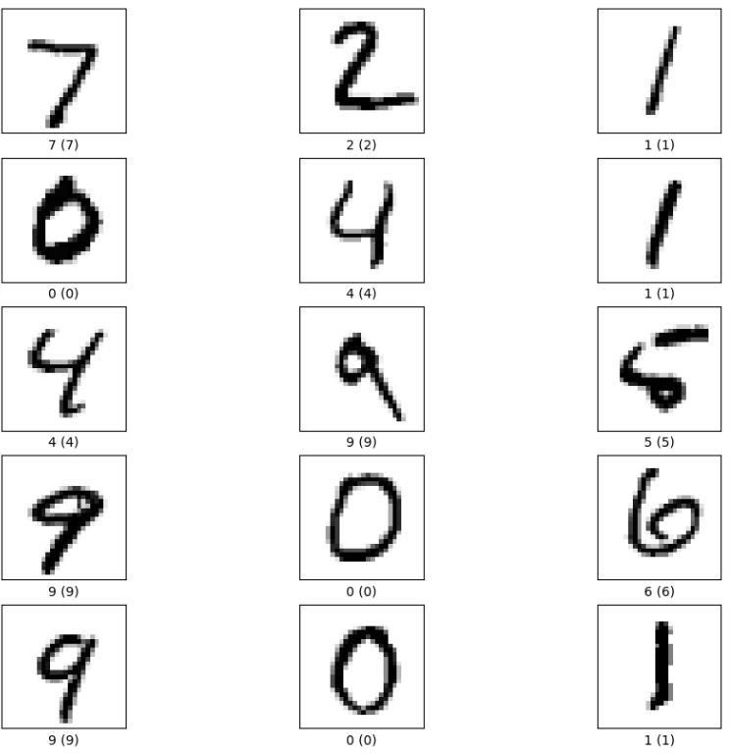

RESULT:
Thus the python code is to train a Convolutional Neural Network (CNN) model on the MNIST dataset and evaluate its performance by making predictions on the test set executed successfully.
EX.NO: - 3 FACE RECOGNITION USING CNN
DATE: -
AIM:
The aim of this program is to perform real-time face detection using the OpenCV library in Python. It captures video from your default camera (usually the webcam), detects faces in the video frames, and highlights the detected faces with green rectangles.

PROCEDURE:
- Import the OpenCV library.
- Create a Cascade Classifier object and load the pre-trained face detection model (download -'haarcascade_frontalface_default.xml').
- Initialize the video capture using the default camera (usually the webcam).
- Start an infinite loop to continuously capture and process frames from the camera.
- Read a frame from the camera.
- Convert the frame to grayscale.
- Use the Cascade Classifier to detect faces in the gray scale frame.
- For each detected face , draw a green rectangle around it.
- Display the frame with detected faces in a window called 'Face Detection.'
- Check for the 'q' key press; if it's pressed , exit the loop.
- Release the video capture and close all OpenCV windows when the loop is exited.

PROGRAM:
import cv2
#Load the pre-trained face detection model
face_cascade=cv2.Cascade Classifier(cv2.data.haarcascades+ 'haarcascade_frontalface_default.xml')
#Initialize the video capture cap = cv2.VideoCapture(0) while True:
ret,frame=cap.read()
gray=cv2.cvtColor(frame,cv2.COLOR_BGR2GRAY)
# Detect faces in the grayscale frame
faces=face_cascade.detectMultiScale(gray,scaleFactor=1.1,minNeighbors=5,
minSize=(30, 30)) for (x, y, w, h) in faces:
cv2.rectangle(frame,(x,y),(x+w,y+h),(0,255,0),3) #
Display the frame with detected faces cv2.imshow('Face Detection', frame) if cv2.waitKey(1) & 0xFF == ord('q'):
break
#Release the video capture and close OpenCV windows cap.release() cv2.destroyAllWindows()
OUTPUT:

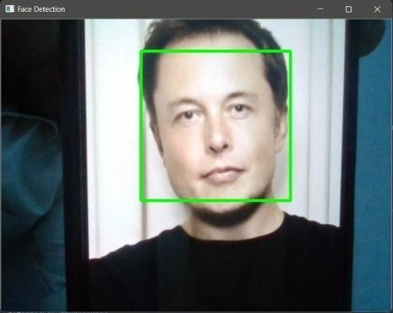

RESULT:
The program provides real-time face detection in the video feed from your camera, and the output is a window displaying the live video with highlighted faces
EX.NO: - 4 TEXT GENERATION USING RNN
DATE: -
AIM:
The aim of this Python code is to train a text generation model using RNN and Generate text based on a given input text.
PROCEDURE:

- Read and process a text file (in this case ,a Shakespeare a text).
- Tokenize the text ,create a character-to-index mapping ,and convert the text to numerical values.
- Create a dataset for training the text generation model.
- Build a deep learning model using TensorFlow's Keras API .The model consists of an embedding layer ,two LSTM layers ,dropout layers, batch normalization ,and a dense output layer.
- Define a custom loss function for training the model.
- Generate text using the trained model, starting from a user-provided input text.
PROGRAM:
import numpy as np import tensorflow as tf

def process_text (file_path): text=open(file_path,'rb').read().decode(encoding='utf-8')#Read,thendecodeforpy2 compat.
vocab=sorted(set(text))
#Creating a mapping from unique characters to indices and vice versa char2idx = {u: i for i, u in enumerate(vocab)} idx2char= np.array(vocab) text_as_int=np.array([char2idx[c]forcintext]) return text_as_int, vocab, char2idx, idx2char

def split_input_target(chunk):
input_text,target_text=chunk[:-1], chunk[1:]
return input_text , target_text

def create_dataset(text_as_int,seq_length=100,batch_size=64,buffer_size=10000):
char_dataset = tf.data.Dataset.from_tensor_slices(text_as_int)
dataset=char_dataset.batch(seq_length+1,drop_remainder=True).map(spl
it_input_target) dataset=dataset.shuffle(buffer_size).batch(batch_size,drop_remainder=True) return dataset

def build_model(vocab_size,embedding_dim=256,rnn_units=1024,batch_size=64):
model = tf.keras.Sequential([
tf.keras.layers.Embedding(vocab_size,embedding_dim,
batch_input_shape=[batch_size, None]),
tf.keras.layers.LSTM(rnn_units,return_sequences=True,stateful=True,
recurrent_initializer='glorot_uniform'), tf.keras.layers.Dropout(0.1), tf.keras.layers.BatchNormalization(),
tf.keras.layers.LSTM(rnn_units,return_sequences=True,stateful=True,
recurrent_initializer='glorot_uniform'), tf.keras.layers.Dropout(0.1), tf.keras.layers.BatchNormalization(), tf.keras.layers.Dense(vocab_size)
])
return model

def loss(labels,logits):
return tf.keras.losses.sparse_categorical_crossentropy(labels,logits,from_logits=True)

def generate_text(model,char2idx,idx2char,start_string,generate_char_num=1000, temperature=1.0):
#Evaluation step (generating text using the l earned model)
#Low temperatures results in more predictable text, higher temperatures results in more surprising text.
# Converting our start string to numbers (vectorizing) input_eval = [char2idx[s] for s in start_string] input_eval = tf.expand_dims(input_eval, 0) text_generated=[]#Emptystringtostoreourresults model.reset_states() foriinrange(generate_char_num): predictions=model(input_eval) predictions = tf.squeeze(predictions, 0) predictions /= temperature
# using a categorical distribution to predict the character returned by the model predicted_id=tf.random.categorical(predictions,num_samples=1)[-1,0].numpy() input_eval=tf.expand_dims([predicted_id],axis=0) text_generated.append(idx2char[predicted_id])
returnstart_string+''.join(text_generated)

#path_to_file=tf.keras.utils.get_file('nietzsche.txt','https://s3.amazonaws.com/text- datasets/nietzsche.txt')
path_to_file = tf.keras.utils.get_file('shakespeare.txt',
'https://storage.googleapis.com/download.tensorflow.org/data/shakespeare.txt')

text_as_int,vocab,char2idx,idx2char=process_text(path_to_file) dataset = create_dataset(text_as_int) model=build_model(vocab_size=len(vocab)) model.compile(optimizer='adam', loss=loss) model.summary() history = model.fit(dataset, epochs=50) model.save_weights("gen_text_weights.h5",save_format='h5') # To keep this prediction step simple, use a batch size of 1 model = build_model(vocab_size=len(vocab),batch_size=1) model.load_weights("gen_text_weights.h5") model.summary()

user_input=input("Writethebeginningofthetext,theprogramwillcompleteit.Yourinput is: ")
generated_text=generate_text(model,char2idx,idx2char,start_string=user_input, generate_char_num=2000) print(generated_text)

OUTPUT:
“ First Citizen:We are accounted poor citizens, the patricians good. What authority sure its on would relieve us: if they would yield us but the super fluity , while it were wholesome, we might guess they relieved us humanely ;but they think we are too dear: the leanness that afflicts us, the object of our misery, is as an inventory to particularise their abundance; our sufferance is a gain to them Let us revenge this with our pikes, ere we become rakes: for the gods know I speak this in hunger for bread, not in thirst for revenge. ”

RESULT:
The code demonstrates how to train a text generation model and use it to create coherent text based on a given starting point.
EX.NO: - 5 SENTIMENT ANALYSIS USING LSTM DATE: -
AIM:
The aim of this code is to perform sentiment analysis on a dataset of comments using deep learning techniques.

PROCEDURE:
- Import necessary libraries including NumPy, Pandas, Matplotlib, Hazm (a Persian natural language processing library), and scikit-learn.
- Read a dataset from a CSV file called 'Snappfood-SentimentAnalysis.csv'.
- Perform data preprocessing, including tokenization, lemmatization, normalization, and removing stop words and punctuations.
- Create a new dataset containing the cleaned text and sentiment labels.
- Tokenize and pad the text data for model training.
- Build a deep learning model using Keras with an embedding layer, Bidirectional LSTM layers, SpatialDropout1D, Batch Normalization, and a Dense output layer.
- Compile the model with the Adam optimizer and binary cross-entropy loss.
- Train the model on the training data.
- Make predictions on both the training and test data.
- Evaluate the model using classification reports to measure its performance.

PROGRAM:
import numpy as np import pandas as pd import matplotlib.pyplot as plt import hazm import string from sklearn.model_selection import train_test_split from sklearn.preprocessing import LabelEncoder from keras.preprocessing.text import Tokenizer from keras.utils import pad_sequences
from keras.models import Sequential
from keras.layers import Dense,Dropout,Flatten,Spatial Dropout1D, Embedding, Bidirectional, LSTM, Batch Normalization from keras.callbacks importModelCheckpoint,EarlyStopping from sklearn.utils import class_weight

from sklearn.metrics import classification_report from collections import Counter

data=pd.read_csv('Snappfood-SentimentAnalysis.csv',delimiter='\t',on_bad_lines='skip') data

data.info() data.label_id.value_counts() data.isnull().sum() data=data[['comment','label_id']] data data.drop(inplace=True) data punctuations = string.punctuation+"٬"+"،" translator = str.maketrans('','', punctuations) stopwords = hazm.stopwords_list() hazm.word_tokenize(data['comment'][10]) lem = hazm.Lemmatizer() norm = hazm.Normalizer()
dataset = pd.DataFrame(columns=['Text','Sentiment'])

for index,row in data.iterrows():
text =row['comment'] text_tokenized= hazm.word_tokenize(text) text_lem=[lem.lemmatize(x)for xin text_tokenized] text_norm = [norm.normalize(x) for x in text_lem] clean_text=[x for x in text_norm if not x in stopwords] final_text = [x.translate(translator) for x in clean_text] dataset.loc[index] = ({
'Text' : ''.join(final_text),
'Sentiment':row['label_id']
}) dataset.Sentiment.value_counts() dataset.Sentiment.value_counts() dataset['Text'] dataset['words_count']=dataset['Text'].apply(lambdat:len(hazm.word_tokenize(t))) max_len = dataset["words_count"].max() max_len
texts=''.join(dataset['Text']) tokens=hazm.word_tokenize(texts) counter = Counter(tokens) min_freg=35 filtered=[word for word,count in counter.items() if count>=min_freg] unique_words = set(filtered) n_words=len(unique_words) n_words
X= dataset['Text'] Y=dataset['Sentiment'] xtrain,xtest,ytrain,ytest=train_test_split(X,Y,test_size=0.01,random_state=4234) tokenizer = Tokenizer(num_words = n_words) tokenizer.fit_on_texts(xtrain) def Tokenization_padSequences(x,maxlen=max_len):
xseq = tokenizer.texts_to_sequences(x) xpad=pad_sequences(xseq,padding='post',maxlen=max_len) return xpad
xtrain_pad=Tokenization_padSequences(xtrain) xtest_pad = Tokenization_padSequences(xtest) xtest_pad sequences = tokenizer.texts_to_sequences(dataset['Text']) print(dataset['Text'][200]) print(sequences[200]) model = Sequential() model.add(Embedding(n_words, 80, input_length=max_len)) model.add(Bidirectional(LSTM(256,dropout=0.2,return_sequences=True))) model.add(SpatialDropout1D(0.2)) model.add(Bidirectional(LSTM(128,dropout=0.2))) model.add(BatchNormalization()) model.add(Dense(1, activation='sigmoid')) model.compile(optimizer='Adam',metrics=['accuracy'],loss='binary_crossentropy') model.summary()

np.unique(ytrain) model.fit(xtrain_pad,ytrain,epochs=2,batch_size=10,validation_data=(xtest_pad,ytest)) ypred_train = (model.predict(xtrain_pad) > 0.5).astype(int) print(classification_report(ytrain, ypred_train)) ypred=(model.predict(xtest_pad)>0.5).astype(int) print(classification_report(ytest, ypred))

OUTPUT:
The output includes the model summary, training and evaluation reports, and the model's predictions.
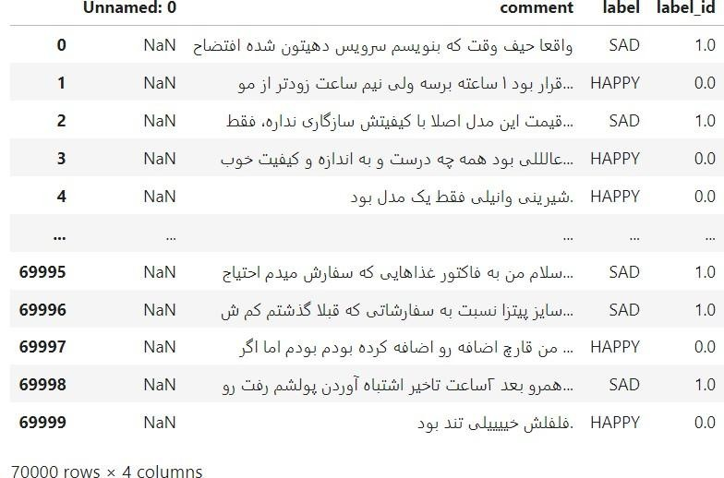

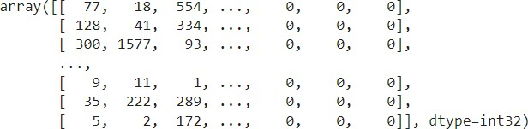

Model:"sequential"

Layer(type) OutputShape Param#
=================================================================
embedding(Embedding) (None,231,80) | 144800
bidirectional (Bidirectiona(None, 231, 512) l) | 690176
spatial_dropout1d(SpatialD(None,231,512) ropout1D) | 0
bidirectional_1 (Bidirectio(None, 256) nal) | 656384
batch_normalization(BatchN(None,256) ormalization) | 1024
dense(Dense) (None,1) 257
=================================================================
Totalparams: 1,492,641
Trainableparams:1,492,129 Non-trainableparams:512

Epoch1/20
459/459[==============================]-99s194ms/step -loss: 0.4216 -accura cy:0.8075-val_loss:0.4008-val_accuracy:0.8245
Epoch 2/20
459/459[==============================]-67s147ms/step -loss: 0.3860 -accura cy:0.8295-val_loss: 0.3657 -val_accuracy: 0.8331
.
.
.
Epoch 20/20
459/459[==============================]-64s 138ms/step-loss:0.2415 -accura cy:0.8986-val_loss: 0.4892 -val_accuracy: 0.8187

22/22[==============================]-1s 25ms/step precision recallf1-scoresupport

0.0 0.82 0.81 0.81 340
1.0 0.82 0.83 0.82 355
accuracy 0.82 695
macroavg 0.82 0.82 0.82 695
weightedavg 0.82 0.82 0.82 695

RESULT:
The code provides a sentiment analysis model capable of classifying text comments into sentiment categories. The result includes various metrics like accuracy, precision, recall, and F1-score to assess the model's performance on both the training and test datasets.
EX.NO:- 6 PARTS OF SPEECH TAGGING USING SEQUENCE TO
DATE:- SEQUENCE ARCHITECTURE

AIM:-
The aim of the provided Python code is to perform Part-of-Speech(POS)tagging on a Given text using a Recurrent Neural Network (RNN)model.

PROCEDURE:-
- Import the necessary libraries and modules, including NLTK, numpy, Keras, and related functions.
- Define a paragraph of text that you want to perform POS tagging on.
- Tokenize the paragraph into words using NLTK's ‘word_tokenize’ function.
- Perform POS tagging on the tokenized words using NLTK's`pos_tag` function.
- Create a vocabulary and encode words into integers using Keras's `Tokenizer`and `texts_to_sequences` functions.
- Create a vocabulary for POS tags and encode the min to integers.
- Prepare the data for training by converting the word sequences and POS tag sequences into numpy arrays.
- Define an RNN model using Keras with embedding , Simple RNN, and Time Distributed layers.
- Compile the model with the appropriate loss and optimizer.
- Train the model on the data.
- Use the trained model top redict POS tags for the input text.
- Extract the predicted POS tags and display them along side the original words.

PROGRAM:-
import nltk import numpy as np from nltk.tokenize import word_tokenize from nltk.corpus import brown from keras.preprocessing.text importTokenizer from keras.preprocessing.sequence import pad_sequences from keras.models import Sequential from keras.layers import Embedding, SimpleRNN ,Dense, TimeDistributed from keras.utils import to_categorical

#Download NLTK data for tokenization and POS tagging nltk.download('punkt') nltk.download('averaged_perceptron_tagger')

paragraph="""
Natural language processing (NLP) is a field of computer science, artificial intelligence, and computational linguistics concerned with the interactions between computers and human (natural) languages. NLP focuses on the interaction between humans and computers using natural language. The ultimate goal of NLP is to read, decipher, understand, and make sense of the human language in a manner that is both valuable and meaningful. Most NLP techniques rely on machine learning to derive meaning from human languages."""

#Tokenize the paragraph into words words = word_tokenize(paragraph) #PerformPOStaggingusingNLTK pos_tags = nltk.pos_tag(words)
#Createavocabularyandencodewordstointegers tokenizer = Tokenizer() tokenizer.fit_on_texts(words) word_sequences = tokenizer.texts_to_sequences(words) word_sequences=pad_sequences(word_sequences,padding='post') # Create a vocabulary for POS tags pos_tags_set=set(tagforword,taginpos_tags) num_pos_tags = len(pos_tags_set)
pos_tag_to_idx={tag: i fori, tag in enumerate(pos_tags_set)}

#Encode POS tags to integers
pos_tag_sequences=[pos_tag_to_idx[tag]for _,tagin pos_tags]

#Prepare data for training
X= np.array(word_sequences)
Y=np.array(pos_tag_sequences)

#Define and compile the RNN model model = Sequential()
model.add(Embedding(input_dim=len(tokenizer.word_index)+1,output_dim=32, input_length=X.shape[1])) model.add(SimpleRNN(64,return_sequences=True))
model.add(TimeDistributed(Dense(num_pos_tags,activation='softmax')))#Use TimeDistributed layer

model.compile(loss='sparse_categorical_crossentropy',optimizer='adam', metrics=['accuracy'])

#Train the model
model.fit(X,Y,epochs=10,batch_size=32,verbose=2)

# POS tagging prediction predictions=model.predict(X) predicted_pos_tags = []

#Extract the predicted POS tags for i in range(len(X)):

predicted_pos_tags.append([list(pos_tag_to_idx.keys())[list(pos_tag_to_idx.values()).index(t ag)] for tag in predictions[i].argmax(axis=-1)])
#Display the original text with predicted POS tags forword,pos_tag_listinzip(words,predicted_pos_tags): print(f"{word}: {pos_tag_list}")

OUTPUT:-

The output of the code will display the original text with their predicted POS tags.
[nltk_data] Downloading package punkt to /root/nltk_data...
[nltk_data] Unzipping tokenizers/punkt.zip.
[nltk_data] Downloading package averaged_perceptron_tagger to
/root/nltk_data... [nltk_data] Unzipping taggers/averaged_perceptron_tagger.zipTrue
Epoch1/10
3/3-2s-loss:2.9998-accuracy:0.0460-2s/epoch-501ms/step Epoch
2/10
3/3-0s-loss:2.9815-accuracy:0.0812-14ms/epoch-5ms/step Epoch
3/10
3/3-0s-loss:2.9644-accuracy:0.1119-12ms/epoch-4ms/step Epoch
4/10
3/3-0s-loss:2.9466-accuracy:0.1167-12ms/epoch-4ms/step Epoch
5/10
3/3-0s-loss:2.9289-accuracy:0.1403-13ms/epoch-4ms/step Epoch
6/10
3/3-0s-loss:2.9101-accuracy:0.1444-13ms/epoch-4ms/step Epoch
7/10
3/3-0s-loss:2.8902-accuracy:0.1526-12ms/epoch-4ms/step Epoch
8/10
3/3-0s-loss:2.8690-accuracy:0.1485-16ms/epoch-5ms/step Epoch
9/10
3/3-0s-loss:2.8466-accuracy:0.1470-12ms/epoch-4ms/step
Epoch 10/10
3/3-0s-loss:2.8226-accuracy:0.1579-19ms/epoch-6ms/step Natural:
['JJ']
language: ['NN'] processing:['NN']
(: [',']
NLP:['NN']
): [',']
is:['VBZ'] a:['DT'] field: ['NN'] of: ['IN'] computer: ['NN'] science:['NN']
,: [','] artificial: ['JJ'] intelligence:['NN']
,: [',']
and: ['NN'] computational:['JJ'] linguistics: ['NN'] concerned: ['NN'] with: ['IN'] the: ['DT'] interactions:['NN'] between: ['NN'] computers: ['NN'] and:['NN'] RESULT:-
The RNN model is trained to predict POS tags for words in the input text. The result consists of the predicted POS tags associated with each word in the given text.
EX.NO: -7 MACHINE TRANSLATION USING ENCODER-DECODER MODEL DATE: -
AIM:
The aim of this code is to create a machine translation model from English to French Using a sequence-to-sequence architecture with LSTM layers.

PROCEDURE:
- Import necessary libraries, including NumPy, Pandas, and TensorFlow's Keras module.
- Define hyperparameters such as batch size, epochs, latent dimension, and the number of samples.
- Load the data from the ‘fra.txt’ file and preprocess it to create input and target sequences.
- Build token dictionaries for both input and target characters.
- Create one-hot encoded data for encoder and decoder inputs as well as decoder targets.
- Define the encoder and decoder models.
- Compile the model for training using the RMSprop optimizer and categorical cross-entropy loss.
- Train the model on the training data.
- Save the trained model to a file named eng2french.h5.
- Define sampling models for inference.
- Implement a decoding function to translate English input sentences to French.
- Iterate over a set of input sentences and generate translations.

PROGRAM:
import numpy as np import pandas as pd from tensorflow.keras.models import Model
from tensorflow.keras.layers import Input, LSTM, Dense

batch_size=64 epochs=40 latent_dim=256 num_samples=10000

data_path='/content/fra.txt'

# Vectorize the data. input_texts = [] target_texts = [] input_characters = set() target_characters=set() with open(data_path,'r',encoding='utf-8')asf: lines
= f.read().split('\n') for line in lines[:min(num_samples,len(lines)-1)]: input_text, target_text, _ = line.split('\t') #We use"tab"as the"start sequence" character #for the targets, and "\n" as "endsequence" character.
target_text = '\t' + target_text + '\n' input_texts.append(input_text) target_texts.append(target_text) for char in input_text:
ifcharnotininput_characters:
input_characters.add(char) for char in target_text:
if char not in target_characters:
target_characters.add(char)

input_characters=sorted(list(input_characters)) target_characters=sorted(list(target_characters))

num_encoder_tokens=len(input_characters) num_decoder_tokens=len(target_characters) max_encoder_seq_length=max([len(txt) for txt in input_texts]) max_decoder_seq_length=max([len(txt)fortxtintarget_texts])

print('Numberofsamples:',len(input_texts)) print('Number of unique input tokens:', num_encoder_tokens) print('Number of unique output tokens:', num_decoder_tokens) print('Max sequence length for inputs:', max_encoder_seq_length) print('Maxsequencelengthforoutputs:',max_decoder_seq_length)

input_token_index=dict(
[(char,i)fori,charinenumerate(input_characters)]) target_token_index=dict(
[(char,i)fori,charinenumerate(target_characters)])

encoder_input_data= np.zeros(
(len(input_texts),max_encoder_seq_length,num_encoder_tokens), dtype='float32') decoder_input_data= np.zeros(
(len(input_texts),max_decoder_seq_length,num_decoder_tokens), dtype='float32') decoder_target_data=np.zeros(
(len(input_texts),max_decoder_seq_length,num_decoder_tokens), dtype='float32')

for i,(input_text, target_text) in enumerate(zip(input_texts,target_texts)):
for t, char in enumerate(input_text): encoder_input_data[i,t,input_token_index[char]]=1. encoder_input_data[i, t + 1:, input_token_index['']] = 1. for t, char in enumerate(target_text): #decoder_target_data is a head of decoder_input_data by one time step decoder_input_data [i, t, target_token_index[char]] = 1.
if t >0:
#decoder_target_datawillbeaheadbyonetimestep # and will not include the start character.
decoder_target_data[i,t-1,target_token_index[char]]=1. decoder_input_data[i, t + 1:, target_token_index['']] = 1.
decoder_target_data[i, t:, target_token_index['']] = 1.

#Define an input sequence and process it.
encoder_inputs=Input(shape=(None,num_encoder_tokens)) encoder = LSTM(latent_dim, return_state=True) encoder_outputs, state_h, state_c = encoder(encoder_inputs)
# We discard `encoder_outputs` and only keep the states. encoder_states = [state_h, state_c]

# Set up the decoder, using `encoder_states` as initial state. decoder_inputs=Input(shape = (None,num_decoder_tokens))
# We set up our decoder to return full output sequences,
#and to return internal states as well.We don't use the
# return states in the training model, but we will use them in inference.
decoder_lstm=LSTM(latent_dim,return_sequences=True,return_state=True) decoder_outputs, _, _ = decoder_lstm(decoder_inputs,
initial_state=encoder_states)
decoder_dense=Dense(num_decoder_tokens,activation='softmax') decoder_outputs = decoder_dense(decoder_outputs)

#Define the modelthatwill turn
#`encoder_input_data`&`decoder_input_data`into`decoder_target_data` model = Model([encoder_inputs, decoder_inputs], decoder_outputs) #Run training model.compile(optimizer='rmsprop',loss='categorical_crossentropy', metrics=['accuracy']) model.fit([encoder_input_data,decoder_input_data],decoder_target_data, batch_size=batch_size, epochs=epochs, validation_split=0.2)

model.save('eng2french.h5')

#Definesamplingmodels
encoder_model=Model(encoder_inputs, encoder_states)

decoder_state_input_h = Input(shape=(latent_dim,)) decoder_state_input_c = Input(shape=(latent_dim,)) decoder_states_inputs=[decoder_state_input_h,decoder_state_input_c] decoder_outputs, state_h, state_c = decoder_lstm( decoder_inputs,initial_state=decoder_states_inputs) decoder_states = [state_h, state_c] decoder_outputs=decoder_dense(decoder_outputs) decoder_model = Model(
[decoder_inputs]+decoder_states_inputs,
[decoder_outputs] + decoder_states)

#Reverse-look up token index to decode sequences back to
# something readable.
reverse_input_char_index= dict(
(i,char)forchar,iininput_token_index.items()) reverse_target_char_index
= dict(
(i,char)for char,i in target_token_index.items())

def decode_sequence(input_seq): #Encode the input as state vectors.
states_value=encoder_model.predict(input_seq)

# Generate empty target sequence of length 1. target_seq=np.zeros((1,1,num_decoder_tokens))
#Populate the first character of target sequence with the start character. target_seq[0, 0, target_token_index['\t']] = 1.
#Sampling loop forabatch of sequences #(to simplify, here we assume a batch of size1).
stop_condition = False decoded_sentence = '' while not stop_condition:
output_tokens,h,c=decoder_model.predict(
[target_seq] + states_value)

#Sample a token sampled_token_index = np.argmax(output_tokens[0, -1, :]) sampled_char=reverse_target_char_index[sampled_token_index] decoded_sentence += sampled_char #Exit condition : either hit max length
# or find stop character. if(sampled_char== '\n'or len(decoded_sentence)>max_decoder_seq_length): stop_condition = True

# Update the target sequence (of length 1).
target_seq=np.zeros((1,1,num_decoder_tokens)) target_seq[0,0,sampled_token_index]=1.

# Update states states_value=[h,c] return decoded_sentence for seq_index in range(100):
#Take one sequence(part of the training set)
# for trying out decoding.
input_seq=encoder_input_data[seq_index:seq_index+1] decoded_sentence = decode_sequence(input_seq)
print('-') print('Input sentence:', input_texts[seq_index]) print('Decodedsentence:',decoded_sentence)

OUTPUT:
Number of samples: 10000
Number of unique input tokens:71
Number of unique output tokens:93
Max sequence length for inputs: 15
Maxsequencelengthforoutputs:59
Epoch 1/40
125/125[==============================]-11s25ms/step-loss:1.2294- accuracy:0.7319-val_loss:1.2328-val_accuracy:0.7112
Epoch 2/40
125/125[==============================]-2s13ms/step-loss:0.9437 - accuracy: 0.7476-val_loss: 1.0409-val_accuracy: 0.7087
.
.
Epoch 40/40
125/125[==============================]-1s11ms/step-loss: 0.3223-accuracy:
0.9032-val_loss: 0.4583-val_accuracy: 0.8676

Input sentence: Go.
Decoded sentence: Pars!

1/1[==============================]- 0s 16ms/step
1/1[==============================]- 0s 20ms/step
1/1[==============================]- 0s 21ms/step
1/1[==============================]- 0s 18ms/step
1/1[==============================]- 0s 23ms/step
1/1[==============================]- 0s 20ms/step
1/1[==============================]- 0s 18ms/step
1/1[==============================]- 0s 21ms/step

RESULT:
The code trains a machine translation model that can translate English sentences into
French.The result includes the translations of input sentences provided in the 'fra.txt' dataset.
EX.NO: -8 IMAGE AUGMENTATION USING GAN
DATE:-
AIM:
The aim of this code is to train a Generative Adversarial Network(GAN) to generate synthetic images that resemble handwritten digits from the MNIST dataset.

PROCEDURE:
- Import necessary libraries and set up constants for image dimensions, channels, and noise vector size.
- Define a generator model and a discriminator model using Keras.
- Compile the discriminator model with binary cross-entropy loss and the Adam optimizer.
- Create the generator model, which takes a noise vector as input and generates images.
- Create a combined GAN model where the generator is trained to fool the discriminator.
- Compile the combined model with binary cross-entropy loss and the Adam optimizer.
- Load the MNIST dataset and preprocess it.
- Define labels for real and fake images.
- Training loop:
- Train the discriminator:
  - Select a random batch of real images from the dataset.
  - Generate a batch of fake images using the generator.
  - Calculate the discriminator loss for both real and fake images and update the discriminator's weights.
- Train the generator:
  - Generate a new batch of fake images.
  - Calculate the generator loss by trying to make the discriminator classify the fake images as real.
- Print and store losses and accuracies at regular intervals.
- Generate and save sample images at regular intervals.

PROGRAM:

fromkeras.datasetsimportmnist fromkeras.layersimportInput,Dense,Reshape,Flatten from keras.layers import Activation fromkeras.layers.advanced_activationsimportLeakyReLU from keras.models import Sequential, Model
fromkeras.optimizersimportAdam

importmatplotlib.pyplotasplt

import sys

importnumpy asnp

"""Specifythedatasize"""

img_rows=28 img_cols=28 channels=1
img_shape=(img_rows,img_cols, channels)

z_dim=100

"""GeneratorNetwork"""

defgenerator(img_shape, z_dim):

model =Sequential()

#Hidden layer
model.add(Dense(128,input_dim=z_dim))

# Leaky ReLU model.add(LeakyReLU(alpha=0.01))

# Output layer with tanh activation model.add(Dense(28*28*1,activation='tanh')) model.add(Reshape(img_shape))

z=Input(shape=(z_dim,)) img = model(z)

returnModel(z,img)

#Hidden layer
model.add(Dense(128,input_dim=z_dim))

# Leaky ReLU model.add(LeakyReLU(alpha=0.01))

# Output layer with tanh activation model.add(Dense(28*28*1,activation='tanh')) model.add(Reshape(img_shape))

z=Input(shape=(z_dim,)) img = model(z)

returnModel(z,img)

"""DiscriminatorNetwork"""

defdiscriminator(img_shape):

model =Sequential()

model.add(Flatten(input_shape=img_shape))

# Hidden layer model.add(Dense(128))

# Leaky ReLU model.add(LeakyReLU(alpha=0.01))# Outputlayerwithsigmoid activation model.add(Dense(1,activation='sigmoid')) img=Input(shape=img_shape) prediction = model(img)

returnModel(img,prediction)

discriminator = discriminator(img_shape) discriminator.compile(loss='binary_crossentropy',
optimizer=Adam(),metrics=['accuracy'])

# Build the Generator
generator=generator(img_shape, z_dim)

#Generated image to be used as input z = Input(shape=(100,))
img =generator(z)

#Keep Discriminator’s parameters constant during Generator training discriminator.trainable = False

#The Discriminator’sprediction prediction = discriminator(img)

#Combined GAN model to train the Generator combined = Model(z, prediction)
combined.compile(loss='binary_crossentropy',optimizer=Adam())

"""GAN Training function"""

losses=[]
accuracies=[]

deftrain(iterations,batch_size, sample_interval):

#Load the dataset
#path = "C:\\Users\\hgani\\Desktop\\CARLIFE
DATA\\carlife_all_data\\Carlife_jpg"#X_train = cv2.imread(path + '\\'+ str(i) for i in os.listdir(path))
(X_train,_),(_,_)=mnist.load_data() data_slice = 3000
X_train=X_train[:data_slice,:] #
Rescale -1 to 1
X_train= X_train/ 127.5-1.
X_train=np.expand_dims(X_train, axis=3)

#Labels for real and fake examples real = np.ones((batch_size, 1))
fake=np.zeros((batch_size,1))

for iteration in range(iterations): #Select a random batch of real images idx=np.random.randint(0,X_train.shape[0],batch_size) imgs = X_train[idx]
z=np.random.normal(0, 1,(batch_size, 100))

gen_imgs=generator.predict(z) d_loss_real = discriminator.train_on_batch(imgs, real) d_loss_fake=discriminator.train_on_batch(gen_imgs,fake) d_loss = 0.5 * np.add(d_loss_real, d_loss_fake) z=np.random.normal(0,1,(batch_size,100)) gen_imgs = generator.predict(z)
g_loss=combined.train_on_batch(z,real)

ifiteration % sample_interval==0:
print("%d[Dloss:%f,acc.:%.2f%%][Gloss:%f]"% (iteration, d_loss[0], 100*d_loss[1], g_loss)) losses.append((d_loss[0], g_loss)) accuracies.append(100*d_loss[1]) sample_images(iteration)

def sample_images(iteration,image_grid_rows=4,image_grid_columns=4):
z=np.random.normal(0, 1,
(image_grid_rows*image_grid_columns,z_dim))

gen_imgs = generator.predict(z) gen_imgs=0.5*gen_imgs+0.5 fig,axs=plt.subplots(image_grid_rows,image_grid_columns,
figsize=(4,4),sharey=True,sharex=True)

cnt= 0 for i in range(image_grid_rows):
for j in range(image_grid_columns):
# Output image grid axs[i,j].imshow(gen_imgs[cnt,:,:,0],cmap='gray')
axs[i,j].axis('off')
cnt+=1

import warnings ; warnings.simplefilter('ignore')

iterations=20000 batch_size=128 sample_interval=1000 train(iterations, batch_size, sample_interval) OUTPUT:
0[Dloss:0.002651,acc.:100.00%][Gloss:6.328685]
1000[Dloss:0.020505,acc.:100.00%][Gloss:4.181127]
2000 [D loss: 0.077820, acc.: 96.88%] [G loss: 5.661728]
3000 [D loss: 0.197608, acc.: 92.97%] [G loss: 6.843472]
4000 [D loss: 0.136775, acc.: 94.92%] [G loss: 5.205476]
5000 [D loss: 0.461468, acc.: 78.52%] [G loss: 2.651729]
6000 [D loss: 0.119333, acc.: 95.31%] [G loss: 4.650574]
7000 [D loss: 0.349625, acc.: 84.77%] [G loss: 3.938936]
8000 [D loss: 0.478075, acc.: 80.47%] [G loss: 3.259602]
9000 [D loss: 0.324833, acc.: 86.33%] [G loss: 4.168482]
10000 [D loss: 0.217681, acc.: 91.80%] [G loss: 3.417312]
11000 [D loss: 0.411692, acc.: 83.20%] [G loss: 3.185366]
12000 [D loss: 0.282608, acc.: 87.11%] [G loss: 3.108163]
13000 [D loss: 0.283514, acc.: 86.72%] [G loss: 3.717927]
14000 [D loss: 0.341416, acc.: 84.77%] [G loss: 3.769761]
15000 [D loss: 0.382134, acc.: 81.64%] [G loss: 3.191629]
16000 [D loss: 0.329370, acc.: 85.94%] [G loss: 3.672557] 17000 [D loss: 0.251924, acc.: 88.67%] [G loss: 3.597138] 18000 [D loss: 0.247567, acc.: 90.62%] [G loss: 3.474238]
19000 [D loss: 0.336493, acc.: 84.38%] [G loss: 3.227752]

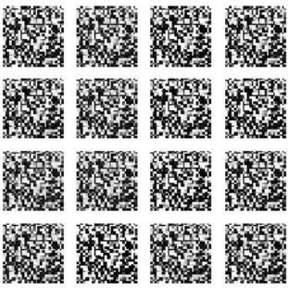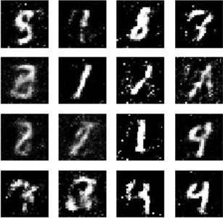

RESULT:
The result of running this code is the training of a GAN model to generate synthetic handwritten digit images similar to those in the MNIST dataset. The quality of generated images improves as training progresses, and you can visualize the generated images in the sample image grid displayed during training. The aim is to train the generator to produce images that are indistinguishable from real MNIST digits.

