cyTRON: Installation Guide

The aim of this guide is to support the user to install the software, get the R libraries, and setup the environmental variables required for the correct execution of cyTRON. This is not intended as an exhaustive step-by-step guide; all the instructions have been tested on Linux Ubuntu 18.04.1 64 bit, macOS High Sierra 10.13.1 64 bit and Microsoft Windows 10 64 bit on October 13rd, 2018.

# Install Required Software

cyTRON requires the download and installation of the following software for its execution:

* Java SE Development Kit (in this guide we use jre 8)
* Cytoscape (in this guide we used Cytoscape 3.6.1)
* R (in this guide we used R 3.5.1)

Please refer to the respective Web resources to download the proper version of the tools and install them before the next steps.

Also, please note that cyTRON requires the R TRONCO library: check the minimum R version compatible with TRONCO. The command Rscript that comes with R needs to be correctly configured and runnable without administration privileges on the machine.

# Setup on Linux Ubuntu 18.04.1 64 bit

## R Setup

Before setting up R directly, open a Terminal session and run the following commands:

* sudo apt-get update
* sudo apt-get install libcurl4-openssl-dev libssl-dev

Install R and open an R session. Run the following commands:

* update.packages(ask = FALSE)
* install.packages("rJava", dependencies=TRUE)
* install.packages("devtools", dependencies=TRUE)
* library("devtools")
* install_github("BIMIB-DISCo/TRONCO")
* system.file("jri", package="rJava")
* Sys.getenv("R_HOME")

At this point, do not close the R session as we will get back to it later to copy the displayed paths.

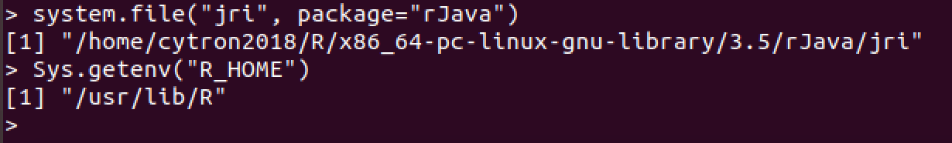

## Environment Setup

The first step aims at making JRI available for JVMs as follow:

* open a Terminal session
* go to the folder previously returned by the R command system.file("jri", package="rJava")
* execute the command cp libjri.so /usr/lib

Note that the cp command my require sudo privileges to run. Also, in the case the directory “/usr/lib” does not represent a valid Java Library Path, you will have to copy the file into a valid one.

As a last step, we now need to set the “R_HOME” environmental variables:

* one a Terminal session
* run the command nano /etc/environment
* add the variable R_HOME with the value obtained by the R command Sys.getenv("R_HOME"). Here is an example of line to be included in the file: R_HOME="/usr/lib/R"
* reboot the system

At this point cyTRON can be installed and executed.

# Setup on macOS High Sierra 10.13.1 64 bit

## R Setup

Install R and open an R session. Run the following commands:

* update.packages(ask = FALSE)
* install.packages("rJava", dependencies=TRUE)
* install.packages("devtools", dependencies=TRUE)
* library("devtools")
* install github("BIMIB-DISCo/TRONCO")
* system.file("jri", package="rJava")
* Sys.getenv("R_HOME")

We note that for some configurations of OS X 32/64 bits, rJava as for its defaults fails to load. A comprehensive guide on how to fix this problem is out of the scope of this guide; thus we refer to available online resources.

At this point, do not close the R session as we will get back to it later to copy the displayed paths.

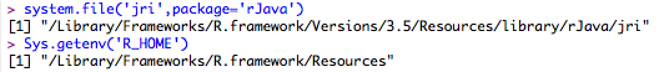

## Environment Setup

The first step aims at making JRI available for JVMs as follow:

* open a Terminal session
* go to the folder previously returned by the R command system.file("jri", package="rJava")
* execute the command cp libjri.jnilib /Library/Java/Extensions

Note that the cp command my require sudo privileges to run. Also, in the case the directory “/Library/Java/Extensions” does not represent a valid Java Library Path, you will have to copy the file into a valid one.

As a last step, we now need to set the “R_HOME” environmental variables:

* one a Terminal session
* run the command nano ∼/.bash profile
* export the variable R_HOME with the value obtained by the R command Sys.getenv("R_HOME"). Here is an example of line to be included: export R_HOME="Library/Frameworks/R.framework/Resources"
* reboot the system

At this point cyTRON can be installed and executed.

# Setup on Microsoft Windows 10 64 bit

## R Setup

Install R and open an R session. Run the following commands:

* update.packages(ask = FALSE)
* install.packages("rJava", dependencies=TRUE)
* install.packages("devtools", dependencies=TRUE)
* library("devtools")
* install github("BIMIB-DISCo/TRONCO")
* system.file("jri", package="rJava")
* Sys.getenv("R_HOME")
* .libPaths()

At this point, do not close the R session as we will get back to it later to copy the displayed paths.

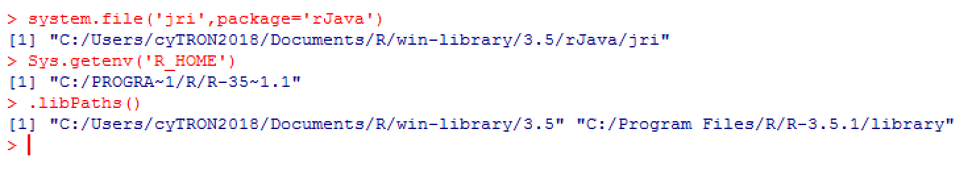

## Environment Setup

The first step aims at making JRI available for JVMs as follow:

* go to the folder previously returned by the R command system.file("jri", package="rJava")
* locate and copy the jri.dll file to the folder C:\Windows\System32

Note that if you are running an x64 OS, you have to copy the jri.dll file inside the x64 sub-folder located within the folder returned by the R command system.file("jri", package="rJava").

The second step of this guide aims at exporting R to the JVMs:

* go to the installation folder of R and proceed to the bin sub-folder
* choosed the sub-folder x64 or i386 depending on you OS
* copy all the .dll files located here (namely, R.dll, Rblas.dll, Rgraphapp.dll, Rinconv.dll, and Rlapack.dll) to the C:\Windows\System32 folder

Notice that if C:\Windows\System32 is not a valid Java Library Path, you will have to move the copied .dll files into a valid one.

As a last step, we now need to set two environmental variables:

* R_HOME with the value obtained by the R command Sys.getenv("R HOME")
* R_LIBS_USER with the values obtained by the R command .libPaths() divided by semicolons

A comprehensive guide on how to set environmental variables in Microsoft Windows is out of the scope of this guide; thus we refer to available online resources.

At this point cyTRON can be installed and executed.