The de.NBI project RBC 3&4 – For RNA-binding proteins and post-transcriptional regulation

*The RBC 3&4 project at Max Delbrück Center offers tools, services and training for the analysis of RNA-binding proteins and post-transcriptional regulation*

**

Nikolaus Rajewsky, Co-Project leader

*Max Delbrück Center*

[*rajewsky@mdc-berlin.de*](mailto:rajewsky@mdc-berlin.de)

­

Uwe Ohler, Co-Project leader

*Max Delbrück Center* [*uwe.ohler@mdc-berlin.de*](mailto:uwe.ohler@mdc-berlin.de)

**Collection of tools and services offered by RBC3&4:**

* **DoRiNA database** – Database for RNA-binding protein binding sites and miRNA binding sites from various resources including our in-house tool PicTar2
* **RiboTaper** – A toolbox for analysis of Ribosome profiling data
* **RCAS** – A pipeline for annotation of RNA-specific features such as RNA-modification sites and RBP binding sites.
* **microMummie** – MicroRNA target site identification by integrating sequence and binding information
* **PARalyzer** - definition of RNA binding sites from PAR-CLIP short-read sequence data
* **Local Galaxy server** – aimed for wetlab researchers being able to run bioinformatics tools and analysis pipelines developed for.

RiboTaper:  P-site positions are color-coded by the frame; the method estimates the significance of each frequency component. Exons from different transcript classes are shown with their periodicity significance (Calviello *et al.* Nature Met. 2016)

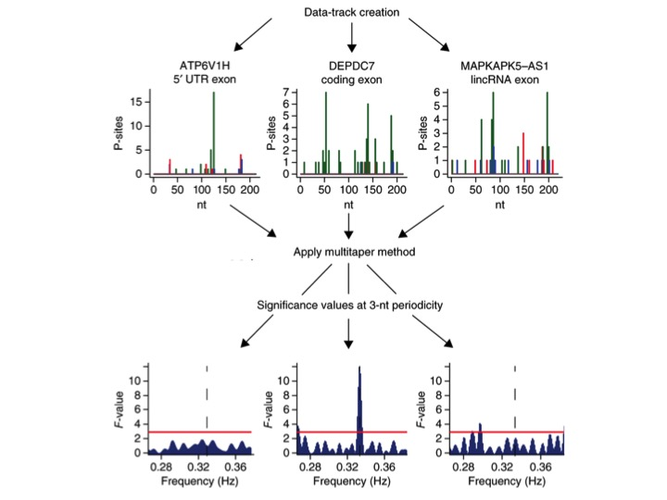

DoRiNA integrates experimental and computational datasets for RBP and miRNA binding sites. (Blin *et al.* NAR 2015)

