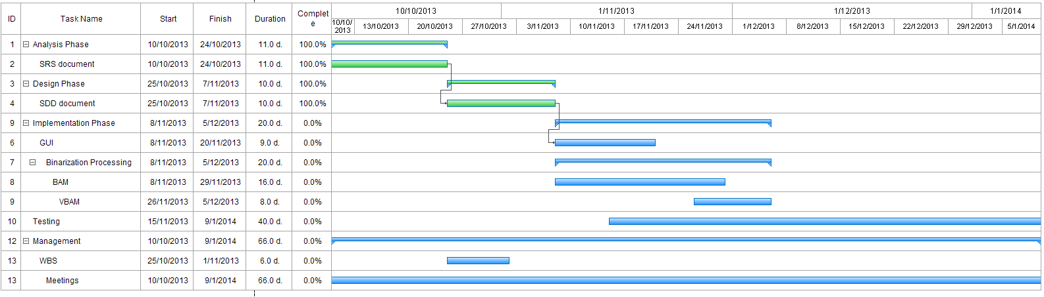

**Gantt chart for Image Binarization System**