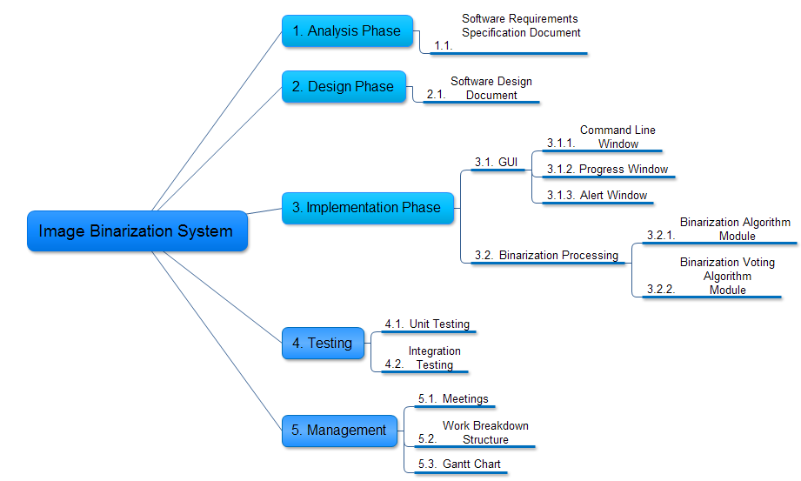

**Work Breakdown Structure for Image Binarization System**