V1_de:

BVP after processing (AGC 1it):

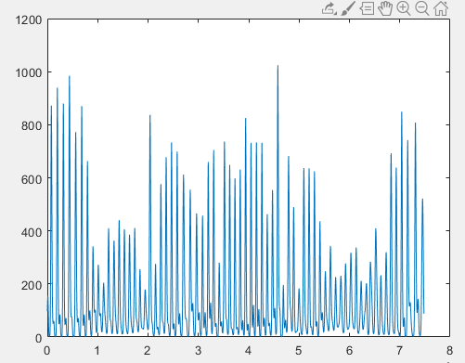

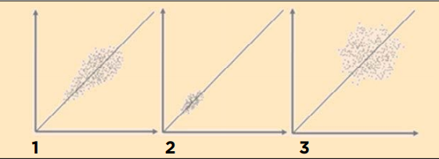

Baseline:

German:

* HR_mean = 107 bpm
* HRV_sdnn = 21 ms
* HRV_rmssd = 0.189 ms
* CSI = 6.27
* CVI = -2.69

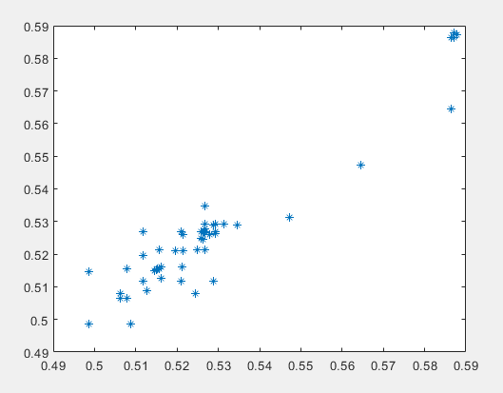

Dependent Training:

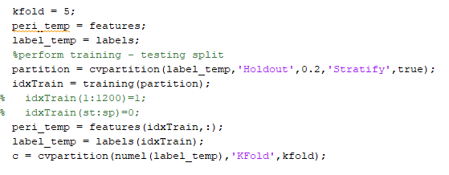

* Validation with k-fold (k=5)
* Testing through Hold-out (not seen observations)
* Solver: SMO
* SVM (linear) 🡪 Gmean = 100%
* KNN (seuclidean) 🡪 Gmean = 96.08% (worst result)
* ENS (GentleBoost) 🡪 Gmean = 100%

V2_de:

BVP after processing (AGC 1it):

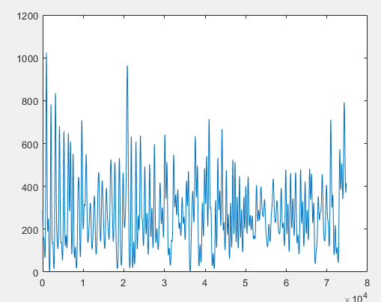

German:

* HR_mean = 113 bpm
* HRV_sdnn = 21.3 ms
* HRV_rmssd = 0.403 ms
* CSI = 2.90
* CVI = -2.34

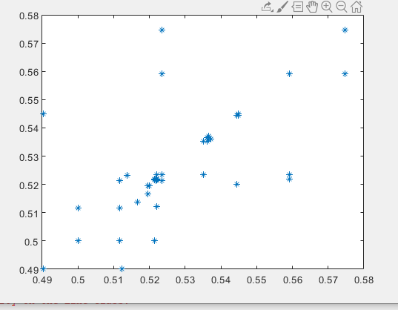

Baseline:

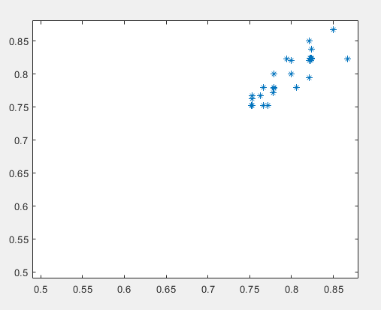

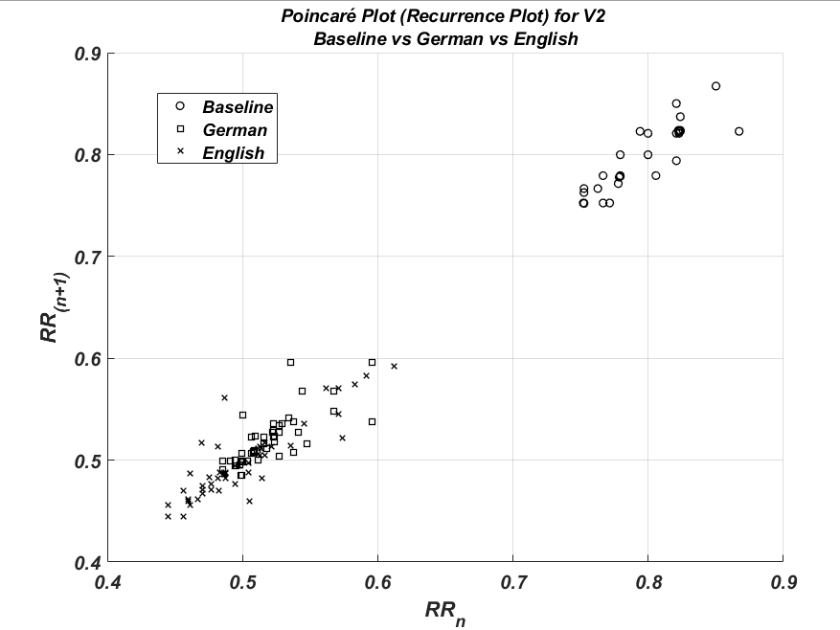

Dependent Training:



* Validation with k-fold (k=5)
* Testing through Hold-out (not seen observations)
* Solver: SMO
* SVM (linear) 🡪 Gmean = 100%
* KNN (seuclidean) 🡪 Gmean = 100%
* ENS (Bag) 🡪 Gmean = 100%

V3_de:

BVP after processing (AGC 1it):

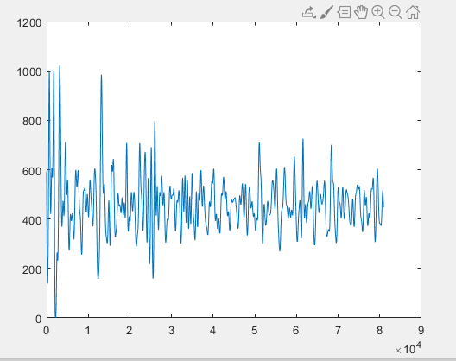

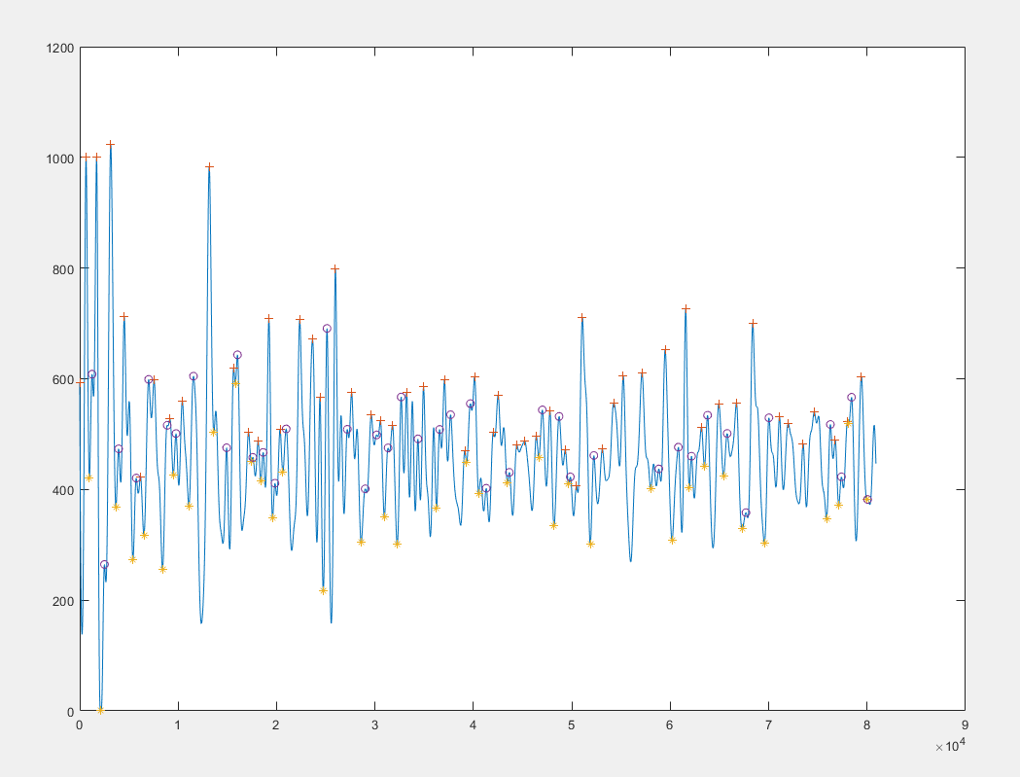

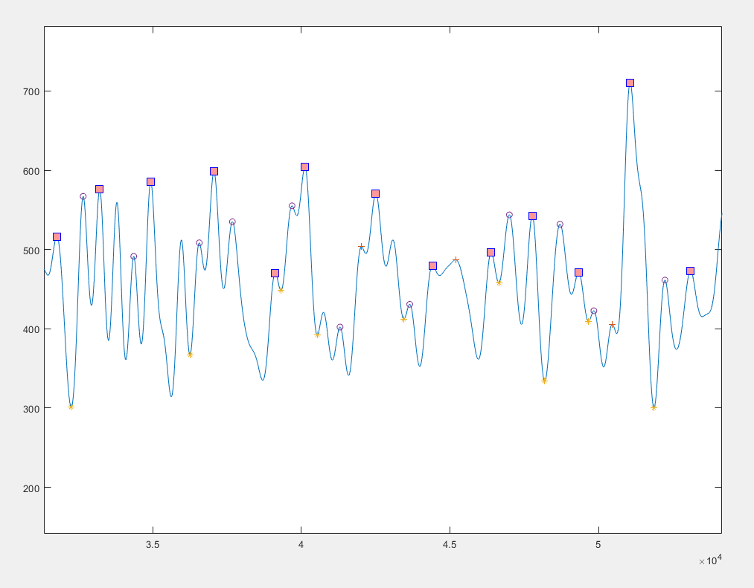

German:

* HR_mean = bpm
* HRV_sdnn = 118 ms
* HRV_rmssd = 1.3 ms
* CSI = 4.64
* CVI = -1.0092

