SERVICENOW-BASED EMPLOYEE LAPTOP REQUEST APPLICATION
Platform: ServiceNow
Application Type: Custom Scoped Application
Project: Employee Laptop Request Management System
Prepared By: Nadakuditi Bindu
Document Type: Technical Project Documentation

1. Introduction
The ServiceNow-Based Employee Laptop Request Application is a custom application developed to manage employee laptop requests in a centralized and controlled manner.
The application replaces manual request processes with a structured digital workflow. Employees can submit laptop requests through ServiceNow, which are stored in a custom table and automatically processed through validation and manager approval.
The application also uses role-based access control to ensure employees and managers have appropriate access based on their responsibilities.

1.1 Project Objective
The main objective of this project is to create a simple and automated laptop request management system that:
- Allows employees to submit laptop requests.
- Stores request information in a centralized table.
- Prevents duplicate requests within the same year.
- Automatically sends requests to the employee's manager for approval.
- Updates request status based on the approval decision.
- Sends email notifications to employees.
- Provides role-based access using ACLs.
- Reduces manual intervention.

2. Business Requirements
The primary business requirement is to provide a centralized system for managing employee laptop requests.
The application should allow employees to submit requests and should ensure that each request follows a defined approval process.

2.1 Business Goals
The main business goals are:
- Provide one platform for laptop requests.
- Capture employee and request details.
- Categorize requests as Basic or Advanced.
- Prevent multiple laptop requests from the same employee within one year.
- Provide manager approval.
- Track request status.
- Notify employees about approval decisions.
- Restrict access based on user roles.

2.2 Functional Scope
The application includes the following functionality:
- Employee laptop request submission
- Requester information
- Manager information
- Duplicate request validation
- Manager approval
- Email notifications
- Role-based access
- ACL configuration

3. Application Configuration
A custom ServiceNow application was created to manage the employee laptop request process.
The application provides a dedicated scope for the project and contains the required tables, Record Producer, Business Rule, Flow Designer automation, security configuration, and other application components.

3.1 Update Set
An Update Set was created to capture the configuration changes made during development.
The Update Set was made current before starting the development activities so that the application configuration could be tracked and prepared for deployment.

3.2 Custom Table
A custom table named Laptop Request was created.
Table Name: x_2063774_projec_0_laptop_request
The table stores all employee laptop request records.

3.3 Table Fields
Field | Type | Purpose
Number | Auto Number | Unique request number
Requester | Reference | Employee submitting request
Employee Email | Email | Employee contact email
Request Date | Date/Time | Request submission date
Short Description | String | Request summary
Manager | Reference | Approving manager
Type of Request | Choice | Basic / Advanced
Status | Choice | Pending Approval / Approved / Rejected
Reason | Choice | Software Development / Personal Use / Other

3.4 Data Model
The custom table acts as the main data source for the application.
The Requester and Manager fields use references to ServiceNow users, while the Choice fields provide controlled values for request type, status, and reason.
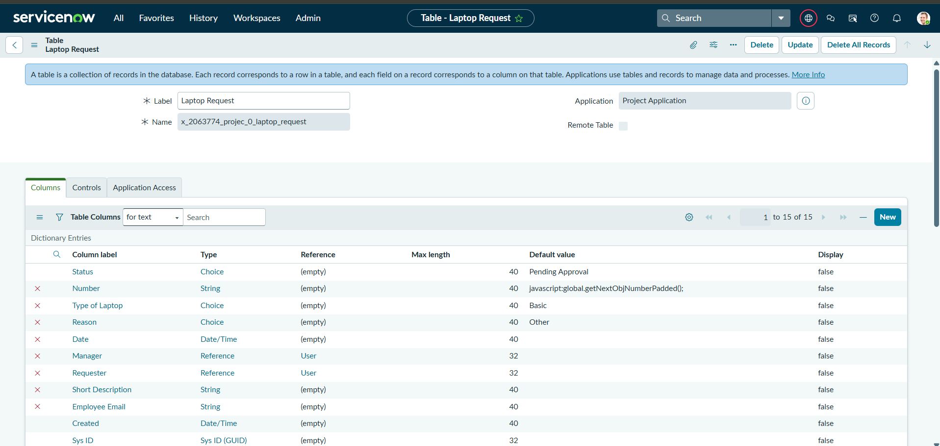

4. Record Producer Configuration
A Record Producer was created to provide a simple interface for employees to submit laptop requests.
Name: Laptop Request

4.1 Configuration Steps
The following configuration was performed:
- Created a new Record Producer.
- Provided the name Laptop Request.
- Selected the Laptop Request table.
- Added the required variables.
- Configured variable types according to the table fields.
- Mapped the variables to the corresponding table fields.
- Saved the Record Producer.
- Added it to the Employee Service Catalog.

4.3 Request Submission Process
The employee request process works as follows:
- Employee opens the Employee Service Catalog.
- Employee selects Laptop Request.
- Employee enters the required information.
- Employee selects Basic or Advanced.
- Employee provides the reason.
- Employee submits the request.
- The Record Producer creates a record in the Laptop Request Form table.
- Backend validation is performed.
- The approval process starts automatically.

4.4 Purpose
The Record Producer acts as the front-end entry point for employees while the custom table acts as the backend storage location.

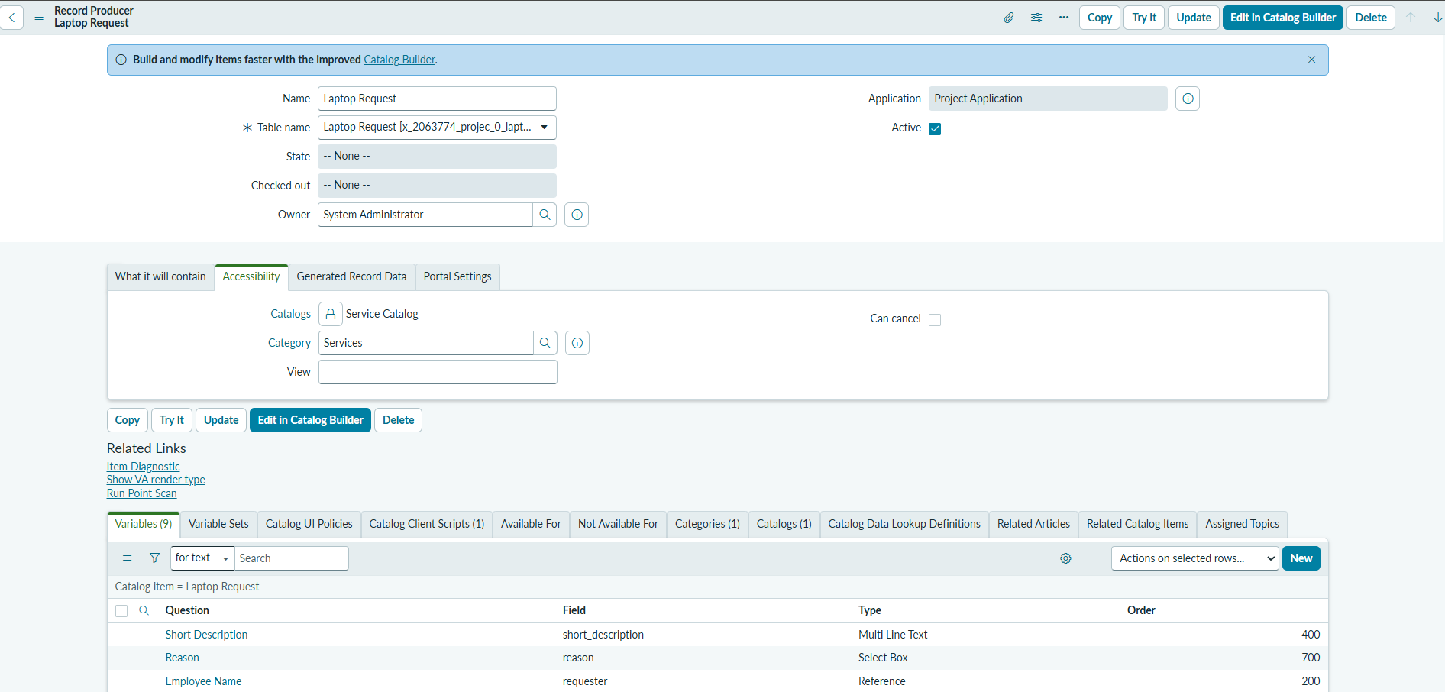
5. Business Rule
A Business Rule was implemented to enforce the requirement that an employee can submit only one laptop request per calendar year.

5.1 Business Rule Details
Name: Laptop Request BR
Table: Laptop Request
When: Before Insert
The Business Rule runs when a new laptop request is submitted.

5.2 Business Logic
The system performs the following validation:
- A new laptop request is submitted.
- The system identifies the requester.
- The system checks for an existing request from the same employee.
- The request date is checked against the current calendar year.
- If an existing request is found, the new request is blocked.
- An error message is displayed.
- If no existing request is found, the request is allowed.
Request Blocked – Employee already has a laptop request for the current year.
This ensures that the one-request-per-year policy is consistently enforced.

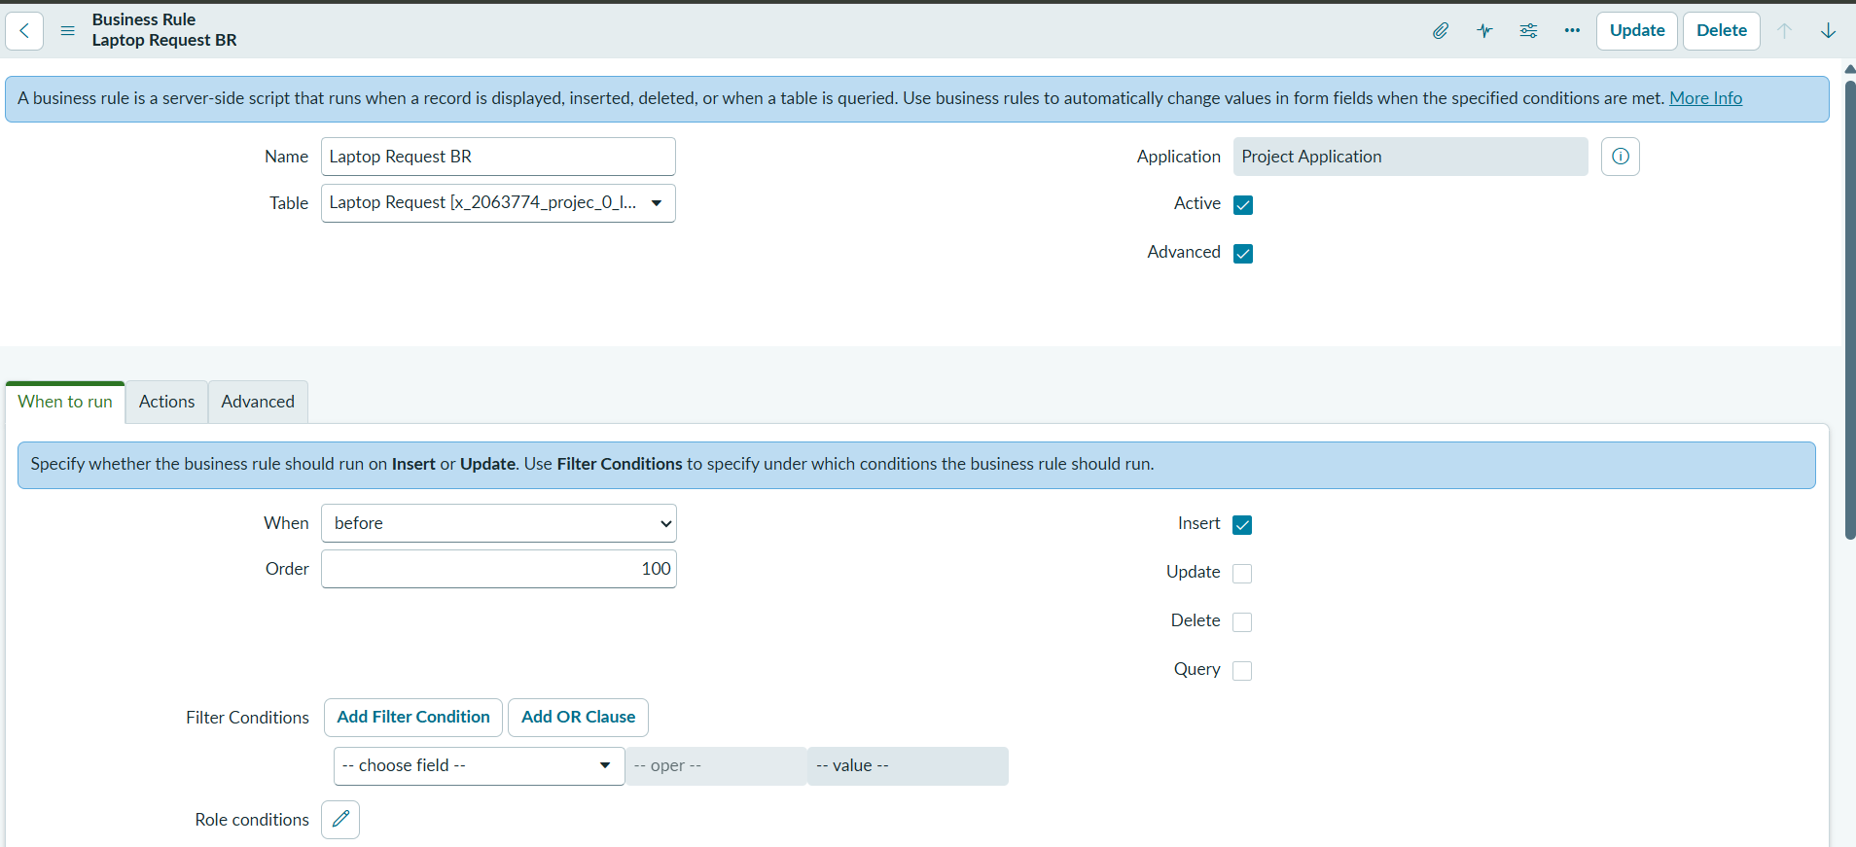

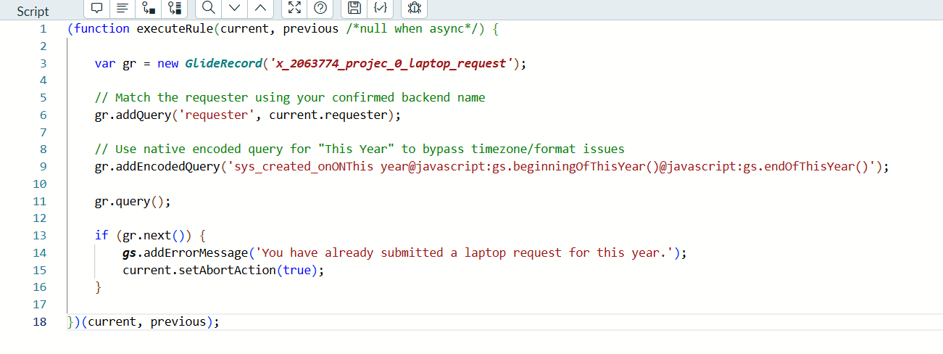

6. Flow Designer Automation
Flow Designer was used to automate the laptop request approval process.
The purpose of the flow is to automatically initiate manager approval after a request is created and update the request according to the manager's decision.
Trigger: Record Created

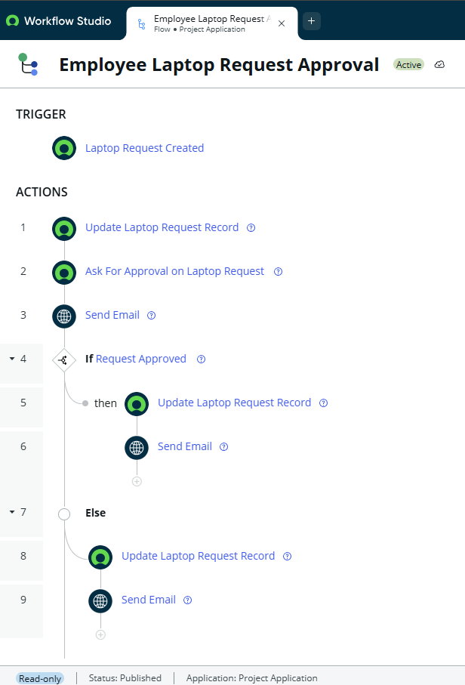
6.1 Overall Flow
Employee submits request
↓
Record Created
↓
Pending Approval
↓
Manager Approval
↙ ↘
Approved Rejected
↓ ↓
Update Status Update Status
↓ ↓
Email Employee Email Employee

7. Security Configuration
Role-based security was implemented to control access to the application.
Two custom roles were created:
7.1 Roles
Role | Purpose
it_employee | Create and manage laptop requests
it_manager | View laptop requests

7.2 Groups
Two groups were created:
Group | Role | Members
IT Employees | it_employee | 10 users
IT Managers | it_manager | 8 users
Groups simplify user administration by assigning roles to groups instead of individual users.

7.3 Access Control Lists
ACLs were configured for the Laptop Request Form table.

Manager Access
Operation | Role
Read | it_manager
Managers can view requests but do not have Create or Write permissions through the configured ACLs.

Employee Access
Operation | Role
Read | it_employee
Create | it_employee
Write | it_employee
Employees can create and manage permitted laptop request records.

8. Testing and Functional Validation
Testing was performed to verify that the application works according to the defined requirements.

Test Scenario | Expected Result | Result
Employee creates request | Request created | Passed
Employee edits request | Edit allowed | Passed
Employee submits second request in same year | Request blocked | Passed
Manager views request | Access allowed | Passed
Manager creates request | Access blocked | Passed
Manager edits request | Access blocked | Passed
New request created | Status becomes Pending Approval | Passed
Manager approves request | Status becomes Approved | Passed
Manager rejects request | Status becomes Rejected | Passed
Approval notification | Employee notified | Passed
Rejection notification | Employee notified | Passed

8.2 Functional Testing
The employee request creation process was tested from submission through approval.
The testing confirmed that:
- The Record Producer creates the request correctly.
- Request information is stored in the custom table.
- The initial status is set to Pending Approval.
- Manager approval is triggered automatically.
- Approval decisions update the request status.
- Email notifications are generated.
8.3 Security Testing
Security testing was performed using employee and manager roles.
The results confirmed:
- Employees can create requests.
- Employees can view and manage permitted records.
- Managers can view requests.
- Managers cannot create or modify requests through the configured ACLs.
- Duplicate requests are blocked.
8.4 Testing Result
The application successfully passed the defined functional and security test scenarios.
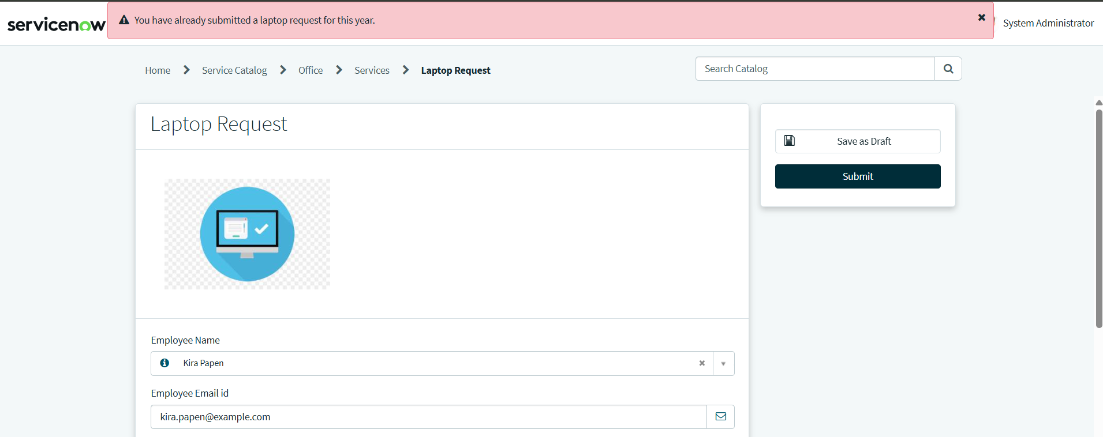

9. Key Achievements
The project successfully implemented:
- Custom ServiceNow application
- Custom Laptop Request Form table
- One-request-per-year Business Rule
- Flow Designer automation
- Approval decision handling
- Email notifications
- ACL-based security
- Update Set configuration

10. Future Enhancements
The application can be extended in the future with additional functionality such as:
- IT asset inventory integration
- Automatic laptop assignment
- IT fulfillment tasks
- Laptop availability checking
- SLA management
- Advanced approval rules
- Reporting dashboards
- Request analytics
- Automated asset delivery tracking

Conclusion

PROJECT SUMMARY
Component | Implementation
Application | Custom ServiceNow Application
Table | Laptop Request Form
Record Producer | Laptop Request
Business Rule | Laptop Request BR
Automation | Flow Designer
Approval | Manager Approval
Roles | it_employee, it_manager
Groups | IT Employees, IT Managers
Security | ACLs
Deployment | Update Set

The ServiceNow-Based Employee Laptop Request Application provides a centralized solution for managing laptop requests.
It automates request submission, validation, manager approval, status updates, and notifications, while using roles, groups, and ACLs for secure access.
The project demonstrates practical knowledge of ServiceNow application development, Business Rules, Record Producers, Flow Designer, and security configuration.

