1. IDEATION PHASE
ServiceNow-Based Employee Laptop Request Application
Prepared By: Nadakuditi Bindu

1.1 Problem Discovery
The project began with a simple business problem: employee laptop requests need a centralized and controlled process. Manual communication can make request information, approvals and status difficult to manage consistently. The proposed ServiceNow solution focuses on creating a single digital entry point and a defined request lifecycle.

1.2 Stakeholder Needs
Stakeholder | Need | Expected Benefit
Employee | Simple request submission and clear status | Less manual follow-up
Manager | Controlled approval of employee requests | Better accountability
IT Team | Centralized request records and access control | Improved visibility and administration
Organization | Consistent request policy | Standardized process

1.3 User Pain Points
• Requests can be handled outside a centralized system.
• Duplicate laptop requests need to be prevented.
• Approval status needs to be visible and traceable.
• Employees need confirmation when an approval decision is made.
• Different users require different access levels.

1.4 Ideation Workflow

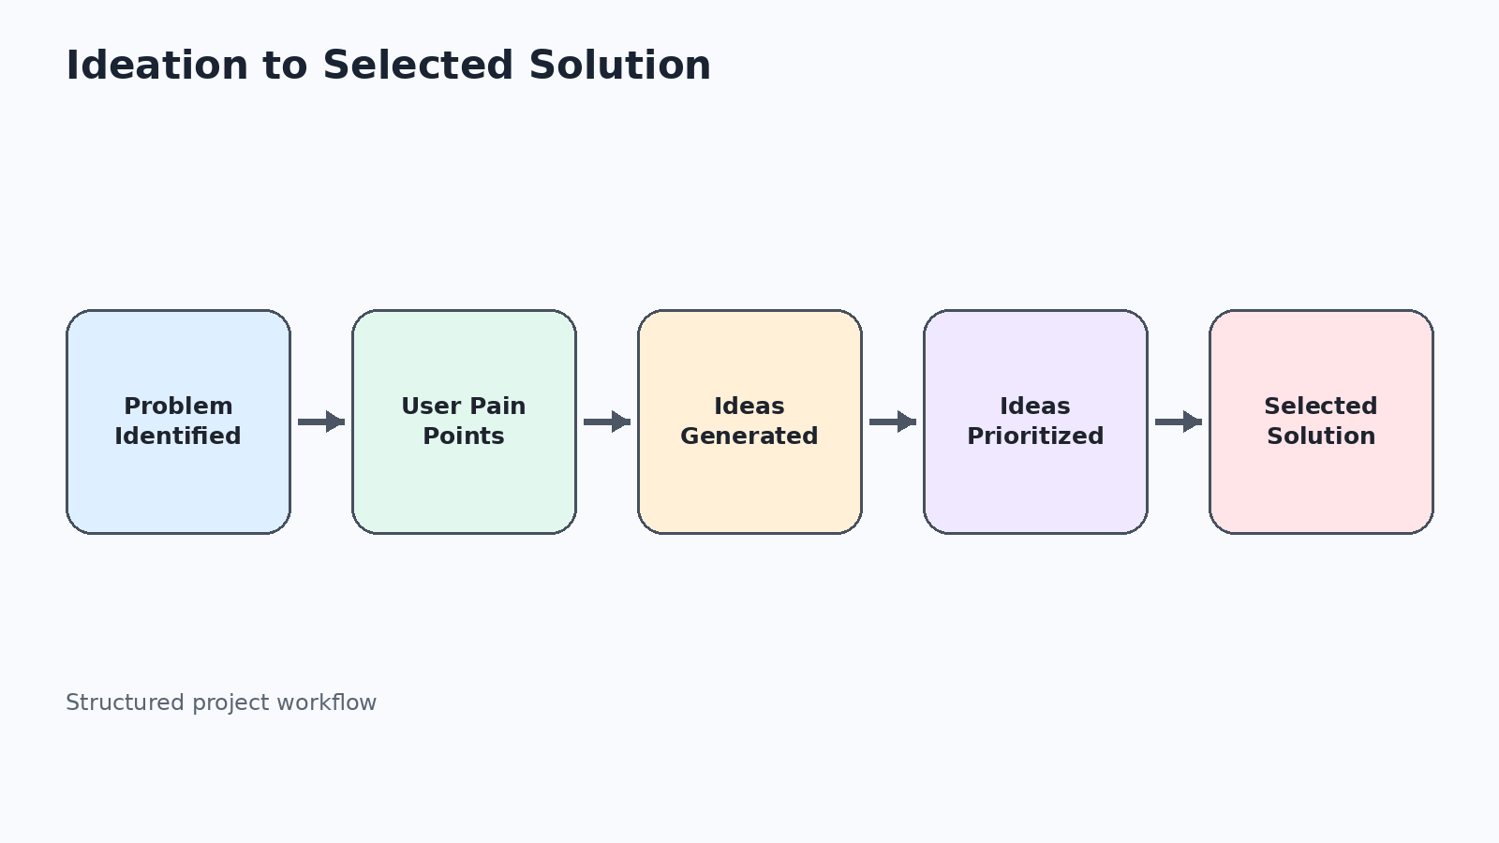

1.5 Brainstormed Solution Areas

Area | Idea | Reason for Inclusion
Submission | Employee Service Catalog + Record Producer | Creates a simple front-end entry point.
Data | Custom Laptop Request table | Provides centralized structured storage.
Validation | One request per employee per calendar year | Enforces the defined policy.
Approval | Manager approval through Flow Designer | Creates an automated approval stage.
Communication | Approval / rejection emails | Keeps the employee informed.
Security | Roles, groups and ACLs | Restricts access according to responsibility.

1.6 Idea Prioritization
Priority | Selected Capability | Decision
High | Centralized request submission | Core
High | Annual duplicate validation | Core
High | Manager approval automation | Core
High | Status and notification handling | Core
High | Role-based access | Core

1.7 Selected Concept

The selected concept is a ServiceNow-Based Employee Laptop Request Application using a custom table, Record Producer, Business Rule, Flow Designer, approval handling, notifications and role-based security. The concept directly addresses the identified request, approval, validation and access needs.

1.8 Ideation Outcome

The ideation phase converted the business problem into a focused ServiceNow solution concept. The next phase translates this concept into measurable business, functional, data and security requirements.

