2. REQUIREMENT ANALYSIS
ServiceNow-Based Employee Laptop Request Application
Prepared By: Nadakuditi Bindu

2.1 Requirement Objective
The requirement analysis defines what the application must provide to employees, managers and the IT team. Requirements are organized into business, functional, data, security and non-functional areas so they can be implemented and tested.

2.2 Requirement Analysis Workflow

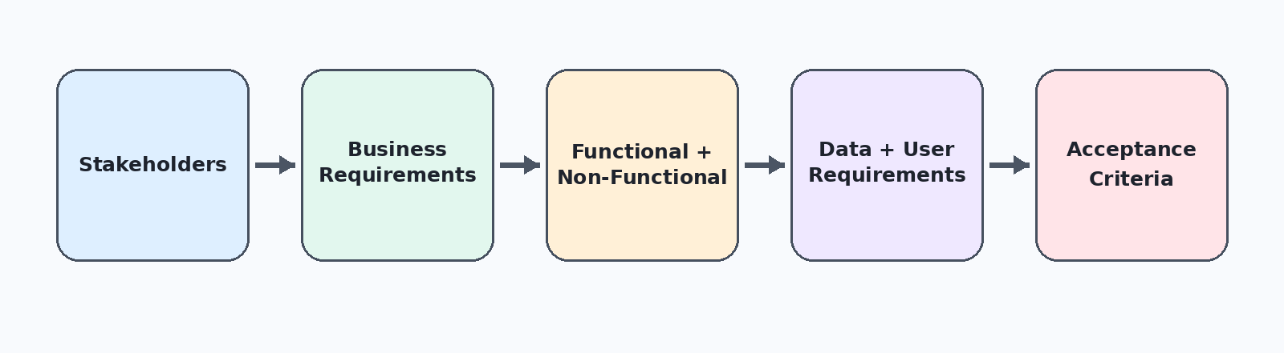

2.3 Business Requirements
ID | Business Requirement | Expected Outcome
BR-01 | Provide one platform for laptop requests | Centralized submission
BR-02 | Capture employee and request details | Complete request record
BR-03 | Differentiate Basic and Advanced requests | Controlled classification
BR-04 | Prevent more than one request per employee per year | Policy enforcement
BR-05 | Provide manager approval | Controlled decision
BR-06 | Track request status | Lifecycle visibility
BR-07 | Notify employees of decisions | Clear communication

2.4 Functional Requirements

ID | Function | Requirement
FR-01 | Submission | Employee can submit a Laptop Request.
FR-02 | Data Capture | Request stores requester, email, date, description, manager, type, status and reason.
FR-03 | Validation | System checks for an existing request from the same employee in the current year.
FR-04 | Approval | New valid requests are sent to the employee's manager for approval.
FR-05 | Decision Handling | Approved requests become Approved; rejected requests become Rejected.
FR-06 | Notification | Employee receives approval or rejection email.
FR-07 | Security | Roles and ACLs control read, create and write access.

2.5 Data Requirements

Field | Type | Purpose / Allowed Value
Number | Auto Number | Unique request identifier
Requester | Reference | Employee submitting request
Employee Email | Email | Contact email
Request Date | Date/Time | Submission date
Short Description | String | Request summary
Manager | Reference | Approving manager
Type of Request | Choice | Basic / Advanced
Status | Choice | Pending Approval / Approved / Rejected
Reason | Choice | Software Development / Personal Use / Other

2.6 User and Security Requirements
User | Required Access
Employee / it_employee | Read, Create and Write permitted request records
Manager / it_manager | Read/view request records and participate in approval
Application Security | Use groups and ACLs to enforce role-based access

2.7 Non-Functional Requirements
• Usability: provide a straightforward employee-facing request interface.
• Security: apply role-based access and ACL controls.
• Consistency: use controlled choice values and validation.
• Maintainability: keep application configuration organized in a scoped application and Update Set.
• Traceability: maintain identifiable request and approval records.

2.8 Requirement Acceptance Focus
Requirement | Acceptance Check
Request submission | A valid employee request creates a record.
Duplicate prevention | A second request in the same year is blocked.
Approval | A valid request reaches manager approval.
Status | Approval outcome changes the request status correctly.
Notification | Employee receives the appropriate decision email.
Security | Manager and employee permissions match the configured ACLs.

