3. PROJECT PLANNING PHASE
ServiceNow-Based Employee Laptop Request Application
Prepared By: Nadakuditi Bindu

3.1 Planning Objective
The planning phase organizes implementation into manageable activities and defines the sequence in which the application components should be configured, validated and prepared for deployment.

3.2 Project Planning Workflow

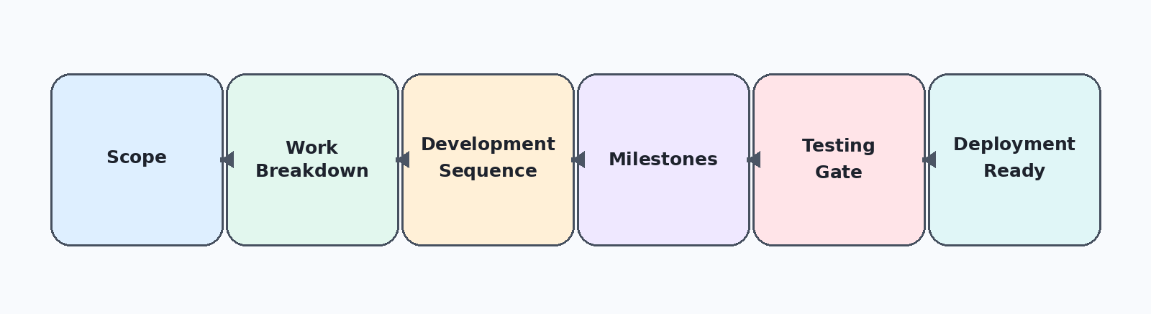

3.3 Work Breakdown Structure
Phase | Work Package | Output
1 | Application foundation | Scoped application + Update Set
2 | Data model | Laptop Request table + fields
3 | Request interface | Laptop Request Record Producer
4 | Backend validation | Laptop Request Business Rule
5 | Automation | Flow Designer approval process
6 | Security | Roles + Groups + ACLs
7 | Validation | Functional + security testing
8 | Deployment preparation | Update Set ready for deployment

3.4 Development Sequence
• Create and make the Update Set current.
• Create the custom scoped application.
• Create the Laptop Request table and fields.
• Create and map the Record Producer.
• Configure the annual duplicate Business Rule.
• Build the Flow Designer approval process.
• Configure roles, groups and ACLs.
• Execute functional and security validation.
• Confirm deployment readiness through the Update Set.

3.5 Milestone Plan
Milestone | Completion Evidence
M1 – Foundation | Application and Update Set created
M2 – Data Model | Custom table and fields configured
M3 – Request Entry | Record Producer mapped and available in Employee Service Catalog
M4 – Validation | Business Rule tested
M5 – Automation | Manager approval flow tested
M6 – Security | Roles, groups and ACLs tested
M7 – Quality Gate | Functional and security scenarios passed
M8 – Deployment | Configuration captured in Update Set

3.6 Project Roles
Role | Responsibility
Employee | Submit and manage permitted laptop request records.
IT Manager | Review requests and provide approval decisions.
Project / Development Team | Configure application, logic, automation and security; perform validation.

3.7 Planning Controls
• Keep configuration changes within the current Update Set.
• Validate table-to-Record Producer mappings before testing.
• Test duplicate prevention before approval automation.
• Validate both approval outcomes.
• Test employee and manager permissions separately.
• Use defined test scenarios as the quality gate before deployment.

3.8 Planning Deliverables

The planned outcome is a controlled, testable ServiceNow application with a clear implementation sequence. The planning structure separates configuration work from validation work so that each major capability can be checked before the project is considered deployment-ready.

