4. PROJECT DESIGN PHASE
ServiceNow-Based Employee Laptop Request Application
Prepared By: Nadakuditi Bindu

4.1 Design Objective
The design phase defines how the approved requirements are represented within ServiceNow. The design connects the employee-facing request experience with the data model, backend validation, automation, approval and security layers.

4.2 Solution Architecture

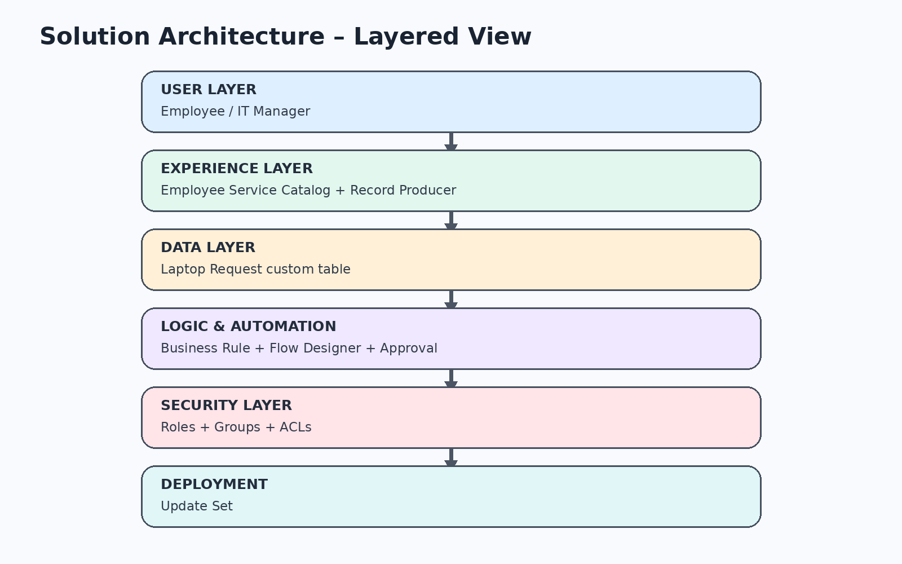

4.3 Application Component Design

Component | Design Purpose
Custom Scoped Application | Provides a dedicated application scope for project artifacts.
Laptop Request Table | Acts as the main data source for employee laptop requests.
Record Producer | Provides the employee-facing request interface.
Business Rule | Validates the one-request-per-year policy before insert.
Flow Designer | Automates approval, decision handling and notifications.
Approval Relationship | Connects the request with the ServiceNow approval table.
Roles / Groups | Organize access according to responsibility.
ACLs | Control read, create and write operations.
Update Set | Captures configuration changes for deployment.

4.4 Data Model Design

Field Group | Design
Identification | Number – Auto Number
Employee | Requester – Reference; Employee Email – Email
Request Details | Request Date – Date/Time; Short Description – String
Approval | Manager – Reference
Classification | Type of Request – Basic / Advanced; Reason – Software Development / Personal Use / Other
Lifecycle | Status – Pending Approval / Approved / Rejected

4.5 Record Producer Design
The Record Producer named Laptop Request is mapped to the Laptop Request table. Variables are configured according to the table field types and mapped to the corresponding fields. The producer is added to the Employee Service Catalog so employees have a clear front-end entry point.

4.6 Business Rule Design
Property | Design Decision
Name | Laptop Request BR
Table | Laptop Request
Execution | Before Insert
Purpose | Prevent a second laptop request by the same employee in the current calendar year.
Success | Allow the request to continue when no current-year duplicate exists.
Failure | Block the request and display an error message.

4.7 Automation Design
A new request starts the Flow Designer process. The request is initialized to Pending Approval, an approval is requested from the manager, and the result determines the final status and employee notification.

4.8 Security Design
Role | Read | Create | Write
it_employee | Yes | Yes | Yes
it_manager | Yes | No | No

4.9 Design Principle
The design separates user interaction, data storage, backend validation, automation and security. This makes the request lifecycle easier to understand, test and maintain without repeating the same configuration across multiple components.

