5. PROJECT DEVELOPMENT
ServiceNow-Based Employee Laptop Request Application
Prepared By: Nadakuditi Bindu

5.1 Development Overview
Development converted the approved design into ServiceNow configuration. The implementation covers the request data model, employee submission interface, annual validation, manager approval automation, security controls and testing.

5.2 Development Workflow

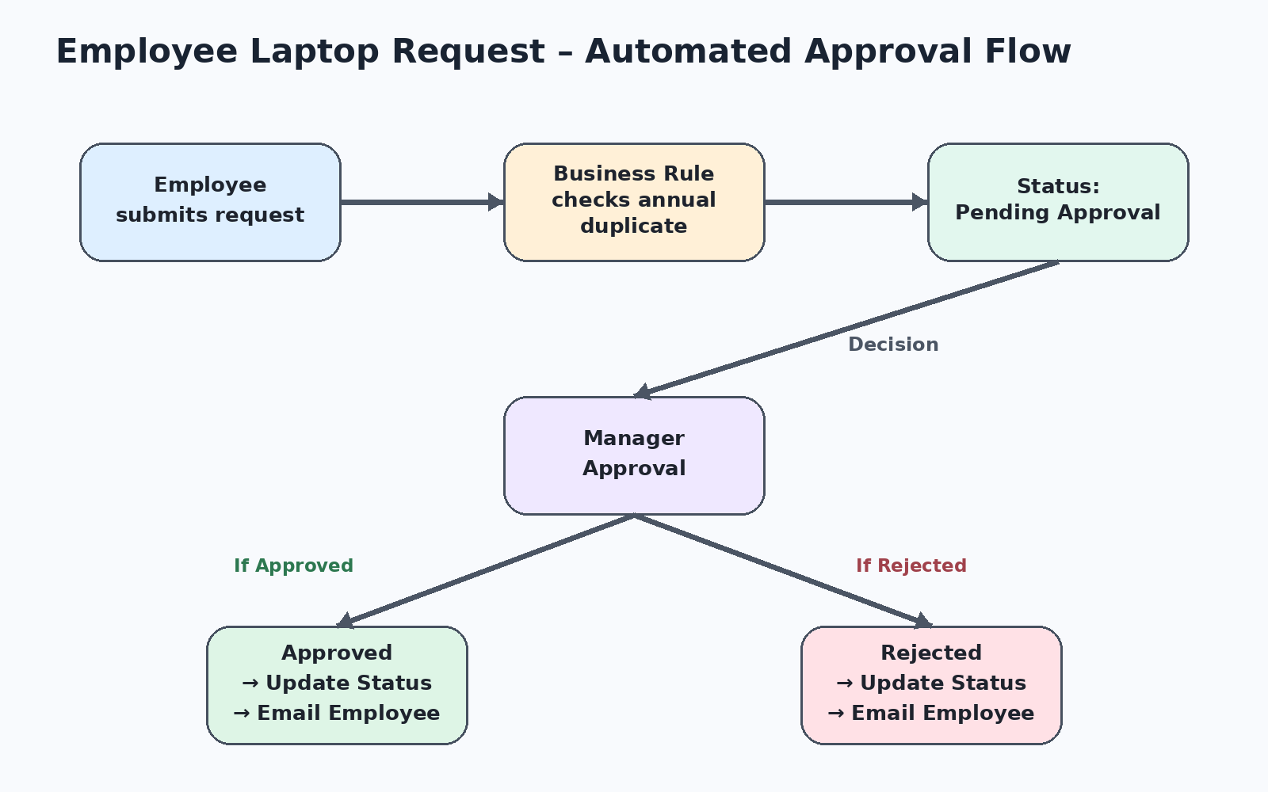

5.3 Application Foundation

Item | Implemented Configuration
Update Set | Created and made current before development.
Application | Custom scoped application.
Table | Laptop Request – x_2063774_projec_0_laptop_request.

5.4 Record Producer Implementation
• Created Record Producer named Laptop Request.
• Selected the Laptop Request table.
• Added variables required by the request.
• Matched variable types with table field types.
• Mapped variables to the corresponding table fields.
• Added the producer to the Employee Service Catalog.

5.5 Business Rule Implementation
Laptop Request BR executes before insert. It identifies the requester, checks for an existing laptop request and evaluates whether that request belongs to the current calendar year. If a matching request exists, the new submission is blocked.
Configured outcome: “Request Blocked – Employee already has a laptop request for the current year.”

5.6 Flow Designer Implementation
Flow Stage | Action
Trigger | Laptop Request record is created.
Initialization | Request status is set to Pending Approval.
Approval | Ask for Approval using the Manager reference.
Decision | Evaluate approval or rejection.
Approved Path | Set status to Approved and send email to requester.
Rejected Path | Set status to Rejected and send email to requester.

5.7 Security Implementation

Security Element | Implementation
Role | it_employee – create and manage laptop requests
Role | it_manager – view laptop requests
Group | IT Employees – it_employee role
Group | IT Managers – it_manager role
ACL | Manager: Read
ACL | Employee: Read + Create + Write

5.8 Functional Test Results

Scenario | Expected Result | Result
Employee creates request | Request created | Passed
Employee edits request | Edit allowed | Passed
Second request in same year | Request blocked | Passed
Manager views request | Access allowed | Passed
Manager creates request | Access blocked | Passed
Manager edits request | Access blocked | Passed
New request | Pending Approval | Passed
Manager approves | Approved | Passed
Manager rejects | Rejected | Passed
Approval notification | Employee notified | Passed
Rejection notification | Employee notified | Passed

5.9 Development Outcome
The implemented configuration passed the defined functional and security scenarios. The completed lifecycle demonstrates that submission, validation, approval, status management, notifications and access controls work together as designed.

