6. PROJECT DOCUMENTATION
ServiceNow-Based Employee Laptop Request Application
Prepared By: Nadakuditi Bindu

6.1 Document Purpose
This document provides a concise technical record of the completed ServiceNow application. It brings together the final configuration, process lifecycle, security model, testing evidence, achievements and future enhancement areas without repeating the detailed planning and design material.

6.2 Project Overview
The ServiceNow-Based Employee Laptop Request Application is a custom scoped application for centralized employee laptop request management. Employees submit requests through a Record Producer, requests are stored in a custom table, duplicate submissions are validated, managers provide approval, and the final decision is communicated to the employee.

6.3 End-to-End Operational Workflow
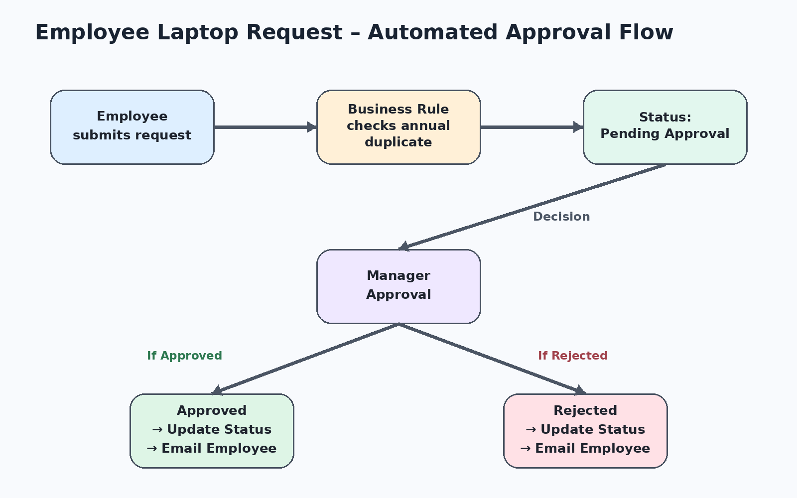

The workflow begins with employee submission. Backend validation checks the annual duplicate rule before the request proceeds to manager approval. The manager decision creates one of two controlled outcomes: Approved or Rejected. Each outcome updates the request and sends the appropriate employee notification.

6.4 Final System Inventory
Component | Final Implementation
Application | Custom ServiceNow scoped application
Table | Laptop Request – x_2063774_projec_0_laptop_request
Record Producer | Laptop Request
Business Rule | Laptop Request BR
Automation | Flow Designer
Approval | Manager approval using ServiceNow approval records
Roles | it_employee, it_manager
Groups | IT Employees, IT Managers
Security | ACLs
Deployment | Update Set

6.5 Security Summary
Access Area | Employee | Manager
View requests | Allowed | Allowed
Create requests | Allowed | Blocked
Write requests | Allowed | Blocked
Approval responsibility | Submitter | Approver

6.6 Validation Summary
Validation Area | Outcome
Request creation | Passed
Annual duplicate prevention | Passed
Pending Approval initialization | Passed
Manager approval | Passed
Approved status | Passed
Rejected status | Passed
Approval notification | Passed
Rejection notification | Passed
Role-based access | Passed

6.7 Key Achievements

• Centralized laptop request management.
• Structured request data using a custom table.
• One-request-per-year policy enforcement.
• Automated manager approval using Flow Designer.
• Automated status and email handling.
• Role-based security using roles, groups and ACLs.
• Configuration captured through an Update Set.
• Functional and security scenarios successfully validated.

6.8 Future Enhancements
Enhancement | Potential Value
IT asset inventory integration | Connect requests with available assets.
Automatic laptop assignment | Reduce manual fulfillment work.
IT fulfillment tasks | Track downstream fulfillment activities.
Laptop availability checking | Validate availability before fulfillment.
SLA management | Measure and manage request timelines.
Advanced approval rules | Support more complex approval conditions.
Reporting dashboards | Provide management visibility.
Request analytics | Identify request trends.
Asset delivery tracking | Track delivery after approval.

6.9 Project Conclusion
The completed application provides a controlled digital lifecycle for employee laptop requests. It combines structured data capture, backend policy enforcement, manager approval, automated status handling, notifications and role-based access. The implementation demonstrates practical ServiceNow application development and provides a foundation for future IT asset and fulfillment enhancements.

