《并行程序设计》
实验报告

学号：
姓名：
班级：

2018/4/28

华南理工大学本科实验报告
课程名称 并行程序设计 成绩评定
实验项目名称OpenMP环境配置及实现所给算法的OpenMP并行化 指导教师 汤德佑 实验地点 B7-233
学生姓名 学号
学院 软件学院 系 软件工程 专业 软件工程
实验时间 2018 年 4 月 29 日 下 午～ 4 月 29 日 下 午
1、实验目标
（1）利用visual studio配置OpenMP环境；
（2）对以下算法利用OpenMP实现并行化。
i Martrix-Vecter 乘法;
ii梯形积分法;
iii PSRS排序

2、求解方法及串行程序代码
Martrix-Vecter 乘法
#include <stdio.h>
#include <stdlib.h>

void Get_dims(int* m_p, int* n_p);
void Read_matrix(char prompt[], double A[], int m, int n);
void Read_vector(char prompt [], double x[], int n);
void Print_matrix(char title[], double A[], int m, int n);
void Print_vector(char title[], double y[], int m);
void Mat_vect_mult(double A[], double x[], double y[], int m, int n);

/*-------------------------------------------------------------------*/
int main(void) {
double* A = NULL;
double* x = NULL;
double* y = NULL;
int m, n;

Get_dims(&m, &n);
A = malloc(m*n*sizeof(double));
x = malloc(n*sizeof(double));
y = malloc(m*sizeof(double));
if (A == NULL || x == NULL || y == NULL) {
fprintf(stderr, "Can't allocate storage\n");
exit(-1);
}
Read_matrix("A", A, m, n);
# ifdef DEBUG
Print_matrix("A", A, m, n);
# endif
Read_vector("x", x, n);
# ifdef DEBUG
Print_vector("x", x, n);
# endif

Mat_vect_mult(A, x, y, m, n);

Print_vector("y", y, m);

free(A);
free(x);
free(y);
return 0;
} /* main */

void Get_dims(
int* m_p /* out */,
int* n_p /* out */) {
printf("Enter the number of rows\n");
scanf("%d", m_p);
printf("Enter the number of columns\n");
scanf("%d", n_p);

if (*m_p <= 0 || *n_p <= 0) {
fprintf(stderr, "m and n must be positive\n");
exit(-1);
}
} /* Get_dims */

void Read_matrix(
char prompt[] /* in */,
double A[] /* out */,
int m /* in */,
int n /* in */) {
int i, j;

printf("Enter the matrix %s\n", prompt);
for (i = 0; i < m; i++)
for (j = 0; j < n; j++)
scanf("%lf", &A[i*n+j]);
} /* Read_matrix */

void Read_vector(
char prompt[] /* in */,
double x[] /* out */,
int n /* in */) {
int i;

printf("Enter the vector %s\n", prompt);
for (i = 0; i < n; i++)
scanf("%lf", &x[i]);
} /* Read_vector */

void Print_matrix(
char title[] /* in */,
double A[] /* in */,
int m /* in */,
int n /* in */) {
int i, j;

printf("\nThe matrix %s\n", title);
for (i = 0; i < m; i++) {
for (j = 0; j < n; j++)
printf("%f ", A[i*n+j]);
printf("\n");
}
} /* Print_matrix */

void Print_vector(
char title[] /* in */,
double y[] /* in */,
int m /* in */) {
int i;

printf("\nThe vector %s\n", title);
for (i = 0; i < m; i++)
printf("%f ", y[i]);
printf("\n");
}

void Mat_vect_mult(
double A[] /* in */,
double x[] /* in */,
double y[] /* out */,
int m /* in */,
int n /* in */) {
int i, j;

for (i = 0; i < m; i++) {
y[i] = 0.0;
for (j = 0; j < n; j++)
y[i] += A[i*n+j]*x[j];
}
}

梯形积分法
#include <stdio.h>

double f(double x); /* Function we're integrating */
double Trap(double a, double b, int n, double h);

int main(void) {
double integral; /* Store result in integral */
double a, b; /* Left and right endpoints */
int n; /* Number of trapezoids */
double h; /* Height of trapezoids */

printf("Enter a, b, and n\n");
scanf("%lf", &a);
scanf("%lf", &b);
scanf("%d", &n);

h = (b-a)/n;
integral = Trap(a, b, n, h);

printf("With n = %d trapezoids, our estimate\n", n);
printf("of the integral from %f to %f = %.15f\n",
a, b, integral);

return 0;
}

double Trap(double a, double b, int n, double h) {
double integral;
int k;

integral = (f(a) + f(b))/2.0;
for (k = 1; k <= n-1; k++) {
integral += f(a+k*h);
}
integral = integral*h;

return integral;
}

double f(double x) {
double return_val;

return_val = x*x;
return return_val;
}

PSRS算法
由于PSRS没有单线程的方式，因此在使用单线程排序时，使用的为STL库内的sort函数。

3、并行程序关键代码
Martrix-Vecter 乘法

使用OpenMP进行矩阵-向量乘法的关键点在于将矩阵的按行进行分块划分，即将矩阵分成若干小矩阵，同时多个线程对每一个小矩阵做向量乘法，从而提升运算速度。

void Mat_vect_mult(
double A[] /* in */,
double x[] /* in */,
double y[] /* out */,
int m /* in */,
int n /* in */,
int count
) {
int i, j;
# pragma omp parallel for num_threads(count)
for (i = 0; i < m; i++) {
y[i] = 0.0;
# pragma omp parallel for num_threads(count)
//进行计算
for (j = 0; j < n; j++) {
y[i] += A[i*n + j] * x[j];
}
}
}

梯形积分法

使用OpenMP实现梯形积分法的关键在于计算单个梯形的面积以及梯形面积的求和，划分的梯形的数量远大于线程的数量，通过给线程分配连续的梯形块，之后每个线程对其子区间简单地用串行梯形积分法，最后再累加线程的结果，注意累加的时候有竞争条件，使用deduction进行避免。

double f(double x) {
double return_val;

return_val = x * x;
return return_val;
}

double Trap(double a, double b, int n, double h,int thread_count) {
double integral;
int k;
integral = (f(a) + f(b)) / 2.0;

#pragma omp parallel for num_threads(thread_count) reduction(+:integral)
for (k = 1; k <= n - 1; k++) {
//cout << "thread num:" << omp_get_thread_num()<<endl;
integral += f(a + k * h);
}
integral = integral * h;
return integral;
}

PSRS算法

实现PSRS算法的关键思路在于，首先对每个线程分配数组的一部分进行局部排序，之后选出主元，在每个线程上新分配一块区域用来保存即将被局部交换的数据，之后每个线程对自己负责的那部分数据，参考选出的主元进行局部交换，局部交换完成后进行排序，这样每个线程就获得了排好序的一部分数组，按照顺序进行访问就能获得完整的排序后的数组。

void PSRS(int *& array, long int n)
{

int id;
int i = 0;
int base = n / num_threads;
int p[num_threads*num_threads];
int pivot[num_threads - 1];

int yu = n % num_threads;
int last_section_num = base + yu;

int * pivot_num = new int[num_threads];
for (int r = 0; r < num_threads; r++) {
pivot_num[r] = 0;
}
int** pivot2 = new int*[num_threads];
int count[num_threads] = { 0 };
omp_set_num_threads(num_threads);

#pragma omp parallel shared(base,n,i,p,pivot,array,count,pivot2) private(id)
{
id = omp_get_thread_num();

if (id != num_threads - 1)
sort(array + id * base, array + (id + 1)*base);
else
sort(array + id * base, array + id * base + last_section_num);

#pragma omp critical
{
for (int k = 0; k < num_threads; k++) {
p[i++] = array[id *base + k*(base / num_threads + 1)];
}

}

#pragma omp barrier
#pragma omp master
{
sort(p, p + i);
for (int m = 0; m < num_threads - 1; m++) {
pivot[m] = p[(m + 1)*num_threads];
}
}

#pragma omp master
{
for (int m = 0; m < num_threads*num_threads; m++) {
cout << "p[" + to_string(m) + "]:" + to_string(p[m]) << endl;
}

for (int m = 0; m < num_threads - 1; m++) {
cout << "pivot[" + to_string(m) + "]:" + to_string(pivot[m]) << endl;
}
}

#pragma omp barrier

if (id != num_threads - 1)
for (int k = 0; k<base; k++)
{
for (int m = 0; m<num_threads - 1; m++)
{
if (array[id*base + k] <= pivot[m])
{
pivot_num[id] = pivot_num[id] + 1;
break;
}

if (array[id*base + k] > pivot[m] && m == num_threads - 2) {
pivot_num[id] = pivot_num[id] + 1;
}
}
}
else
for (int k = 0; k<last_section_num; k++)
{
for (int m = 0; m<num_threads - 1; m++)
{
if (array[id*base + k] <= pivot[m])
{
pivot_num[id] = pivot_num[id] + 1;
break;
}

if (array[id*base + k] > pivot[m] && m == num_threads - 2) {
pivot_num[id] = pivot_num[id] + 1;
}
}
}

#pragma omp barrier

pivot2[id] = (int *)malloc(pivot_num[id] * sizeof(int));

pivot2[id][0] = 0;

#pragma omp barrier
if (id != num_threads - 1)
for (int k = 0; k<base; k++)
{
for (int m = 0; m<num_threads - 1; m++)
{
if (array[id*base + k] <= pivot[m])
{
pivot2[id][count[id]++] = array[id*base + k];
break;
}

if (array[id*base + k] > pivot[m] && m == num_threads - 2) {
pivot2[id][count[id]++] = array[id*base + k];
}
}
}
else
for (int k = 0; k<last_section_num; k++)
{
for (int m = 0; m<num_threads - 1; m++)
{
if (array[id*base + k] <= pivot[m])
{
pivot2[id][count[id]++] = array[id*base + k];
break;
}

if (array[id*base + k] > pivot[m] && m == num_threads - 2) {
pivot2[id][count[id]++] = array[id*base + k];
}
}
}
}

#pragma omp parallel shared(pivot2,pivot_num,count) private(id)
{
int id = omp_get_thread_num();

sort(pivot2[id], pivot2[id] + pivot_num[id]);

int start_position = 0;
for (int i = 0; i < id + 1; i++) {

if (i == 0)
start_position = 0;
else
start_position = start_position + pivot_num[i-1];
}

for (int i = 0; i < pivot_num[id]; i++) {
array[start_position + i] = pivot2[id][i];
}

}

}

4、性能分析
Martrix-Vecter 乘法
使用的矩阵大小为10000*10000
线程数 | 1 | 2 | 4 | 8 | 16
时间(s) | 0.478 | 0.27 | 0.245 | 0.197 | 0.197
截图编号 | 图 1-1 | 图 1-2 | 图 1-3 | 图 1-4 | 图 1-5
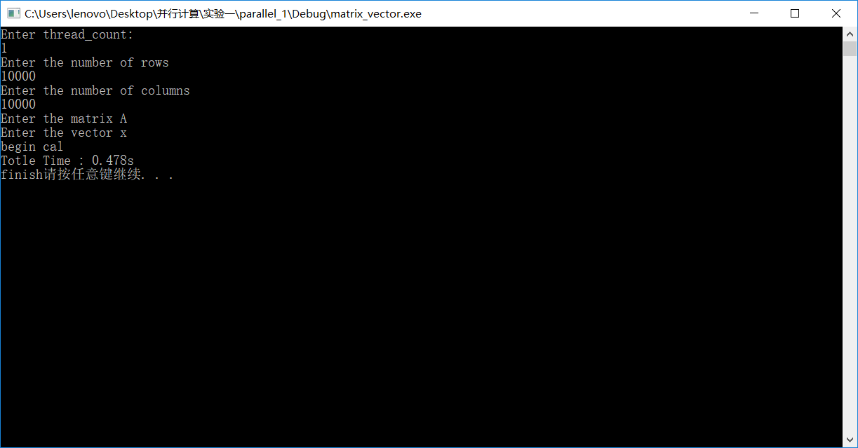
图 1-1

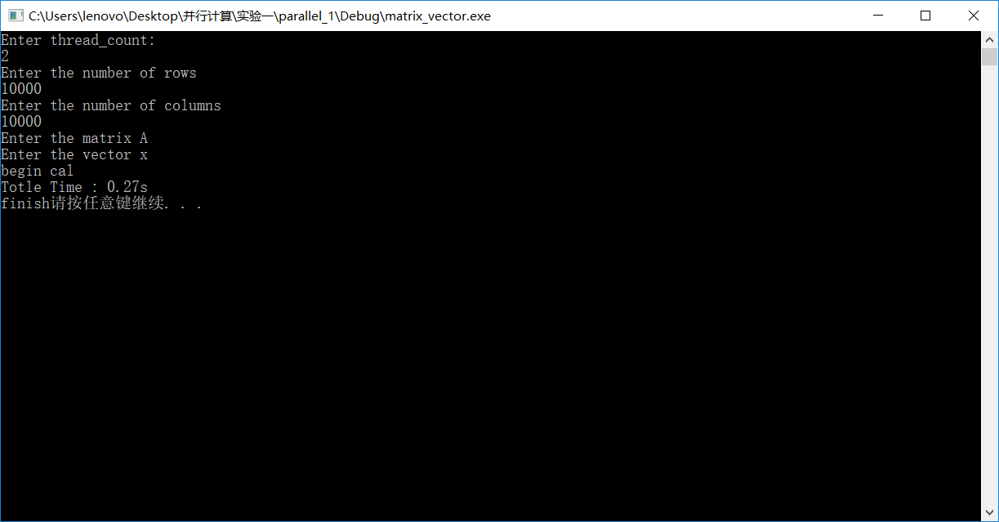
图 1-2

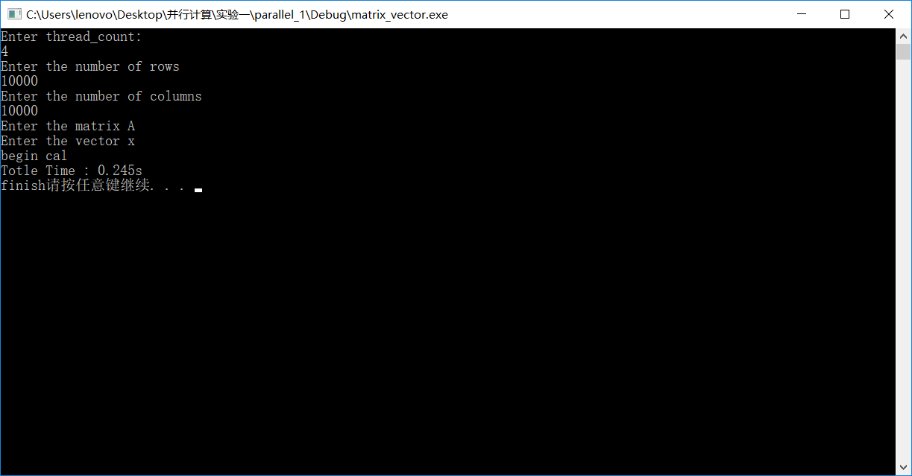
图 1-3

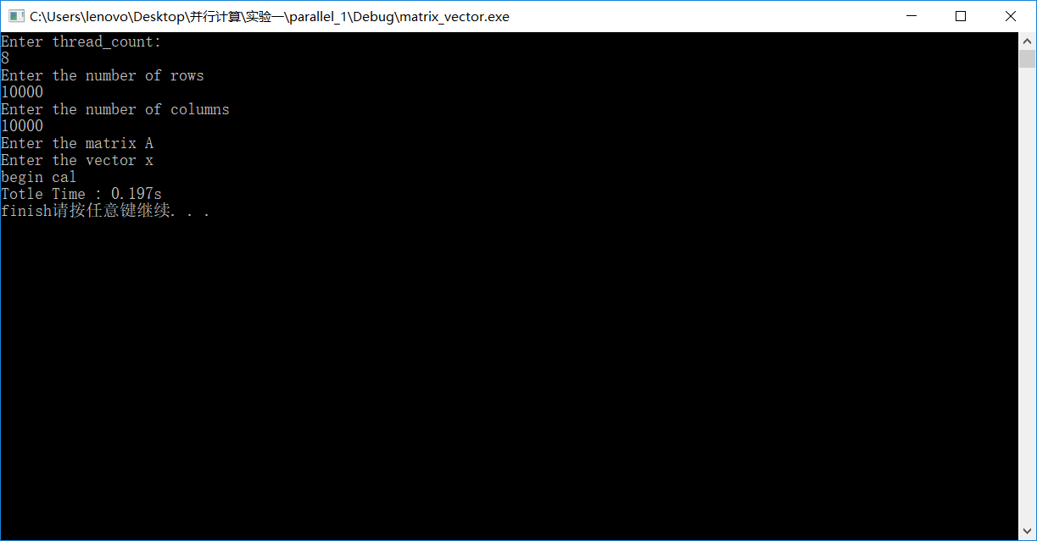
图 1-4

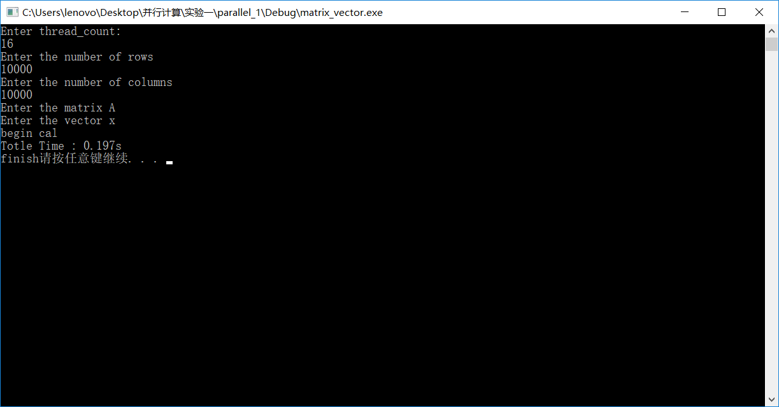
图 1-5

梯形积分法
a=1,b=1000,n= 1000000000
线程数 | 1 | 2 | 4 | 8 | 16
时间(s) | 30.3584 | 15.8952 | 9.08259 | 8.70615 | 8.79635
截图编号 | 图 2-1 | 图 2-2 | 图 2-3 | 图 2-4 | 图 2-5

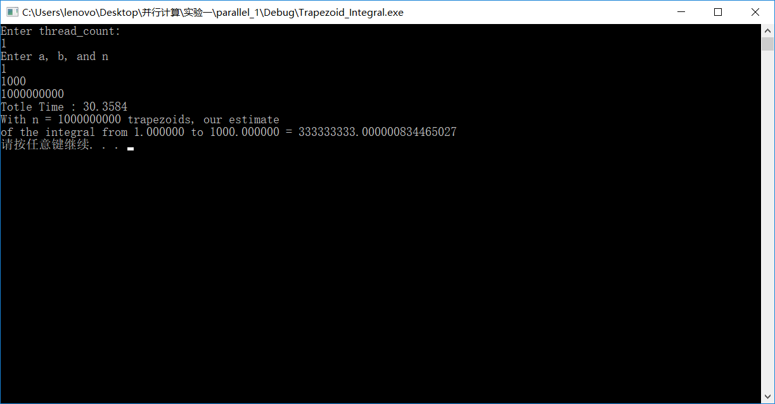
图 2-1

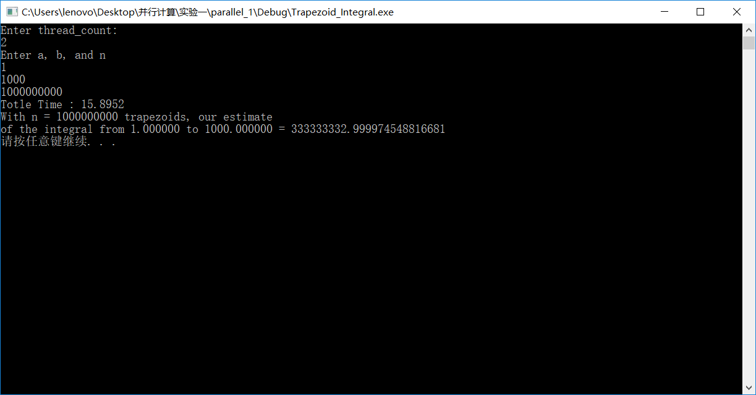
图 2-2

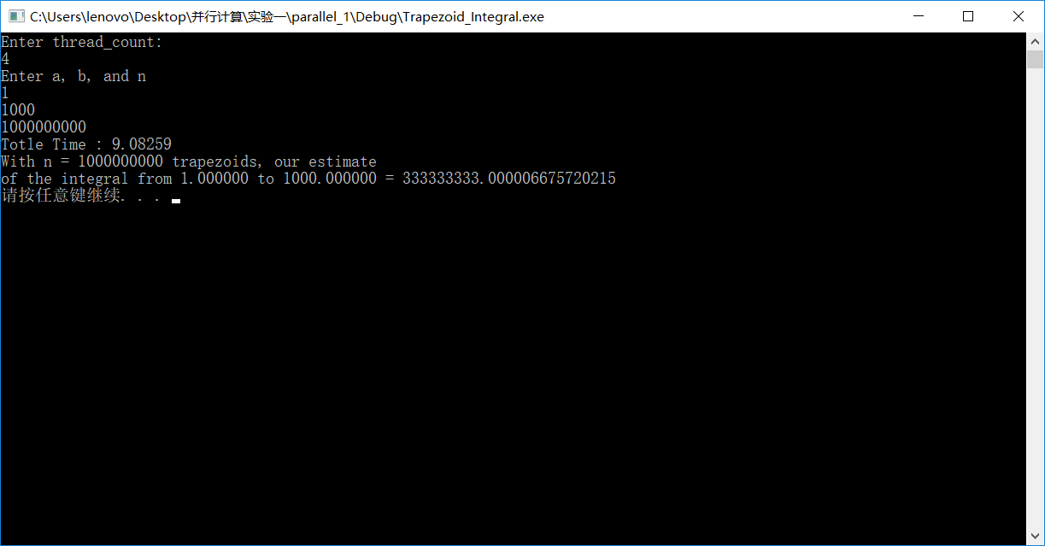
图 2-3

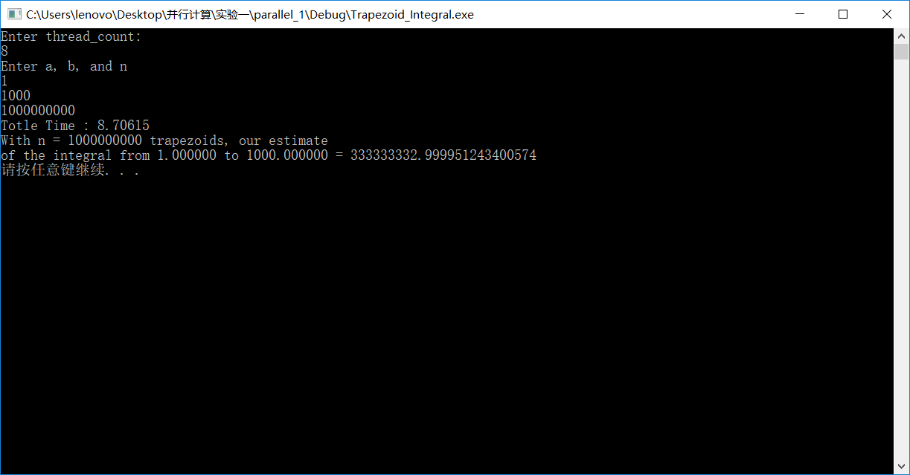
图 2-4

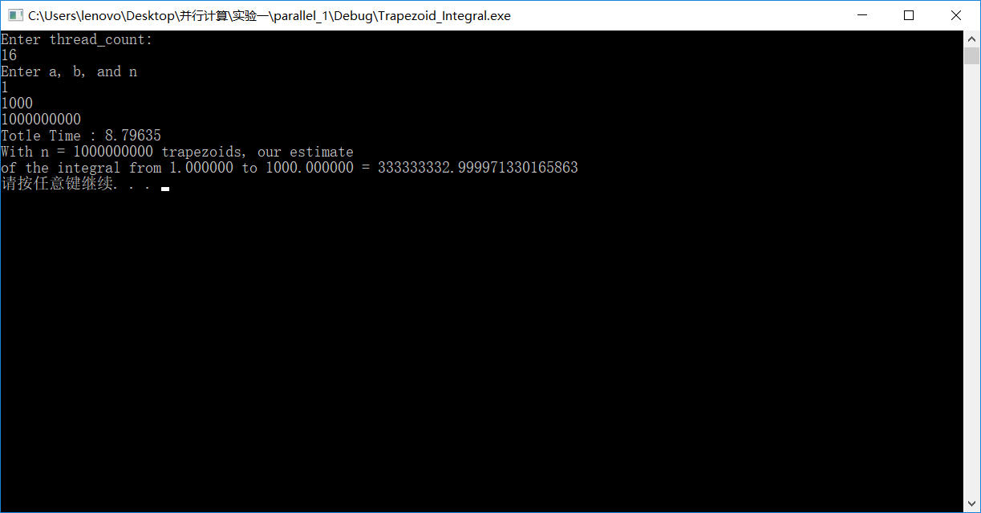
图 2-5

PSRS算法

表1 采用1线程情况时各数据集的测试结果
数据集 | 1 |  | 2 |  | 3 |  | 4
运行方式 | 串行 | 并行 | 串行 | 并行 | 串行 | 并行 | 串行 | 并行
运行时间(s) | 4.40 |  | 8.03 |  | 17.45 |  | 33.08

加速比

效率
截图编号 | 图 3-1 |  | 图 4-1 |  | 图 5-1 |  | 图6-1

表2 采用2线程情况时各数据集的测试结果
数据集 | 1 |  | 2 |  | 3 |  | 4
运行方式 | 串行 | 并行 | 串行 | 并行 | 串行 | 并行 | 串行 | 并行
运行时间(s) | 4.40 | 3.10 | 8.03 | 6.93 | 17.45 | 14.26 | 33.08 | 28.01
加速比 |  | 1.41 |  | 1.15 |  | 1.22 |  | 1.18
效率 |  | 0.705 |  | 0.57 |  | 0.61 |  | 0.59
截图编号 | 图 3-1 | 图 3-2 | 图 4-1 | 图 4-2 | 图 5-1 | 图 5-2 | 图6-1 | 图6-2

表3 采用4线程情况时各数据集的测试结果
数据集 | 1 |  | 2 |  | 3 |  | 4
运行方式 | 串行 | 并行 | 串行 | 并行 | 串行 | 并行 | 串行 | 并行
运行时间(s) | 4.40 | 2.79 | 8.03 | 5.74 | 17.45 | 11.67 | 33.08 | 24.52
加速比 |  | 1.57 |  | 1.39 |  | 1.49 |  | 1.34
效率 |  | 0.39 |  | 0.34 |  | 0.37 |  | 0.33
截图编号 | 图 3-1 | 图 3-3 | 图 4-1 | 图 4-3 | 图 5-1 | 图 5-3 | 图6-1 | 图6-3

表4 采用8线程情况时各数据集的测试结果
数据集 | 1 |  | 2 |  | 3 |  | 4
运行方式 | 串行 | 并行 | 串行 | 并行 | 串行 | 并行 | 串行 | 并行
运行时间(s) | 4.40 | 1.87 | 8.03 | 4.21 | 17.45 | 8.56 | 33.08 | 15.79
加速比 |  | 2.16 |  | 1.90 |  | 2.03 |  | 2.09
效率 |  | 0.27 |  | 0.23 |  | 0.25 |  | 0.26
截图编号 | 图 3-1 | 图 3-4 | 图 4-1 | 图 4-4 | 图 5-1 | 图 5-4 | 图6-1 | 图6-4

表5 采用16线程情况时各数据集的测试结果
数据集 | 1 |  | 2 |  | 3 |  | 4
运行方式 | 串行 | 并行 | 串行 | 并行 | 串行 | 并行 | 串行 | 并行
运行时间(s) | 4.40 | 2.23 | 8.03 | 5.65 | 17.45 | 8.99 | 33.08 | 19.43
加速比 |  | 1.97 |  | 1.42 |  | 1.94 |  | 1.70
效率 |  | 0.12 |  | 0.08 |  | 0.12 |  | 0.10
截图编号 | 图 3-1 | 图 3-5 | 图 4-1 | 图 4-5 | 图 5-1 | 图 5-5 | 图6-1 | 图6-5

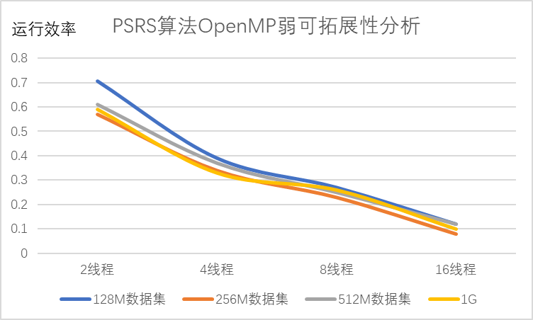

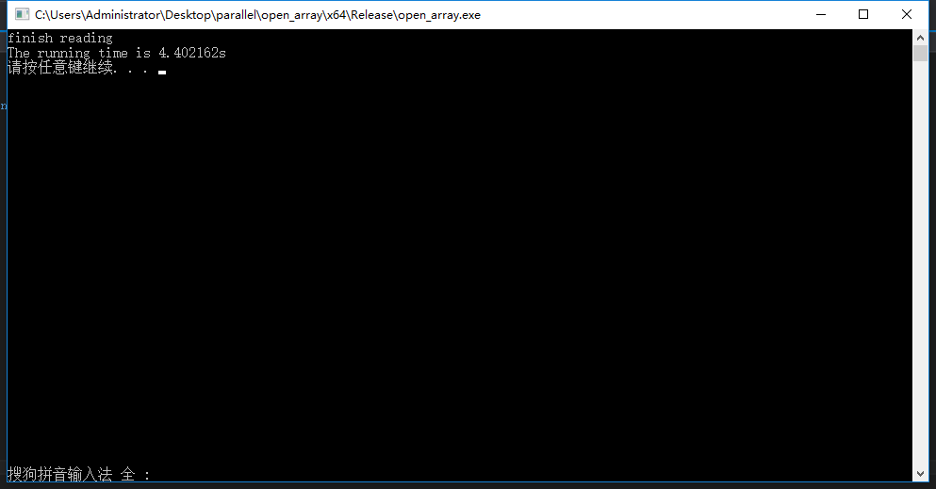
图 3-1

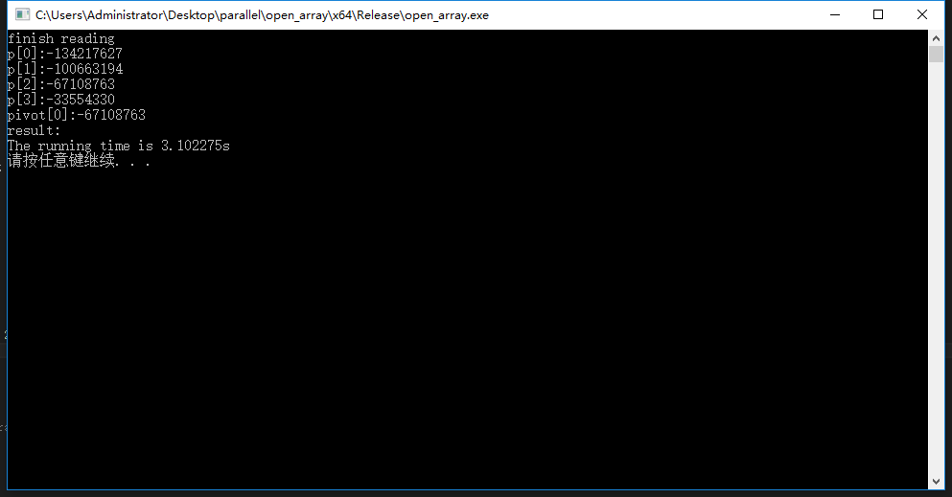
图 3-2

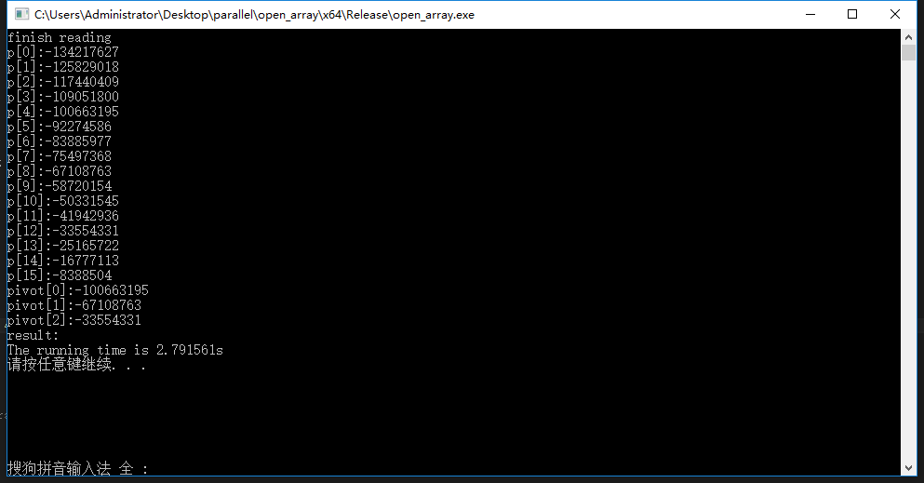
图 3-3

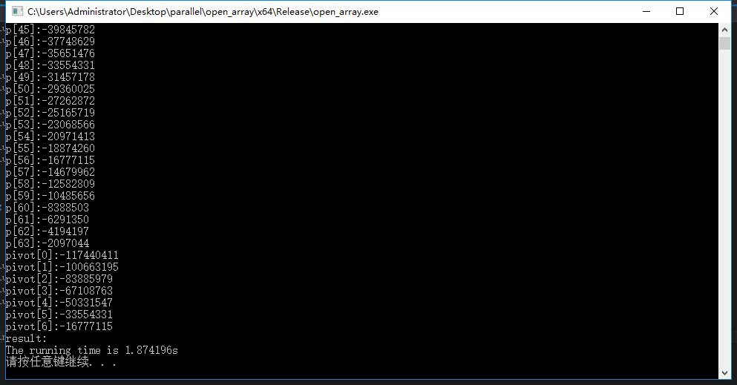
图 3-4

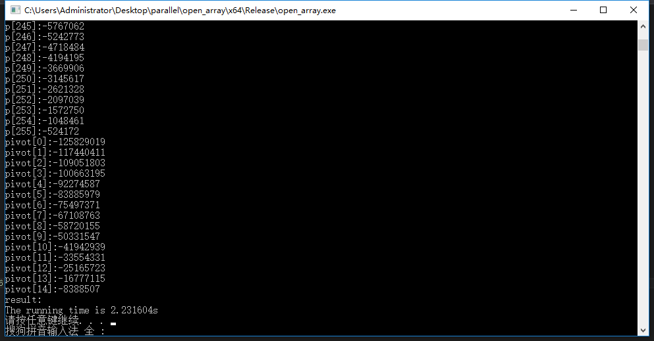
图 3-5

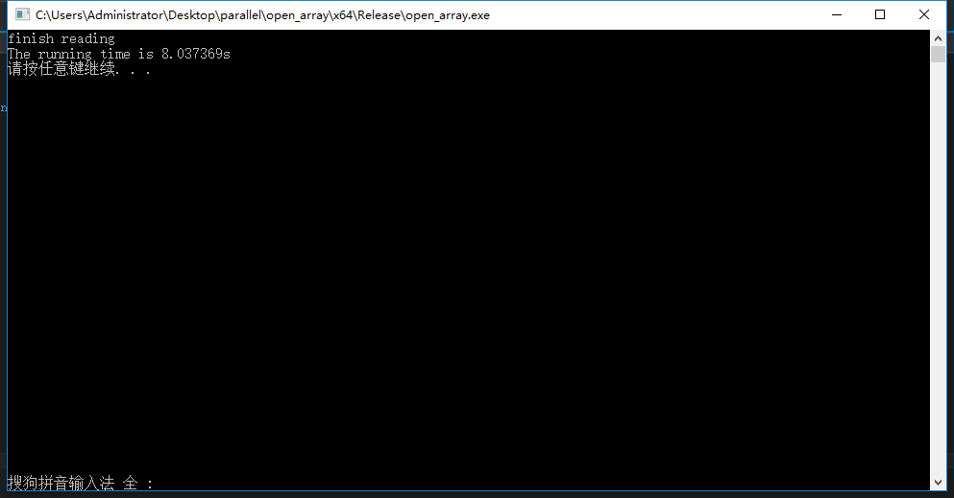
图 4-1

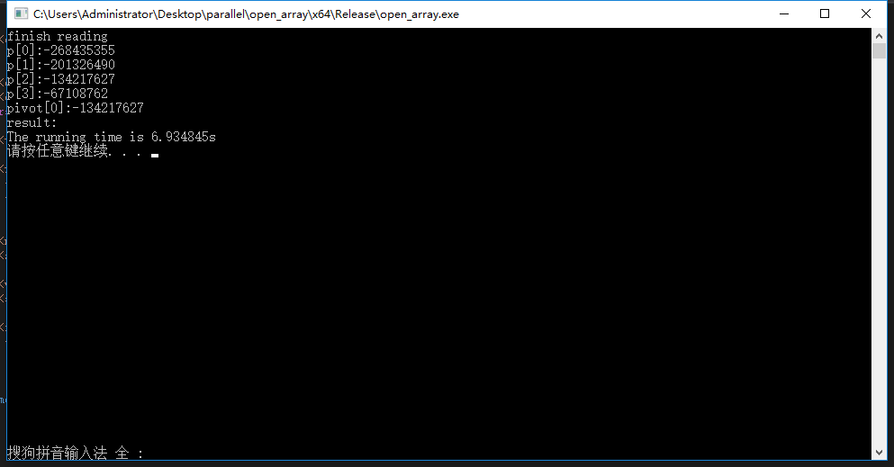
图 4-2

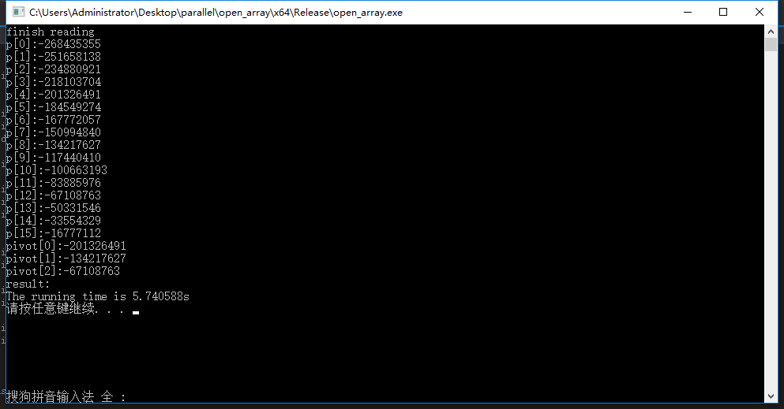
图 4-3
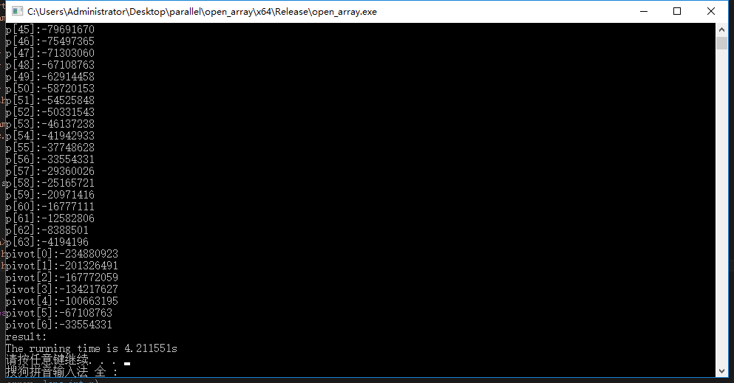
图 4-4

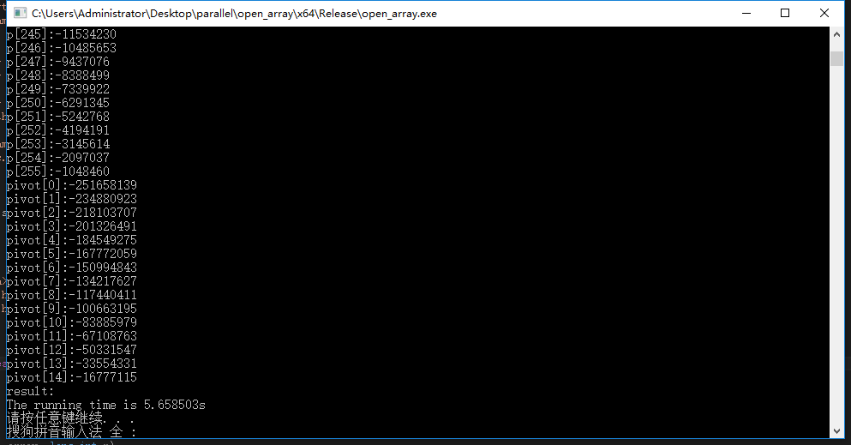
图 4-5

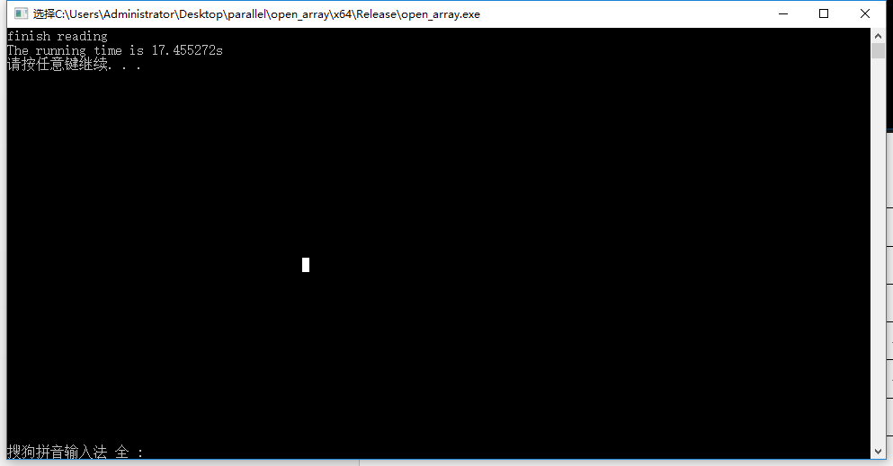
图 5-1

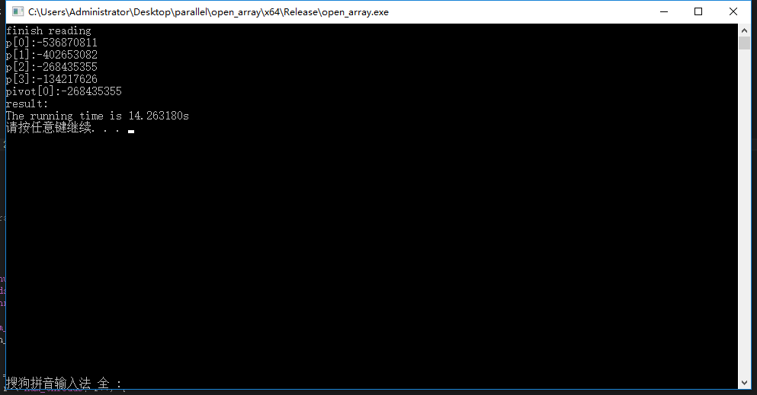
图 5-2

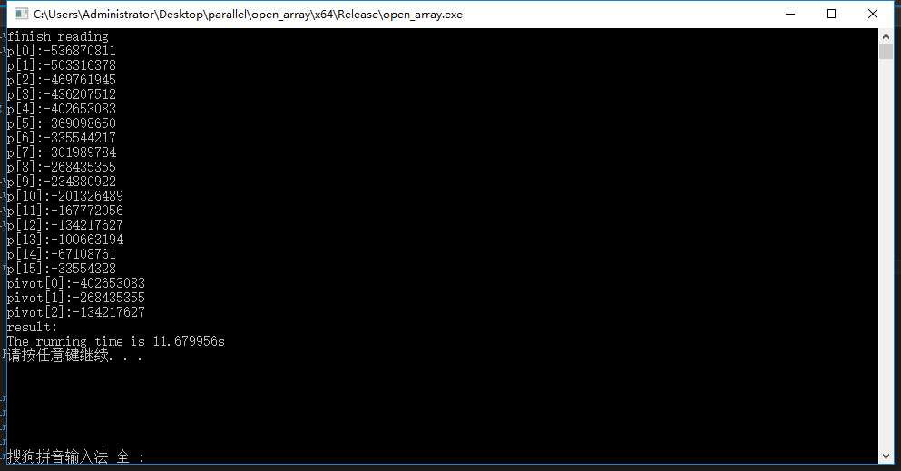
图 5-3

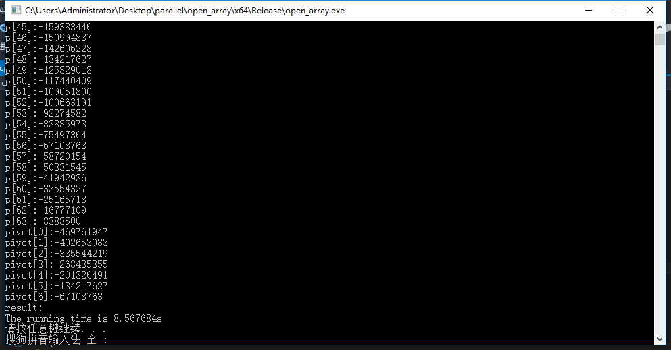
图 5-4

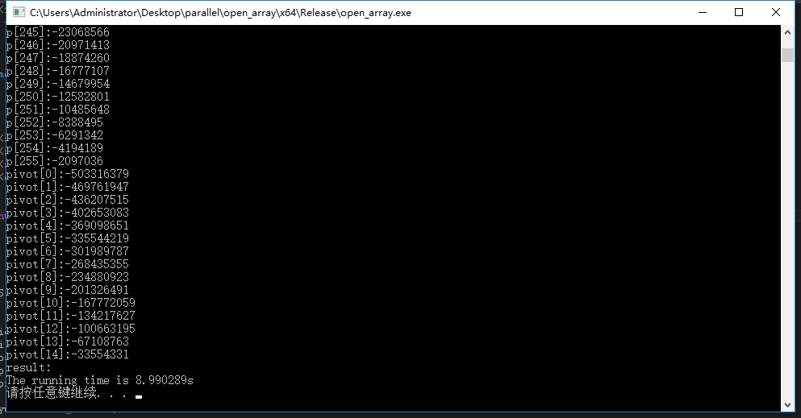
图 5-5

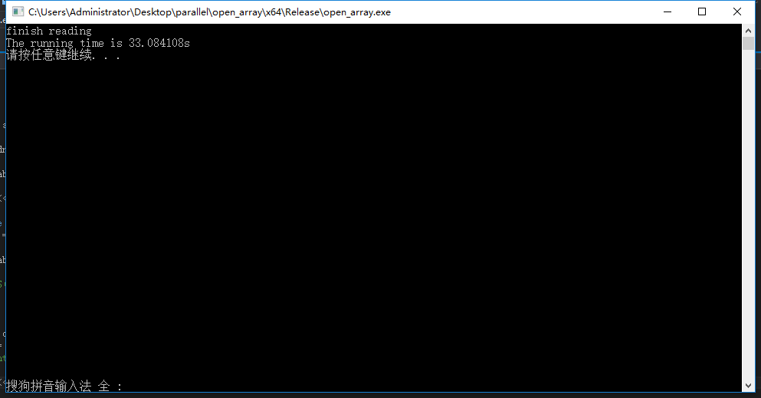
图 6-1

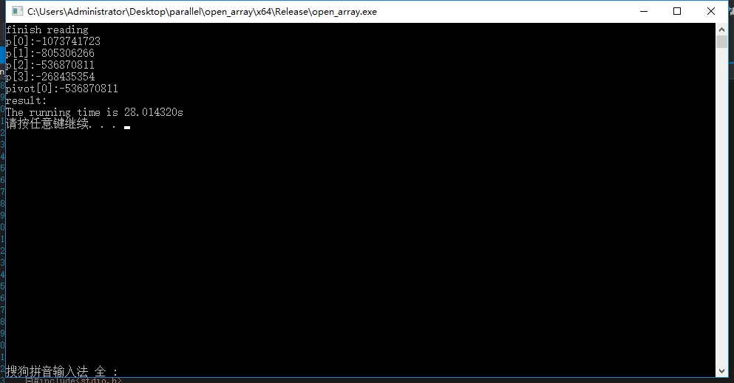
图 6-2

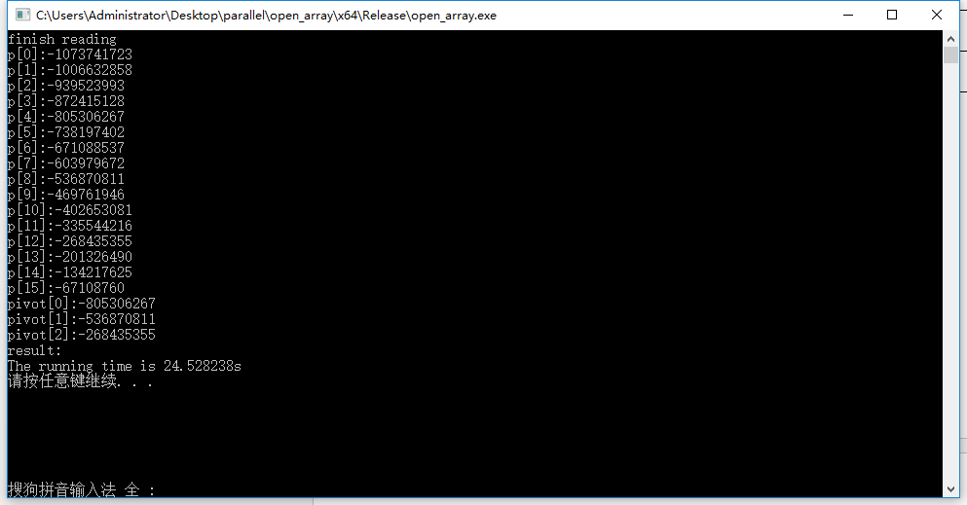
图 6-3

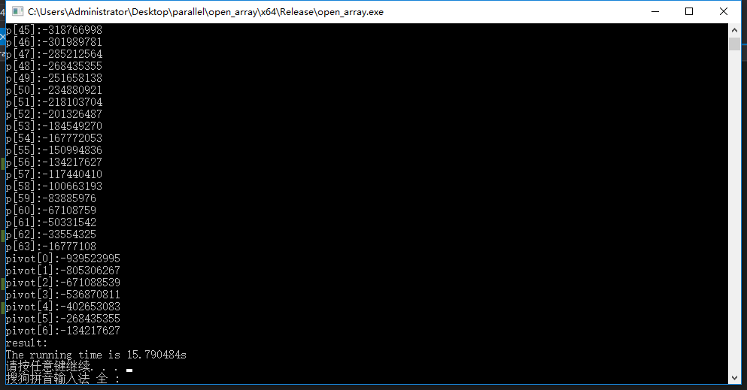
图 6-4

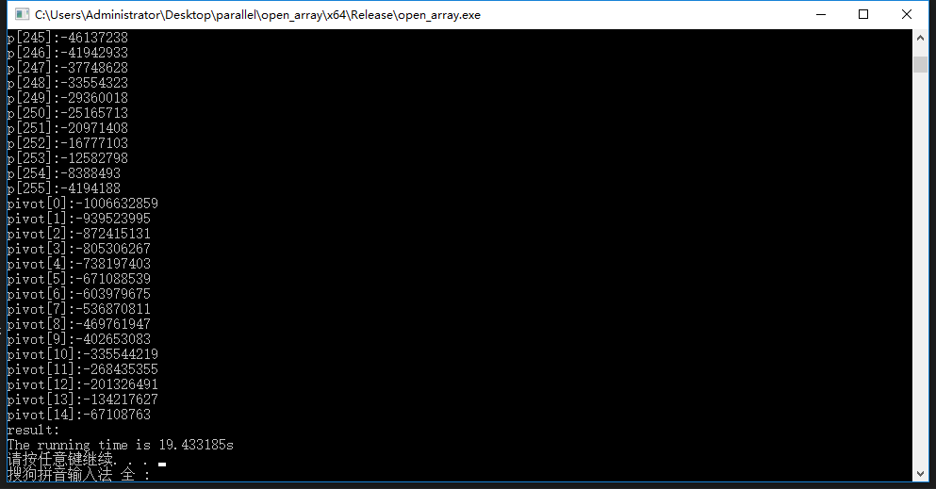
图 6-5

5、总结
本次实验采用OpenMP实现了矩阵-向量乘法、梯形积分法以及PSRS排序算法。OpenMP是用于共享内存并行系统的多处理器程序设计的一套指导性编译处理方案。OpenMP提供了对并行算法的高层的抽象描述，通过在源代码中加入专用的pragma来指明自己的并行意图，由此编译器可以自动将程序进行并行化，在必要时需要加入同步互斥以及通信。当选择忽略这些pragma，或者编译器不支持OpenMp时，程序又可退化为通常的程序(一般为串行)，代码仍然可以正常运作，只是不能利用多线程来加速程序执行。
本次实验由于个人电脑计算资源的限制，CPU为双核四线程处理器，因此在跑实验的过程中仅在2线程时效率最高，之后效率开始逐步下降，16线程时效率仅0.1左右，可以认为在提升计算资源的情况下，效率仍可进一步提升。

6、附件
Martrix-Vecter 乘法
#include "stdafx.h"
#include <stdio.h>
#include <stdlib.h>

//openmp 头文件
#include<omp.h>

//产生随机数的头文件
#include<cstdlib>
#include<ctime>
#define random(a,b) (rand()%(b-a+1)+a)

//计算时间的头文件
#include<time.h>

#include<iostream>
using namespace std;

void Get_dims(int* m_p, int* n_p);
void Read_matrix(char prompt[], double A[], int m, int n);
void Read_vector(char prompt[], double x[], int n);
void Print_matrix(char title[], double A[], int m, int n);
void Print_vector(char title[], double y[], int m);
void Mat_vect_mult(double A[], double x[], double y[], int m, int n);

/*-------------------------------------------------------------------
* Function: Get_dims
* Purpose: Read the dimensions of the matrix from stdin
* Out args: m_p: number of rows
* n_p: number of cols
*
* Errors: If one of the dimensions isn't positive, the program
* prints an error and quits
*/
void Get_dims(
int* m_p /* out */,
int* n_p /* out */) {
printf("Enter the number of rows\n");
scanf("%d", m_p);
printf("Enter the number of columns\n");
scanf("%d", n_p);

if (*m_p <= 0 || *n_p <= 0) {
fprintf(stderr, "m and n must be positive\n");
exit(-1);
}
} /* Get_dims */

/*-------------------------------------------------------------------
* Function: Read_matrix
* Purpose: Read the contents of the matrix from stdin
* In args: prompt: description of matrix
* m: number of rows
* n: number of cols
* Out arg: A: the matrix
*/
void Read_matrix(
char prompt[] /* in */,
double A[] /* out */,
int m /* in */,
int n /* in */) {
int i, j;

printf("Enter the matrix %s\n", prompt);
for (i = 0; i < m; i++) {

for (j = 0; j < n; j++) {

//scanf("%lf", &A[i*n + j]);
A[i*n + j] = random(1, 10);

}

}

} /* Read_matrix */

/*-------------------------------------------------------------------
* Function: Read_matrix
* Purpose: Read a vector from stdin
* In args: prompt: description of matrix
* n: order of matrix
* Out arg: x: the vector being read in
*/
void Read_vector(
char prompt[] /* in */,
double x[] /* out */,
int n /* in */) {
int i;

printf("Enter the vector %s\n", prompt);
for (i = 0; i < n; i++)
x[i] = random(1, 10);
//scanf("%lf", &x[i]);
} /* Read_vector */

/*-------------------------------------------------------------------
* Function: Print_matrix
* Purpose: Print a matrix to stdout
* In args: title: title for output
* A: the matrix
* m: number of rows
* n: number of cols
*/
void Print_matrix(
char title[] /* in */,
double A[] /* in */,
int m /* in */,
int n /* in */) {
int i, j;

printf("\nThe matrix %s\n", title);
for (i = 0; i < m; i++) {
for (j = 0; j < n; j++)
printf("%f ", A[i*n + j]);
printf("\n");
}
} /* Print_matrix */

/*-------------------------------------------------------------------
* Function: Print_vector
* Purpose: Print the contents of a vector to stdout
* In args: title: title for output
* y: the vector to be printed
* m: the number of elements in the vector
*/
void Print_vector(
char title[] /* in */,
double y[] /* in */,
int m /* in */) {
int i;

printf("\nThe vector %s\n", title);
for (i = 0; i < m; i++)
printf("%f ", y[i]);
printf("\n");
} /* Print_vector */

/*-------------------------------------------------------------------
* Function: Mat_vect_mult
* Purpose: Multiply a matrix by a vector
* In args: A: the matrix
* x: the vector being multiplied by A
* m: the number of rows in A and components in y
* n: the number of columns in A components in x
* Out args: y: the product vector Ax
*/
void Mat_vect_mult(
double A[] /* in */,
double x[] /* in */,
double y[] /* out */,
int m /* in */,
int n /* in */,
int count
) {

int i, j;

# pragma omp parallel for num_threads(count)
for (i = 0; i < m; i++) {
y[i] = 0.0;

# pragma omp parallel for num_threads(count)
//进行计算
for (j = 0; j < n; j++) {

y[i] += A[i*n + j] * x[j];

}

}

} /* Mat_vect_mult */

/*-------------------------------------------------------------------*/
int main(int argc, char **argv) {
double* A = NULL;
double* x = NULL;
double* y = NULL;

char ca[2] = "A";
char cx[2] = "x";
char cy[2] = "y";

int m, n;

int thread_count ;
cout << "Enter thread_count:" << endl;
cin >> thread_count;

Get_dims(&m, &n);
A = (double*)malloc(m*n * sizeof(double));
x = (double*)malloc(n * sizeof(double));
y = (double*)malloc(m * sizeof(double));

//A = new double[m*n];
//x = new double[n];
//y = new double[m];

if (A == NULL || x == NULL || y == NULL) {
fprintf(stderr, "Can't allocate storage\n");
exit(-1);
}
Read_matrix( ca, A, m, n);
//# ifdef DEBUG
//Print_matrix(ca, A, m, n);
//# endif
Read_vector(cx, x, n);
//# ifdef DEBUG
//Print_vector(cx, x, n);
//# endif

cout << "begin cal";
cout << endl;

clock_t startTime, endTime;
startTime = clock();

Mat_vect_mult(A, x, y, m, n,thread_count);

endTime = clock();
cout << "Totle Time : " << (double)(endTime - startTime) / CLOCKS_PER_SEC << "s" << endl;

//Print_vector(cy, y, m);

cout << "finish";

free(A);
free(x);
free(y);

system("pause");
return 0;
} /* main */

梯形积分法
#include "stdafx.h"
#include <stdio.h>
#include <stdlib.h>

//openmp 头文件
#include<omp.h>

//产生随机数的头文件
#include<cstdlib>
#include<ctime>
#define random(a,b) (rand()%(b-a+1)+a)

//计算时间的头文件
#include<time.h>

#include<iostream>
using namespace std;

double f(double x); /* Function we're integrating */
double Trap(double a, double b, int n, double h, int thread_count);

int main(void) {
double integral; /* Store result in integral */
double a, b; /* Left and right endpoints */
int n; /* Number of trapezoids */
double h; /* Height of trapezoids */

int thread_count;

cout << "Enter thread_count:" << endl;
cin >> thread_count;

printf("Enter a, b, and n\n");
scanf("%lf", &a);
scanf("%lf", &b);
scanf("%d", &n);

h = (b - a) / n;

double s = omp_get_wtime();
clock_t startTime, endTime;
startTime = clock();

integral = Trap(a, b, n, h, thread_count);

double e = omp_get_wtime();
endTime = clock();
//cout << "Totle Time : " << (double)(endTime - startTime) / CLOCKS_PER_SEC << "s" << endl;
cout << "Totle Time : " << e - s << endl;

printf("With n = %d trapezoids, our estimate\n", n);
printf("of the integral from %f to %f = %.15f\n",
a, b, integral);

system("pause");
return 0;
} /* main */

/*------------------------------------------------------------------
* Function: Trap
* Purpose: Estimate integral from a to b of f using trap rule and
* n trapezoids
* Input args: a, b, n, h
* Return val: Estimate of the integral
*/
double Trap(double a, double b, int n, double h,int thread_count) {
double integral;
int k;

integral = (f(a) + f(b)) / 2.0;

#pragma omp parallel for num_threads(thread_count) reduction(+:integral)
for (k = 1; k <= n - 1; k++) {

//cout << "thread num:" << omp_get_thread_num()<<endl;
integral += f(a + k * h);
}

integral = integral * h;

return integral;
} /* Trap */

/*------------------------------------------------------------------
* Function: f
* Purpose: Compute value of function to be integrated
* Input args: x
*/
double f(double x) {
double return_val;

return_val = x * x;
return return_val;
} /* f */

PSRS算法
#include<cstdlib>
#include<ctime>
#define random(a,b) (rand()%(b-a+1)+a)
#include<time.h>
#include<fstream>
#include <cassert>
#include <sstream>
#include<math.h>
#include<string>
#include<vector>
#include<algorithm>
#include<iostream>
#include <malloc.h>
#include<stdio.h>
#include<string.h>
#include<stdlib.h>
#include<omp.h>

#define num_threads 16

using namespace std;

void PSRS(int *& array, long int n)
{

int id;
int i = 0;
int base = n / num_threads;
int p[num_threads*num_threads];
int pivot[num_threads - 1];

int yu = n % num_threads;
int last_section_num = base + yu;

int * pivot_num = new int[num_threads];
for (int r = 0; r < num_threads; r++) {
pivot_num[r] = 0;
}
int** pivot2 = new int*[num_threads];
int count[num_threads] = { 0 };

omp_set_num_threads(num_threads);

#pragma omp parallel shared(base,n,i,p,pivot,array,count,pivot2) private(id)
{
id = omp_get_thread_num();

if (id != num_threads - 1)
sort(array + id * base, array + (id + 1)*base);
else
sort(array + id * base, array + id * base + last_section_num);

#pragma omp critical
{
for (int k = 0; k < num_threads; k++) {
p[i++] = array[id *base + k*(base / num_threads + 1)];
}

}

#pragma omp barrier
#pragma omp master
{
sort(p, p + i);
for (int m = 0; m < num_threads - 1; m++) {
pivot[m] = p[(m + 1)*num_threads];
}
}

#pragma omp master
{
for (int m = 0; m < num_threads*num_threads; m++) {
cout << "p[" + to_string(m) + "]:" + to_string(p[m]) << endl;
}

for (int m = 0; m < num_threads - 1; m++) {
cout << "pivot[" + to_string(m) + "]:" + to_string(pivot[m]) << endl;
}
}

#pragma omp barrier

if (id != num_threads - 1)
for (int k = 0; k<base; k++)
{
for (int m = 0; m<num_threads - 1; m++)
{
if (array[id*base + k] <= pivot[m])
{
pivot_num[id] = pivot_num[id] + 1;
break;
}

if (array[id*base + k] > pivot[m] && m == num_threads - 2) {
pivot_num[id] = pivot_num[id] + 1;
}
}
}
else
for (int k = 0; k<last_section_num; k++)
{
for (int m = 0; m<num_threads - 1; m++)
{
if (array[id*base + k] <= pivot[m])
{
pivot_num[id] = pivot_num[id] + 1;
break;
}

if (array[id*base + k] > pivot[m] && m == num_threads - 2) {
pivot_num[id] = pivot_num[id] + 1;
}
}
}

#pragma omp barrier

pivot2[id] = (int *)malloc(pivot_num[id] * sizeof(int));

pivot2[id][0] = 0;

#pragma omp barrier
if (id != num_threads - 1)
for (int k = 0; k<base; k++)
{
for (int m = 0; m<num_threads - 1; m++)
{
if (array[id*base + k] <= pivot[m])
{
pivot2[id][count[id]++] = array[id*base + k];
break;
}

if (array[id*base + k] > pivot[m] && m == num_threads - 2) {
pivot2[id][count[id]++] = array[id*base + k];
}
}
}
else
for (int k = 0; k<last_section_num; k++)
{
for (int m = 0; m<num_threads - 1; m++)
{
if (array[id*base + k] <= pivot[m])
{
pivot2[id][count[id]++] = array[id*base + k];
break;
}

if (array[id*base + k] > pivot[m] && m == num_threads - 2) {
pivot2[id][count[id]++] = array[id*base + k];
}
}
}

}

#pragma omp parallel shared(pivot2,pivot_num,count) private(id)
{
int id = omp_get_thread_num();

sort(pivot2[id], pivot2[id] + pivot_num[id]);

int start_position = 0;
for (int i = 0; i < id + 1; i++) {

if (i == 0)
start_position = 0;
else
start_position = start_position + pivot_num[i-1];
}

for (int i = 0; i < pivot_num[id]; i++) {
array[start_position + i] = pivot2[id][i];
}

}

i = 0;
printf("result:\n");

}

void read(int * &buffer, long size) {

ifstream infile;
infile.open("./data1024M.txt", ios::binary);
if (!infile.is_open()) {
cout << "error\n";
exit(0);
}
buffer = (int *)malloc(size*sizeof(int));

infile.read((char*)buffer, sizeof(int)*size);
infile.close();

}

int main()
{

int * abrray;

long dnum = pow(2, 20) * 1024;

read(abrray, pow(2, 20) * 1024); // pow(2, 20) * 256

cout << "finish reading" << endl;

double begin, end, time;
begin = omp_get_wtime();

PSRS(abrray, pow(2, 20) * 1024);

end = omp_get_wtime();
time = end - begin;
printf("The running time is %lfs\n", time);

system("pause");
return 0;
}

