《并行程序设计》
实验报告

学号：
姓名：
班级：

2018/5/6

华南理工大学本科实验报告
课程名称 并行程序设计 成绩评定
实验项目名称MPI环境配置及实现所给算法的MPI并行化 指导教师 汤德佑 实验地点 B7-233
学生姓名 学号
学院 软件学院 系 软件工程 专业 软件工程
实验时间 2018 年 5 月 6 日 下 午～ 5 月 6 日 下 午
1、实验目标
（1）利用visual studio配置MPI环境；
（2）对以下算法利用MPI实现并行化。
i. Martrix-Vecter 乘法;
ii梯形积分法;
iii PSRS排序

2、串行程序代码(串行程序已经放在网络教学平台，请把主要代码部分摘抄在下面)
Martrix-Vecter 乘法
#include <stdio.h>
#include <stdlib.h>

void Get_dims(int* m_p, int* n_p);
void Read_matrix(char prompt[], double A[], int m, int n);
void Read_vector(char prompt [], double x[], int n);
void Print_matrix(char title[], double A[], int m, int n);
void Print_vector(char title[], double y[], int m);
void Mat_vect_mult(double A[], double x[], double y[], int m, int n);

/*-------------------------------------------------------------------*/
int main(void) {
double* A = NULL;
double* x = NULL;
double* y = NULL;
int m, n;

Get_dims(&m, &n);
A = malloc(m*n*sizeof(double));
x = malloc(n*sizeof(double));
y = malloc(m*sizeof(double));
if (A == NULL || x == NULL || y == NULL) {
fprintf(stderr, "Can't allocate storage\n");
exit(-1);
}
Read_matrix("A", A, m, n);
# ifdef DEBUG
Print_matrix("A", A, m, n);
# endif
Read_vector("x", x, n);
# ifdef DEBUG
Print_vector("x", x, n);
# endif

Mat_vect_mult(A, x, y, m, n);

Print_vector("y", y, m);

free(A);
free(x);
free(y);
return 0;
} /* main */

void Get_dims(
int* m_p /* out */,
int* n_p /* out */) {
printf("Enter the number of rows\n");
scanf("%d", m_p);
printf("Enter the number of columns\n");
scanf("%d", n_p);

if (*m_p <= 0 || *n_p <= 0) {
fprintf(stderr, "m and n must be positive\n");
exit(-1);
}
} /* Get_dims */

void Read_matrix(
char prompt[] /* in */,
double A[] /* out */,
int m /* in */,
int n /* in */) {
int i, j;

printf("Enter the matrix %s\n", prompt);
for (i = 0; i < m; i++)
for (j = 0; j < n; j++)
scanf("%lf", &A[i*n+j]);
} /* Read_matrix */

void Read_vector(
char prompt[] /* in */,
double x[] /* out */,
int n /* in */) {
int i;

printf("Enter the vector %s\n", prompt);
for (i = 0; i < n; i++)
scanf("%lf", &x[i]);
} /* Read_vector */

void Print_matrix(
char title[] /* in */,
double A[] /* in */,
int m /* in */,
int n /* in */) {
int i, j;

printf("\nThe matrix %s\n", title);
for (i = 0; i < m; i++) {
for (j = 0; j < n; j++)
printf("%f ", A[i*n+j]);
printf("\n");
}
} /* Print_matrix */

void Print_vector(
char title[] /* in */,
double y[] /* in */,
int m /* in */) {
int i;

printf("\nThe vector %s\n", title);
for (i = 0; i < m; i++)
printf("%f ", y[i]);
printf("\n");
}

void Mat_vect_mult(
double A[] /* in */,
double x[] /* in */,
double y[] /* out */,
int m /* in */,
int n /* in */) {
int i, j;

for (i = 0; i < m; i++) {
y[i] = 0.0;
for (j = 0; j < n; j++)
y[i] += A[i*n+j]*x[j];
}
}

梯形积分法
#include <stdio.h>

double f(double x); /* Function we're integrating */
double Trap(double a, double b, int n, double h);

int main(void) {
double integral; /* Store result in integral */
double a, b; /* Left and right endpoints */
int n; /* Number of trapezoids */
double h; /* Height of trapezoids */

printf("Enter a, b, and n\n");
scanf("%lf", &a);
scanf("%lf", &b);
scanf("%d", &n);

h = (b-a)/n;
integral = Trap(a, b, n, h);

printf("With n = %d trapezoids, our estimate\n", n);
printf("of the integral from %f to %f = %.15f\n",
a, b, integral);

return 0;
}

double Trap(double a, double b, int n, double h) {
double integral;
int k;

integral = (f(a) + f(b))/2.0;
for (k = 1; k <= n-1; k++) {
integral += f(a+k*h);
}
integral = integral*h;

return integral;
}

double f(double x) {
double return_val;

return_val = x*x;
return return_val;
}

PSRS算法
由于PSRS没有单进程的方式，因此在使用单进程排序时(即假设只有一个主机)，使用的为STL库内的sort函数。

3、并行程序关键代码
Martrix-Vecter 乘法

使用MPI进行矩阵-向量乘法的关键点在于将矩阵按行进行分块划分，即将矩阵分成若干小矩阵，然后将每个小矩阵分发给不同的进程，不同的进程对每一个小矩阵做向量乘法，最后将结果汇聚到主进程，从而提升运算速度。

int main(int argc, char *argv[]) {

int myid, numprocs;
MPI_Init(NULL, NULL);
MPI_Comm_rank(MPI_COMM_WORLD, &myid);
MPI_Comm_size(MPI_COMM_WORLD, &numprocs);

double* A = NULL;
double* x = NULL;
//double* y = NULL;

char ca[2] = "A";
char cx[2] = "x";
char cy[2] = "y";

//int* m[1], n[1];
int * m = new int[1];
int * n = new int[1];

//int* section_num[1];
//int* last_sectionnum[1];
int * section_num = new int[1];
int * last_sectionnum = new int[1];

double * result=NULL;
double * local_result;
int local_i = 0;

double start_time = 0;
double end_time = 0;
double diff_time = 0;
double total_time = 0;

if (myid == 0) {

m[0] = 10000; // atoi(argv[1]);
n[0] = 10000; //atoi(argv[2]);

section_num[0] = m[0] / numprocs;
last_sectionnum[0] = section_num[0] + m[0] % numprocs;

result = new double[m[0]];

}

MPI_Bcast(m, 1, MPI_INT, 0, MPI_COMM_WORLD);
MPI_Bcast(n, 1, MPI_INT, 0, MPI_COMM_WORLD);
MPI_Bcast(section_num, 1, MPI_INT, 0, MPI_COMM_WORLD);
MPI_Bcast(last_sectionnum, 1, MPI_INT, 0, MPI_COMM_WORLD);

A = new double[m[0] * n[0]];
x = new double[n[0]];

if (A == NULL || x == NULL) {
fprintf(stderr, "Can't allocate storage\n");
exit(-1);
}
if (myid != numprocs - 1) {
local_result = new double[section_num[0]];
}
else {
local_result = new double[last_sectionnum[0]];
}

if (myid == 0) {
Read_matrix(ca, A, m[0], n[0]);
Read_vector(cx, x, n[0]);

}

MPI_Bcast(A, m[0] * n[0], MPI_DOUBLE, 0, MPI_COMM_WORLD);
MPI_Bcast(x, n[0], MPI_DOUBLE, 0, MPI_COMM_WORLD);

start_time = MPI_Wtime();

if (myid != numprocs - 1)
{

for (int i = myid*section_num[0]; i<myid*section_num[0] + section_num[0]; i++) {
local_result[local_i] = 0;
for (int j = 0; j<n[0]; j++) {
local_result[local_i] = local_result[local_i] + A[i*n[0] + j] * x[j];
}
local_i++;
}

}
else {

for (int i = myid*section_num[0]; i<myid*section_num[0] + last_sectionnum[0]; i++) {
local_result[local_i] = 0;
for (int j = 0; j<n[0]; j++) {
local_result[local_i] = local_result[local_i] + A[i*n[0] + j] * x[j];
}
local_i++;
}

}

end_time = MPI_Wtime();
diff_time = end_time - start_time;

MPI_Gather(local_result, section_num[0], MPI_DOUBLE, result, section_num[0], MPI_DOUBLE, 0, MPI_COMM_WORLD);

if (myid == 0) {
cout << "total time is " << diff_time << " s" << endl;
}

free(A);
free(x);
free(local_result);

MPI_Finalize();

system("pause");
return 0;
}

梯形积分法

使用MPI实现梯形积分法的关键在于计算单个梯形的面积以及梯形面积的求和，划分的梯形的数量远大于进程的数量，通过给不同的进程分发连续的梯形块，之后每个进程对其子区间简单地用串行梯形积分法，最后再把结果汇聚到主进程进行累加。

int main() {

int my_rank, comm_sz, n = 10000000000, local_n;
double a = 1.0, b = 1000.0, h, local_a, local_b;
double local_int, total_int;
int source;

double start_time;
double end_time;
double total_time;

MPI_Init(NULL, NULL);
MPI_Comm_rank(MPI_COMM_WORLD, &my_rank);
MPI_Comm_size(MPI_COMM_WORLD, &comm_sz);

start_time = MPI_Wtime();

h = (b - a) / n;
local_n = n / comm_sz;

local_a = a + my_rank*local_n*h;
local_b = local_a + local_n*h;
local_int = Trap(local_a, local_b, local_n, h);

if (my_rank != 0) {

MPI_Send(&local_int, 1, MPI_DOUBLE, 0, 0, MPI_COMM_WORLD);

}
else {
total_int = local_int;
for (source = 1; source < comm_sz; source++) {
MPI_Recv(&local_int, 1, MPI_DOUBLE, source, 0, MPI_COMM_WORLD, MPI_STATUS_IGNORE);
total_int += local_int;
}

}

end_time = MPI_Wtime();

if (my_rank == 0) {
cout << "Total time is " << end_time - start_time << " s" << endl;
}

cout << "With n = " + to_string(n) + " trapezoids, our estimate of the integral from " + to_string(a) + " to " + to_string(b) + " = " + to_string(total_int) + "\r\n";

MPI_Finalize();

//system("pause");
return 0;

}

PSRS算法

使用MPI实现PSRS算法的关键思路在于，首先主进程读入数据，然后给每个进程分发数组的一部分进行局部排序，之后每个进程随机采样，然后汇聚到主进程选出主元，在每个进程上新分配一块区域用来保存即将被局部交换的数据，之后每个进程对自己负责的那部分数据，参考选出的主元进行局部交换，利用MPI的函数进行分发，局部交换完成后进行排序，这样每个进程就获得了排好序的一部分数组，按照顺序进行访问就能获得完整的排序后的数组。

int main(int argc, char *argv[]) {

int myid, numprocs;
MPI_Init(NULL, NULL);
MPI_Comm_rank(MPI_COMM_WORLD, &myid);
MPI_Comm_size(MPI_COMM_WORLD, &numprocs);

int * data = NULL; //store the global data
int data_per_node = data_num / numprocs;//the number of data for each node to process

//int * local_data = new int[data_per_node]; //store the local data, after partition
int * local_data = (int*)malloc(data_per_node*sizeof(int));

//int * local_sample = new int[numprocs]; //store the local sample
int * local_sample = (int*)malloc(numprocs*sizeof(int));
int count = 0;

//int * root_sample = new int[numprocs*numprocs];
int * root_sample = (int*)malloc(numprocs*numprocs*sizeof(int));

int * pivot = new int[numprocs - 1];

int * local_partion_num = new int[numprocs];
for (int i = 0; i<numprocs; i++) {
local_partion_num[i] = 0;
}
int * local_partion_num_all = new int[numprocs*numprocs];
// for(int i=0;i<numprocs;i++){
// local_partion_num_matrix[i]= new int[numprocs];
// // for(int j=0;j<numprocs;j++){
// // local_partion_num_matrix[i][j] = 0;
// // }
// }

//store the number of data each compute node should process
int* local_partion_num_sum = new int[1];

//store the location of each pivot in each compute node
int* local_partition_location = new int[numprocs];
for (int i = 0; i<numprocs; i++) {
local_partition_location[i] = 0;
}
int * local_partition_location_all = new int[numprocs*numprocs];

int * after_partition_data;

//read data
if (myid == 0) {

//data = new int[data_num];
//data = (int*)malloc(data_num*sizeof(int));

//read data
read(data, data_num);

// for(int i=0;i<data_num;i++){
// cout<<data[i]<<" ";
// if(i%10 == 0)
// cout<<endl;
// }
}

double start_time = MPI_Wtime();

//scatter the data to each compute node
MPI_Scatter(data, data_per_node, MPI_INT, local_data, data_per_node, MPI_INT, 0, MPI_COMM_WORLD);

//sort the local data for each node
sort(local_data, local_data + data_per_node);

//sample
for (int i = 0; i<numprocs; i++) {
//cout<<"myid "+ to_string(myid) +" local sample:" + to_string( local_data[ i * (data_per_node / (numprocs + 1)) ] ) +"\r\n";
local_sample[i] = local_data[i * (data_per_node / (numprocs + 1))];
}

//gather the sample
MPI_Gather(local_sample, numprocs, MPI_INT, root_sample, numprocs, MPI_INT, 0, MPI_COMM_WORLD);

//sort the sample in the root and pick the pivot
if (myid == 0) {

//sort the local sample
sort(root_sample, root_sample + numprocs*numprocs);

//select the pivot
for (int i = 0; i<numprocs - 1; i++) {
pivot[i] = root_sample[(i + 1)*(numprocs + 1)];

cout << "myid " + to_string(myid) + " pivot:" + to_string( pivot[i] ) + "\r\n";
}

}

//broadcast the pivot to all compute node
MPI_Bcast(pivot, numprocs - 1, MPI_INT, 0, MPI_COMM_WORLD);

//traverse the local_data and record the number for each partition
for (int i = 0; i<data_per_node; i++) {

//record the number for each partition
for (int j = 0; j<numprocs - 1; j++) {

//record the partition location
// if(local_data[i]<=pivot[j] && local_data[i+1]>pivot[j]){
// //cout<<"local_data[i] "<<local_data[i]<<" local_data[i+1] "<< local_data[i+1] <<" pivot "<<pivot[j]<<endl;
// // if(j == 0){
// // local_partition_location[j] = i;
// // }
// // else{
// // local_partition_location[j] = i - local_partition_location[j-1];
// // if(j == numprocs-2){
// // local_partition_location[j+1] = data_per_node-i;
// // }
// // }
// local_partition_location[j+1] = i;
// }

if (local_data[i]<pivot[j]) {
local_partion_num[j] = local_partion_num[j] + 1;
break;
}

if (local_data[i] >= pivot[j] && j == numprocs - 2) {
local_partion_num[j + 1] = local_partion_num[j + 1] + 1;
break;
}

}

}

int ** local_partition_data = new int*[numprocs];
//do the copy
//1.allocat the space
for (int i = 0; i<numprocs; i++) {
//local_partition_data[i] = new int[local_partion_num[i]];
local_partition_data[i] = (int*)malloc(local_partion_num[i] *sizeof(int));
}
//2.do the copy
int * local_count = new int[numprocs];
for (int i = 0; i<numprocs; i++) {
local_count[i] = 0;
}
for (int i = 0; i<data_per_node; i++) {

for (int j = 0; j<numprocs - 1; j++) {

if (local_data[i]<pivot[j]) {
local_partition_data[j][local_count[j]++] = local_data[i];
// local_partition_data[ local_count[j]++ ] = 100;
// memcpy(local_partition_data[][ local_count[j]++ ],local_data[i],sizeof(int));
break;
}

if (local_data[i] >= pivot[j] && j == numprocs - 2) {
local_partition_data[j + 1][local_count[j + 1]++] = local_data[i];
break;
}

}

}

//reduce the num the each compute node
for (int i = 0; i<numprocs; i++) {
MPI_Reduce(local_partion_num + i, local_partion_num_sum, 1, MPI_INT, MPI_SUM, i, MPI_COMM_WORLD);
}
// for(int i=0;i<numprocs;i++){
// MPI_Reduce(local_partion_num[myid]+i,local_partion_num_sum,1,MPI_INT,MPI_SUM,i,MPI_COMM_WORLD);
// }

//each compute node store all the partition situation
for (int i = 0; i<numprocs; i++) {
MPI_Gather(local_partion_num, numprocs, MPI_INT, local_partion_num_all, numprocs, MPI_INT, i, MPI_COMM_WORLD);
}

// for(int i=0;i<numprocs;i++){
// MPI_Gather(local_partition_location,numprocs,MPI_INT,local_partition_location_all,numprocs,MPI_INT,i,MPI_COMM_WORLD);
// }

//allocat the space for the local partition data
after_partition_data = new int[local_partion_num_sum[0]];

//do the partition
for (int i = 0; i<numprocs; i++) {

//1.construct the parameter
int * reccount = new int[numprocs];
for (int j = 0; j<numprocs; j++) {
reccount[j] = local_partion_num_all[i + j*numprocs];
}
int * displs = new int[numprocs];
for (int j = 0; j<numprocs; j++) {
if (j == 0)
displs[j] = 0;
else
displs[j] = displs[j - 1] + reccount[j - 1];
}

//2.send the data
MPI_Gatherv(local_partition_data[i], local_partion_num[i], MPI_INT, after_partition_data, reccount, displs, MPI_INT, i, MPI_COMM_WORLD);
}

sort(after_partition_data, after_partition_data + local_partion_num_sum[0]);

// cout<<" myid"<<myid<<endl;
// for(int i=0;i<local_partion_num_sum[0];i++){
// cout<<after_partition_data[i]<<" ";
// }
// cout<<endl;

// for(int i=0;i<numprocs;i++){
// cout<<" myid"<<myid<<" "<<local_partion_num[i]<<endl;
// }

// cout<<" myid"<<myid<<endl;
// for(int i=0;i<numprocs*numprocs;i++){

// cout<<local_partition_location_all[i]<<" ";
// }
// cout<<endl;

//cout<<" myid"<<myid<<" local_partion_num_sum:"<<local_partion_num_sum[0]<<endl;

// cout<<" myid"<<myid<<endl;
// for(int i=0;i<numprocs*numprocs;i++){

// cout<<local_partion_num_all[i]<<" ";
// }
// cout<<endl;

// for(int i=0;i<numprocs;i++){
// cout<<" myid"<<myid<<" "<<local_partition_location[i];
// }cout<<endl;

// for(int i=0;i<numprocs;i++){
// cout<<" myid"<<myid<<" "<<i<<" "<<local_partion_num[myid][i]<<endl;
// }

// if(myid == 0){
// for(int i=0;i<numprocs*numprocs;i++){
// //cout<<data_per_node<<endl;
// cout<<" myid"<<myid<<" "<<root_sample[i]<<endl;
// }
// }

//cout the pivot
// for(int i=0;i<numprocs-1;i++){
// cout<<" myid"<<myid<<" pivot:"<<pivot[i]<<endl;
// }

double end_time = MPI_Wtime();
double diff_time = end_time - start_time;

MPI_Barrier(MPI_COMM_WORLD);
if (myid == 0) {
//cout<<"total time is "<<total_time[0]<<" s"<<endl;
cout << "total time is " << diff_time << " s" << endl;
}

MPI_Finalize();
return 0;
}

4、性能分析
Martrix-Vecter 乘法
使用的矩阵大小为10000*10000
线程数 | 1 | 2 | 4 | 8 | 16
时间(s) | 0.246441 | 0.121464 | 0.0651697 | 0.0399847 | 0.0229015
截图编号 | 图 1-1 | 图 1-2 | 图 1-3 | 图 1-4 | 图 1-5

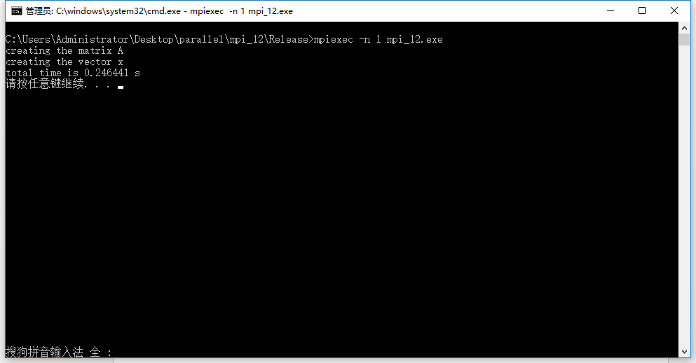
图 1-1

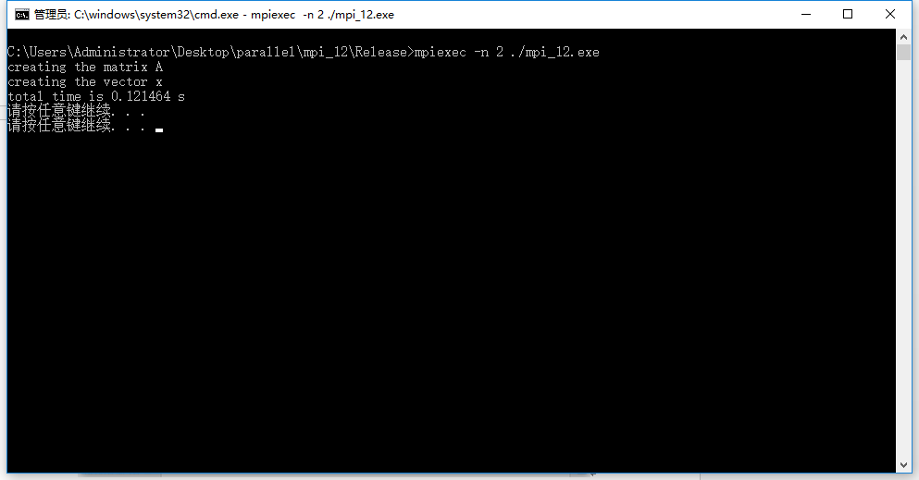
图 1-2

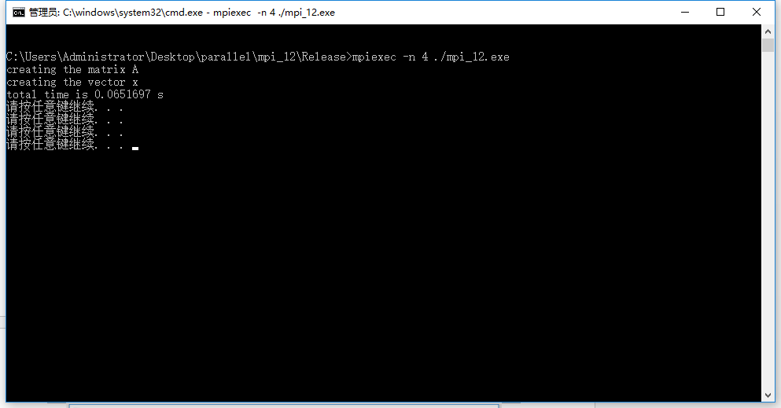
图 1-3

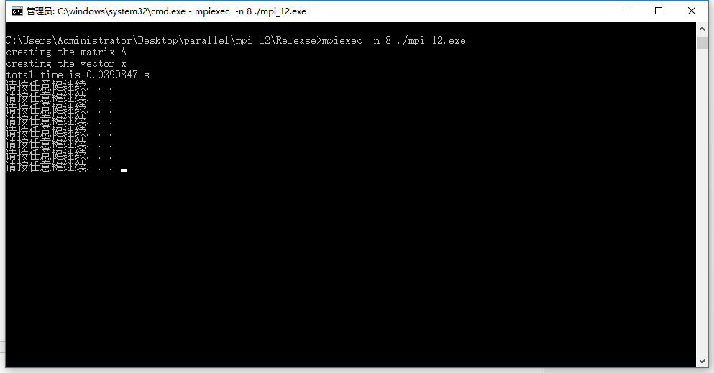
图 1-4

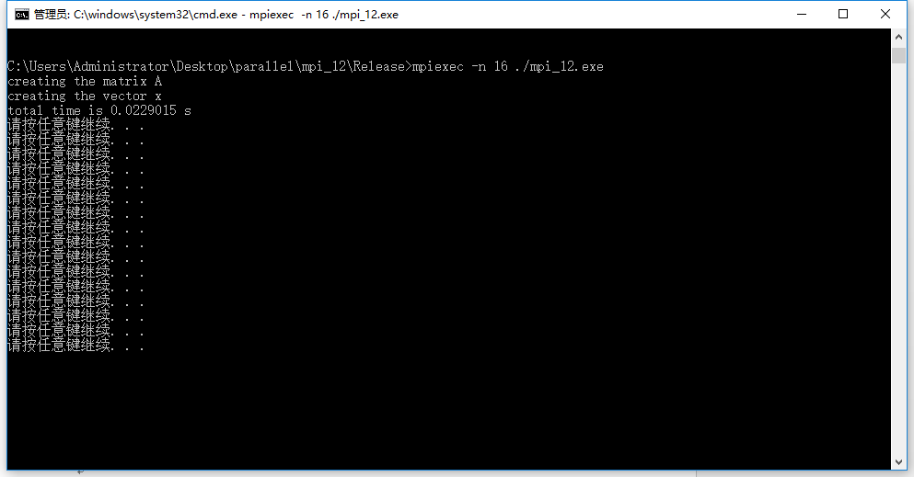
图 1-5

梯形积分法
a=1,b=1000,n= 1000000000
线程数 | 1 | 2 | 4 | 8 | 16
时间(s) | 1.52743 | 0.841618 | 0.445318 | 0.266308 | 0.18693
截图编号 | 图 2-1 | 图 2-2 | 图 2-3 | 图 2-4 | 图 2-5

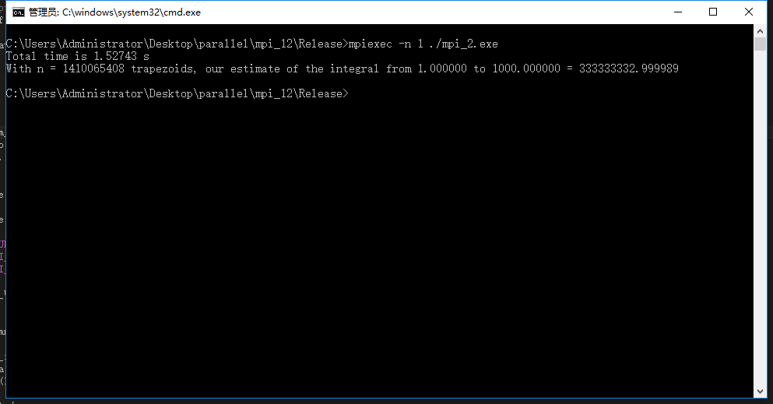
图 2-1

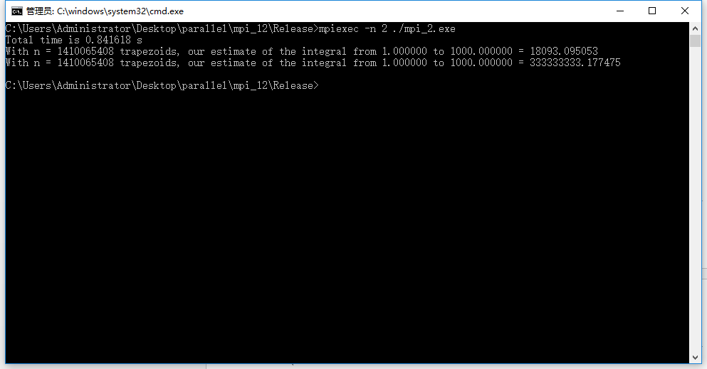
图 2-2

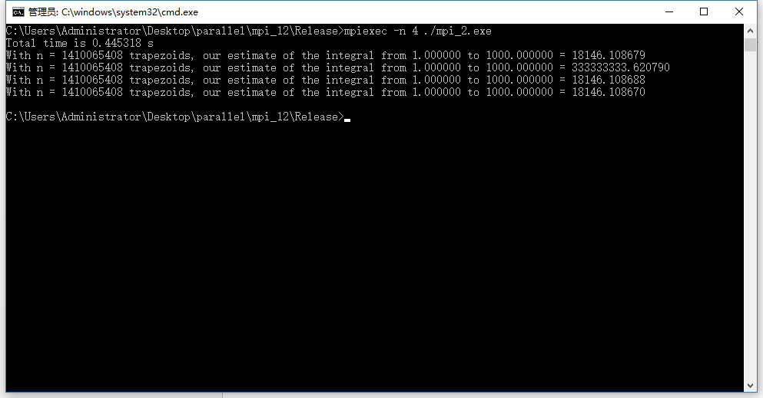
图 2-3

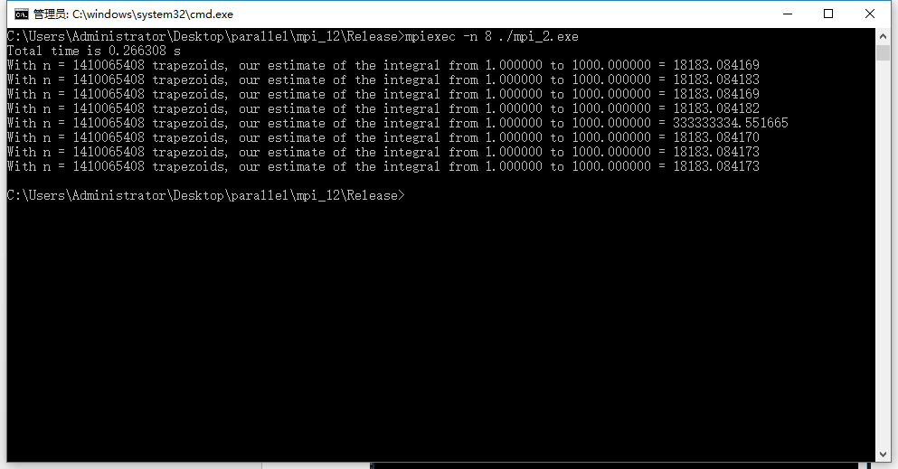
图 2-4

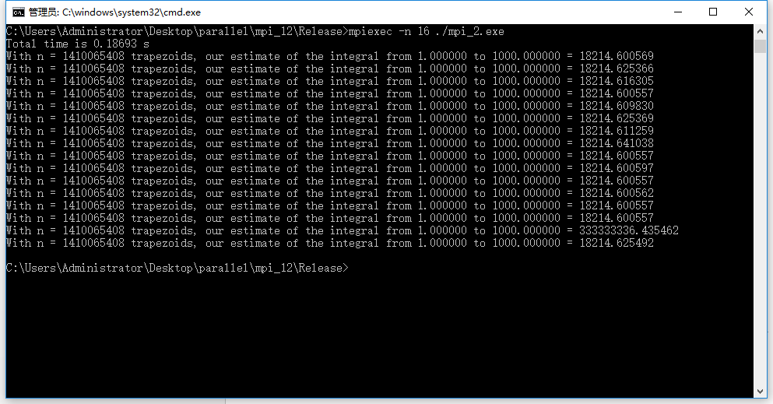
图 2-5

PSRS算法

表1 采用1线程情况时各数据集的测试结果
数据集 | 1 |  | 2 |  | 3 |  | 4
运行方式 | 串行 | 并行 | 串行 | 并行 | 串行 | 并行 | 串行 | 并行
运行时间(s) | 4.40 |  | 8.03 |  | 17.45 |  | 33.08

加速比

效率
截图编号 | 图 3-1 |  | 图 4-1 |  | 图 5-1 |  | 图6-1

表2 采用2线程情况时各数据集的测试结果
数据集 | 1 |  | 2 |  | 3 |  | 4
运行方式 | 串行 | 并行 | 串行 | 并行 | 串行 | 并行 | 串行 | 并行
运行时间(s) | 4.40 | 3.10 | 8.03 | 6.93 | 17.45 | 14.26 | 33.08 | 28.01
加速比 |  | 1.41 |  | 1.15 |  | 1.22 |  | 1.18
效率 |  | 0.705 |  | 0.57 |  | 0.61 |  | 0.59
截图编号 | 图 3-1 | 图 3-2 | 图 4-1 | 图 4-2 | 图 5-1 | 图 5-2 | 图6-1 | 图6-2

表3 采用4线程情况时各数据集的测试结果
数据集 | 1 |  | 2 |  | 3 |  | 4
运行方式 | 串行 | 并行 | 串行 | 并行 | 串行 | 并行 | 串行 | 并行
运行时间(s) | 4.40 | 2.79 | 8.03 | 5.74 | 17.45 | 11.67 | 33.08 | 24.52
加速比 |  | 1.57 |  | 1.39 |  | 1.49 |  | 1.34
效率 |  | 0.39 |  | 0.34 |  | 0.37 |  | 0.33
截图编号 | 图 3-1 | 图 3-3 | 图 4-1 | 图 4-3 | 图 5-1 | 图 5-3 | 图6-1 | 图6-3

表4 采用8线程情况时各数据集的测试结果
数据集 | 1 |  | 2 |  | 3 |  | 4
运行方式 | 串行 | 并行 | 串行 | 并行 | 串行 | 并行 | 串行 | 并行
运行时间(s) | 4.40 | 1.87 | 8.03 | 4.21 | 17.45 | 8.56 | 33.08 | 15.79
加速比 |  | 2.16 |  | 1.90 |  | 2.03 |  | 2.09
效率 |  | 0.27 |  | 0.23 |  | 0.25 |  | 0.26
截图编号 | 图 3-1 | 图 3-4 | 图 4-1 | 图 4-4 | 图 5-1 | 图 5-4 | 图6-1 | 图6-4

表5 采用16线程情况时各数据集的测试结果
数据集 | 1 |  | 2 |  | 3 |  | 4
运行方式 | 串行 | 并行 | 串行 | 并行 | 串行 | 并行 | 串行 | 并行
运行时间(s) | 4.40 | 2.23 | 8.03 | 5.65 | 17.45 | 8.99 | 33.08 | 19.43
加速比 |  | 1.97 |  | 1.42 |  | 1.94 |  | 1.70
效率 |  | 0.12 |  | 0.08 |  | 0.12 |  | 0.10
截图编号 | 图 3-1 | 图 3-5 | 图 4-1 | 图 4-5 | 图 5-1 | 图 5-5 | 图6-1 | 图6-5

数据集 | 128M
线程数 | 1 | 2 | 4 | 8 | 16
运行时间(s) |  | 4.04421 | 2.21991 | 1.67083 | 1.6394
加速比 | 无
效率
截图编号 | 图 3-1 | 图 3-2 | 图 3-3 | 图 3-4 | 图 3-5

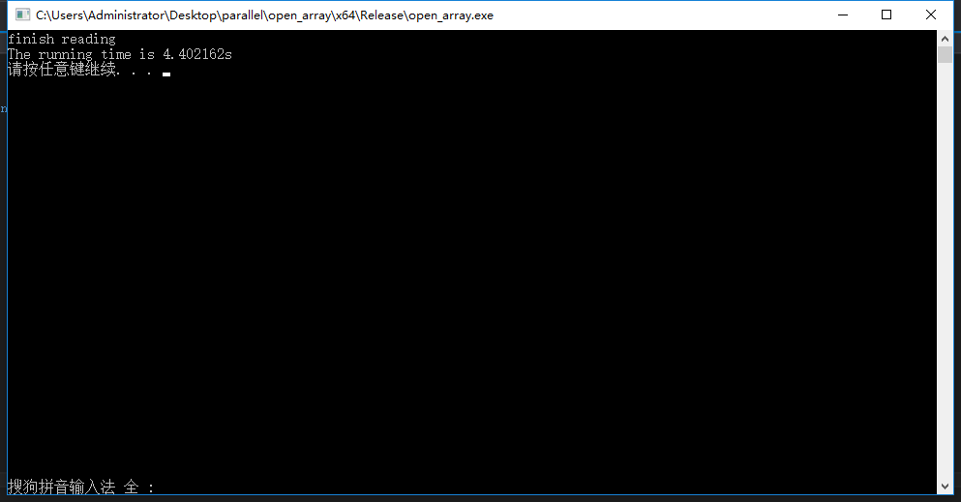
图 3-1

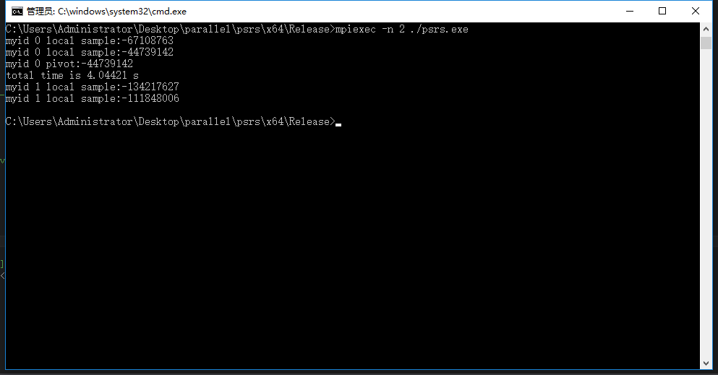
图 3-2

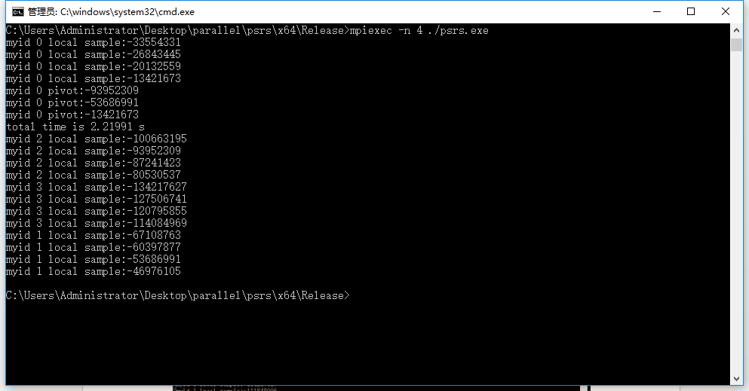
图 3-3

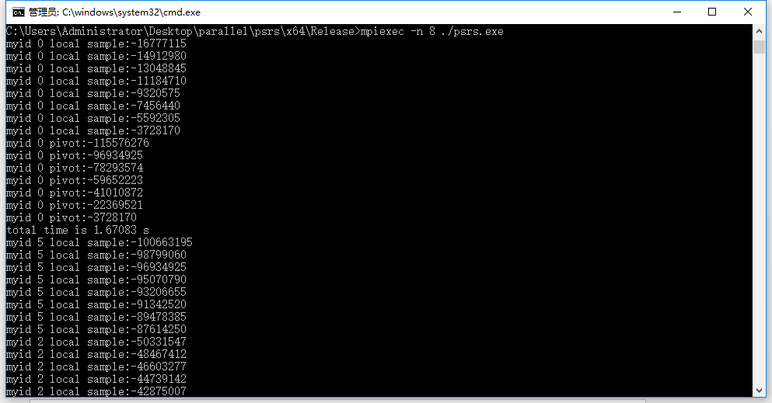
图 3-4

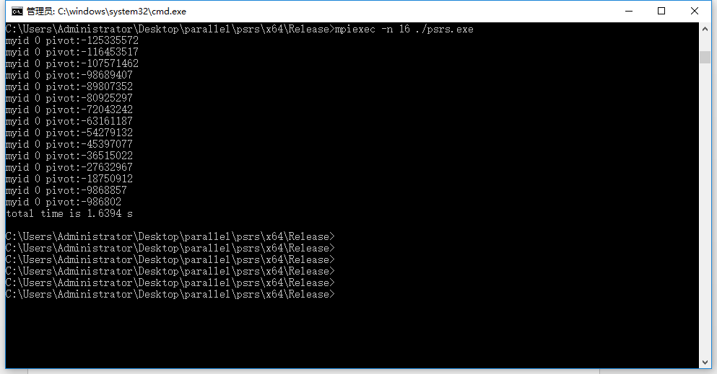
图 3-5

数据集 | 256M
线程数 | 1 | 2 | 4 | 8 | 16
运行时间(s) |  | 8.30566 | 4.57464 | 3.23842 | 3.09712
加速比 | 无
效率
截图编号 | 图 4-1 | 图 4-2 | 图 4-3 | 图 4-4 | 图 4-5

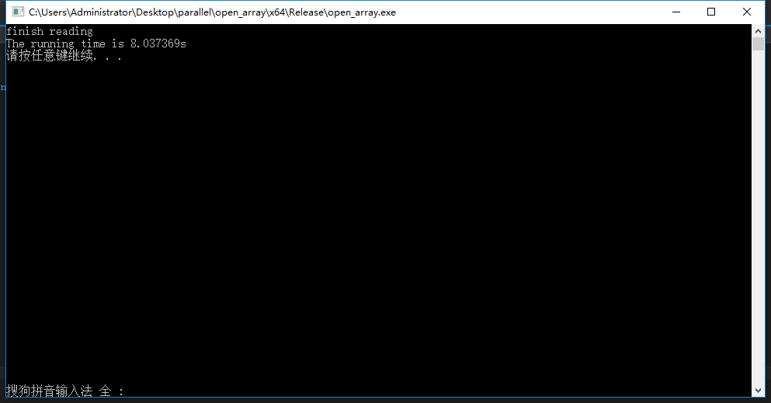
图 4-1

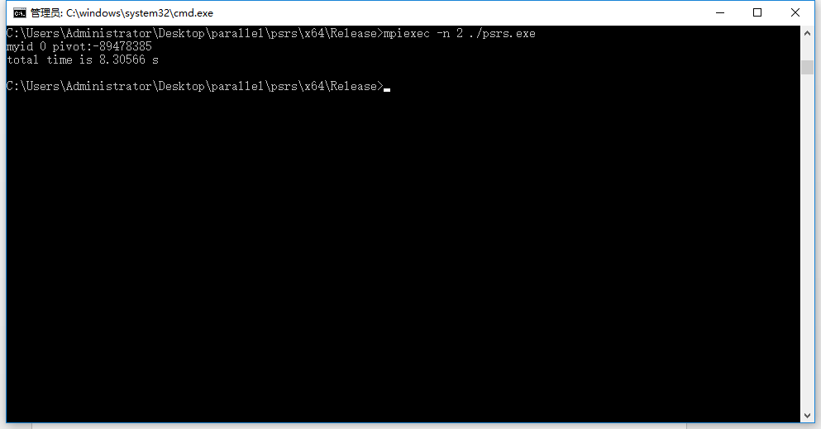
图 4-2

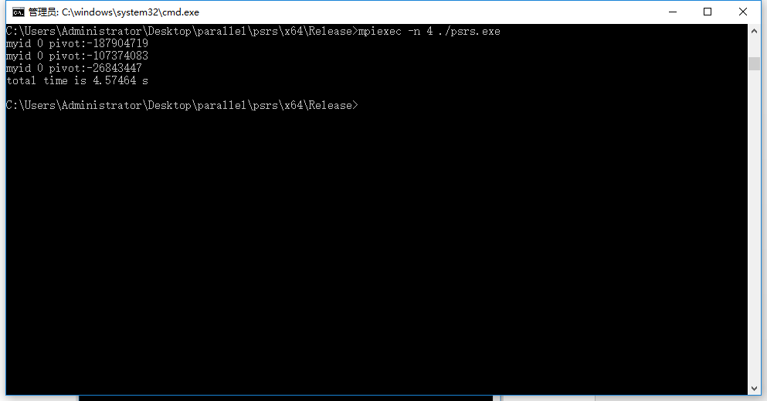
图 4-3

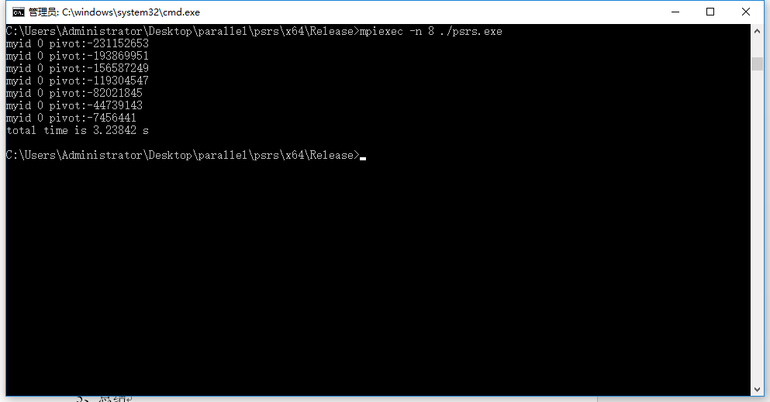
图 4-4

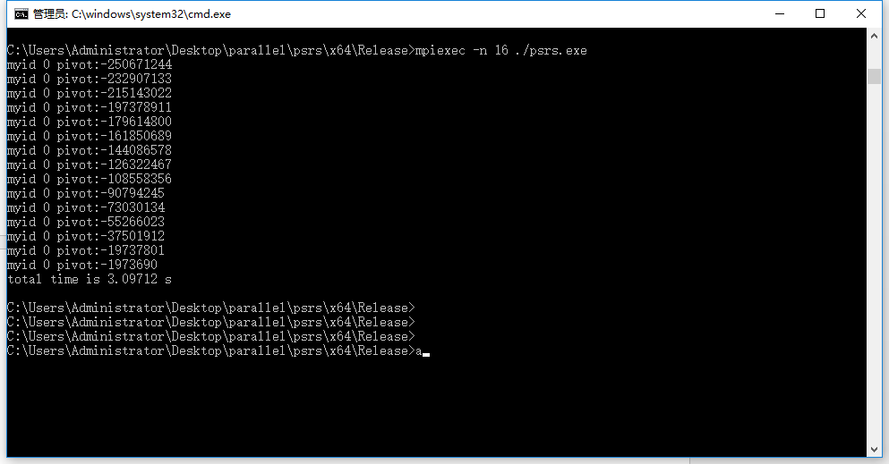
图 4-5

数据集 | 512M
线程数 | 1 | 2 | 4 | 8 | 16
运行时间(s) |  | 17.3331 | 9.75158 | 6.98277 | 6.97439
加速比 | 无
效率
截图编号 | 图 5-1 | 图 5-2 | 图 5-3 | 图 5-4 | 图 5-5

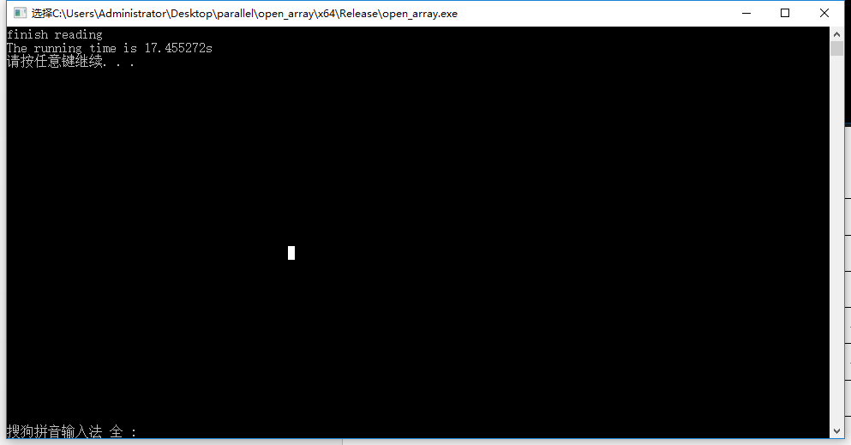
图 5-1

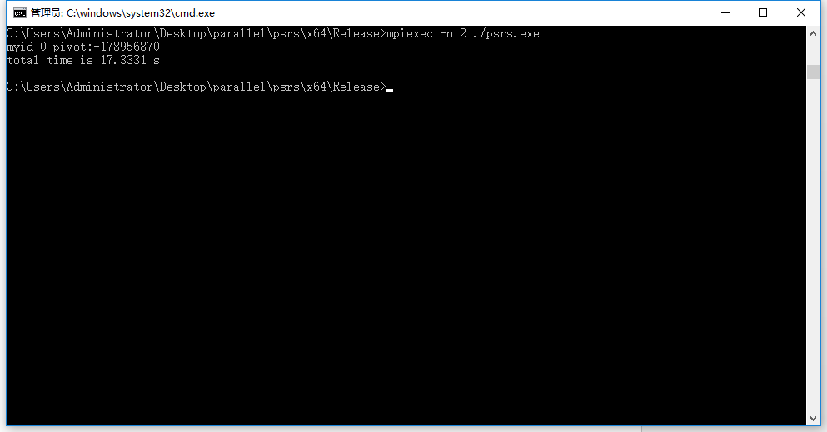
图 5-2

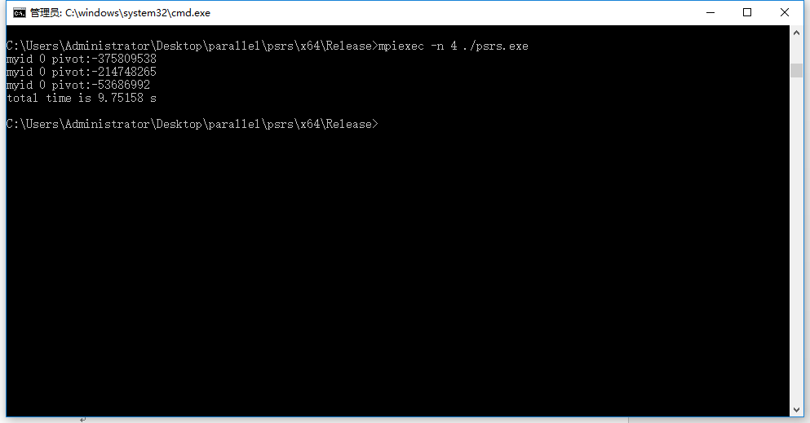
图 5-3

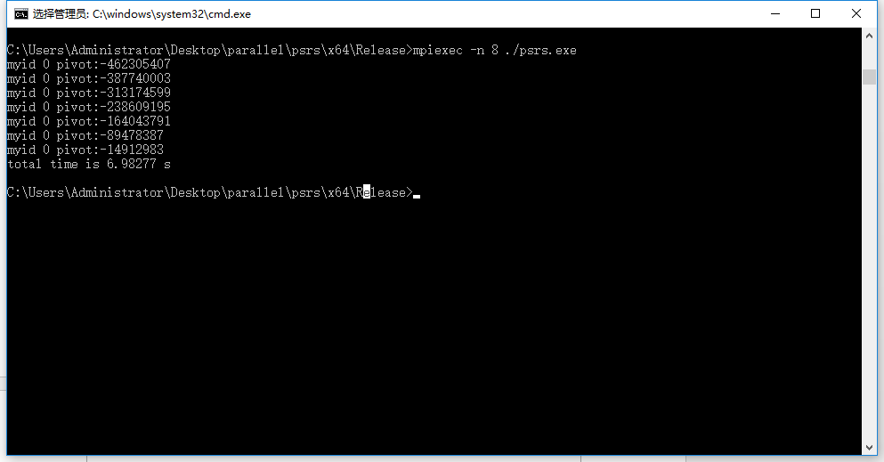
图 5-4

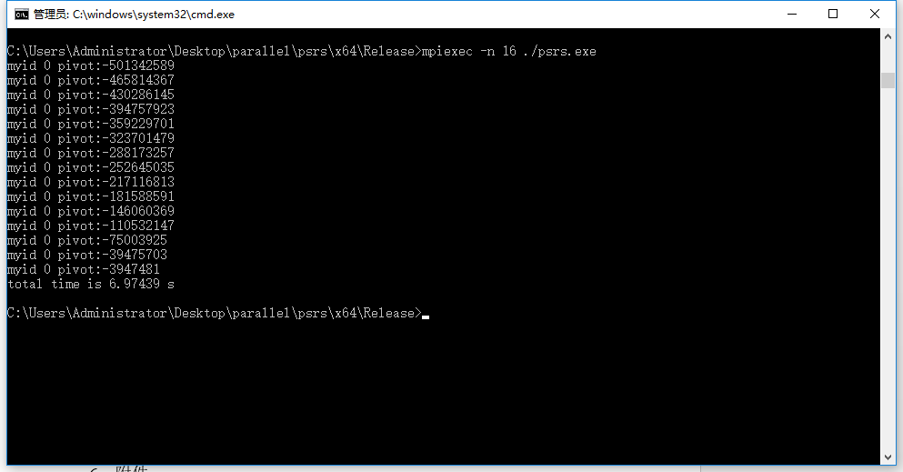
图 5-5

数据集 | 1G
线程数 | 1 | 2 | 4 | 8 | 16
运行时间(s)
加速比 | 无
效率
截图编号 | 图 6-1 | 图 6-2 | 图 6-3 | 图 6-4 | 图 6-5

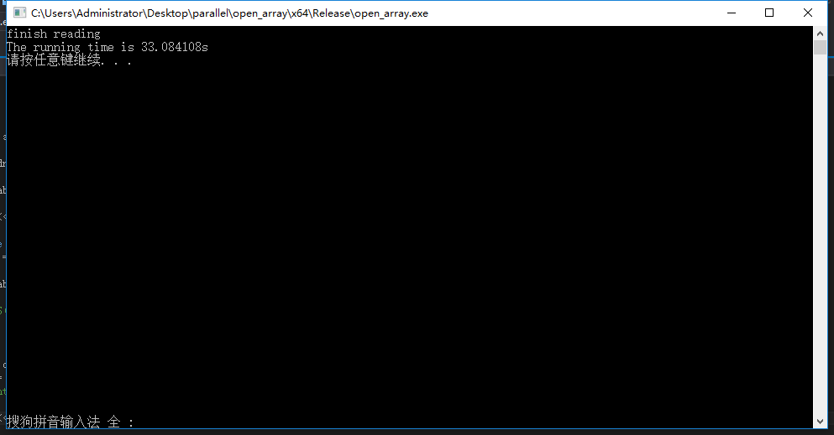
图 6-1

5、总结
[包括体会、问题和建议]

6、附件
Martrix-Vecter 乘法

#include <stdio.h>
#include <stdlib.h>
#include <mpi.h>
#include<iostream>
#include<cstdlib>
#include<ctime>
#define random(a,b) (rand()%(b-a+1)+a)
#include<vector>

using namespace std;

void Read_matrix(
char prompt[] /* in */,
double A[] /* out */,
int m /* in */,
int n /* in */) {
int i, j;

printf("creating the matrix %s\n", prompt);
for (i = 0; i < m; i++) {

for (j = 0; j < n; j++) {

//scanf("%lf", &A[i*n + j]);
A[i*n + j] = random(1, 10);

}

}

}

void Read_vector(
char prompt[] /* in */,
double x[] /* out */,
int n /* in */) {
int i;

printf("creating the vector %s\n", prompt);
for (i = 0; i < n; i++)
x[i] = random(1, 10);
//scanf("%lf", &x[i]);
} /* Read_vector */

/*-------------------------------------------------------------------*/
int main(int argc, char *argv[]) {

int myid, numprocs;
MPI_Init(NULL, NULL);
MPI_Comm_rank(MPI_COMM_WORLD, &myid);
MPI_Comm_size(MPI_COMM_WORLD, &numprocs);

double* A = NULL;
double* x = NULL;
//double* y = NULL;

char ca[2] = "A";
char cx[2] = "x";
char cy[2] = "y";

//int* m[1], n[1];
int * m = new int[1];
int * n = new int[1];

//int* section_num[1];
//int* last_sectionnum[1];
int * section_num = new int[1];
int * last_sectionnum = new int[1];

double * result=NULL;
double * local_result;
int local_i = 0;

double start_time = 0;
double end_time = 0;
double diff_time = 0;
double total_time = 0;

if (myid == 0) {

m[0] = 10000; // atoi(argv[1]);
n[0] = 10000; //atoi(argv[2]);

section_num[0] = m[0] / numprocs;
last_sectionnum[0] = section_num[0] + m[0] % numprocs;

result = new double[m[0]];

}

MPI_Bcast(m, 1, MPI_INT, 0, MPI_COMM_WORLD);
MPI_Bcast(n, 1, MPI_INT, 0, MPI_COMM_WORLD);
MPI_Bcast(section_num, 1, MPI_INT, 0, MPI_COMM_WORLD);
MPI_Bcast(last_sectionnum, 1, MPI_INT, 0, MPI_COMM_WORLD);

A = new double[m[0] * n[0]];
x = new double[n[0]];

if (A == NULL || x == NULL) {
fprintf(stderr, "Can't allocate storage\n");
exit(-1);
}
if (myid != numprocs - 1) {
local_result = new double[section_num[0]];
}
else {
local_result = new double[last_sectionnum[0]];
}

if (myid == 0) {
Read_matrix(ca, A, m[0], n[0]);
Read_vector(cx, x, n[0]);

}

MPI_Bcast(A, m[0] * n[0], MPI_DOUBLE, 0, MPI_COMM_WORLD);
MPI_Bcast(x, n[0], MPI_DOUBLE, 0, MPI_COMM_WORLD);

start_time = MPI_Wtime();

if (myid != numprocs - 1)
{

for (int i = myid*section_num[0]; i<myid*section_num[0] + section_num[0]; i++) {
local_result[local_i] = 0;
for (int j = 0; j<n[0]; j++) {
local_result[local_i] = local_result[local_i] + A[i*n[0] + j] * x[j];
}
local_i++;
}

}
else {

for (int i = myid*section_num[0]; i<myid*section_num[0] + last_sectionnum[0]; i++) {
local_result[local_i] = 0;
for (int j = 0; j<n[0]; j++) {
local_result[local_i] = local_result[local_i] + A[i*n[0] + j] * x[j];
}
local_i++;
}

}

end_time = MPI_Wtime();
diff_time = end_time - start_time;

MPI_Gather(local_result, section_num[0], MPI_DOUBLE, result, section_num[0], MPI_DOUBLE, 0, MPI_COMM_WORLD);

if (myid == 0) {
cout << "total time is " << diff_time << " s" << endl;
}

free(A);
free(x);
free(local_result);

MPI_Finalize();

system("pause");
return 0;
} /* main */

梯形积分法
#include <stdio.h>
#include <stdlib.h>
#include <mpi.h>
#include<iostream>
#include<cstdlib>
#include<ctime>
#include<vector>
#include <string>

using namespace std;

double f(double x) {
double return_val;

return_val = x*x;
return return_val;
}

double Trap(double left_endpt, double right_endpt, int trap_count, double base_len) {

double estimate, x;
int i;

estimate = (f(left_endpt) + f(right_endpt)) / 2.0;
for (i = 0; i <= trap_count - 1; i++) {
x = left_endpt + i*base_len;
estimate += f(x);
}
estimate = estimate*base_len;

return estimate;
}

int main() {

int my_rank, comm_sz, n = 10000000000, local_n;
double a = 1.0, b = 1000.0, h, local_a, local_b;
double local_int, total_int;
int source;

double start_time;
double end_time;
double total_time;

MPI_Init(NULL, NULL);
MPI_Comm_rank(MPI_COMM_WORLD, &my_rank);
MPI_Comm_size(MPI_COMM_WORLD, &comm_sz);

start_time = MPI_Wtime();

h = (b - a) / n;
local_n = n / comm_sz;

local_a = a + my_rank*local_n*h;
local_b = local_a + local_n*h;
local_int = Trap(local_a, local_b, local_n, h);

if (my_rank != 0) {

MPI_Send(&local_int, 1, MPI_DOUBLE, 0, 0, MPI_COMM_WORLD);

}
else {
total_int = local_int;
for (source = 1; source < comm_sz; source++) {
MPI_Recv(&local_int, 1, MPI_DOUBLE, source, 0, MPI_COMM_WORLD, MPI_STATUS_IGNORE);
total_int += local_int;
}

}

end_time = MPI_Wtime();

if (my_rank == 0) {
cout << "Total time is " << end_time - start_time << " s" << endl;
}

cout << "With n = " + to_string(n) + " trapezoids, our estimate of the integral from " + to_string(a) + " to " + to_string(b) + " = " + to_string(total_int) + "\r\n";

MPI_Finalize();

//system("pause");
return 0;

}

PSRS算法

#include <stdio.h>
#include <stdlib.h>
#include <mpi.h>
#include<iostream>
#include<cstdlib>
#include<ctime>
#include<vector>
#include<fstream>
#include<algorithm>
#include<math.h>
#include <malloc.h>
#include<string>

using namespace std;

#define data_num pow(2, 20) * 1024

void read(int * &buffer, long size) {

ifstream infile;
infile.open("./data1024M.txt", ios::binary);
if (!infile.is_open()) {
cout << "error\n";
exit(0);
}

//buffer = new int[size];
buffer = (int*)malloc(size*sizeof(int));

infile.read((char*)buffer, sizeof(int)*size);
infile.close();

}

int main(int argc, char *argv[]) {

int myid, numprocs;
MPI_Init(NULL, NULL);
MPI_Comm_rank(MPI_COMM_WORLD, &myid);
MPI_Comm_size(MPI_COMM_WORLD, &numprocs);

int * data = NULL; //store the global data
int data_per_node = data_num / numprocs;//the number of data for each node to process

//int * local_data = new int[data_per_node]; //store the local data, after partition
int * local_data = (int*)malloc(data_per_node*sizeof(int));

//int * local_sample = new int[numprocs]; //store the local sample
int * local_sample = (int*)malloc(numprocs*sizeof(int));
int count = 0;

//int * root_sample = new int[numprocs*numprocs];
int * root_sample = (int*)malloc(numprocs*numprocs*sizeof(int));

int * pivot = new int[numprocs - 1];

int * local_partion_num = new int[numprocs];
for (int i = 0; i<numprocs; i++) {
local_partion_num[i] = 0;
}
int * local_partion_num_all = new int[numprocs*numprocs];
// for(int i=0;i<numprocs;i++){
// local_partion_num_matrix[i]= new int[numprocs];
// // for(int j=0;j<numprocs;j++){
// // local_partion_num_matrix[i][j] = 0;
// // }
// }

//store the number of data each compute node should process
int* local_partion_num_sum = new int[1];

//store the location of each pivot in each compute node
int* local_partition_location = new int[numprocs];
for (int i = 0; i<numprocs; i++) {
local_partition_location[i] = 0;
}
int * local_partition_location_all = new int[numprocs*numprocs];

int * after_partition_data;

//read data
if (myid == 0) {
read(data, data_num);
}

double start_time = MPI_Wtime();

//scatter the data to each compute node
MPI_Scatter(data, data_per_node, MPI_INT, local_data, data_per_node, MPI_INT, 0, MPI_COMM_WORLD);

//sort the local data for each node
sort(local_data, local_data + data_per_node);

//sample
for (int i = 0; i<numprocs; i++) {
//cout<<"myid "+ to_string(myid) +" local sample:" + to_string( local_data[ i * (data_per_node / (numprocs + 1)) ] ) +"\r\n";
local_sample[i] = local_data[i * (data_per_node / (numprocs + 1))];
}

//gather the sample
MPI_Gather(local_sample, numprocs, MPI_INT, root_sample, numprocs, MPI_INT, 0, MPI_COMM_WORLD);

//sort the sample in the root and pick the pivot
if (myid == 0) {

//sort the local sample
sort(root_sample, root_sample + numprocs*numprocs);

//select the pivot
for (int i = 0; i<numprocs - 1; i++) {
pivot[i] = root_sample[(i + 1)*(numprocs + 1)];

cout << "myid " + to_string(myid) + " pivot:" + to_string( pivot[i] ) + "\r\n";
}

}

//broadcast the pivot to all compute node
MPI_Bcast(pivot, numprocs - 1, MPI_INT, 0, MPI_COMM_WORLD);

//traverse the local_data and record the number for each partition
for (int i = 0; i<data_per_node; i++) {

//record the number for each partition
for (int j = 0; j<numprocs - 1; j++) {

//record the partition location
// if(local_data[i]<=pivot[j] && local_data[i+1]>pivot[j]){
// //cout<<"local_data[i] "<<local_data[i]<<" local_data[i+1] "<< local_data[i+1] <<" pivot "<<pivot[j]<<endl;
// // if(j == 0){
// // local_partition_location[j] = i;
// // }
// // else{
// // local_partition_location[j] = i - local_partition_location[j-1];
// // if(j == numprocs-2){
// // local_partition_location[j+1] = data_per_node-i;
// // }
// // }
// local_partition_location[j+1] = i;
// }

if (local_data[i]<pivot[j]) {
local_partion_num[j] = local_partion_num[j] + 1;
break;
}

if (local_data[i] >= pivot[j] && j == numprocs - 2) {
local_partion_num[j + 1] = local_partion_num[j + 1] + 1;
break;
}

}

}

int ** local_partition_data = new int*[numprocs];
//do the copy
//1.allocat the space
for (int i = 0; i<numprocs; i++) {
//local_partition_data[i] = new int[local_partion_num[i]];
local_partition_data[i] = (int*)malloc(local_partion_num[i] *sizeof(int));
}
//2.do the copy
int * local_count = new int[numprocs];
for (int i = 0; i<numprocs; i++) {
local_count[i] = 0;
}
for (int i = 0; i<data_per_node; i++) {

for (int j = 0; j<numprocs - 1; j++) {

if (local_data[i]<pivot[j]) {
local_partition_data[j][local_count[j]++] = local_data[i];
// local_partition_data[ local_count[j]++ ] = 100;
// memcpy(local_partition_data[][ local_count[j]++ ],local_data[i],sizeof(int));
break;
}

if (local_data[i] >= pivot[j] && j == numprocs - 2) {
local_partition_data[j + 1][local_count[j + 1]++] = local_data[i];
break;
}

}

}

//reduce the num the each compute node
for (int i = 0; i<numprocs; i++) {
MPI_Reduce(local_partion_num + i, local_partion_num_sum, 1, MPI_INT, MPI_SUM, i, MPI_COMM_WORLD);
}
// for(int i=0;i<numprocs;i++){
// MPI_Reduce(local_partion_num[myid]+i,local_partion_num_sum,1,MPI_INT,MPI_SUM,i,MPI_COMM_WORLD);
// }

//each compute node store all the partition situation
for (int i = 0; i<numprocs; i++) {
MPI_Gather(local_partion_num, numprocs, MPI_INT, local_partion_num_all, numprocs, MPI_INT, i, MPI_COMM_WORLD);
}

// for(int i=0;i<numprocs;i++){
// MPI_Gather(local_partition_location,numprocs,MPI_INT,local_partition_location_all,numprocs,MPI_INT,i,MPI_COMM_WORLD);
// }

//allocat the space for the local partition data
after_partition_data = new int[local_partion_num_sum[0]];

//do the partition
for (int i = 0; i<numprocs; i++) {

//1.construct the parameter
int * reccount = new int[numprocs];
for (int j = 0; j<numprocs; j++) {
reccount[j] = local_partion_num_all[i + j*numprocs];
}
int * displs = new int[numprocs];
for (int j = 0; j<numprocs; j++) {
if (j == 0)
displs[j] = 0;
else
displs[j] = displs[j - 1] + reccount[j - 1];
}

//2.send the data
MPI_Gatherv(local_partition_data[i], local_partion_num[i], MPI_INT, after_partition_data, reccount, displs, MPI_INT, i, MPI_COMM_WORLD);
}

sort(after_partition_data, after_partition_data + local_partion_num_sum[0]);

// cout<<" myid"<<myid<<endl;
// for(int i=0;i<local_partion_num_sum[0];i++){
// cout<<after_partition_data[i]<<" ";
// }
// cout<<endl;

// for(int i=0;i<numprocs;i++){
// cout<<" myid"<<myid<<" "<<local_partion_num[i]<<endl;
// }

// cout<<" myid"<<myid<<endl;
// for(int i=0;i<numprocs*numprocs;i++){

// cout<<local_partition_location_all[i]<<" ";
// }
// cout<<endl;

//cout<<" myid"<<myid<<" local_partion_num_sum:"<<local_partion_num_sum[0]<<endl;

// cout<<" myid"<<myid<<endl;
// for(int i=0;i<numprocs*numprocs;i++){

// cout<<local_partion_num_all[i]<<" ";
// }
// cout<<endl;

// for(int i=0;i<numprocs;i++){
// cout<<" myid"<<myid<<" "<<local_partition_location[i];
// }cout<<endl;

// for(int i=0;i<numprocs;i++){
// cout<<" myid"<<myid<<" "<<i<<" "<<local_partion_num[myid][i]<<endl;
// }

// if(myid == 0){
// for(int i=0;i<numprocs*numprocs;i++){
// //cout<<data_per_node<<endl;
// cout<<" myid"<<myid<<" "<<root_sample[i]<<endl;
// }
// }

//cout the pivot
// for(int i=0;i<numprocs-1;i++){
// cout<<" myid"<<myid<<" pivot:"<<pivot[i]<<endl;
// }

double end_time = MPI_Wtime();
double diff_time = end_time - start_time;

MPI_Barrier(MPI_COMM_WORLD);
if (myid == 0) {
//cout<<"total time is "<<total_time[0]<<" s"<<endl;
cout << "total time is " << diff_time << " s" << endl;
}

MPI_Finalize();
return 0;
}

