Organismal Bioogy Data Lab 1

Your Name

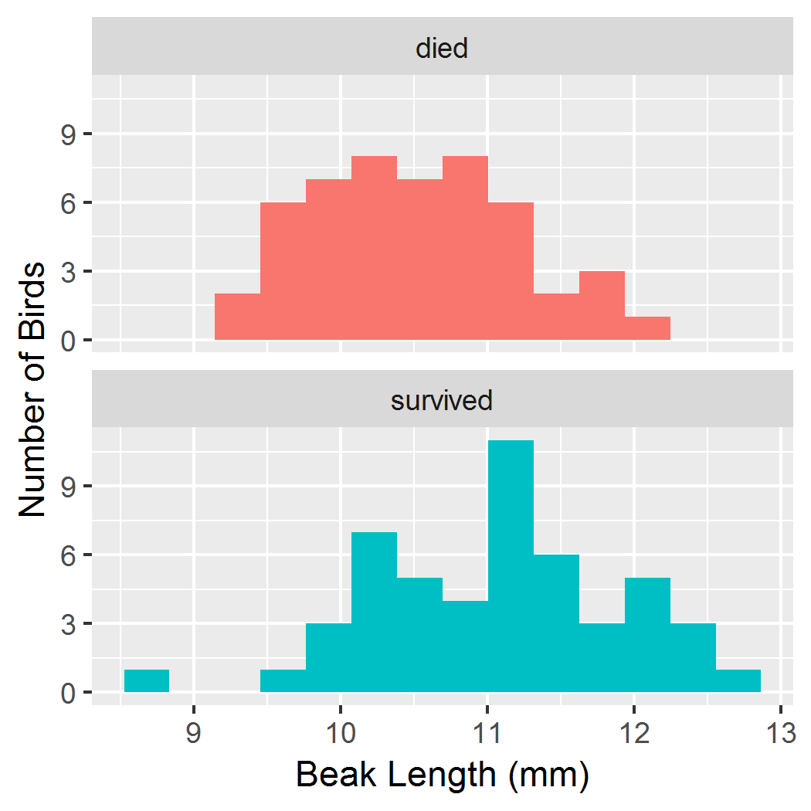 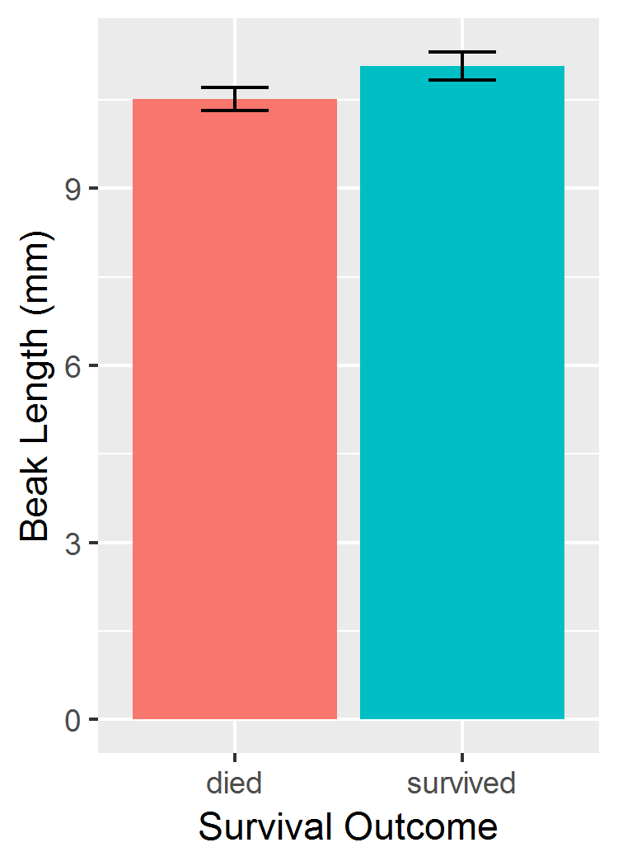

Figure 1. **Distribution of beak lengths among medium ground finches (*Geospiza fortis*) that survived or died during the 1977 drought on Daphne Major, Galapagos archipelago.** Each sample consists of 50 individuals. Birds were banded and measured during 1975-1977 and resighted in 1978.

Figure 2. **Mean beak length varied between** **medium ground finches (*Geospiza fortis*) that survived or died during the 1977 drought on Daphne Major, Galapagos archipelago**. Each sample consists of 50 individuals. Birds were banded and measured during 1975-1977 and resighted in 1978. Error bars are ± 1 standard error of the mean.

RESULTS

Birds that survived the 1977 drought generally had longer beaks than those that died (Fig. 1). Mean beak depths were 11.1 mm in survivors and 10.5 mm in non-survivors (Fig. 2). This difference was stastistically significant according to a Welch's two-sample t-test assuming unequal variances ($t=3.6335$, $df=94.807$, $p=0.0004539$).