Organismal Biology Data Lab 1

[Your Name]

[replace with figure 1 – plant height histogram] [replace with figure 2 – plant height bar chart]

[replace with figure 3 – rame length histogram] [replace with figure 4 – rame length bar chart]

Figure 1. [replace with figure legend]

Figure 2. [replace with figure legend]

Figure 3. [replace with figure legend]

Figure 4. [replace with figure legend]

RESULTS

[replace with paragraph about plant heights]

[replace with pargraph about rame lengths]

---

[INTRUCTIONS – REPLACE EVERYTHING IN SQUARE BRACKETS WITH YOUR OWN FIGURES AND TEXT]

[SEE BELOW FOR EXAMPLE -- DELETE THIS EXAMPLE BELOW BEFORE YOU TURN IN YOUR ASSIGNMENT]

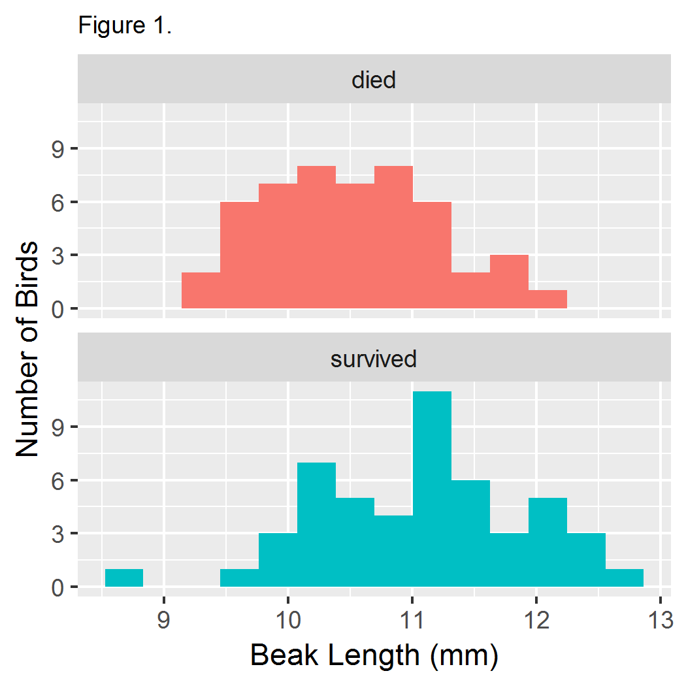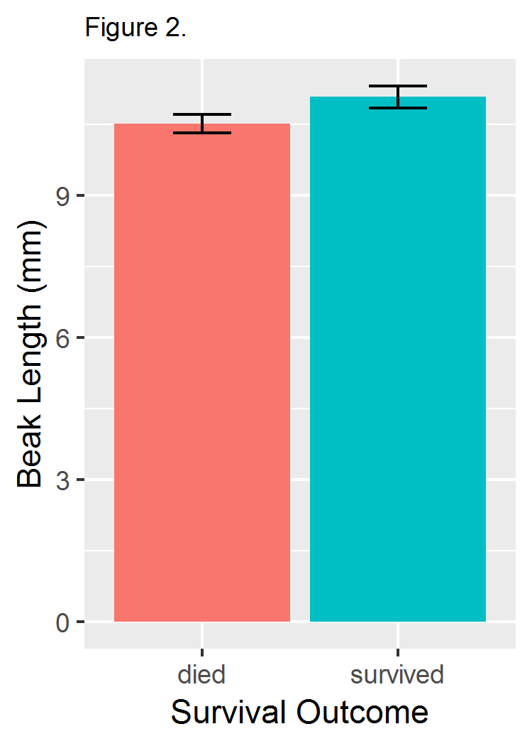

Figure 1. **Distribution of beak lengths among medium ground finches (*Geospiza fortis*) that survived or died during the 1977 drought on Daphne Major, Galapagos archipelago.** Each sample consists of 50 individuals. Birds were banded and measured during 1975-1977 and resighted in 1978.

Figure 2. **Mean beak length varied between** **medium ground finches (*Geospiza fortis*) that survived or died during the 1977 drought on Daphne Major, Galapagos archipelago**. Each sample consists of 50 individuals. Birds were banded and measured during 1975-1977 and resighted in 1978. Error bars represent 95% confidence intervals.

RESULTS

Birds that survived the 1977 drought generally had longer beaks than those that died (Fig. 1). Mean beak depths were 11.1 mm in survivors and 10.5 mm in non-survivors (Fig. 2). This difference was stastistically significant according to a Welch's two-sample t-test assuming unequal variances ($t=3.6335$, $df=94.807$, $p=0.0004539$).