*Cichlidae* Response to Water Depth

Group 4:

Darrell Albert (1190134), Megan Brock (1086245),

James Martin (1184367), Rachel Ucci (1178171)

**Introduction**

The life expectancy of fish can be used as an important bioindicator of the health of aquatic ecosystems. Fish life expectancy and body size both respond to stressors within the ecosystem, serving as an indicator for environmental health and the changes it undergoes (Pinna et al., 2023; Ahti et. al., 2020).

Lake depth also plays a significant role in influencing the functioning of aquatic ecosystems. It has been found that fish are particularly sensitive to changes in lake depth, which can influence their health and longevity (McFarlane, 2023). Deeper bodies of water can display stratification, which leads to multiple distinct thermal layers that can provide unique habitats and ecosystems for different aquatic species. This can have an impact on fish longevity through their impact on varying functions within fish species such as metabolic rates and growth rates (Rawson, 1952). Furthermore, studies have shown that fish in deeper waters tend to have larger swim bladders to aid in buoyancy and equilibrium, and thus are generally larger in size as depth increases (Evans & Page, 2003; Ribbink & Hill, 1979; Sobradillo et al., 2019). However, while deeper waters tend to be a more stable habitat for aquatic species, it is also true that in deeper waters with less sunlight, and thus limited photosynthesis, there is a lower concentration of nutrients, which can be harmful to fish productivity (Smith & Brown, 2002).

*Cichlidae* are a large family of fish that fill many ecological roles in their trophic level. This family is of concern as they are confined to a small geographic area in Africa, and thus have a chance of quickly going extinct (Jonna, 2021). As many of the species fill niches with different adaptations, they can live at different depths, even within the same lakes (Ricci et al., 2022).

This leads us to our question of how *Cichlid* length and longevity is affected by lake depth. We hypothesize first that *Cichlidae* longevity has a positive relationship with increasing lake depth because shallower waters exhibit warmer temperatures, increasing metabolic rate (Rawson, 1952). We predict that *Cichlidae* that live deeper in a body of water will have a longer expected lifespan due to their slower metabolic rate. Next, we hypothesize that *Cichlidae* length has a positive relationship with lake depth because larger fish will have larger swim bladder volumes (Evans & Page, 2003; Ribbink & Hill, 1979; Sobradillo et al., 2019). We predict that *Cichlidae* will have a longer length on average in deeper water. Alternatively, we hypothesize that *Cichlidae* length has a negative relationship with lake depth because resource availability decreases at deeper depths (Smith & Brown, 2002). If this hypothesis is true, we predict that *Cichlidae* will have a shorter length on average in deeper water.

**Methods**

Species list data for Lake Malawi and Tanganyika were pulled from Fishbase (Froese and Pauly, 2024). A column was added to each table to denote what lake each species was from and the tables were then combined. Length type measurement was separated from the original length column to assist in filtering. The new column was named measurement, with only one measuring method included (total length). The lake data table was then merged with the species data table from the R package rfishBase (Boettiger et al., 2012) by species name. From this table, the columns Genus, Species, Family, Lake, DepthrangeDeep, Length (cm), measurement, and Longenvitywild were selected. The table was then filtered so only species in the family *Cichlidae* located in Lake Malawi and Tanganyika that had depth and longevity data and which were measured via total length were selected. After filtering the data we ended up with 71 species of *Cichlidae* between the two lakes. We will create a scatterplot and fix a line of best fit to the graph using ggplot2 (Wickham, 2016).

**Anticipated Results**

We anticipate that our first and second hypotheses will be supported, and that our third will not be. We believe that, for our first hypothesis, the positive relationship between longer lived *Cichlidae* fish and increasing lake depth will be significant. Our second hypothesis, that *Cichlidae* will have longer average maximum body lengths at increasing depths, complements our first hypothesis, as generally larger fish are longer lived (Kuparinen et al., 2023). Therefore, we believe this hypothesis will also be significant. Conversely, we do not believe that our third hypothesis, that *Cichlidae* length will have a shorter average maximum body length at increasing depths, will be significant, as it competes with our second hypothesis.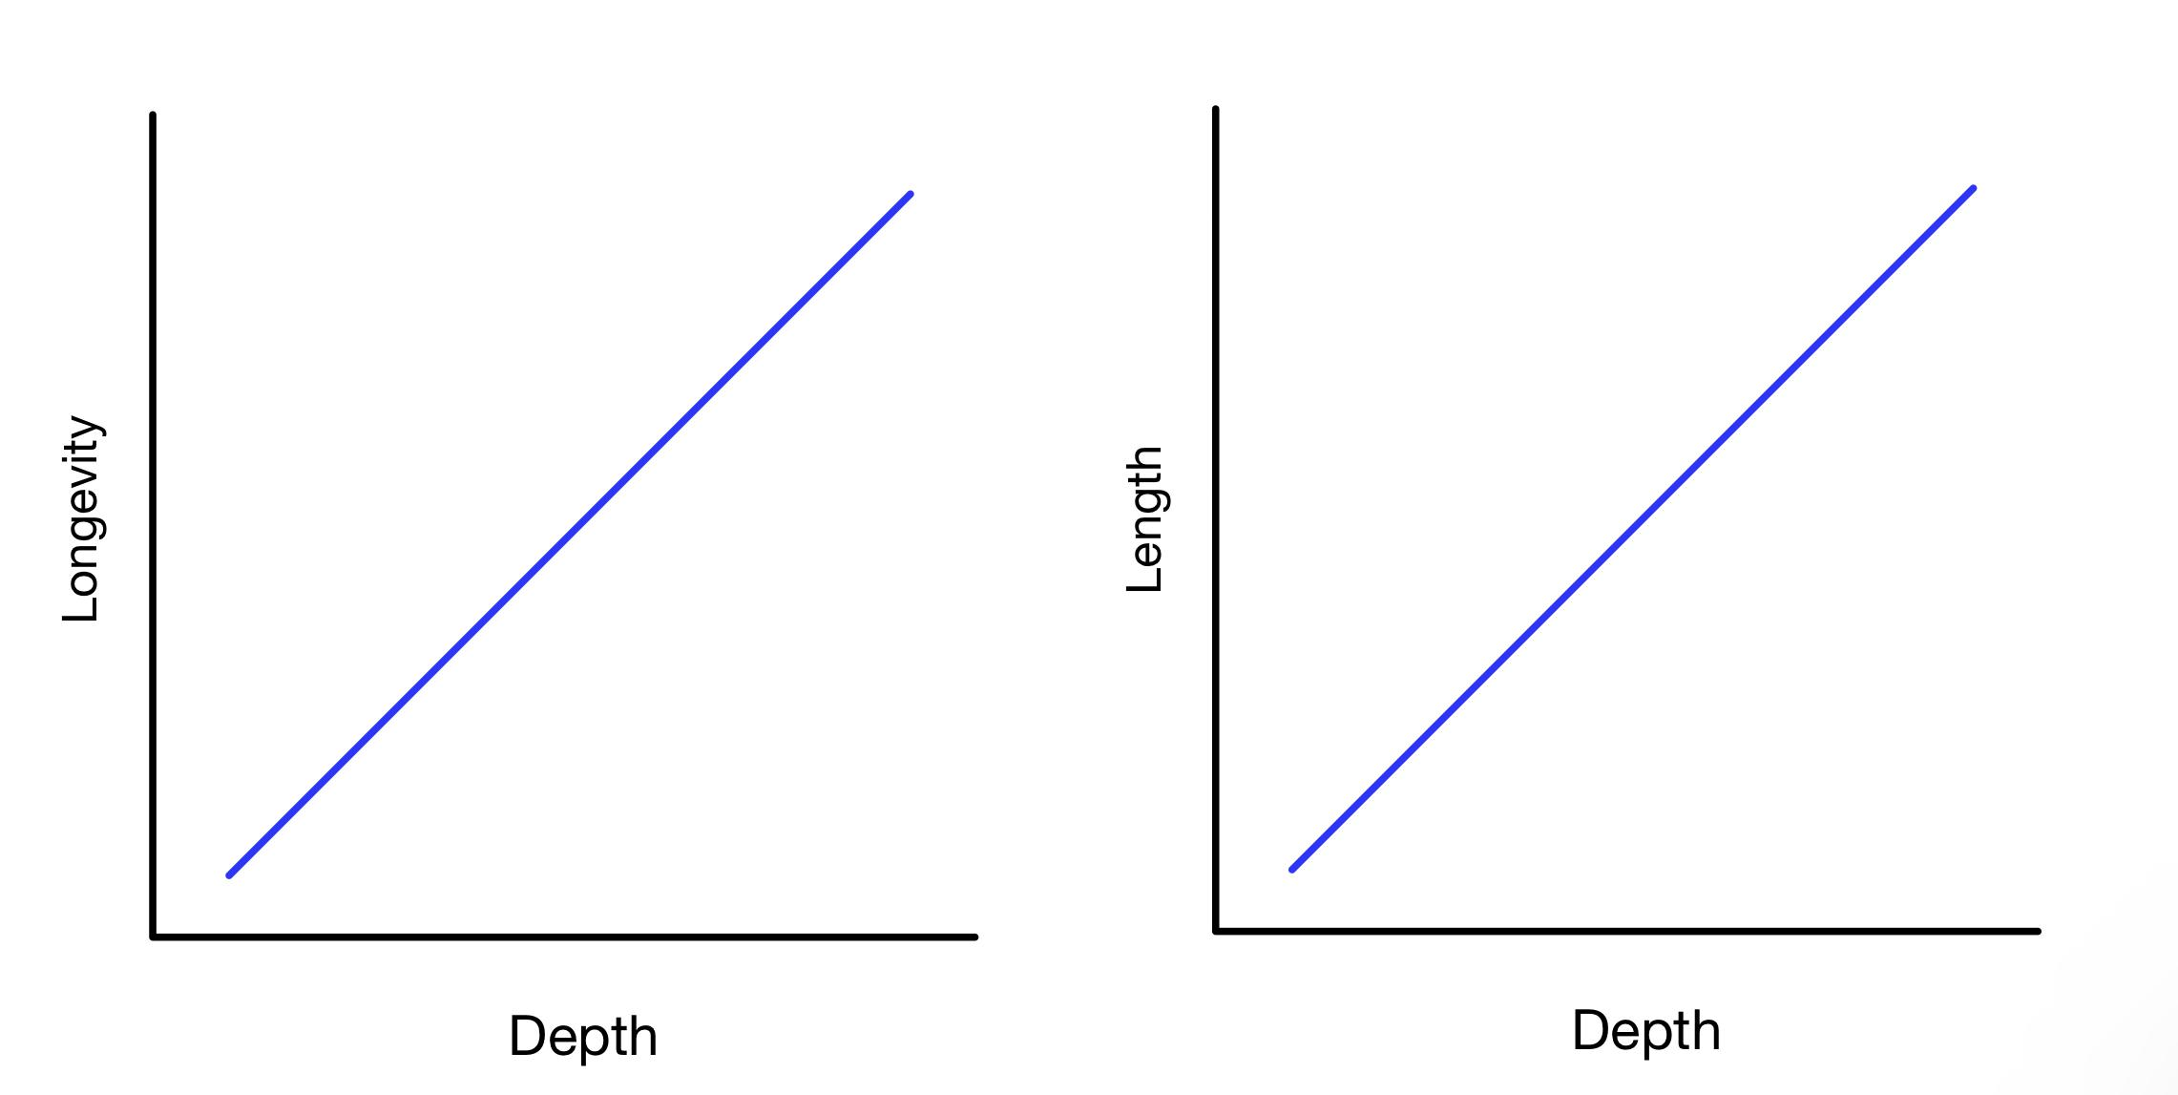

**Significance**

Should our predictions be true, our findings will be significant as it will show how water depth and corresponding factors influence fish life history traits and overall health. Deeper waters likely provide a more stable environment for fish, allowing for larger, longer-lived individuals (McFarlane, 2023). This finding may become increasingly important as climate change warms surface temperature, as we can prioritize the conservation of deeper waters, which may become a critical refuge for species (Pereira et al., 2018). Therefore, understanding depth related trends and its impact on fish, particularly *Cichlidae* which is at a higher risk of endangerment and extinction, may provide some insight in how these fish and other organisms may adapt to forthcoming environmental changes (Jonna, 2021).

**References**

Boettiger, C., Lang, D. T., Wainwright, P. C. (2012). rfishbase: exploring, manipulating and visualizing FishBase data from R. *Journal of Fish Biology, 81(6),* 2030-2039. <https://doi.org/10.1111/j.1095-8649.2012.03464.x>

Evans, J. D. and Page, L. M. (2003). Distribution and Relative Size of the Swim Bladder in *Percina*, With Comparisons to *Etheostoma*, *Crystallaria*, and *Ammocrypta* (Teleostei: Percidae). *Environmental Biology of Fishes, 66,* 61-65. <https://doi.org/10.1023/A:1023238125892>

Froese, R. and D. Pauly. Editors. (2024). FishBase. World Wide Web electronic publication. www.fishbase.org, version (06/2024)

Jacobson, P. C., Hansen, G. J. A., Bethke, B. J., Cross, T. K. (2017). Disentangling the effects of a century of eutrophication and climate warming on freshwater lake fish assemblages. *PLoS ONE*, *12*(8), e0182667. <https://doi.org/10.1371/journal.pone.0182667>

Jonna, R. 2021. "Cichlidae" (On-line), Animal Diversity Web. Accessed October 10, 2024 at <https://animaldiversity.org/accounts/Cichlidae/>

Kuparinen, A., Yeung, E., Hutchings, J. A. (2023). Correlation between body size and longevity: New analysis and data covering six taxonomic classes of vertebrates. *Acta Oecologica, 119*. <https://doi.org/10.1016/j.actao.2023.103917>

McFarlane, F. (2023, September 20). *The long and short of fish lifespans - Environomics Future Science Platform*. Environomics Future Science Platform. <https://research.csiro.au/environomics/the-long-and-short-of-fish-lifespans/>

Pauliina A. Ahti, Anna Kuparinen, and Silva Uusi-Heikkilä. (2020). Size does matter — the eco-evolutionary effects of changing body size in fish. *Environmental Reviews. 28(3),* 311-324. <https://doi.org/10.1139/er-2019-0076>

Pereira, P. H. C., Macedo, C. H., Nunes, J. d. A. C. C., Marangoni, L. F. B., & Bianchini, A. (2018). Effects of depth on reef fish communities: Insights of a “deep refuge hypothesis” from Southwestern Atlantic reefs. PLOS ONE, 13(9). <https://doi.org/10.1371/journal.pone.0203072>

Pinna, M., Zangaro, F., Saccomanno, B., Scalone, C., Bozzeda, F., Fanini, L., & Specchia, V. (2023). An Overview of Ecological Indicators of fish to evaluate the anthropogenic pressures in aquatic ecosystems: from traditional to innovative DNA-Based approaches. *Water*, *15*(5), 949. <https://doi.org/10.3390/w15050949>

Rawson, D. S. (1952). Mean Depth and the Fish Production of Large Lakes. *Ecology*, *33(4),* 513 - 521. <https://doi.org/10.2307/1931525>

Ribbink, A. J. and Hill, B. J. (1979). Depth equilibration by two predatory cichlid fish from Lake Malawi. *Journal of Fish Biology, 14(6),* 507-510. <https://doi.org/10.1111/j.1095-8649.1979.tb03548.x>

Ricci, V., Ronco, F., Musilova, Z., Salzburger, W. (2022). Molecular evolution and depth-related adaptations of rhodopsin in the adaptive radiation of cichlid fishes in Lake Tanganyika. *Molecular Biology, 31(10),* 2882-2897. <https://doi.org/10.1111/mec.16429>

Smith, K. F. and Brown, J. H. (2002). Patterns of diversity, depth range and body size among pelagic fishes along a gradient of depth. *Global Ecology and Biogeography, 11(4),* 313-322. <https://doi.org/10.1046/j.1466-822X.2002.00286.x>

Sobradillo, B., Boyra, G., Martinez, U., Carrera, P., Peña, M., Irigoien, X. (2019). Target Strength and swimbladder morphology of Mueller’s pearlside (*Maurolicus muelleri*). *Sci Rep, 9*. <https://doi.org/10.1038/s41598-019-53819-6>

Wickham, H. (2016). *ggplot2: Elegant Graphics for Data Analysis.* tidyverse.org. <https://ggplot2.tidyverse.org>