COMP261 – Assignment 5

Q1:
^(file.+\.pdf)$

Q2:
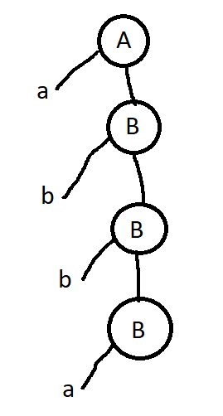

Q3:
One or more “ab” then any number of “c”

Q4:
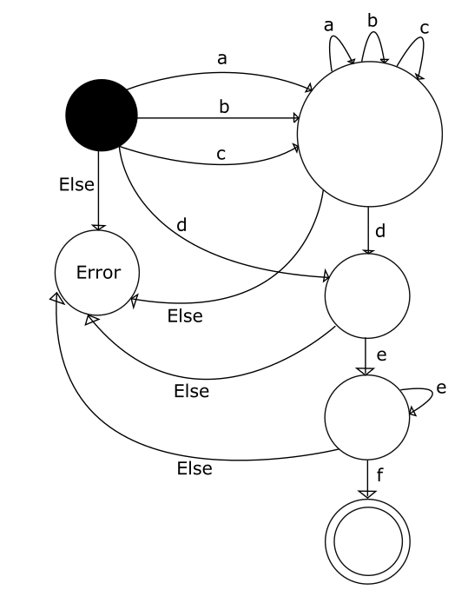

Q5:
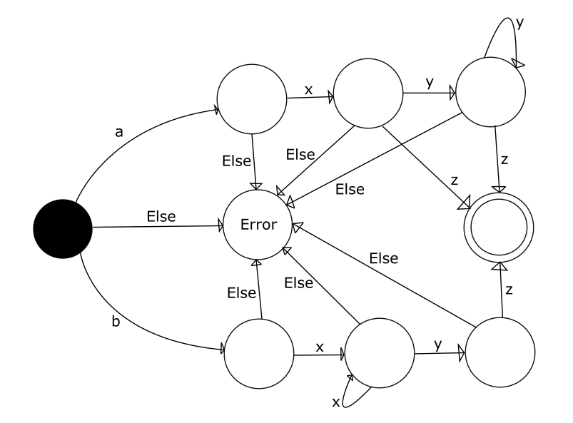

Q6:
A, D, F

Q7:
NAMEOF ::= [A-Z][a-z]+

Q8:
T ::= NAMEOF | T EXPR | “(ie.” T “)”
NAMEOF :: = [A-Z][a-z]+
EXPR ::= “with” T | “without” T

Q9:
LIST ::= NUM EXPR
NUM ::= [0-9]+
EXPR ::= “” | “,” LIST

