COMP261 – Assignment 5

Q1:
^(file.+\.pdf)$

Q2:

Q3:
One or more “ab” then any number of “c”

Q4:
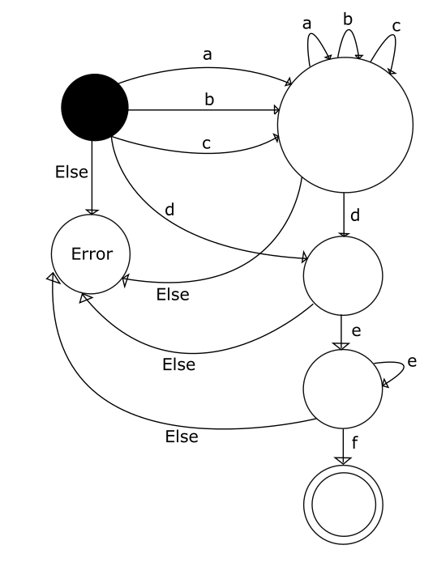

Q5:
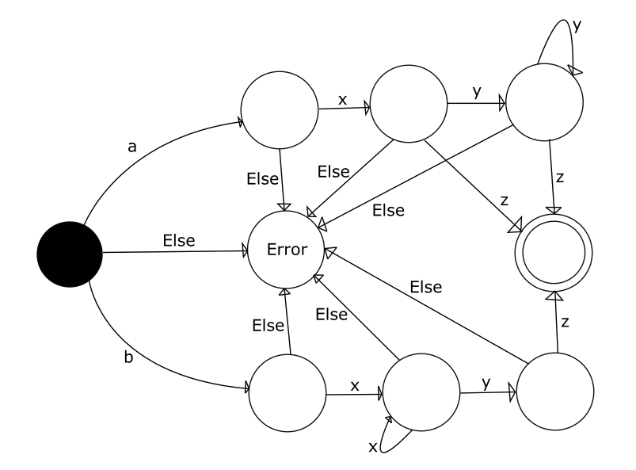

Q6:
A, D, F

Q7:
NAMEOF ::= [A-Z][a-z]+

Q8:

Q9:

