Implement and Manage Zero Trust Network Access (ZTNA) with Zscaler: Secure Access To Cloud Applications.

S.No | NAME | COLLEGE NAME | CONTACT
1. | GOBIKASRI S | SRI KRISHNA ADITHYA COLLEGE OF ARTS AND SCIENCE | 23bscs117gobikasris@skacas.ac.in
2. | SHAFIQ AHAMMED N | SRI KRISHNA ADITHYA COLLEGE OF ARTS AND SCIENCE | 23bscs148shafiqahammedn@skacas.ac.in
3. | KAMESPRABU M | SRI KRISHNA ADITHYA COLLEGE OF ARTS AND SCIENCE | 23bscs123kamesprabum@skacas.ac.in
4. | JAYSURYA R | SRI KRISHNA ADITHYA COLLEGE OF ARTS AND SCIENCE | 23bscs122jaysuryar@skacas.ac.in
5. | BIPIN RAJ G | SRI KRISHNA ADITHYA COLLEGE OF ARTS AND SCIENCE | 23bscs114bipinrajg@skacas.ac.in

Project details

Title: Zero Trust Network Access (ZTNA) with Zscaler: Securing Access to Cloud Applications

AI-Enhanced User Protection (AIUP)

AI-Enhanced User Protection (AIUP) is an advanced security approach that integrates Artificial Intelligence (AI) with Zero Trust Network Access (ZTNA) to strengthen protection for users accessing cloud applications. Traditional security systems rely mainly on static rules and predefined policies, which may not effectively detect evolving cyber threats. AIUP introduces intelligent monitoring and automated decision-making to continuously evaluate user behaviour, device posture, and network activity in real time.
In modern organizations, employees frequently access cloud services such as file storage, enterprise resource planning systems, and collaboration platforms from different devices and locations. This increased flexibility also expands the attack surface for cybercriminals. AIUP helps mitigate these risks by analysing patterns in user activity and identifying suspicious behaviour before it leads to a security incident.
When implemented with Zscaler Zero Trust Network Access, AIUP enhances the security framework by ensuring that every access request is verified using AI-driven analytics. Instead of trusting users based solely on login credentials, the system continuously evaluates contextual factors such as device health, location, access frequency, and behavioural anomalies.

Abstract:

With the rapid adoption of cloud computing, organizations increasingly rely on cloud applications for communication, collaboration, and data management. However, traditional security models that depend on perimeter-based protection and Virtual Private Networks (VPNs) are no longer sufficient to secure modern distributed environments. Zero Trust Network Access (ZTNA) has emerged as an advanced security framework that follows the principle of “Never Trust, Always Verify,” ensuring that every access request is authenticated, authorized, and continuously validated before granting access to resources.

This project focuses on implementing and managing ZTNA using the cloud security platform provided by Zscaler to secure access to cloud applications. The proposed approach restricts users from accessing the entire network and instead provides application-specific access based on identity, device posture, and security policies. By integrating technologies such as artificial intelligence–based threat detection, vulnerability assessment, and security monitoring, organizations can effectively reduce the risk of unauthorized access and data breaches.

The project also explores vulnerability identification, network security scanning using tools like Nessus, and security monitoring concepts including Security Operations Canters (SOC) and Security Information and Event Management (SIEM). The implementation of ZTNA enhances security, improves visibility, and ensures safe access to cloud-based applications

Use Case Scenarios:

Scenario 1: Secure Employee Access to Cloud Storage Application

An employee working from home needs to access the organization’s cloud storage system to upload project documents and collaborate with colleagues. Using ZTNA through Zscaler, the employee securely connects to the cloud storage application without receiving direct access to the entire corporate network. The system validates the employee’s identity using Single Sign-On (SSO) and Multi-Factor Authentication (MFA) while also checking the device’s security posture.

Output:

- Employee identity verified through corporate login system
- Device security posture validated (Firewall enabled, antivirus active)
- Secure connection established only to Cloud Storage Application
- Internal corporate network remains hidden from the user

Scenario 2: Manager Accessing Cloud-Based Financial Dashboard

A finance manager needs to access a cloud-based financial analytics dashboard to review company performance and generate reports. Instead of accessing the system through a traditional VPN, the manager uses ZTNA-enabled secure access. The platform ensures that the manager can only access the financial dashboard and not other sensitive internal systems.

Output:

- Manager identity authenticated using enterprise identity provider
- Access policy enforced for Financial Dashboard application only
- Secure encrypted connection established via ZTNA gateway
- Unauthorized attempts to access other internal applications automatically blocked

Scenario 3: Remote Staff Accessing Cloud Email Platform

Employees frequently access the company’s cloud-based email system to communicate with clients and team members. With ZTNA implemented through Zscaler, each login request is verified before access is granted. The system continuously monitors the session to detect suspicious activities such as unusual login locations or abnormal data transfers.

Output:

- Employee identity verified through secure authentication process
- AI-based behavior monitoring enabled during the session
- Secure connection established to Cloud Email Platform
- Suspicious activities automatically detected and blocked

Scenario 4: Secure Access to Cloud-Based Customer Relationship Management (CRM) System

Sales representatives working remotely need access to the organization’s cloud-based CRM system to update customer information and track sales leads. Through ZTNA, users are granted application-specific access only to the CRM platform while all other internal applications remain invisible.

Output:

- Sales representative identity verified using MFA authentication
- Access restricted to CRM Application only
- Internal databases and administrative systems remain hidden
- All user activities logged for security monitoring and auditing

Scenario 5: Temporary Contractor Access to Cloud Project Management Tool

A temporary contractor hired for a short-term project requires access to the organization’s cloud-based project management platform. Using ZTNA policies configured through Zscaler, the organization grants limited-time access only to the required application while preventing visibility of the broader network infrastructure.

Output:
- Contractor identity verified using temporary login credentials
- Access limited to Project Management Application
- Session activity monitored through security logging system
- Access automatically revoked after contract expiration.

Stage-1

Title Of the Project: -

Zero Trust Network Access (ZTNA) with Zscaler: Securing Access to Cloud Applications

Overview: -

The rapid growth of cloud computing has transformed the way organizations store data, run applications, and allow users to access digital resources. Employees, students, and administrators often access cloud-based applications such as file storage systems, collaboration tools, and enterprise platforms from different locations and devices. While this flexibility improves productivity and accessibility, it also introduces new cybersecurity risks such as unauthorized access, credential theft, and data breaches. Traditional security models that rely on perimeter-based protection and Virtual Private Networks (VPNs) are often insufficient in modern distributed environments because they grant broad network access once a user is authenticated.

To address these challenges, organizations are adopting the Zero Trust Network Access (ZTNA) security model. ZTNA is based on the principle of “Never Trust, Always Verify.” This means that every user, device, and connection request must be continuously authenticated and authorized before access to applications is granted. Instead of allowing users to connect to an entire internal network, ZTNA provides access only to specific applications based on identity, device posture, and predefined security policies. This approach significantly reduces the attack surface and prevents unauthorized users from discovering or accessing internal resources.

A leading platform that implements ZTNA is the cloud security solution provided by Zscaler. Zscaler delivers secure access to cloud and internal applications through its globally distributed cloud infrastructure. When a user attempts to access a cloud application, the request is first verified by the Zscaler platform. The system checks user identity through identity providers, evaluates the security posture of the device, and enforces security policies before granting access. Once authenticated, a secure connection is established directly between the user and the specific application without exposing the organization’s internal network.

ZTNA with Zscaler also improves visibility and monitoring of user activities. Security teams can track access requests, detect unusual behaviour, and respond to potential threats in real time. Advanced technologies such as artificial intelligence and behavioural analytics help identify suspicious patterns, ensuring that compromised accounts or malicious devices cannot easily gain access to sensitive applications. Additionally, ZTNA eliminates the need for traditional VPN infrastructure, reducing complexity while improving security and performance.

By implementing ZTNA for cloud application access, organizations can protect sensitive data, maintain compliance with security standards, and ensure that only authorized users can interact with critical systems. This approach strengthens the overall cybersecurity posture and provides a scalable security model suitable for modern cloud-based environments.

List of Vulnerability Table:

S.no | Vulnerability Name | CWE - No
1 | Improper Authentication | CWE-287
2 | Improper Access Control | CWE-284
3 | Missing Authorization | CWE-862
4 | Improper Certificate Validation | CWE-295
5 | Use of Broken or Risky Cryptographic Algorithm | CWE-327
6 | Download of Code Without Integrity Check | CWE-494
7 | Server-Side Request Forgery (SSRF) | CWE-918
8 | Cross-Site Scripting (XSS) | CWE-79
9 | SQL Injection | CWE-89
10 | Improper Input Validation | CWE-20

REPORT: -

Vulnerability Name: Improper Authentication
CWE/CVE: CWE-287

OWASP/SANS Category: A07:2025 – Identification and Authentication Failures

Description: Improper Authentication occurs when a system fails to correctly verify the identity of users before granting access to applications or resources. This vulnerability may arise due to weak password policies, lack of multi-factor authentication, insecure session management, or improper validation of login credentials. Attackers can exploit these weaknesses using techniques such as brute-force attacks, credential stuffing, or session hijacking to gain unauthorized access to user accounts and system resources.
Business Impact: Improper authentication can allow unauthorized users to access sensitive applications, confidential data, and internal systems. Attackers who gain access to user accounts may steal information, perform fraudulent activities, or disrupt business operations. In cloud-based environments, compromised credentials can also allow attackers to bypass security controls and move further within the network, leading to data breaches, financial loss, and damage to the organization’s reputation.

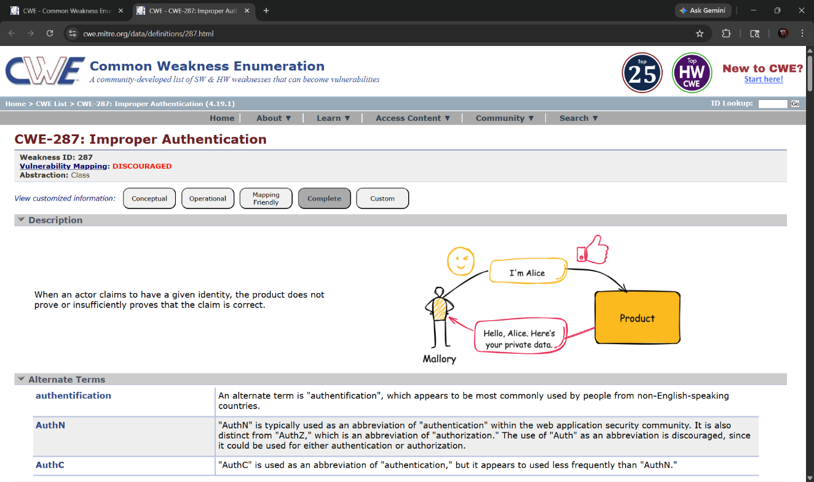

2) Vulnerability Name: Improper Access Control

CWE/CVE: CWE-284

OWASP/SANS Category: A01:2025 – Broken Access Control

Description: Improper Access Control occurs when an application fails to correctly restrict what authenticated users are allowed to access or perform within the system. Access control mechanisms are designed to ensure that users can only access resources or perform actions that they are authorized for. When these controls are not properly implemented, attackers or unauthorized users may bypass restrictions and gain access to sensitive data, files, or administrative functions. This can happen due to improper permission settings, missing authorization checks, or insecure direct object references.
Business Impact: Improper access control can allow attackers to view, modify, or delete sensitive information without authorization. Unauthorized users may gain access to confidential data, perform administrative actions, or manipulate system resources. In cloud environments, such vulnerabilities can expose internal applications and critical business data to attackers. This can lead to data breaches, operational disruptions, financial losses, and damage to the organization’s reputation.
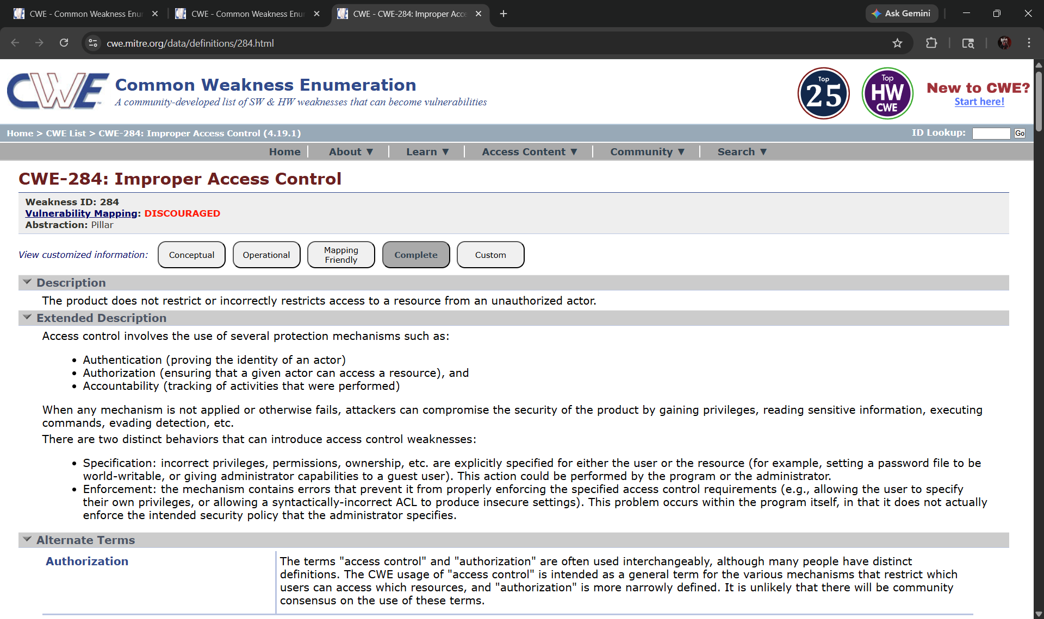

3)Vulnerability Name: Missing Authorization

CWE/CVE: CWE-862

OWASP/SANS Category: A01:2025 – Broken Access Control

Description: Missing Authorization occurs when an application does not properly verify whether an authenticated user has permission to perform a specific action or access certain resources. Even if the user is successfully logged into the system, the application may fail to check whether that user is allowed to view, modify, or delete particular data. Attackers can exploit this weakness by directly accessing restricted URLs, APIs, or system functions without proper authorization checks.
Business Impact: Missing authorization can allow users to access sensitive information or perform critical actions without the required permissions. Attackers may retrieve confidential data, modify important records, or execute administrative operations that should only be available to privileged users. In cloud-based environments, this vulnerability can expose internal applications and critical business data, leading to data breaches, service disruption, financial losses, and damage to the organization’s reputation.

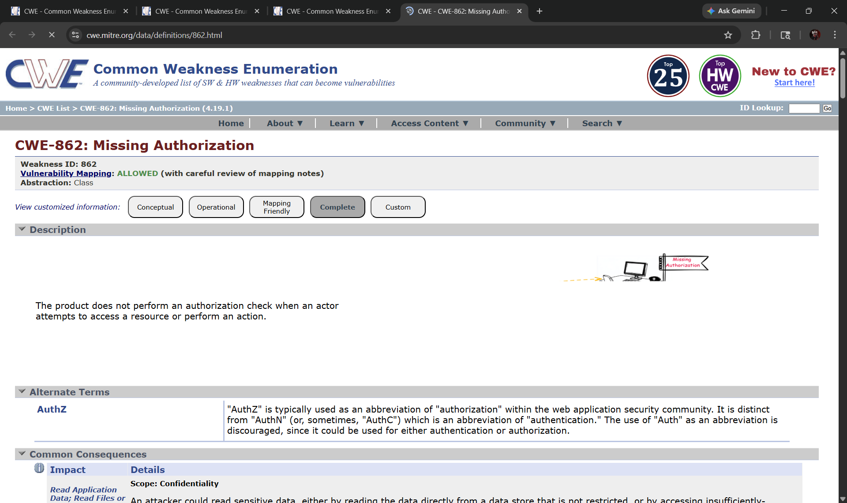

4)Vulnerability Name: Improper Certificate Validation
CWE/CVE: CWE-295
OWASP/SANS Category: A02:2025 – Cryptographic Failures

Description: Improper Certificate Validation occurs when an application fails to correctly verify the authenticity and validity of a digital certificate during secure communication. Certificates are used in protocols such as HTTPS to ensure encrypted and trusted communication between clients and servers. If the application does not properly validate the certificate’s issuer, expiration date, or trust chain, attackers may exploit this weakness to perform man-in-the-middle (MITM) attacks. In such attacks, malicious actors intercept and manipulate communication between users and the server.

Business Impact: Improper certificate validation can allow attackers to intercept sensitive data transmitted between users and applications. This may include login credentials, personal information, or confidential business data. If attackers successfully perform a man-in-the-middle attack, they can read, modify, or redirect communication without the user’s knowledge. This can lead to data breaches, unauthorized access to systems, financial losses, and damage to the organization’s reputation.

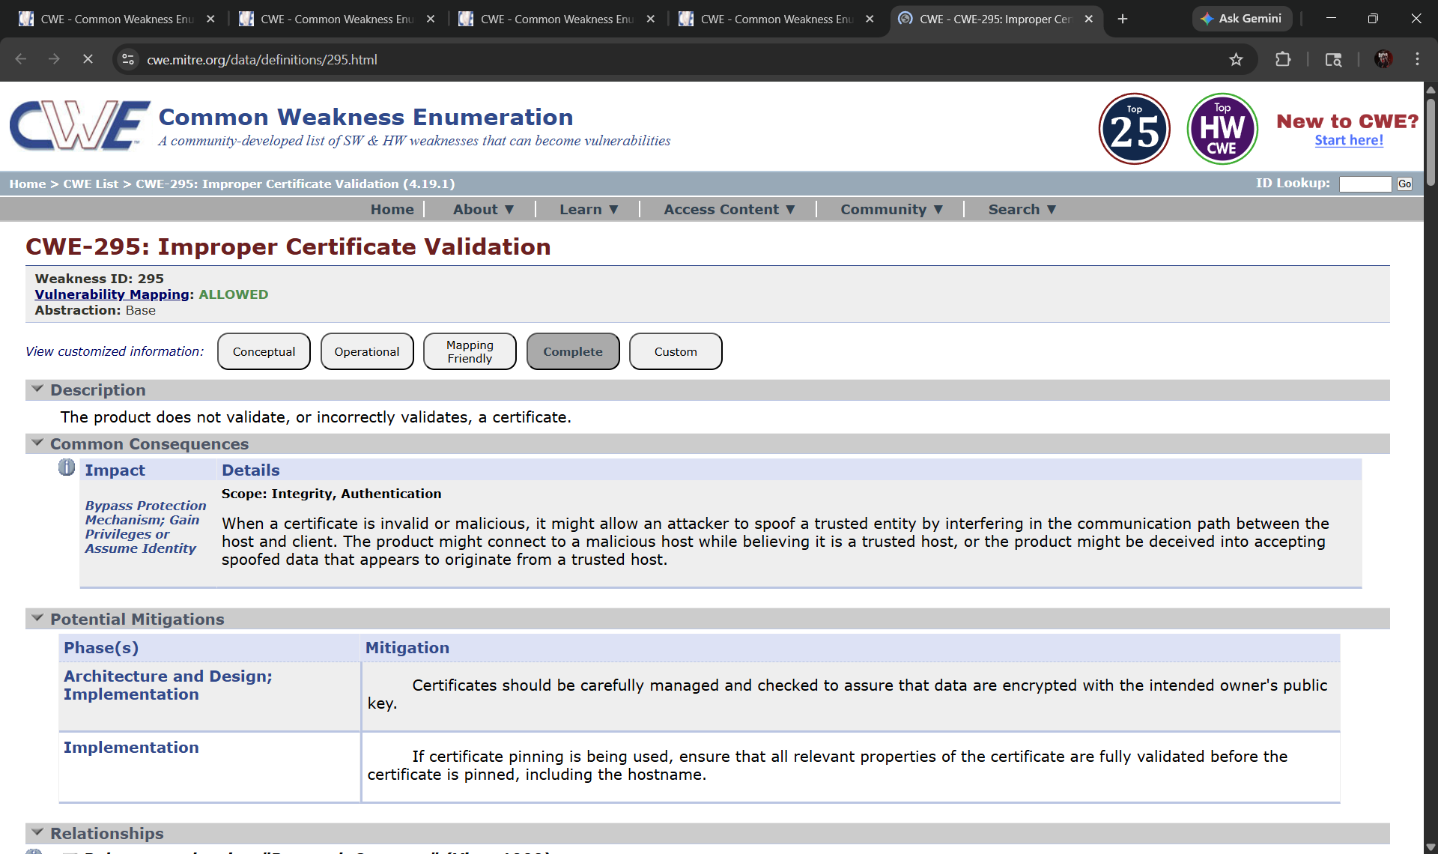

5)Vulnerability Name: Use of Broken or Risky Cryptographic Algorithm

CWE/CVE: CWE-327
OWASP/SANS Category: A02:2025 – Cryptographic Failures

Description: Use of Broken or Risky Cryptographic Algorithm occurs when an application uses outdated, weak, or insecure encryption algorithms to protect sensitive data. Cryptographic algorithms such as MD5, SHA-1, or weak encryption standards may no longer provide adequate security against modern attack techniques. Attackers can exploit these weak algorithms to break encryption, recover confidential data, or bypass security mechanisms. Proper cryptographic practices require the use of strong and modern encryption standards along with secure key management.

Business Impact: Using weak or broken cryptographic algorithms can expose sensitive information such as passwords, financial data, and personal records to attackers. If encryption is compromised, attackers may decrypt confidential data or manipulate secure communications. This can result in data breaches, identity theft, financial loss, and regulatory compliance issues. In cloud-based environments, weak cryptography may also expose critical business data and reduce trust in the organization’s security infrastructure.

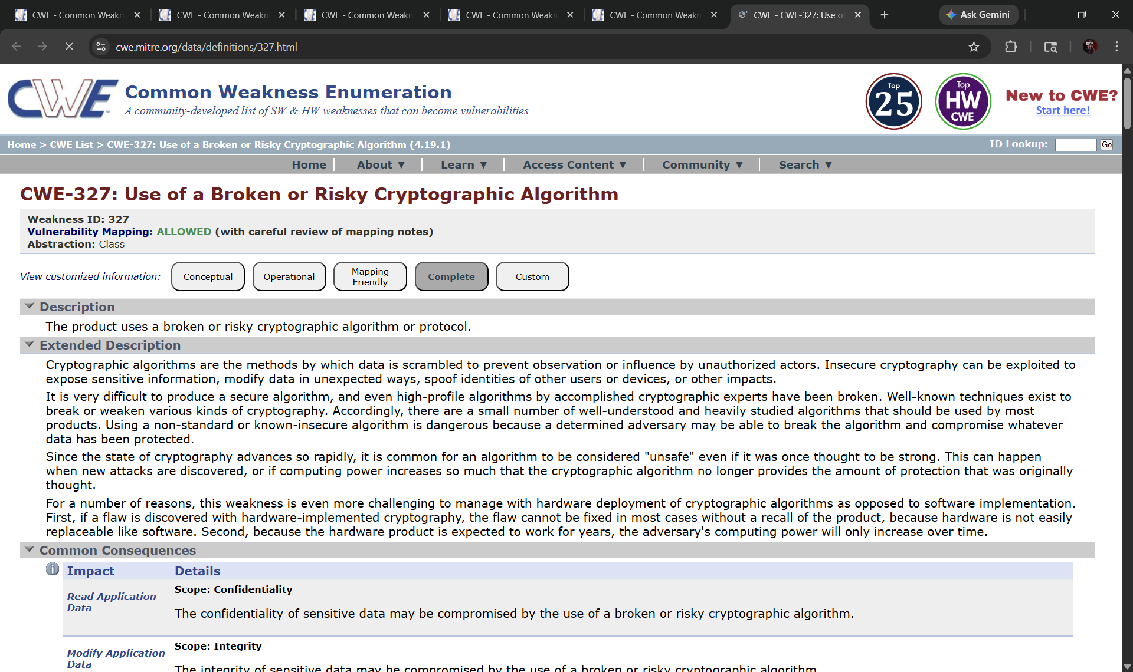

6)Vulnerability Name: Download of Code Without Integrity Check
CWE/CVE: CWE-494
OWASP/SANS Category: A08:2025 – Software and Data Integrity Failures

Description: Download of Code Without Integrity Check occurs when an application downloads and executes external code, updates, or software components without verifying their authenticity or integrity. If proper verification methods such as digital signatures, hash validation, or secure update mechanisms are not implemented, attackers may inject malicious code into the download process. As a result, the system may unknowingly install compromised software that can perform unauthorized actions within the application or network.
Business Impact: This vulnerability can allow attackers to distribute malicious software through trusted update mechanisms or external code repositories. Once the compromised code is executed, attackers may gain unauthorized access to systems, steal sensitive data, or disrupt application functionality. In cloud-based environments, such attacks can spread across multiple systems and users, leading to data breaches, operational downtime, financial losses, and damage to the organization’s reputation.

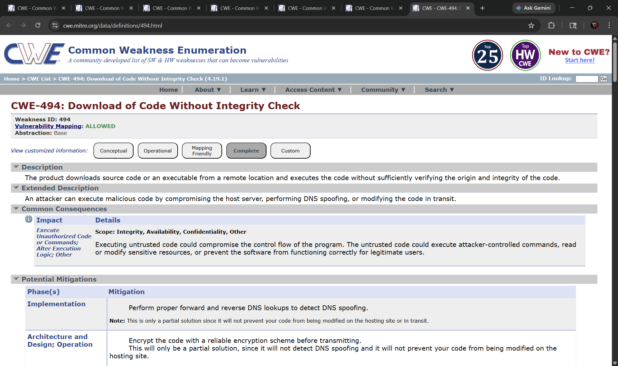

Vulnerability Name: Server-Side Request Forgery (SSRF)

CWE/CVE: CWE-918

OWASP/SANS Category: A10:2025 – Server-Side Request Forgery (SSRF)

Description: Server-Side Request Forgery (SSRF) occurs when a web application allows attackers to manipulate server-side requests to access internal or external resources. In this vulnerability, the attacker tricks the server into sending requests to unintended locations such as internal systems, cloud services, or restricted network resources. Because the request originates from the server itself, it may bypass firewall protections and access sensitive internal services that are normally not exposed to external users.
Business Impact: SSRF vulnerabilities can allow attackers to access internal systems, retrieve sensitive data, or interact with protected services within the organization’s network. In cloud environments, attackers may exploit SSRF to access cloud metadata services and obtain confidential information such as access tokens or configuration details. This can lead to unauthorized access, data breaches, system compromise, and significant security risks for the organization.

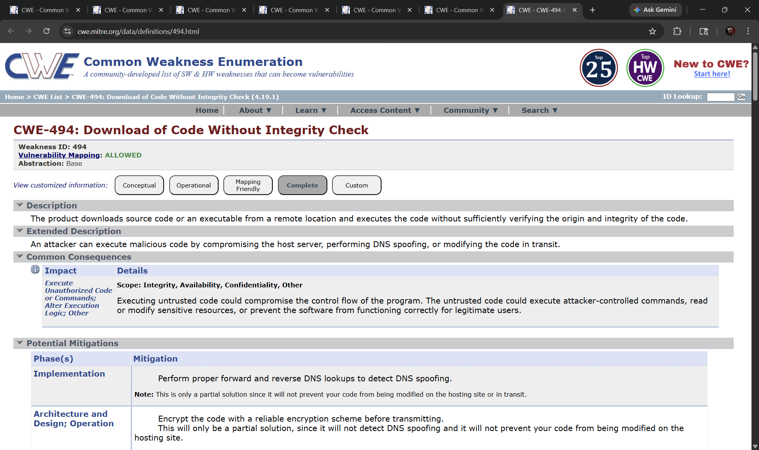

Vulnerability Name: Cross-Site Scripting (XSS)
CWE/CVE: CWE-79

OWASP/SANS Category: A03:2025 – Injection

Description: Cross-Site Scripting (XSS) is a vulnerability that occurs when a web application allows attackers to inject malicious scripts into web pages viewed by other users. This usually happens when the application does not properly validate or sanitize user input before displaying it on a webpage. The injected script executes in the victim’s browser and can perform actions such as stealing session cookies, capturing login credentials, or modifying webpage content without the user’s knowledge.

Business Impact: XSS attacks can compromise user accounts, expose sensitive information, and allow attackers to perform actions on behalf of legitimate users. Attackers may steal authentication tokens, redirect users to malicious websites, or manipulate application data. In cloud-based applications, this can lead to unauthorized access, data breaches, and loss of user trust. Additionally, repeated XSS attacks can damage the organization’s reputation and affect the security of web-based services.

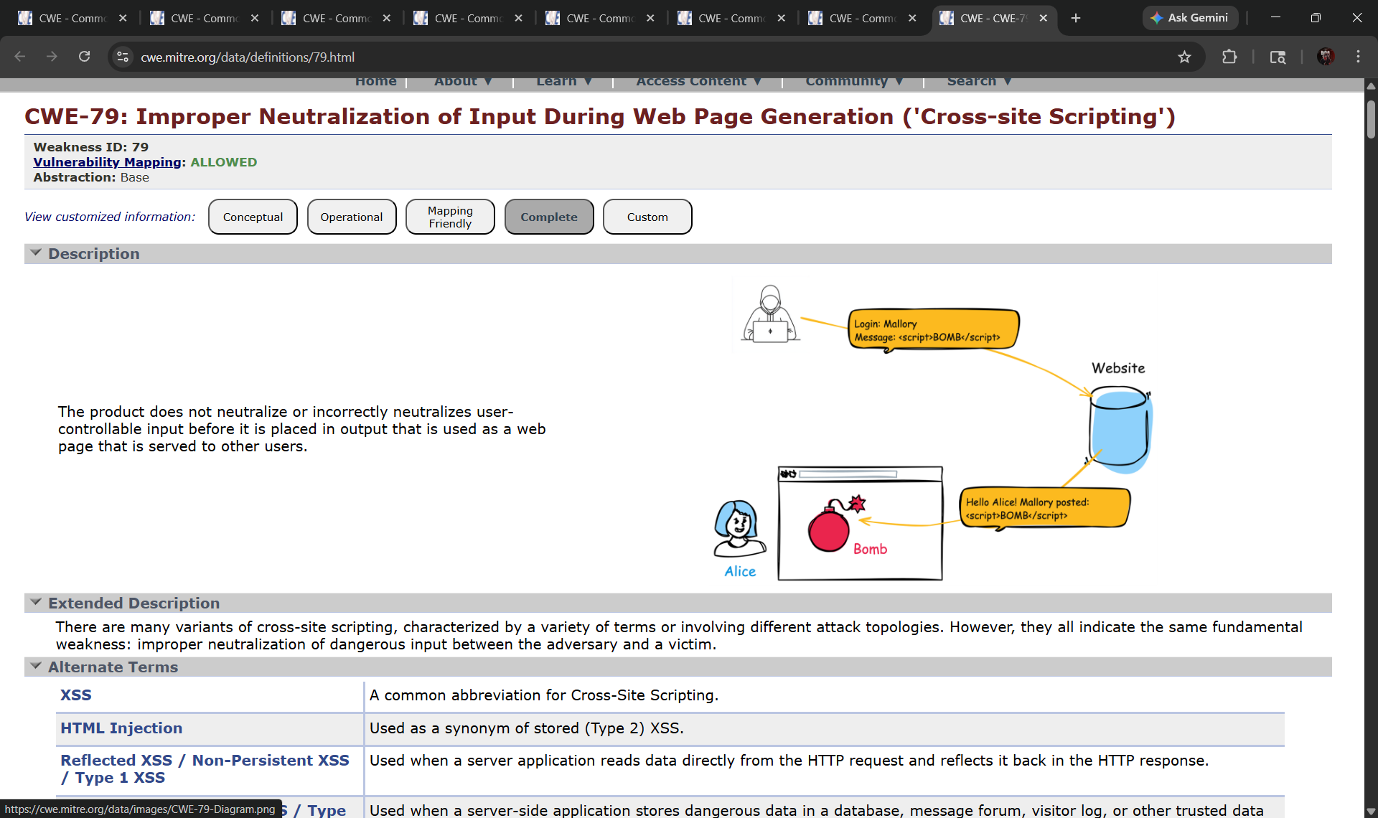

- Vulnerability Name: SQL Injection
CWE/CVE: CWE-89
OWASP/SANS Category: A03:2025 – Injection

Description: SQL Injection is a vulnerability that occurs when an application fails to properly validate or sanitize user input before including it in SQL database queries. Attackers can insert malicious SQL commands into input fields such as login forms, search boxes, or URL parameters. These malicious queries are then executed by the database, allowing attackers to manipulate database operations. As a result, attackers may access, modify, or delete sensitive information stored in the database.

Business Impact: SQL Injection attacks can expose confidential data such as usernames, passwords, financial records, and personal information stored in databases. Attackers may also alter or delete critical data, disrupt application functionality, or gain administrative access to the system. This can lead to data breaches, financial losses, operational disruptions, and damage to the organization’s reputation. In cloud-based environments, compromised databases can also expose large volumes of sensitive business and customer data.
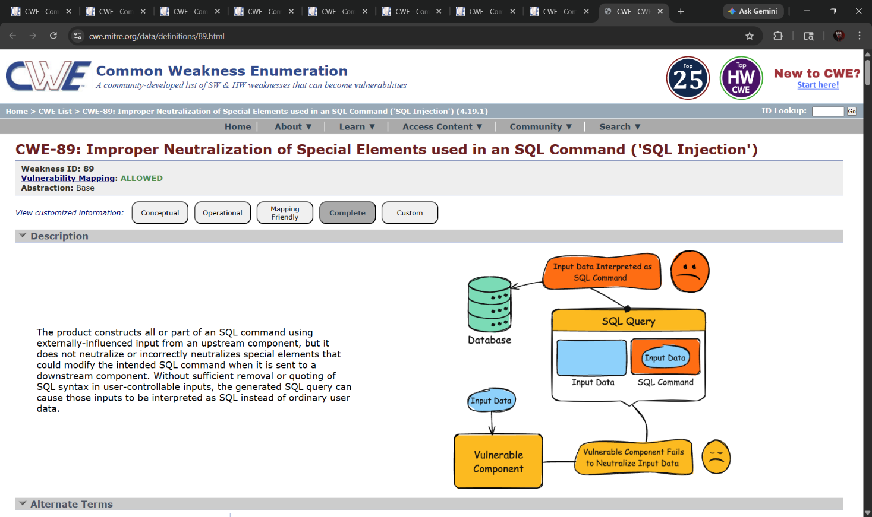

Vulnerability Name: Improper Input Validation
CWE/CVE: CWE-20

OWASP/SANS Category: A03:2025 – Injection

Description: Improper Input Validation occurs when an application fails to properly validate, filter, or sanitize data received from users before processing it. User inputs such as form fields, URLs, file uploads, or API requests may contain malicious or unexpected data. If the application does not check the correctness and format of this input, attackers can exploit the vulnerability to inject harmful commands, manipulate system processes, or bypass security mechanisms.
Business Impact: Improper input validation can allow attackers to execute malicious code, access unauthorized data, or disrupt application functionality. It may also lead to other serious vulnerabilities such as SQL Injection, Cross-Site Scripting (XSS), and command injection. In cloud-based applications, this can expose sensitive business data and compromise system integrity. Such incidents can result in data breaches, service disruption, financial loss, and damage to the organization’s reputation.
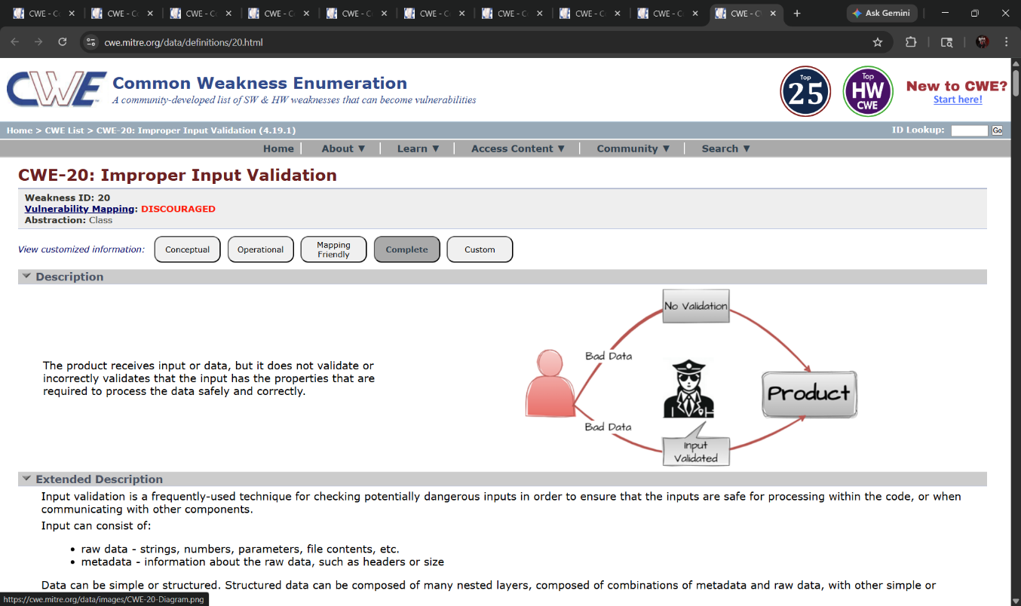

Stage 2

Overview :-

Nessus is one of the most widely used vulnerability scanning tools developed by Tenable, Inc. It is designed to identify security weaknesses in systems, networks, and applications before attackers can exploit them. Nessus operates as a remote vulnerability scanner, meaning it does not require installation on the target system. Instead, it scans systems across the network by sending different types of requests and analyzing the responses to detect potential vulnerabilities.

The primary goal of Nessus is to help organizations maintain a secure IT environment by continuously identifying weaknesses in operating systems, software applications, and network services. Security administrators use Nessus to perform vulnerability assessments and prioritize remediation efforts based on the severity of identified issues..
Nessus is a valuable tool for security professionals who need to identify and remediate vulnerabilities in their networks. It is easy to use and provides comprehensive reports that can be used to prioritise remediation efforts.

Working Principle of Nessus:

Nessus operates using a plugin-based architecture. Plugins are specialized scripts that test for specific vulnerabilities. These plugins contain information about known security flaws, misconfigurations, outdated software, and security policy violations.

During a scan, Nessus first performs host discovery to determine whether a target system is active on the network. Once the host is identified, the scanner gathers information about the system, including the operating system, open ports, and running services. After this discovery phase, Nessus executes various plugins to check for known vulnerabilities associated with the identified services and software.

Nessus then analyzes the responses received from the target system and compares them with its vulnerability database. If a vulnerability is detected, Nessus records it and provides detailed information about the issue.

Steps Involved in Nessus Scanning:

Connection to Target HostNessus connects to the target system using network protocols such as TCP, UDP, and ICMP.

Host Discovery and Information Gathering The scanner identifies the operating system, open ports, and running services on the target machine.

Plugin Execution Nessus runs a set of vulnerability detection plugins to test for known security weaknesses.
- Vulnerability Detection and Analysis The tool analyzes responses from the target system and identifies possible vulnerabilities.
- Report Generation Nessus generates a detailed vulnerability report that includes the severity level, description of the vulnerability, and recommended remediation steps.

Features of Nessus:

Nessus provides several powerful features that make it a preferred vulnerability assessment tool:

- Extensive Vulnerability Database: Nessus includes thousands of plugins that detect vulnerabilities across operating systems, applications, and network devices.
- User-Friendly Interface: The web-based interface makes it easy to configure scans and analyze results.
- Detailed Reporting: Nessus generates comprehensive reports with severity ratings, technical descriptions, and mitigation steps.
- Flexible Scanning Options: It can scan individual hosts, entire networks, or specific services and ports.
- Scheduled Scanning: Security teams can automate scans to run periodically to monitor network security.

Importance of Nessus in Security Assessment:

- Nessus plays a critical role in proactive cybersecurity management. By identifying vulnerabilities early, organizations can take necessary corrective actions to reduce the risk of cyberattacks. Regular vulnerability assessments using Nessus help maintain system integrity, ensure compliance with security standards, and strengthen overall network security.

Target Website :- https://ginandjuice.shop
Target Ip Address:- 34.246.169.176

List of vulnerability:-

s.no | Vulnerability name | Severity | plugins
1 | HSTS Missing From HTTPS Server (RFC 6797) | MEDIUM | 142960
2 | HyperText Transfer Protocol (HTTP) Information | INFO | 24260
3 | SSL Cipher Block Chaining Cipher Suites Supported | INFO | 70544
4 | SSL/TLS Recommended Cipher Suites | INFO | 156899
5 | TLS ALPN Supported Protocol Enumeration | INFO | 84821
6 | Web Server Crafted Request Vendor/Version Information Disclosure | INFO | 11239
7 | Web Server No 404 Error Code Check | INFO | 10386
8 | Service Detection | INFO | 22964
9 | Nessus SYN scanner | INFO | 11219
10 | TLS NPN Supported Protocol Enumeration | INFO | 87242

REPORT: -

- Vulnerability Name: - HSTS Missing From HTTPS Server (RFC 6797)
Severity: - MEDIUM
Plugin: - 142960
Port: - 443
Description: - The remote web server is not enforcing HSTS, as defined by RFC 6797. HSTS is an optional response header that can be configured on the server to instruct the browser to only communicate via HTTPS. The lack of HSTS allows downgrade attacks, SSL-stripping man-in-the-middle attacks, and weakens cookie-hijacking protections.
Solution: Configure the remote web server to use HSTS (HTTP Strict Transport Security) so that browsers automatically enforce HTTPS communication.
Business Impact: If HSTS is not enabled, attackers may downgrade secure HTTPS connections to HTTP and intercept user data through man-in-the-middle attacks. This could lead to data leakage, session hijacking, and loss of user trust in the organization’s website security.

Vulnerability Name: - HyperText Transfer Protocol (HTTP) Information Severity: -INFO
Plugin: - 24260

Port: - 80
Description: - This test gives some information about the remote HTTP protocol such as the version used and whether HTTP Keep-Alive is enabled. This test is informational only and does not denote any security problem.

Solution: - No action is required as this is an informational finding. However, administrators should ensure that the HTTP service is properly configured and secured according to best practices.
Business Impact: This vulnerability does not pose a direct security risk. It simply provides information
about the HTTP service running on the server, which may help administrators

3) Vulnerability Name: - SSL Cipher Block Chaining Cipher Suites Supported

Severity: - LOW
Plugin: - 70544

Port: - 443
Description: - The remote host supports the use of SSL ciphers that operate in Cipher Block Chaining (CBC) mode. These cipher suites offer additional security over Electronic Codebook (ECB) mode, but have the potential to leak information if used improperly.
Solution: - Configure the server to prefer modern and secure cipher suites such as AES-GCM and disable outdated or weaker CBC-based cipher suites where possible..
Business Impact: - Improper use of CBC cipher suites may expose encrypted communications to certain cryptographic attacks, potentially leading to information leakage and weakening the overall security of secure communications.

4)Vulnerability Name: - SSL/TLS Recommended Cipher Suites

Severity: - INFO
Plugin: - 156899

Port: - 443
Description: The remote host has open SSL/TLS ports which advertise discouraged cipher suites. It is recommended to only enable support for strong and secure cipher suites to maintain better encryption standards.
Solution:Configure the server to disable weak or discouraged cipher suites and enable only strong and recommended cipher suites such as AES-GCM and TLS 1.2 or TLS 1.3 based ciphers

Business Impact: Using discouraged or weak cipher suites can reduce the strength of encrypted communications and may make the system more vulnerable to cryptographic attacks, potentially exposing sensitive data.

5) Vulnerability Name: - TLS ALPN Supported Protocol Enumeration

Severity: - INFO
Plugin: - 84821

Port: - 443
Description: - The remote host supports the TLS ALPN (Application-Layer Protocol Negotiation) extension. This plugin enumerates the protocols supported by the server through this extension.
Solution: - No immediate action is required as this is an informational finding. However, administrators should ensure that only necessary and secure protocols are enabled on the server.
Business Impact: - This is an informational result and does not indicate a direct security vulnerability. However, knowledge of supported protocols may help administrators review and maintain secure protocol configurations.

6)Vulnerability Name: - 46180 - Web Server Crafted Request
Vendor/Version Information Disclosure
Severity: - INFO
Plugin: - 11239
Port: - 443
Description: - The web server running on the remote host appears to be hiding its version or name, which is a good security practice. However, by sending a specially crafted request, the scanner was able to retrieve the vendor or version information of the web server.

Solution: - Configure the web server to fully disable server version disclosure by modifying server configuration settings and removing detailed version information from HTTP responses.
Business Impact: - If server vendor or version information is disclosed, attackers may use this information to identify known vulnerabilities associated with that specific server version and plan targeted attacks against the system.

7) Vulnerability Name: - Web Server No404ErrorCodeCheck

Severity: - INFO
Plugin: - 10386

Port: - 80
Description: - The remote web server is configured such that it does not return a “404 Not Found” error code when a nonexistent file is requested. Instead, the server may return a site map, search page, or authentication page.

Solution: - Configure the web server to return proper HTTP status codes, especially the 404 Not Found response when a requested resource does not exist.
Business Impact: - Improper HTTP error handling can make it difficult to identify invalid resources and may help attackers perform automated scanning or enumeration of web directories, potentially exposing hidden resources on the server.

8) Vulnerability Name: - Service Detection

Severity: - INFO

Plugin: - 22964

Port: - 443

Description:
Nessus was able to identify the remote service by analyzing the service banner or by examining the error message returned when the server received an HTTP request..

Solution: Configure the server to minimize service banner information and disable unnecessary banner disclosures in the server configuration.

Business Impact: If service details are exposed through banners or error messages, attackers may use this information to identify the underlying technologies and target known vulnerabilities related to those services.

9) Vulnerability Name:- Nessus SYN Scanner
Severity: - INFO
Plugin: - 11219

Port: - 80
Description: - This plugin performs a SYN “half-open” port scan to identify open ports on the target system. It is generally faster than a full TCP connection scan and is commonly used for network reconnaissance. SYN scans are less intrusive but may leave half-open connections on the target if the network is heavily loaded.

Solution: - Restrict unnecessary open ports using firewall rules and configure intrusion detection or prevention systems to monitor and control unauthorized port-scanning activities.
Business Impact: - Open port detection can reveal network services running on the server. Attackers may use this information to identify potential entry points and attempt exploitation of vulnerable services.

10)Vulnerability Name: - TLS NPN Supported Protocol Enumeration

Severity: - INFO
Plugin: - 87242

Port: - 443
Description: - The remote host supports the TLS NPN (Next Protocol Negotiation) extension.This plugin enumerates the protocols supported by the server through this extension during the TLS handshake process.

Solution: - Ensure that only necessary and secure protocols are enabled on the server and disable deprecated protocol negotiation mechanisms if they are not required.

Business Impact: -This is an informational finding and does not indicate a direct vulnerability. However, knowing the supported protocols may help attackers understand the server configuration and identify potential weaknesses if outdated protocols are enabled.
NESSUS SCAN REPORT:-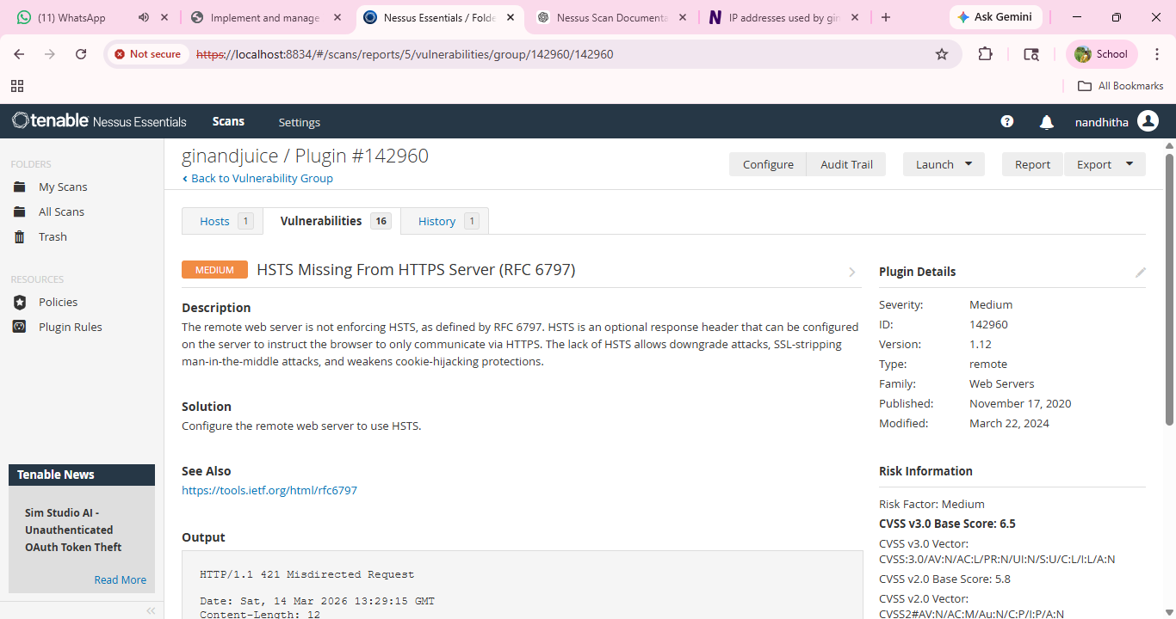
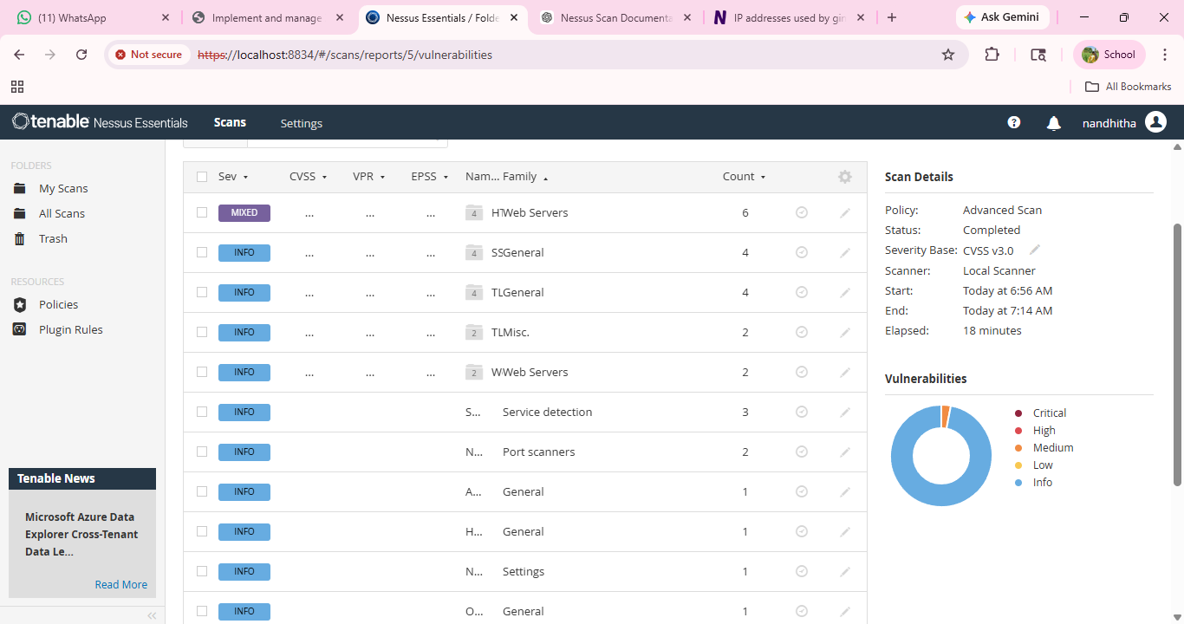

Report: -

Stage-3

Title: - Implementing Zero Trust Network Access (ZTNA) with Zscaler: Secure Access To Cloud Applications.

Zero Trust Network Access (ZTNA):

Zero Trust Network Access (ZTNA) is a modern cybersecurity framework designed to provide secure access to cloud applications and organizational resources without exposing the internal network. Traditional security models often rely on Virtual Private Networks (VPNs) that grant users broad access to the corporate network once they authenticate. However, this approach can create significant security risks if a user account or device becomes compromised.

ZTNA follows the principle of “Never Trust, Always Verify.” Instead of granting full network access, ZTNA verifies the identity, device security posture, and context of every access request before allowing a connection to a specific cloud application. This ensures that users receive only the level of access required to perform their tasks.

By implementing ZTNA, organizations can hide internal and cloud-based applications from direct internet exposure while establishing secure, encrypted connections between users and applications. This significantly reduces the attack surface and prevents attackers from moving laterally across the network if a device or user account is compromised.

ZTNA has become an essential component of modern security architectures, especially in organizations that rely on cloud services, Software-as-a-Service (SaaS) platforms, and remote work environments. It helps protect sensitive resources such as enterprise cloud applications, internal portals, and business data systems.

The ZTNA Access Cycle:

The ZTNA access cycle represents the process through which users securely access cloud applications. Each access request goes through multiple verification stages to ensure security and compliance.

- A user attempts to access a cloud-based or internal application from any location such as home, office, or remote environment. This may include accessing enterprise cloud platforms, databases, or SaaS applications.
- Before granting access, the system verifies the user's identity using authentication mechanisms such as Multi-Factor Authentication (MFA). At the same time, the device posture is checked to ensure it meets security requirements such as updated antivirus software and operating system patches.
- The ZTNA platform evaluates predefined access policies to determine whether the user is authorized to access the requested cloud application. Policies consider factors such as user role, device compliance, and access location.
- If the request satisfies the policy conditions, a secure encrypted connection (micro-tunnel) is established between the user’s device and the specific cloud application.
- During the session, the system continuously monitors user activity to detect suspicious behaviour. If abnormal activity is detected, access can be immediately revoked.
- All access attempts and activities are recorded in logs. These logs help security teams perform monitoring, auditing, and threat detection.

Zscaler (Zscaler Internet Access / Zscaler Private Access):

Zscaler is a cloud-based cybersecurity platform that provides secure access to internet resources and cloud applications without relying on traditional network security appliances.

For implementing ZTNA, Zscaler offers Zscaler Private Access (ZPA). ZPA enables secure, identity-based access to internal and cloud applications without exposing them to the public internet or placing users directly on the internal network.

ZPA works by connecting users to applications through the Zscaler cloud platform. It integrates with several security and identity systems including:

- Identity Providers (IdP)
Systems such as Microsoft Azure Active Directory or Okta verify user identities and enforce authentication policies.
- Device Security Tools
Endpoint security tools such as Microsoft Defender or CrowdStrike validate device health and compliance status.
- Cloud and Internal Business Applications
Applications hosted in cloud platforms such as AWS, Microsoft Azure, Google Cloud, or private data centers.

- Zscaler App Connectors
Lightweight virtual machines deployed within the organization’s infrastructure that securely connect applications to the Zscaler cloud platform

Zscaler enforces security policies based on user identity and application access requirements. Key policy features include:

• Identity-based access control
• Application-level segmentation
• Least-privilege access model

The Zscaler ZTNA Cycle:

The Zscaler ZTNA cycle represents the implementation of Zero Trust principles using the Zscaler cloud platform.

- User Login and Authentication:
A user attempts to access a cloud or internal application. The user is redirected to the organization’s Identity Provider (IdP) for authentication and multi-factor verification.
- Device Posture Check:
Zscaler integrates with endpoint security tools to verify that the user's device meets the organization’s security requirements.
- Policy Evaluation:
The Zscaler cloud platform checks access policies to determine whether the user is authorized to access the requested application.
- Secure Micro-Tunnel Creation:
Once authorized, Zscaler establishes a secure encrypted micro-tunnel between the user's device and the requested application.
- Traffic Inspection:
Zscaler may inspect traffic for malware detection, data loss prevention (DLP), and threat protection.
- Logging and Analytics:
All activities are logged within the Zscaler cloud portal for security monitoring, auditing, and compliance purposes.

Cloud-Based Organizational Network Environment:

Modern organizations increasingly rely on cloud platforms to host their applications and services. A typical organizational cloud network environment includes:

• Cloud infrastructure platforms (AWS, Azure, Google Cloud)
• Enterprise SaaS applications
• Secure web gateways and firewalls
• Identity and access management systems
• Cloud-hosted databases and application servers
• Legacy VPN infrastructure used for remote access

However, traditional VPN solutions provide broad network-level access once a user connects. This creates security risks because a compromised device may gain access to multiple internal systems.

ZTNA solves this problem by allowing users to connect only to specific cloud applications rather than the entire network, improving security and reducing potential attack surfaces.

How ZTNA Using Zscaler Can Be Deployed in a College Environment:

To deploy Zscaler ZTNA (ZPA) in a college environment, the implementation would focus on securing access to cloud-based educational and administrative systems.

The deployment plan includes:

- Application Discovery
Identify all applications used by students, faculty, and administrators such as ERP systems, student portals, cloud storage, and research servers.
- User Segmentation
Define user groups such as Students, Faculty, IT Staff, and External Collaborators with specific access permissions.
- Deploying Zscaler App Connectors
Install App Connectors in the institution’s cloud environment or data center to connect internal applications securely to the Zscaler cloud.
- Identity Integration
Integrate Zscaler with the college Identity Provider (such as Azure AD) to enforce authentication and MFA.

- Access Policy Configuration
Define granular policies such as:
“Students can access LMS systems only after authentication and from compliant devices.”
- Deploying Zscaler Client Connector
Students, faculty, and staff install the Zscaler Client Connector on their devices to securely connect to cloud applications.

Threat Intelligence:

Threat intelligence in ZTNA environments provides insight into potential cyber threats targeting cloud applications.

Sources of threat intelligence include:

- Zscaler Cloud Logs
Logs provide visibility into user access behaviour and application usage patterns.
- External Threat Intelligence Feeds
These feeds provide information about emerging cyber threats, malicious domains, and attacker infrastructure.
- Identity Provider Logs
Unusual login patterns or suspicious authentication attempts can indicate compromised accounts.

Threat intelligence helps organizations implement:
• Adaptive access control
• Threat detection and monitoring
• Proactive blocking of malicious connections

Threat Intelligence Integration:

Threat intelligence integration strengthens security by enabling systems to identify malicious activities before they cause damage.

ZTNA platforms integrate intelligence sources such as:
- Internal security logs and monitoring tools
- External cybersecurity intelligence platforms
- Identity and authentication system logs

By integrating threat intelligence with ZTNA solutions, organizations can automatically block malicious connections and improve overall security posture.

Secure Access to Cloud Applications in an Organizational Network:

Modern organizations rely heavily on cloud applications for daily operations. Employees, students, and administrators may access these services from various locations, increasing potential cybersecurity risks.

A typical cloud-based organizational network includes:

• Cloud infrastructure platforms
• Secure gateways and firewalls
• Identity management systems
• Cloud application servers
• Database and administrative platforms

Traditional VPN solutions allow broad access to the internal network once authenticated. This creates security risks because compromised devices can potentially access multiple systems.
ZTNA eliminates this risk by ensuring users connect only to the specific cloud applications required for their work.

Deployment Approach for Securing Cloud Application Access:

Implementing ZTNA for cloud applications requires a structured deployment strategy.

- Application Identification
Identify cloud applications requiring secure remote access.
- User Segmentation
Define user groups such as students, faculty, administrators, and external partners.
- Secure Application Connectivity
Deploy secure connectors that link applications to the ZTNA platform.

- Identity Integration
Integrate identity providers for authentication and access control.
- Access Policy Configuration
Define policies controlling which users can access specific cloud applications.
- Client Deployment
Install secure client connectors on user devices for encrypted communication.

Conclusion: -
In conclusion, the project “Protecting Remote Access to Internal Applications using Zero Trust Network Access (ZTNA) with Zscaler” provided a comprehensive understanding of modern cybersecurity approaches used to secure organizational resources and internal applications.
In Stage 1, the study focused on identifying and understanding common web and network vulnerabilities. By analysing major security weaknesses based on OWASP Top 10 categories and CWE vulnerabilities, this stage highlighted the importance of proactive vulnerability assessment in protecting applications from cyber threats. Understanding these vulnerabilities forms the foundation for implementing effective security controls.
In Stage 2, the project explored vulnerability scanning using the Nessus vulnerability assessment tool. By analysing Nessus scan results and plugin severity levels, it became possible to identify potential security weaknesses within a target system. The detailed vulnerability reports provided insights into threat severity, affected components, and recommended remediation strategies. This stage emphasized the importance of continuous vulnerability scanning in maintaining a strong security posture.
In Stage 3, the project introduced the concept of Zero Trust Network Access (ZTNA) and its implementation using Zscaler Private Access (ZPA). This stage demonstrated a modern security approach that replaces traditional VPN-based access with identity-based, application-level connectivity. By ensuring that users can only access specific applications rather than the entire network, ZTNA reduces the attack surface and prevents lateral movement within the network. This approach is particularly important in today's digital environment where remote work, cloud services, and distributed networks are increasingly common.
Overall, the project demonstrates how combining vulnerability assessment tools with modern Zero Trust security frameworks can significantly enhance the protection of internal applications and organizational resources.

Future Scope:-
The future of cybersecurity continues to evolve as organizations adopt cloud computing, remote work environments, and digital transformation strategies. Protecting internal applications will require more advanced security models and intelligent monitoring systems.
Some of the key future developments in this domain include:
1. AI-Driven Security Monitoring
Artificial Intelligence and Machine Learning will play a significant role in cybersecurity by enabling systems to detect unusual user behaviour, identify potential threats automatically, and respond to attacks in real time.
2. Advanced Zero Trust Architecture
Future Zero Trust implementations will incorporate continuous authentication, behavioural analysis, and contextual risk assessment to dynamically adjust user access privileges.
3. Integration with Cloud Security Platforms
As more applications move to cloud environments, ZTNA solutions will integrate more closely with cloud security tools such as Secure Access Service Edge (SASE) platforms to provide unified security across networks and cloud services.
4. Automated Vulnerability Management
Future vulnerability scanning tools will incorporate automation and AI-driven analysis to detect vulnerabilities faster and prioritize remediation based on risk levels.
5. Enhanced Threat Intelligence Integration
Organizations will increasingly rely on threat intelligence feeds to identify emerging cyber threats and automatically block malicious activity before it impacts internal systems.
6. Improved Remote Access Security
With the continued growth of remote work, Zero Trust solutions will evolve to provide stronger identity verification, device security validation, and continuous monitoring of user activities.

Topics Explored:-
The following key topics were explored during the development of this project:
- Web Application Vulnerabilities and Security Risks
- OWASP Top 10 Security Risks
- Common Weakness Enumeration (CWE) Vulnerabilities
- Vulnerability Assessment and Penetration Testing
- Nessus Vulnerability Scanning and Plugin Analysis
- Severity Classification of Vulnerabilities

- Zero Trust Security Architecture
- Zero Trust Network Access (ZTNA)
- Zscaler Private Access (ZPA)
- Identity-Based Access Control
- Secure Remote Access Mechanisms
- Threat Intelligence and Security Monitoring
- Incident Detection and Response Strategies
Tools Explored:-
During this project, several cybersecurity tools and technologies were studied and analyzed to understand their role in protecting internal applications and identifying vulnerabilities.
- Nmap – Network scanning tool used for discovering hosts and services in a network
- Nessus – Vulnerability scanning tool used to identify security weaknesses in systems and applications
- Metasploit Framework – Penetration testing framework used to simulate cyberattacks and exploit vulnerabilities
- Kali Linux – A cybersecurity-focused operating system containing various penetration testing tools
- OWASP ZAP – Open-source web application security testing tool used to detect vulnerabilities in web applications
- Burp Suite – Web application security testing platform used for analysing and testing HTTP traffic

**********THE END************

