This document provides a demo that shows how our scripts perform. The examples are obtained from section **5.1 The linear model** and section **8.9 Seasonal ARIMA models**. You can find the full scripts in the **Scripts** folder of **Forecasting-Cookbook** repository at <https://github.com/sassoftware/sas-viya-forecasting/tree/master/Forecasting-Cookbook>.

Before running the scripts, you need to define a library (time) that contains your SAS datasets. Moreover, you need to set up a CAS session and link a library (mycas) to it.

**5.1 The linear model**

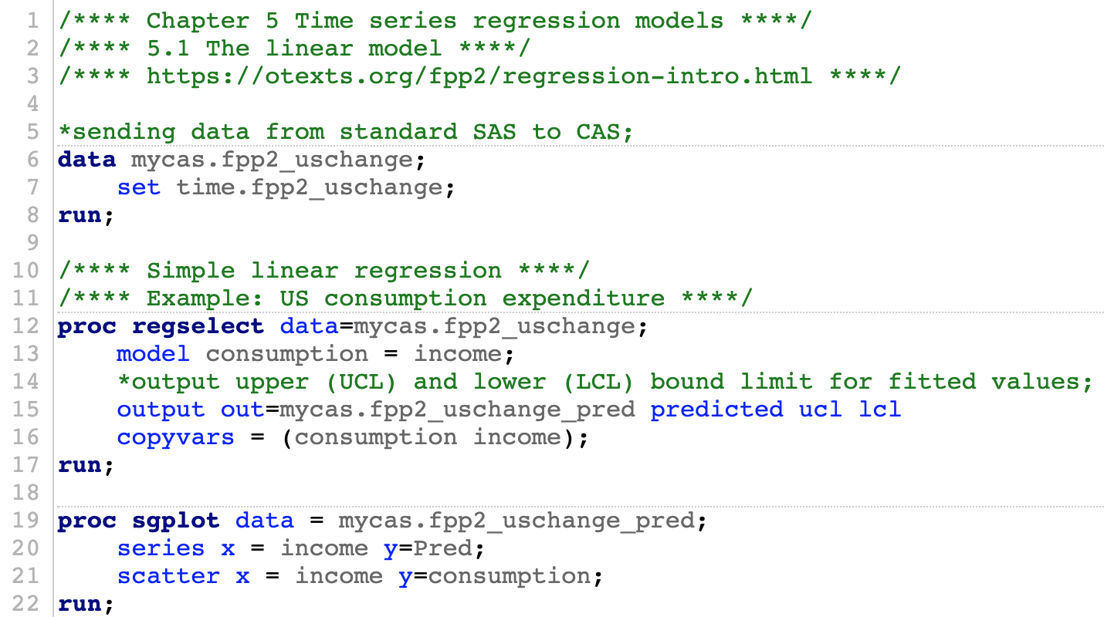

**Parameter Estimates**, and its relevant statistics are displayed in the output:

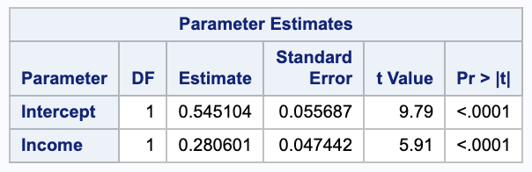

The following is the plot of the fitted values and actual values of consumption with respect to the income levels.

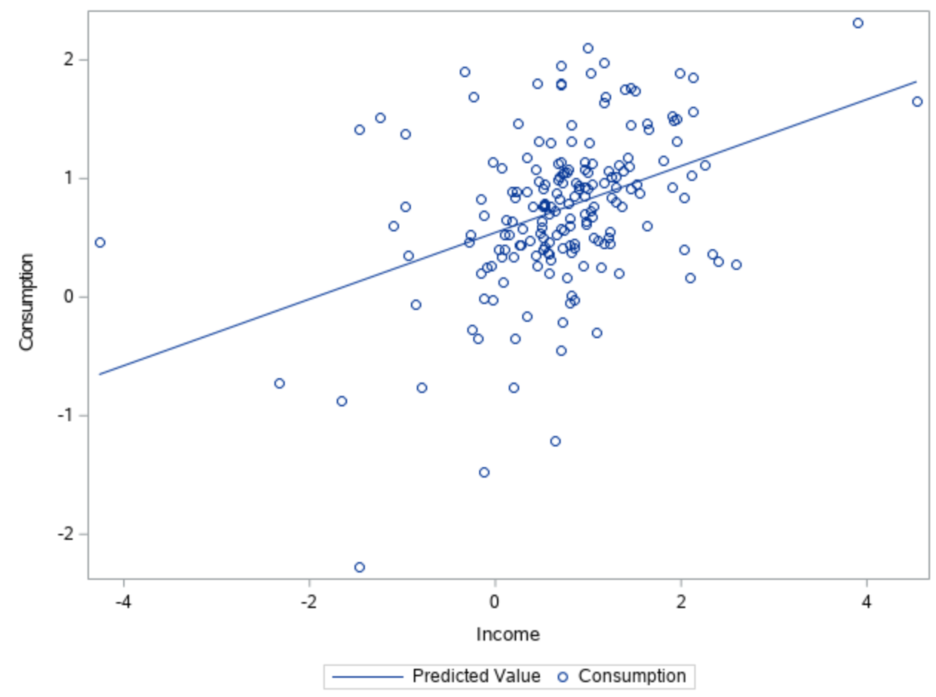

**8.9 Seasonal ARIMA models**

The automatic time series analysis and forecasting (ATSM) package provides objects that are designed to support automatic time series modeling and automatic forecasting. For more information about the statistical methodology that underlies this package, see the chapters about the HPFDIAGNOSE, HPFENGINE, and HPFSELECT procedures in *SAS Forecast Server Procedures: User's Guide*. In addition, it is helpful to review [**Chapter 10: The TSMODEL Procedure**](https://go.documentation.sas.com/api/docsets/casforecast/8.4/content/casforecast.pdf?locale=en#nameddest=casforecast_tsmodel_toc) in SAS Visual Forecasting 8.4: Forecasting Procedures, and [**Chapter 12: Time Series Model Package**](https://go.documentation.sas.com/api/docsets/castsp/8.4/content/castsp.pdf?locale=en#nameddest=castsp_contents). Each of the objects in the ATSM package is designed to carry out a particular task in the time series analysis process.

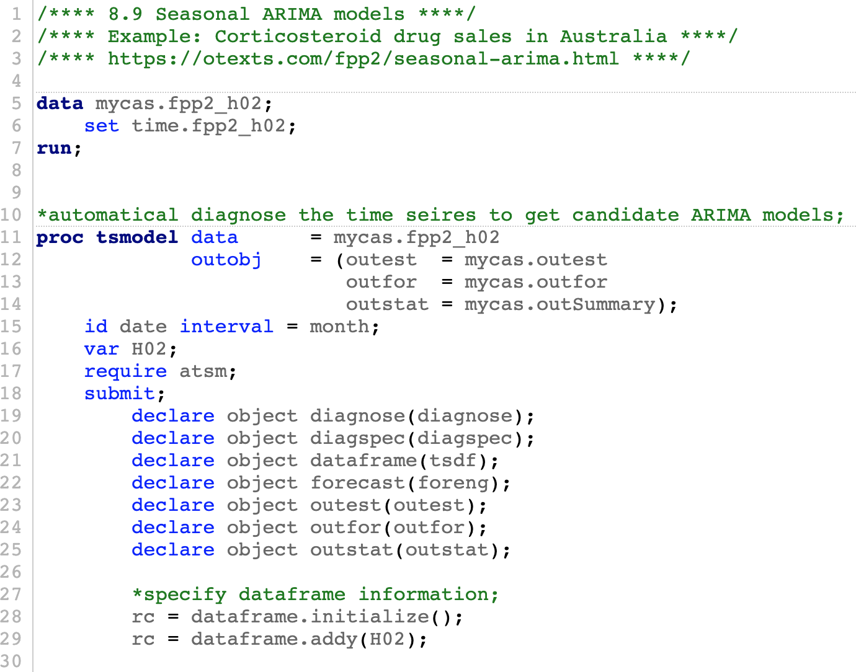

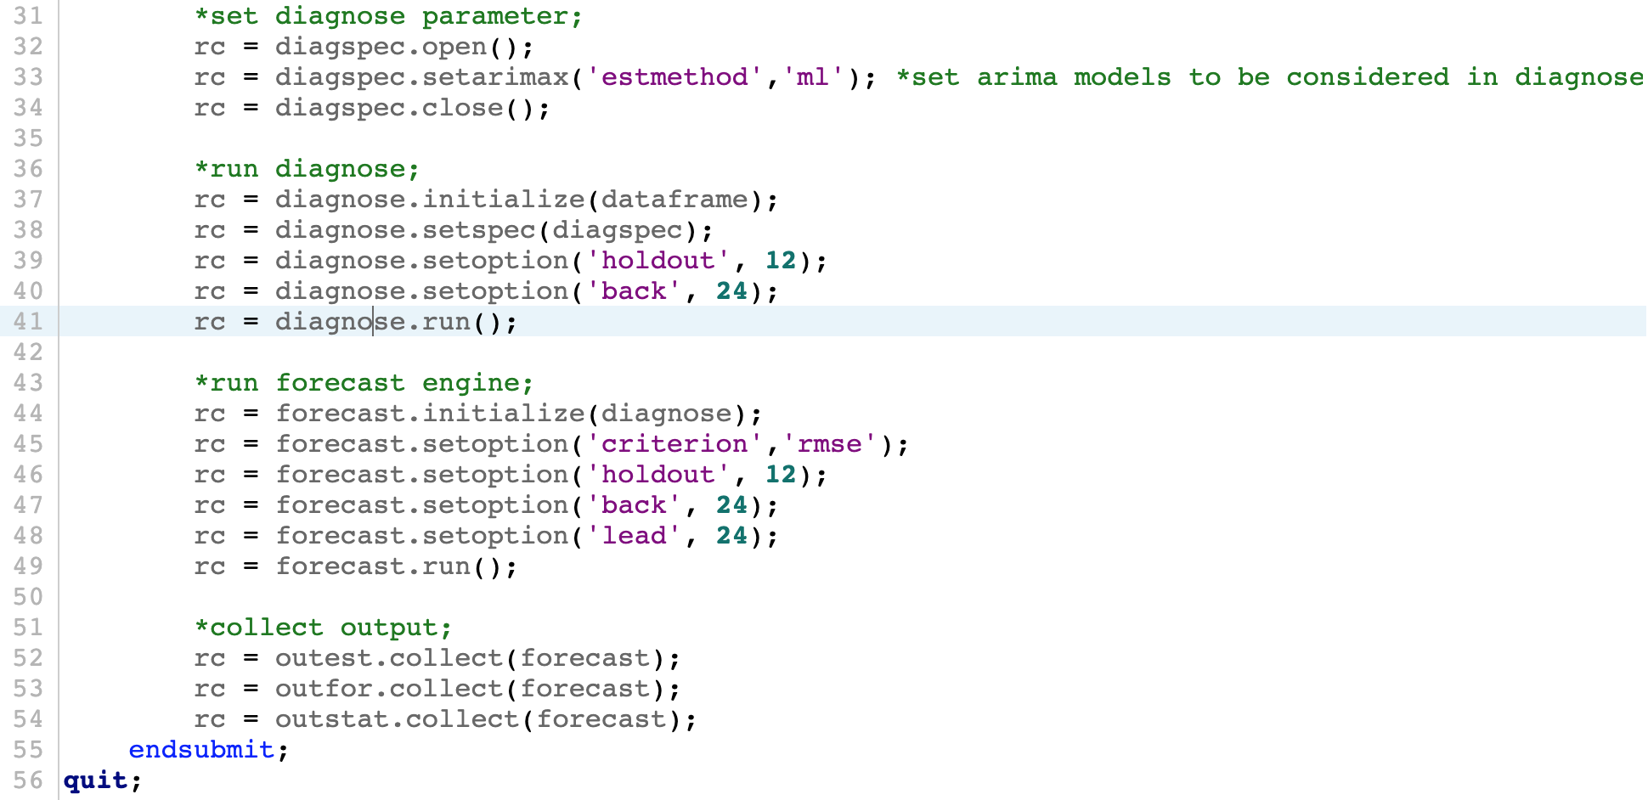

In this example, the best ARIMA model is fitted on the data. One can create a plot of fitted values as below:

