**When**: November 21, 22(backup)

**Where**: Satellite – Mt. Takato

GS – BIRS GS, 8F

**Who**:

Mt. Takato

Yudai, Rintaro, Linh, Hoksong

Kyutech GS

Tharindu, Javier, Sirash

**To bring**:

Mt.Takato

|  |  |  |
| --- | --- | --- |
| □ satellite (assembled) | □ Pelican case | □ soldering iron and lead |
| □ spectrum analyzer | □ external power supply | □ laptop |
| □ styro foam | □ multimeter | □ pen |
| □ satellite pad, bubble wrap | □ adapters (e.g. SMA adapters) | □ phone charger |
| □ RF cable | □ kapton tape | □ gloves (box) |
| □ UART cable | □ duct tape | □ alcohol |
| □ charging cable | □ measuring tape | □ tissue (box) |
| □ PICKit 3 programmer | □ Scissors | □ umbrella |
| □ programming board | □ cutter |  |
| □ dipole reference antenna | □ screw box |  |

Kyutech GS

|  |  |  |
| --- | --- | --- |
| □ RF cables | □ attenuators (30, 40 dB) | □ Hand held radio |
| □ adapters | □ multimeter | □ Signal Generator |
| □ spectrum analyzer | □ laptop | □ BIRDS-GS UHF Antenna |
| □ iCOM 9100 | □ pen | □ BIRDS-GS software |

**0 Preparation**

Before going to Mt. Takato, make sure the following have been done.

0.1 Measure and confirm the following output power.

|  |  |
| --- | --- |
| Parameter | Measured Value (dBm) |
| BIRDS-X EM CW Output |  |
| IC-9100 Output (for VHF at BIRDS Room) |  |
| IC-9100 Output (for UHF at 8F, set to 45 dBm) |  |
| SG-RF Amp configuration Output (for UHF at 8F, set to 45 dBm, SG = -8 dBm) |  |
|  |  |

1. **UHF Test**
   1. **Calibration**
      1. **Pointing the BIRDS GS antenna towards Mt. Takato**

In this test, BIRDS-X EM satellite will transmit continuous beacon signal (20dBm) and BIRDS GS antenna will try to capture maximum power from Mt. Takato side.

* + - * Position BIRDS-X EM satellite such that the UHF antenna is　horizontal and facing towards the GS (Note: this will be BIRDS-X EM satellite position all throughout this test).
      * Set the BIRDS-X EM satellite to transmit continuous beacon signal.
      * Point the BIRDS GS antenna in the nominal direction (EL = 0°, AZ = 220°).
      * Measure the received power at the BIRDS GS antenna. Set channel power bandwidth of spectrum analyzer to 500Hz and center frequency 437.375MHz. Record in the table below.
      * Adjust the BIRDS GS antenna direction about the nominal direction to find the direction with the maximum received power. Record in the table below.

|  |  |
| --- | --- |
| BIRDS GS Antenna AZ | Received Signal Power (dBm) |
| 220 |  |
| 217 |  |
|  |  |
|  |  |
|  |  |
|  |  |
|  |  |
|  |  |
|  |  |
|  |  |
|  |  |
|  |  |

* + - * + Fix the BIRDS GS antenna in this direction.

AZ direction: __________

Received Signal Power: __________

Note: when the maximum power is received, and antenna direction should be fixed and it should be kept throughout the test.

* + 1. **Pointing the Horyu-4 GS Antenna towards Mt. Takato**

Repeat the 1.1.1 but this time is for Horyu-4 GS Antenna.

|  |  |
| --- | --- |
| Hoyu-4 GS Antenna AZ | Received Signal Power (dBm) |
| 220 |  |
| 217 |  |
|  |  |
|  |  |
|  |  |
|  |  |
|  |  |
|  |  |
|  |  |
|  |  |
|  |  |
|  |  |

* + - * + Fix the Horyu-4 GS antenna in this direction.

AZ direction: __________

Received Signal Power: __________

* + 1. **Measuring effective downlink attenuation from Mt. Takato to GS**
       - BIRDS-X EM satellite will transmit continuous CW beacon (20 dBm). Carefully take note of this position.
       - Measure the received power by the BIRDS GS antenna and record in the table below.
       - Measure the received power by the Horyu-4 GS antenna and record in the table below.

Using BIRDS GS Antenna

|  |  |
| --- | --- |
| Received Power (dBm) | Effective Downlink Attenuation (dB) (20 dBm – Received Power) |
|  |  |
|  |  |
|  |  |
|  |  |
|  |  |

Using Horyu-4 GS Antenna

|  |  |
| --- | --- |
| Received Power (dBm) | Effective Downlink Attenuation (dB) (20 dBm – Received Power) |
|  |  |
|  |  |
|  |  |
|  |  |
|  |  |

* + 1. **Measuring effective uplink attenuation from GS to Mt. Takato**

This test is performed to check if effective downlink and uplink attenuations are the equal.

* + - * Set-up SG-RF Amplifier GS configuration such that TX output power is 45 dBm (SG = -8 dBm, single tone).

* + - * Connect BIRDS GS Antenna to RF amplifier

BIRDS-X EM

* + - * Setup the BIRDS-X EM satellite on the platform
      * Output single tone from SG
      * Measure received RF power by BIRDS-X EM UHF antenna using SA. Record in the table below.
      * Connect Horyu-4 GS antenna to RF amplifier.
      * Output single tone from SG
      * Measure received RF power by BIRDS-X EM UHF antenna using SA. Record in the table below.

Reference UHF Dipole Antenna

* + - * Setup reference UHF dipole antenna on the platform
      * Output Single tone from SG
      * Measure received RF power by reference UHF dipole antenna using SA. Record in the table below.
      * Connect Horyu-4 GS antenna to RF amplifier.
      * Output single tone from SG
      * Measure received RF power by BIRDS-X EM UHF antenna using SA. Record in the table below.

Received Uplink Power using BIRDS-X EM UHF Antenna and   
BIRDS GS Antenna

|  |  |
| --- | --- |
| Received Power (dBm) | Effective Downlink Attenuation (dB) (45 dBm – Received Power) |
|  |  |
|  |  |
|  |  |
|  |  |
|  |  |

Received Uplink Power using BIRDS-X EM UHF Antenna and   
Horyu-4 GS antenna

|  |  |
| --- | --- |
| Received Power (dBm) | Effective Downlink Attenuation (dB) (45 dBm – Received Power) |
|  |  |
|  |  |
|  |  |
|  |  |
|  |  |

Received Uplink Power using Reference UHF Dipole Antenna and BIRDS GS antenna

|  |  |
| --- | --- |
| Received Power (dBm) | Effective Downlink Attenuation (dB) (45 dBm – Received Power) |
|  |  |
|  |  |
|  |  |
|  |  |
|  |  |

Received Uplink Power using Reference UHF Dipole Antenna and Horyu-4 GS antenna

|  |  |
| --- | --- |
| Received Power (dBm) | Effective Downlink Attenuation (dB) (45 dBm – Received Power) |
|  |  |
|  |  |
|  |  |
|  |  |
|  |  |

* 1. **Uplink Success Rate using SG-RF Amplifier GS Setup**

BIRDS GS antenna will be used for sending uplink signal. It will be connected to RF amplifier output. Horyu-4 GS will be connected to ICOM radio for receiving ACK.

First, BIRDS-X EM uplink success rate will be determined by finding the maximum attenuator connected to RF amplifier wherein ACK can still be received (~75% success rate). Use simplified EM software but remove beacon.

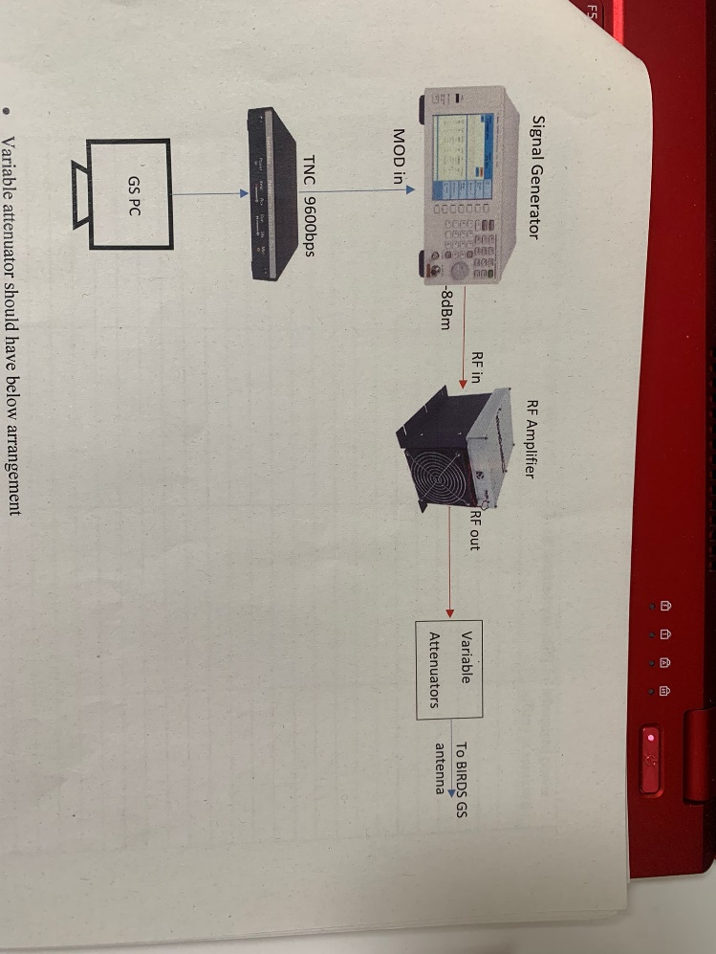

Variable attenuator should have below arrangement

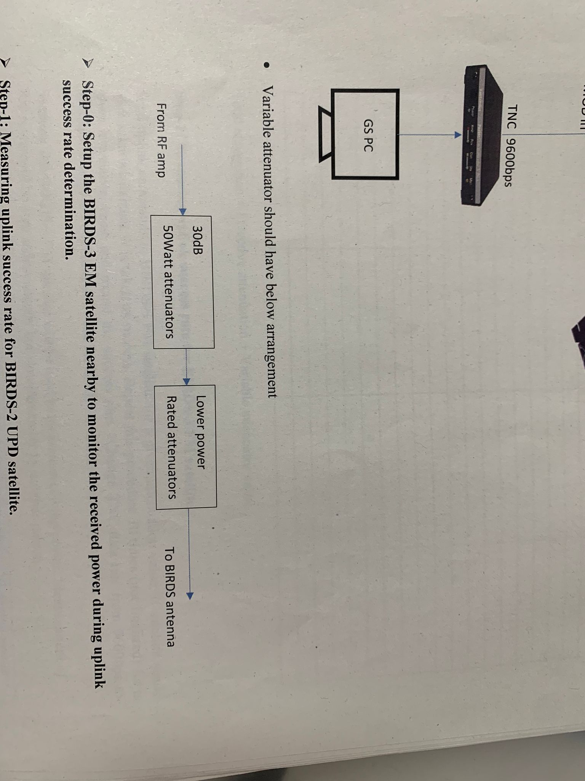

* + 1. **Setup the BIRDS-X EM satellite nearby to monitor the received power during uplink success rate determination**
    2. **Measuring uplink success rate for BIRDS-X EM satellite**

Send the uplink commands to BIRDS-X EM satellite for a given attenuation value. If satellite sends back ACK, it is taken as success. Repeat this procedure 10 times (not finalized) for a given attenuation value and record the success rate.

Mt.Takato side ?? will be used to measure receiving power. Measurement of RX power will be done independently but simultaneously by another person.

|  |  |  |  |
| --- | --- | --- | --- |
| TX Power (dB) | Total Attenuation (dB) | Received Power (dBm) at Mt.Takato | Success Rate (/10) |
|  |  |  |  |
|  |  |  |  |
|  |  |  |  |
|  |  |  |  |
|  |  |  |  |
|  |  |  |  |
|  |  |  |  |
|  |  |  |  |
|  |  |  |  |
|  |  |  |  |
|  |  |  |  |
|  |  |  |  |
|  |  |  |  |
|  |  |  |  |
|  |  |  |  |
|  |  |  |  |
|  |  |  |  |
|  |  |  |  |
|  |  |  |  |
|  |  |  |  |
|  |  |  |  |
|  |  |  |  |
|  |  |  |  |
|  |  |  |  |
|  |  |  |  |
|  |  |  |  |
|  |  |  |  |
|  |  |  |  |
|  |  |  |  |
|  |  |  |  |
|  |  |  |  |

* Total Attenuation = Effective Attenuation + Variable Attenuator Value

* 1. **Uplink Success Rate using ICOM-9100 GS Setup**
     1. **Measuring uplink success rate for BIRDS-X EM satellite**

1. **VHF Test**