**When**: November 21, 22(backup)

**Where**: Satellite – Mt. Takato

GS – BIRS GS, 8F

**Who**:

Mt. Takato

Yudai, Rintaro, Linh, Hoksong

Kyutech GS

Tharindu, Javier, Sirash

**To bring**:

Mt.Takato

|  |  |  |
| --- | --- | --- |
| □ BIRDS-X EM Satellite | □ Pelican Case | □ Soldering iron and lead |
| □ Spectrum Analyzer | □ Portable Power Supply | □ PC |
| □ styro foam (Big and Small) | □ Multimeter | □ Pen |
| □ satellite pad, bubble wrap | □ adapters (e.g. SMA adapters) | □ Phone Charger |
| □ RF Cables | □ kapton tape | □ Gloves (box) |
| □ UART cable (debug) | □ duct tape | □ alcohol |
| □ charging cable | □ measuring tape | □ tissue (box) |
| □ PICKit 3 programmer | □ Scissors | □ umbrella |
| □ programming board | □ cutter | □ Tharindu’s TRX and antenna |
| □ Both reference antenna stand |  |  |
| □ UHF dipole reference antenna | □ screw box | □ VHF dipole reference antenna |

Kyutech GS

|  |  |  |
| --- | --- | --- |
| □ RF cables | □ Attenuator set | □ YAESU FT-2D |
| □ Adapters | □ Multimeter | □ Signal Generator |
| □ Spectrum Analyzer | □ PC | □ BIRDS-GS UHF Antenna |
| □ iCOM-9100 | □ Pen | □ BIRDS-GS PC |
| □ RF Amplifier | □ Signal Generator | □ Horyu-4 GS (UHF and VHF) |
| □ TNC for BIRDS-X |  |  |

**0 Preparation**

Before going to Mt. Takato, make sure the following have been done.

0.1 Measure and confirm the following output power.

|  |  |
| --- | --- |
| Parameter | Measured Value (dBm) |
| BIRDS-X EM CW Output(see if it’s 20 dBm) |  |
| IC-9100 Output (for UHF at 8F, set to 45 dBm) |  |
| SG-RF Amp configuration Output (for UHF at 8F, set to 45 dBm, SG = -8 dBm) |  |
| APRS REF #1 output measurement | 27.70 dBm |
| IC-9100 Output (for VHF at BIRDS Room) |  |
| YAESU FT-2D Output |  |
| Measure each attenuator : |  |
| 40 dB |  |
| 10 dB |  |
|  |  |
|  |  |
|  |  |

0.2 Measure the S11 of reference dipole antenna using VNA.

Center Freq: ___________

S11 Value: ___________

1. **UHF Test**
   1. **Calibration**
      1. **Pointing the BIRDS GS antenna towards Mt. Takato**

In this test, BIRDS-X EM satellite will transmit continuous beacon signal (20dBm) and BIRDS GS antenna will try to capture maximum power from Mt. Takato side.

* + - * Position BIRDS-X EM satellite such that the UHF antenna is　horizontal and facing towards the GS (Note: this will be BIRDS-X EM satellite position all throughout this test).
      * Set the BIRDS-X EM satellite to enable CW beacon by Tharindu’s TRX.
      * Point the BIRDS GS antenna in the nominal direction (EL = 0°, AZ = 220°).
      * Measure the received power at the BIRDS GS antenna. Set channel power bandwidth of spectrum analyzer to 500Hz and center frequency 437.375MHz. Record in the table below.
      * Adjust the BIRDS GS antenna direction about the nominal direction to find the direction with the maximum received power. Record in the table below.

|  |  |
| --- | --- |
| BIRDS GS Antenna AZ | Received Signal Power (dBm) |
| 220 |  |
| 217 |  |
|  |  |
|  |  |
|  |  |
|  |  |
|  |  |
|  |  |
|  |  |
|  |  |
|  |  |
|  |  |

* + - * + Fix the BIRDS GS antenna in this direction.

AZ direction: __________

Received Signal Power: __________

Note: when the maximum power is received, and antenna direction should be fixed and it should be kept throughout the test.

* + 1. **Pointing the Horyu-4 GS Antenna towards Mt. Takato**

Repeat the 1.1.1 but this time is for Horyu-4 GS Antenna.

|  |  |
| --- | --- |
| Hoyu-4 GS Antenna AZ | Received Signal Power (dBm) |
| 220 |  |
| 217 |  |
|  |  |
|  |  |
|  |  |
|  |  |
|  |  |
|  |  |
|  |  |
|  |  |
|  |  |
|  |  |

* + - * + Fix the Horyu-4 GS antenna in this direction.

AZ direction: __________

Received Signal Power: __________

* + 1. **Measuring effective uplink attenuation from GS to Mt. Takato**
       - Set-up SG-RF Amplifier GS configuration such that TX output power is 45 dBm (SG = -8 dBm, single tone).

* + - * Connect BIRDS GS Antenna to RF amplifier

Reference UHF Dipole Antenna

* + - * Setup reference UHF dipole antenna on the platform
      * Output Single tone from SG
      * Measure received RF power by reference UHF dipole antenna using SA. Record in the table below.

Received Uplink Power using Reference UHF Dipole Antenna and BIRDS GS antenna

|  |  |
| --- | --- |
| Received Power (dBm) | Effective Downlink Attenuation (dB) (45 dBm – Received Power) |
|  |  |
|  |  |
|  |  |
|  |  |
|  |  |

* 1. **Uplink Success Rate using SG-RF Amplifier GS Setup**

BIRDS GS antenna will be used for sending uplink signal. It will be connected to RF amplifier output. Horyu-4 GS will be connected to ICOM radio for receiving ACK.

First, BIRDS-X EM uplink success rate will be determined by finding the maximum attenuator connected to RF amplifier wherein ACK can still be received (~75% success rate). Use simplified EM software but remove beacon. We will use this setup since the output of BW can be changed by SG and New UHF TRX is particularly sensitive for that parameter.

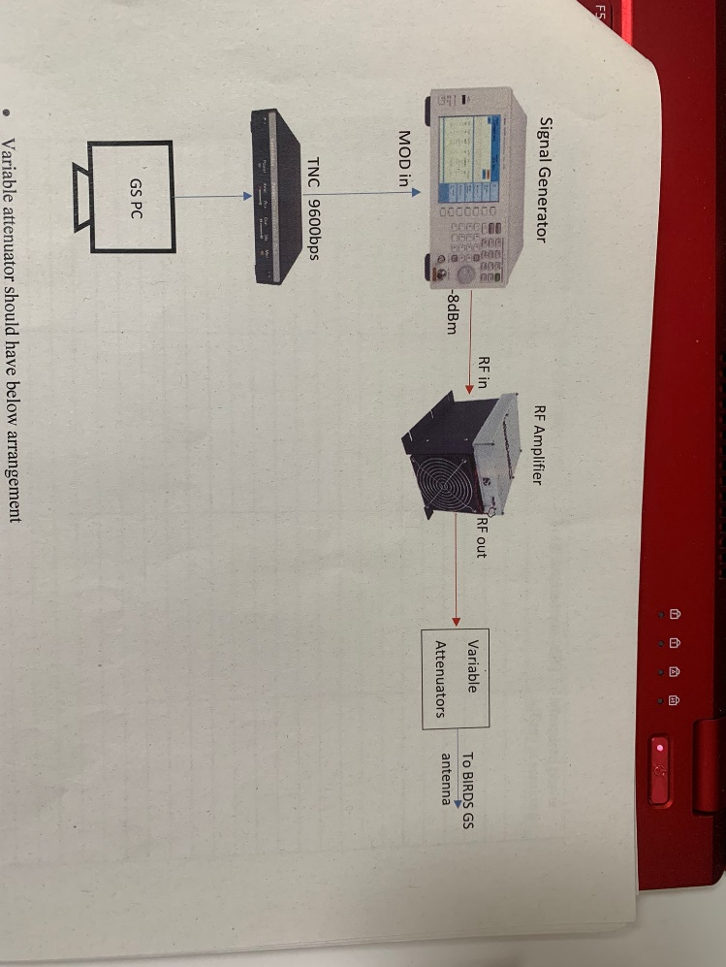

4800 bps

Variable attenuator should have below arrangement

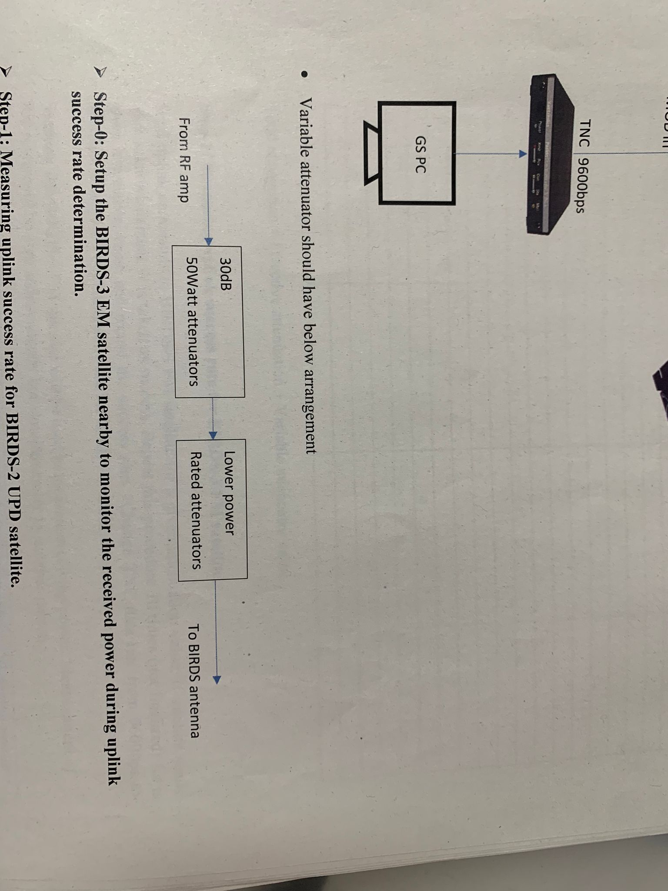

Send the uplink commands to BIRDS-X EM satellite for a given attenuation value. If satellite sends back ACK, it is taken as success. Repeat this procedure 10 times (not finalized) for a given attenuation value and record the success rate.

|  |  |  |  |
| --- | --- | --- | --- |
| TX Power (dB) | Total Attenuation (dB) | Received Power (dBm) at Mt.Takato | Success Rate (/10) |
|  |  |  |  |
|  |  |  |  |
|  |  |  |  |
|  |  |  |  |
|  |  |  |  |
|  |  |  |  |
|  |  |  |  |
|  |  |  |  |
|  |  |  |  |
|  |  |  |  |
|  |  |  |  |
|  |  |  |  |
|  |  |  |  |
|  |  |  |  |
|  |  |  |  |
|  |  |  |  |
|  |  |  |  |
|  |  |  |  |
|  |  |  |  |
|  |  |  |  |
|  |  |  |  |
|  |  |  |  |
|  |  |  |  |
|  |  |  |  |
|  |  |  |  |
|  |  |  |  |
|  |  |  |  |
|  |  |  |  |
|  |  |  |  |

* Total Attenuation = Effective Attenuation + Variable Attenuator Value

* 1. **Uplink Success Rate using ICOM-9100 GS Setup**

In this test, we do the same test as in 1.2 but use IC-9100 setup. BIRDS GS antenna will be connected to IC-9100 to transmit command signal (45 dBm) and receive ACK, as shown below. This is because some BIRDS GS have only this configuration.

Send the uplink commands to BIRDS-X EM satellite for a given attenuation value. If satellite sends back ACK, it is taken as success. Repeat this procedure 10 times (not finalized) for a given attenuation value and record the success rate.

|  |  |  |  |
| --- | --- | --- | --- |
| TX Power (dB) | Total Attenuation (dB) | Received Power (dBm) at Mt.Takato | Success Rate (/10) |
|  |  |  |  |
|  |  |  |  |
|  |  |  |  |
|  |  |  |  |
|  |  |  |  |
|  |  |  |  |
|  |  |  |  |
|  |  |  |  |
|  |  |  |  |
|  |  |  |  |
|  |  |  |  |
|  |  |  |  |
|  |  |  |  |
|  |  |  |  |
|  |  |  |  |
|  |  |  |  |
|  |  |  |  |
|  |  |  |  |
|  |  |  |  |
|  |  |  |  |
|  |  |  |  |
|  |  |  |  |
|  |  |  |  |
|  |  |  |  |
|  |  |  |  |
|  |  |  |  |
|  |  |  |  |
|  |  |  |  |
|  |  |  |  |
|  |  |  |  |

1. **VHF Test**
   1. **Calibration**
      1. **Pointing the Horyu-4 VHF antenna towards Mt.Takato**

In this test, BIRDS-X EM satellite (APRS REF #1) will transmit beacon signal ( ______dBm) and BIRDS GS antenna will try to capture maximum power from Mt. Takato side.

* + - * Position BIRDS-X EM satellite such that the VHF antenna is　horizontal and facing towards the GS (Note: this will be BIRDS-X EM satellite position all throughout this test).
      * Set the BIRDS-X EM satellite to enable APRS REF #1 beacon mode by Tharindu’s TRX.
      * Point the Horyu-4 VHF antenna in the nominal direction (EL = 0°, AZ = 220°).
      * Measure the received power at the Horyu-4 VHF antenna. Set channel power bandwidth of spectrum analyzer to 500Hz and center frequency 145.825MHz. Record in the table below.
      * Adjust the Horyu-4 VHF antenna direction about the nominal direction to find the direction with the maximum received power. Record in the table below.

|  |  |
| --- | --- |
| BIRDS GS Antenna AZ | Received Signal Power (dBm) |
| 220 |  |
| 217 |  |
|  |  |
|  |  |
|  |  |
|  |  |
|  |  |
|  |  |
|  |  |
|  |  |

* + - * + Fix the Horyu-4 VHF antenna in this direction.

AZ direction: __________

Received Signal Power: __________

Note: when the maximum power is received, and antenna direction should be fixed and it should be kept throughout the test.

* + 1. **Measuring the effective uplink attenuation from GS to Mt.Takato**
       - Set-up SG-RF Amplifier GS configuration such that TX output power is 45 dBm (SG = -8 dBm, single tone).

* + - * Connect BIRDS GS Antenna to RF amplifier

Reference VHF Dipole Antenna

* + - * Setup reference VHF dipole antenna on the platform
      * Output Single tone from SG
      * Measure received RF power by reference VHF dipole antenna using SA. Record in the table below.

Received Uplink Power using Reference VHF Dipole Antenna and Horyu-4 VHF antenna

|  |  |
| --- | --- |
| Received Power (dBm) | Effective Downlink Attenuation (dB) (45 dBm – Received Power) |
|  |  |
|  |  |
|  |  |
|  |  |

* 1. **Uplink Success Rate using Handy TRX with Horyu-4 GS Setup**

Horyu-4 VHF antenna will be used for sending uplink signal. It will be connected to YAESU FT-2D handy transceiver. (5W(maximum), 2.5W, 1W, 0.1W ) This configuration is also used for receiving ACK. First, BIRDS-X EM uplink success rate will be determined by finding the maximum attenuation connected to the handy TRX wherein ACK can still be received (~75% success rate). Use simplified EM software but remove beacon.

|  |  |  |  |
| --- | --- | --- | --- |
| TX Power (dB) | Total Attenuation (dB) | Received Power (dBm) at Mt.Takato | Success Rate (/10) |
|  |  |  |  |
|  |  |  |  |
|  |  |  |  |
|  |  |  |  |
|  |  |  |  |
|  |  |  |  |
|  |  |  |  |
|  |  |  |  |
|  |  |  |  |
|  |  |  |  |
|  |  |  |  |
|  |  |  |  |
|  |  |  |  |
|  |  |  |  |
|  |  |  |  |
|  |  |  |  |
|  |  |  |  |
|  |  |  |  |
|  |  |  |  |
|  |  |  |  |
|  |  |  |  |
|  |  |  |  |
|  |  |  |  |
|  |  |  |  |
|  |  |  |  |
|  |  |  |  |
|  |  |  |  |
|  |  |  |  |
|  |  |  |  |

* 1. **Uplink Success Rate using ICOM-9100 GS Setup (with other config)**

Horyu-4 VHF antenna will be used for sending uplink signal. It will be connected to ICOM-9100 transceiver. This configuration is also used for receiving ACK. First, BIRDS-X EM uplink success rate will be determined by finding the maximum attenuation connected to the handy TRX wherein ACK can still be received (~75% success rate). Use simplified EM software but remove beacon.

|  |  |  |  |
| --- | --- | --- | --- |
| TX Power (dB) | Total Attenuation (dB) | Received Power (dBm) at Mt.Takato | Success Rate (/10) |
|  |  |  |  |
|  |  |  |  |
|  |  |  |  |
|  |  |  |  |
|  |  |  |  |
|  |  |  |  |
|  |  |  |  |
|  |  |  |  |
|  |  |  |  |
|  |  |  |  |
|  |  |  |  |
|  |  |  |  |
|  |  |  |  |
|  |  |  |  |
|  |  |  |  |
|  |  |  |  |
|  |  |  |  |
|  |  |  |  |
|  |  |  |  |
|  |  |  |  |
|  |  |  |  |
|  |  |  |  |
|  |  |  |  |
|  |  |  |  |
|  |  |  |  |
|  |  |  |  |
|  |  |  |  |
|  |  |  |  |
|  |  |  |  |

Note:

* Sensitivity test should be done with both antenna panel?
* Are we measuring worse case since we don’t include antenna gain in an effective downlink attenuation?