**When**: November 21, 22(backup)

**Where**: Satellite – Mt. Takato

GS – BIRS GS, 8F

**Who**:

Mt. Takato

Yudai, Rintaro, Linh, Hoksong

Kyutech GS

Tharindu, Javier, Sirash

**To bring**:

Mt.Takato

|  |  |  |
| --- | --- | --- |
| □ BIRDS-X EM Satellite | □ Pelican Case | □ Soldering iron and lead |
| □ Spectrum Analyzer (JIC) | □ Portable Power Supply | □ PC |
| □ styro foam (Big and Small) | □ Multimeter | □ Pen |
| □ satellite pad, bubble wrap | □ adapters (e.g. SMA adapters) | □ Phone Charger |
| □ RF Cables | □ kapton tape | □ Gloves (box) |
| □ UART cable (debug) | □ duct tape | □ alcohol |
| □ charging cable | □ measuring tape | □ tissue (box) |
| □ PICKit 3 programmer | □ Scissors | □ umbrella |
| □ programming board | □ cutter | □ Tharindu’s TRX and antenna and micro mini usb cable |
|  | □ screw box |  |

Kyutech GS

|  |  |  |
| --- | --- | --- |
| □ RF cables | □ Attenuator set | □ YAESU FT-2D |
| □ Adapters | □ Multimeter | □ Signal Generator |
| □ Spectrum Analyzer | □ PC | □ BIRDS-GS UHF Antenna |
| □ iCOM-9100 | □ Pen | □ BIRDS-GS PC |
| □ RF Amplifier | □ Signal Generator | □ Horyu-4 GS (UHF and VHF) |
| □ TNC for BIRDS-X |  |  |

Outline

0. Preparation

0.1 Measure and confirm the following output power

1. UHF Test (Addnics)

1.1 Calibration

1.1.1 Pointing the BIRDS GS UHF Antenna towards Mt.Takato

1.1.2 Pointing the Horyu-4 GS UHF Antenna towards Mt.Takato

1.1.3 Measure the Effective Uplink/Downlink Attenuation from GS to Mt. Takato

1.2 Uplink Success Rate using SG-RF Amplifier GS setup

1.3 Uplink Success Rate using ICOM-9100 GS setup

1.4 Uplink Success Rate using Tharindu GS setup

2. UHF Test (New)

3. VHF Test (APRS REF #1)

3.1 Calibration

3.1.1 Pointing the Horyu-4 VHF antenna towards Mt. Takato

3.1.2 Measure the Effective Uplink/Downlink Attenuation from GS to Mt. Takato

3.2 Uplink Success Rate using Handy TRX with Horyu-4 GS setup

3.3 Uplink Success Rate using ICOM-9100 GS setup

4. VHF Test (APRS REF #2)

5. VHF Test (APRS Canada)

6. VHF Test (APRS Paraguay)

7. VHF Test (APRS Sri Lanka - 1)

8. VHF Test (APRS Sri Lanka - 2)

**0 Preparation**

Before going to Mt. Takato, make sure the following have been done.

0.1 Measure and confirm the following output power.

|  |  |
| --- | --- |
| Parameter | Measured Value (dBm) |
| BIRDS-X EM (Addnics) CW Output (see if it’s 20 dBm) |  |
| BIRDS-X EM (New) CW Output |  |
| IC-9100 Output (for UHF at 8F, set to 45 dBm) |  |
| SG-RF Amp configuration Output (for UHF at 8F, set to 45 dBm, SG = -8 dBm) |  |
| APRS REF #1 output measurement | 27.70 dBm |
| APRS REF #2 output measurement | 30.78 dBm |
| APRS Canada output measurement | 30.15 dBm |
| APRS Paraguay output measurement | 29.24 dBm |
| APRS Sri Lanka -1 output measurement | 26.45 dBm |
| APRS Sri Lanka -2 output measurement | 32.14 dBm |
| IC-9100 Output (for VHF at BIRDS Room) |  |
| YAESU FT-2D Output |  |
| Measure each attenuator : |  |
| 40 dB |  |
| 10 dB |  |
|  |  |
|  |  |
|  |  |

1. **UHF Test (Addnics)**
   1. **Calibration**
      1. **Pointing the BIRDS GS antenna towards Mt. Takato**

In this test, BIRDS-X EM satellite will transmit continuous beacon signal (20dBm) and BIRDS GS antenna will try to capture maximum power from Mt. Takato side.

* + - * Position BIRDS-X EM satellite such that the UHF antenna is　horizontal and facing towards the GS (Note: this will be BIRDS-X EM satellite position all throughout this test).
      * Set the BIRDS-X EM satellite to enable CW beacon by Tharindu’s TRX.
      * Point the BIRDS GS antenna in the nominal direction (EL = 0°, AZ = 220°).
      * Measure the received power at the BIRDS GS antenna. Set channel power bandwidth of spectrum analyzer to 500Hz and center frequency 437.375MHz. Record in the table below.
      * Adjust the BIRDS GS antenna direction about the nominal direction to find the direction with the maximum received power. Record in the table below.

|  |  |
| --- | --- |
| BIRDS GS Antenna AZ | Received Signal Power (dBm) |
| 220 |  |
| 217 |  |
|  |  |
|  |  |
|  |  |
|  |  |
|  |  |
|  |  |
|  |  |
|  |  |
|  |  |
|  |  |

* + - * + Fix the BIRDS GS antenna in this direction.

AZ direction: __________

Received Signal Power: __________

Note: when the maximum power is received, and antenna direction should be fixed and it should be kept throughout the test.

* + 1. **Pointing the Horyu-4 GS Antenna towards Mt. Takato**

Repeat the 1.1.1 but this time is for Horyu-4 GS Antenna.

|  |  |
| --- | --- |
| Hoyu-4 GS Antenna AZ | Received Signal Power (dBm) |
| 220 |  |
| 217 |  |
|  |  |
|  |  |
|  |  |
|  |  |
|  |  |
|  |  |
|  |  |
|  |  |
|  |  |
|  |  |

* + - * + Fix the Horyu-4 GS antenna in this direction.

AZ direction: __________

Received Signal Power: __________

* + 1. **Measuring Effective Uplink/Downlink Attenuation from GS to Mt. Takato**
       - BIRDS-X EM satellite will transmit continuous CW beacon (20 dBm). Carefully take note of this position.
       - Measure the received power by the BIRDS GS antenna and record in the table below.

Using BIRDS GS UHF Antenna

|  |  |
| --- | --- |
| Received Power (dBm) | Effective Downlink Attenuation (dB) (20 dBm – Received Power) |
|  |  |
|  |  |
|  |  |
|  |  |
|  |  |
|  |  |
|  |  |
|  |  |

* 1. **Uplink Success Rate using SG-RF Amplifier GS Setup**

BIRDS GS antenna will be used for sending uplink signal. It will be connected to RF amplifier output. Horyu-4 GS will be connected to ICOM radio for receiving ACK.

First, BIRDS-X EM uplink success rate will be determined by finding the maximum attenuator connected to RF amplifier wherein ACK can still be received (~75% success rate). Use simplified EM software but remove beacon. We will use this setup since the output of BW can be changed by SG and New UHF TRX is particularly sensitive for that parameter.

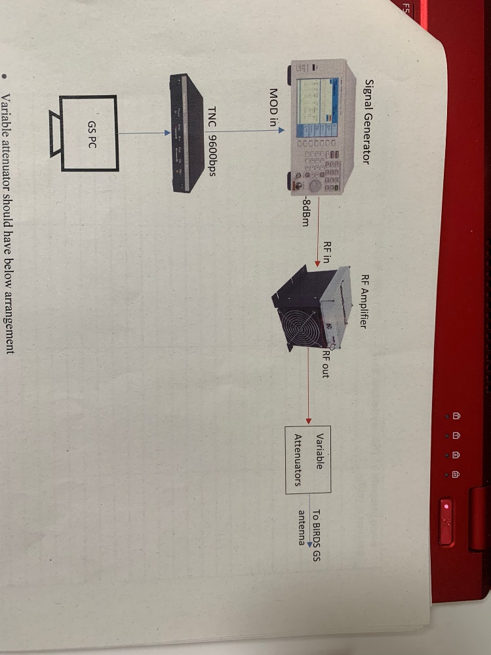

4800 bps

Variable attenuator should have below arrangement

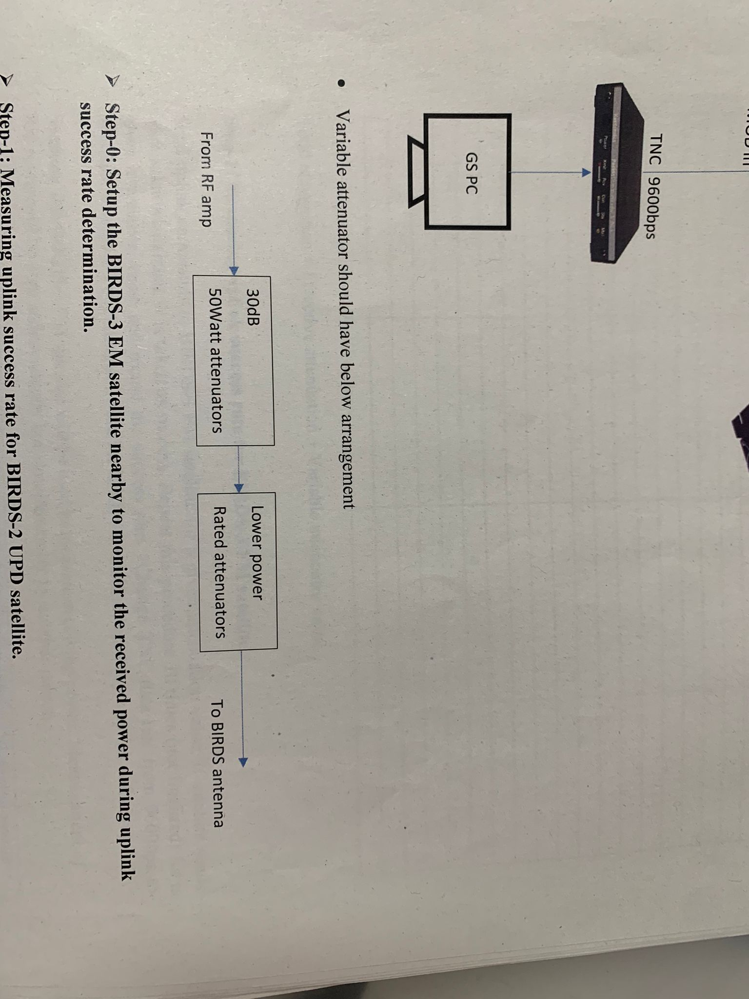

Send the uplink commands to BIRDS-X EM satellite for a given attenuation value. If satellite sends back ACK, it is taken as success. Repeat this procedure 10 times (not finalized) for a given attenuation value and record the success rate.

|  |  |  |  |
| --- | --- | --- | --- |
| TX Power (dB) | Total Attenuation (dB) | Received Power (dBm) at Mt.Takato | Success Rate (/10) |
|  |  |  |  |
|  |  |  |  |
|  |  |  |  |
|  |  |  |  |
|  |  |  |  |
|  |  |  |  |
|  |  |  |  |
|  |  |  |  |
|  |  |  |  |
|  |  |  |  |
|  |  |  |  |
|  |  |  |  |
|  |  |  |  |
|  |  |  |  |
|  |  |  |  |
|  |  |  |  |
|  |  |  |  |
|  |  |  |  |
|  |  |  |  |
|  |  |  |  |
|  |  |  |  |
|  |  |  |  |
|  |  |  |  |
|  |  |  |  |
|  |  |  |  |
|  |  |  |  |
|  |  |  |  |
|  |  |  |  |
|  |  |  |  |

* Total Attenuation = Effective Attenuation + Variable Attenuator Value

* 1. **Uplink Success Rate using ICOM-9100 GS Setup**

In this test, we do the same test as in 1.2 but use IC-9100 setup. BIRDS GS antenna will be connected to IC-9100 to transmit command signal (45 dBm) and receive ACK, as shown below. This is because some BIRDS GS have only this configuration.

Send the uplink commands to BIRDS-X EM satellite for a given attenuation value. If satellite sends back ACK, it is taken as success. Repeat this procedure 10 times (not finalized) for a given attenuation value and record the success rate.

|  |  |  |  |
| --- | --- | --- | --- |
| TX Power (dB) | Total Attenuation (dB) | Received Power (dBm) at Mt.Takato | Success Rate (/10) |
|  |  |  |  |
|  |  |  |  |
|  |  |  |  |
|  |  |  |  |
|  |  |  |  |
|  |  |  |  |
|  |  |  |  |
|  |  |  |  |
|  |  |  |  |
|  |  |  |  |
|  |  |  |  |
|  |  |  |  |
|  |  |  |  |
|  |  |  |  |
|  |  |  |  |
|  |  |  |  |
|  |  |  |  |
|  |  |  |  |
|  |  |  |  |
|  |  |  |  |
|  |  |  |  |
|  |  |  |  |
|  |  |  |  |
|  |  |  |  |
|  |  |  |  |
|  |  |  |  |
|  |  |  |  |
|  |  |  |  |
|  |  |  |  |
|  |  |  |  |
|  |  |  |  |

* 1. **Uplink Success Rate using Tharindu GS Setup**

In this test, we do the same test as in 1.2 and 1.3 but use Tharindu’s setup. Send the uplink commands to BIRDS-X EM satellite for a given attenuation value. If satellite sends back ACK, it is taken as success. Repeat this procedure 10 times (not finalized) for a given attenuation value and record the success rate.

|  |  |  |  |
| --- | --- | --- | --- |
| TX Power (dB) | Total Attenuation (dB) | Received Power (dBm) at Mt.Takato | Success Rate (/10) |
|  |  |  |  |
|  |  |  |  |
|  |  |  |  |
|  |  |  |  |
|  |  |  |  |
|  |  |  |  |
|  |  |  |  |
|  |  |  |  |
|  |  |  |  |
|  |  |  |  |
|  |  |  |  |
|  |  |  |  |
|  |  |  |  |
|  |  |  |  |
|  |  |  |  |
|  |  |  |  |
|  |  |  |  |
|  |  |  |  |
|  |  |  |  |
|  |  |  |  |
|  |  |  |  |
|  |  |  |  |
|  |  |  |  |
|  |  |  |  |
|  |  |  |  |
|  |  |  |  |
|  |  |  |  |

1. **UHF Test (New)**

Do same as in 1 but for Tharindu’s TRX.

* 1. **Calibration**
     1. **Pointing the BIRDS GS antenna towards Mt. Takato**

In this test, BIRDS-X EM satellite (New TRX) will transmit continuous beacon signal (______dBm) and BIRDS GS antenna will try to capture maximum power from Mt. Takato side.

* + - * Position BIRDS-X EM satellite such that the UHF antenna is　horizontal and facing towards the GS (Note: this will be BIRDS-X EM satellite position all throughout this test).
      * Set the BIRDS-X EM satellite to enable CW beacon by Tharindu’s TRX.
      * Point the BIRDS GS antenna in the nominal direction (EL = 0°, AZ = 220°).
      * Measure the received power at the BIRDS GS antenna. Set channel power bandwidth of spectrum analyzer to 500Hz and center frequency 437.375MHz. Record in the table below.
      * Adjust the BIRDS GS antenna direction about the nominal direction to find the direction with the maximum received power. Record in the table below.

|  |  |
| --- | --- |
| BIRDS GS Antenna AZ | Received Signal Power (dBm) |
| 220 |  |
| 217 |  |
|  |  |
|  |  |
|  |  |
|  |  |
|  |  |
|  |  |
|  |  |
|  |  |
|  |  |
|  |  |

* + - * + Fix the BIRDS GS antenna in this direction.

AZ direction: __________

Received Signal Power: __________

Note: when the maximum power is received, and antenna direction should be fixed and it should be kept throughout the test.

**2.1.1 Pointing the Horyu-4 GS Antenna towards Mt. Takato**

Repeat the 1.1.1 but this time is for Horyu-4 GS Antenna.

|  |  |
| --- | --- |
| Hoyu-4 GS Antenna AZ | Received Signal Power (dBm) |
| 220 |  |
| 217 |  |
|  |  |
|  |  |
|  |  |
|  |  |
|  |  |
|  |  |
|  |  |
|  |  |
|  |  |
|  |  |

* + - * + Fix the Horyu-4 GS antenna in this direction.

AZ direction: __________

Received Signal Power: __________

**2.2.1 Measuring Effective Uplink/Downlink Attenuation from GS to Mt. Takato**

Using BIRDS GS UHF Antenna

|  |  |
| --- | --- |
| Received Power (dBm) | Effective Downlink Attenuation (dB) (____ dBm – Received Power) |
|  |  |
|  |  |
|  |  |
|  |  |
|  |  |
|  |  |
|  |  |
|  |  |

**2.1 Uplink Success Rate using SG-RF Amplifier GS Setup**

|  |  |  |  |
| --- | --- | --- | --- |
| TX Power (dB) | Total Attenuation (dB) | Received Power (dBm) at Mt.Takato | Success Rate (/10) |
|  |  |  |  |
|  |  |  |  |
|  |  |  |  |
|  |  |  |  |
|  |  |  |  |
|  |  |  |  |
|  |  |  |  |
|  |  |  |  |
|  |  |  |  |
|  |  |  |  |
|  |  |  |  |
|  |  |  |  |
|  |  |  |  |
|  |  |  |  |
|  |  |  |  |
|  |  |  |  |
|  |  |  |  |
|  |  |  |  |
|  |  |  |  |
|  |  |  |  |
|  |  |  |  |
|  |  |  |  |
|  |  |  |  |
|  |  |  |  |
|  |  |  |  |
|  |  |  |  |
|  |  |  |  |
|  |  |  |  |
|  |  |  |  |

* Total Attenuation = Effective Attenuation + Variable Attenuator Value

**2.2 Uplink Success Rate using ICOM-9100 GS Setup**

|  |  |  |  |
| --- | --- | --- | --- |
| TX Power (dB) | Total Attenuation (dB) | Received Power (dBm) at Mt.Takato | Success Rate (/10) |
|  |  |  |  |
|  |  |  |  |
|  |  |  |  |
|  |  |  |  |
|  |  |  |  |
|  |  |  |  |
|  |  |  |  |
|  |  |  |  |
|  |  |  |  |
|  |  |  |  |
|  |  |  |  |
|  |  |  |  |
|  |  |  |  |
|  |  |  |  |
|  |  |  |  |
|  |  |  |  |
|  |  |  |  |
|  |  |  |  |
|  |  |  |  |
|  |  |  |  |
|  |  |  |  |
|  |  |  |  |
|  |  |  |  |
|  |  |  |  |
|  |  |  |  |
|  |  |  |  |
|  |  |  |  |
|  |  |  |  |
|  |  |  |  |
|  |  |  |  |
|  |  |  |  |

**2.3** **Uplink Success Rate using Tharindu GS Setup**

|  |  |  |  |
| --- | --- | --- | --- |
| TX Power (dB) | Total Attenuation (dB) | Received Power (dBm) at Mt.Takato | Success Rate (/10) |
|  |  |  |  |
|  |  |  |  |
|  |  |  |  |
|  |  |  |  |
|  |  |  |  |
|  |  |  |  |
|  |  |  |  |
|  |  |  |  |
|  |  |  |  |
|  |  |  |  |
|  |  |  |  |
|  |  |  |  |
|  |  |  |  |
|  |  |  |  |
|  |  |  |  |
|  |  |  |  |
|  |  |  |  |
|  |  |  |  |
|  |  |  |  |
|  |  |  |  |
|  |  |  |  |
|  |  |  |  |
|  |  |  |  |
|  |  |  |  |
|  |  |  |  |
|  |  |  |  |
|  |  |  |  |

1. **VHF Test (APRS REF #1)**
   1. **Calibration**
      1. **Pointing the Horyu-4 VHF antenna towards Mt.Takato**

In this test, BIRDS-X EM satellite (APRS REF #1) will transmit beacon signal ( 27.70 dBm) and BIRDS GS antenna will try to capture maximum power from Mt. Takato side.

* + - * Position BIRDS-X EM satellite such that the VHF antenna is　horizontal and facing towards the GS (Note: this will be BIRDS-X EM satellite position all throughout this test).
      * Set the BIRDS-X EM satellite to enable APRS REF #1 beacon mode by Tharindu’s TRX.
      * Point the Horyu-4 VHF antenna in the nominal direction (EL = 0°, AZ = 220°).
      * Measure the received power at the Horyu-4 VHF antenna. Set channel power bandwidth of spectrum analyzer to 500Hz and center frequency 145.825MHz. Record in the table below.
      * Adjust the Horyu-4 VHF antenna direction about the nominal direction to find the direction with the maximum received power. Record in the table below.

|  |  |
| --- | --- |
| BIRDS GS Antenna AZ | Received Signal Power (dBm) |
| 220 |  |
| 217 |  |
|  |  |
|  |  |
|  |  |
|  |  |
|  |  |
|  |  |
|  |  |
|  |  |

* + - * + Fix the Horyu-4 VHF antenna in this direction.

AZ direction: __________

Received Signal Power: __________

Note: when the maximum power is received, and antenna direction should be fixed and it should be kept throughout the test.

* + 1. **Measuring the Effective Uplink/Downlink attenuation from GS to Mt.Takato**
       - APRS REF#1 will transmit beacon (27.70 dBm). Carefully take note of this position.
       - Measure the received power by the BIRDS GS antenna and record in the table below.

Using Horyu-4 GS VHF Antenna

|  |  |
| --- | --- |
| Received Power (dBm) | Effective Downlink Attenuation (dB) (27.70 dBm – Received Power) |
|  |  |
|  |  |
|  |  |
|  |  |
|  |  |
|  |  |
|  |  |
|  |  |

* 1. **Uplink Success Rate using Handy TRX with Horyu-4 GS Setup**

Horyu-4 VHF antenna will be used for sending uplink signal. It will be connected to YAESU FT-2D handy transceiver. (5W(maximum), 2.5W, 1W, 0.1W ) This configuration is also used for receiving ACK. First, BIRDS-X EM uplink success rate will be determined by finding the maximum attenuation connected to the handy TRX wherein ACK can still be received (~75% success rate). Use simplified EM software but remove beacon.

|  |  |  |  |
| --- | --- | --- | --- |
| TX Power (dB) | Total Attenuation (dB) | Received Power (dBm) at Mt.Takato | Success Rate (/10) |
|  |  |  |  |
|  |  |  |  |
|  |  |  |  |
|  |  |  |  |
|  |  |  |  |
|  |  |  |  |
|  |  |  |  |
|  |  |  |  |
|  |  |  |  |
|  |  |  |  |
|  |  |  |  |
|  |  |  |  |
|  |  |  |  |
|  |  |  |  |
|  |  |  |  |
|  |  |  |  |
|  |  |  |  |
|  |  |  |  |
|  |  |  |  |
|  |  |  |  |
|  |  |  |  |
|  |  |  |  |
|  |  |  |  |
|  |  |  |  |
|  |  |  |  |
|  |  |  |  |
|  |  |  |  |
|  |  |  |  |
|  |  |  |  |

* 1. **Uplink Success Rate using ICOM-9100 GS Setup**

Horyu-4 VHF antenna will be used for sending uplink signal. It will be connected to ICOM-9100 transceiver. This configuration is also used for receiving ACK. First, BIRDS-X EM uplink success rate will be determined by finding the maximum attenuation connected to the handy TRX wherein ACK can still be received (~75% success rate). Use simplified EM software but remove beacon.

|  |  |  |  |
| --- | --- | --- | --- |
| TX Power (dB) | Total Attenuation (dB) | Received Power (dBm) at Mt.Takato | Success Rate (/10) |
|  |  |  |  |
|  |  |  |  |
|  |  |  |  |
|  |  |  |  |
|  |  |  |  |
|  |  |  |  |
|  |  |  |  |
|  |  |  |  |
|  |  |  |  |
|  |  |  |  |
|  |  |  |  |
|  |  |  |  |
|  |  |  |  |
|  |  |  |  |
|  |  |  |  |
|  |  |  |  |
|  |  |  |  |
|  |  |  |  |
|  |  |  |  |
|  |  |  |  |
|  |  |  |  |
|  |  |  |  |
|  |  |  |  |
|  |  |  |  |
|  |  |  |  |
|  |  |  |  |
|  |  |  |  |
|  |  |  |  |
|  |  |  |  |

**4. VHF Test (APRS REF #2)**

**4.1 Calibration**

**4.1.1 Pointing the Horyu-4 VHF antenna towards Mt.Takato**

In this test, BIRDS-X EM satellite (APRS REF #2) will transmit beacon signal ( 30.78 dBm) and BIRDS GS antenna will try to capture maximum power from Mt. Takato side.

|  |  |
| --- | --- |
| BIRDS GS Antenna AZ | Received Signal Power (dBm) |
| 220 |  |
| 217 |  |
|  |  |
|  |  |
|  |  |
|  |  |
|  |  |
|  |  |
|  |  |
|  |  |

* + - * + Fix the Horyu-4 VHF antenna in this direction.

AZ direction: __________

Received Signal Power: __________

Note: when the maximum power is received, and antenna direction should be fixed and it should be kept throughout the test.

**4.1.2 Measuring the Effective Uplink/Downlink attenuation from GS to Mt.Takato**

Using Horyu-4 GS VHF Antenna

|  |  |
| --- | --- |
| Received Power (dBm) | Effective Downlink Attenuation (dB) (27.70 dBm – Received Power) |
|  |  |
|  |  |
|  |  |
|  |  |
|  |  |
|  |  |
|  |  |
|  |  |

**4.2 Uplink Success Rate using Handy TRX with Horyu-4 GS Setup**

|  |  |  |  |
| --- | --- | --- | --- |
| TX Power (dB) | Total Attenuation (dB) | Received Power (dBm) at Mt.Takato | Success Rate (/10) |
|  |  |  |  |
|  |  |  |  |
|  |  |  |  |
|  |  |  |  |
|  |  |  |  |
|  |  |  |  |
|  |  |  |  |
|  |  |  |  |
|  |  |  |  |
|  |  |  |  |
|  |  |  |  |
|  |  |  |  |
|  |  |  |  |
|  |  |  |  |
|  |  |  |  |
|  |  |  |  |
|  |  |  |  |
|  |  |  |  |
|  |  |  |  |
|  |  |  |  |
|  |  |  |  |
|  |  |  |  |
|  |  |  |  |
|  |  |  |  |
|  |  |  |  |
|  |  |  |  |
|  |  |  |  |
|  |  |  |  |
|  |  |  |  |

**4.3 Uplink Success Rate using ICOM-9100 GS Setup**

|  |  |  |  |
| --- | --- | --- | --- |
| TX Power (dB) | Total Attenuation (dB) | Received Power (dBm) at Mt.Takato | Success Rate (/10) |
|  |  |  |  |
|  |  |  |  |
|  |  |  |  |
|  |  |  |  |
|  |  |  |  |
|  |  |  |  |
|  |  |  |  |
|  |  |  |  |
|  |  |  |  |
|  |  |  |  |
|  |  |  |  |
|  |  |  |  |
|  |  |  |  |
|  |  |  |  |
|  |  |  |  |
|  |  |  |  |
|  |  |  |  |
|  |  |  |  |
|  |  |  |  |
|  |  |  |  |
|  |  |  |  |
|  |  |  |  |
|  |  |  |  |
|  |  |  |  |
|  |  |  |  |
|  |  |  |  |
|  |  |  |  |
|  |  |  |  |
|  |  |  |  |

**5. VHF Test (APRS Canada)**

**5.1 Calibration**

**5.1.1 Pointing the Horyu-4 VHF antenna towards Mt.Takato**

In this test, BIRDS-X EM satellite (APRS Canada) will transmit beacon signal ( 30.15 dBm) and BIRDS GS antenna will try to capture maximum power from Mt. Takato side.

|  |  |
| --- | --- |
| BIRDS GS Antenna AZ | Received Signal Power (dBm) |
| 220 |  |
| 217 |  |
|  |  |
|  |  |
|  |  |
|  |  |
|  |  |

* + - * + Fix the Horyu-4 VHF antenna in this direction.

AZ direction: __________

Received Signal Power: __________

Note: when the maximum power is received, and antenna direction should be fixed and it should be kept throughout the test.

**5.1.2 Measuring the Effective Uplink/Downlink attenuation from GS to Mt.Takato**

Using Horyu-4 GS VHF Antenna

|  |  |
| --- | --- |
| Received Power (dBm) | Effective Downlink Attenuation (dB) (30.15 dBm – Received Power) |
|  |  |
|  |  |
|  |  |
|  |  |
|  |  |
|  |  |
|  |  |

**5.2 Uplink Success Rate using Handy TRX with Horyu-4 GS Setup**

|  |  |  |  |
| --- | --- | --- | --- |
| TX Power (dB) | Total Attenuation (dB) | Received Power (dBm) at Mt.Takato | Success Rate (/10) |
|  |  |  |  |
|  |  |  |  |
|  |  |  |  |
|  |  |  |  |
|  |  |  |  |
|  |  |  |  |
|  |  |  |  |
|  |  |  |  |
|  |  |  |  |
|  |  |  |  |
|  |  |  |  |
|  |  |  |  |
|  |  |  |  |
|  |  |  |  |
|  |  |  |  |
|  |  |  |  |
|  |  |  |  |
|  |  |  |  |
|  |  |  |  |
|  |  |  |  |
|  |  |  |  |
|  |  |  |  |
|  |  |  |  |
|  |  |  |  |
|  |  |  |  |
|  |  |  |  |
|  |  |  |  |

**5.3 Uplink Success Rate using ICOM-9100 GS Setup**

|  |  |  |  |
| --- | --- | --- | --- |
| TX Power (dB) | Total Attenuation (dB) | Received Power (dBm) at Mt.Takato | Success Rate (/10) |
|  |  |  |  |
|  |  |  |  |
|  |  |  |  |
|  |  |  |  |
|  |  |  |  |
|  |  |  |  |
|  |  |  |  |
|  |  |  |  |
|  |  |  |  |
|  |  |  |  |
|  |  |  |  |
|  |  |  |  |
|  |  |  |  |
|  |  |  |  |
|  |  |  |  |
|  |  |  |  |
|  |  |  |  |
|  |  |  |  |
|  |  |  |  |
|  |  |  |  |
|  |  |  |  |
|  |  |  |  |
|  |  |  |  |
|  |  |  |  |
|  |  |  |  |

**6. VHF Test (APRS Paraguay)**

**6.1 Calibration**

**6.1.1 Pointing the Horyu-4 VHF antenna towards Mt.Takato**

In this test, BIRDS-X EM satellite (APRS Canada) will transmit beacon signal ( 29.24 dBm) and BIRDS GS antenna will try to capture maximum power from Mt. Takato side.

|  |  |
| --- | --- |
| BIRDS GS Antenna AZ | Received Signal Power (dBm) |
| 220 |  |
| 217 |  |
|  |  |
|  |  |
|  |  |
|  |  |
|  |  |

* + - * + Fix the Horyu-4 VHF antenna in this direction.

AZ direction: __________

Received Signal Power: __________

Note: when the maximum power is received, and antenna direction should be fixed and it should be kept throughout the test.

**6.1.2 Measuring the Effective Uplink/Downlink attenuation from GS to Mt.Takato**

Using Horyu-4 GS VHF Antenna

|  |  |
| --- | --- |
| Received Power (dBm) | Effective Downlink Attenuation (dB) (29.24 dBm – Received Power) |
|  |  |
|  |  |
|  |  |
|  |  |
|  |  |
|  |  |

**6.2 Uplink Success Rate using Handy TRX with Horyu-4 GS Setup**

|  |  |  |  |
| --- | --- | --- | --- |
| TX Power (dB) | Total Attenuation (dB) | Received Power (dBm) at Mt.Takato | Success Rate (/10) |
|  |  |  |  |
|  |  |  |  |
|  |  |  |  |
|  |  |  |  |
|  |  |  |  |
|  |  |  |  |
|  |  |  |  |
|  |  |  |  |
|  |  |  |  |
|  |  |  |  |
|  |  |  |  |
|  |  |  |  |
|  |  |  |  |
|  |  |  |  |
|  |  |  |  |
|  |  |  |  |
|  |  |  |  |
|  |  |  |  |
|  |  |  |  |
|  |  |  |  |
|  |  |  |  |
|  |  |  |  |
|  |  |  |  |
|  |  |  |  |
|  |  |  |  |
|  |  |  |  |
|  |  |  |  |

**6.3 Uplink Success Rate using ICOM-9100 GS Setup**

|  |  |  |  |
| --- | --- | --- | --- |
| TX Power (dB) | Total Attenuation (dB) | Received Power (dBm) at Mt.Takato | Success Rate (/10) |
|  |  |  |  |
|  |  |  |  |
|  |  |  |  |
|  |  |  |  |
|  |  |  |  |
|  |  |  |  |
|  |  |  |  |
|  |  |  |  |
|  |  |  |  |
|  |  |  |  |
|  |  |  |  |
|  |  |  |  |
|  |  |  |  |
|  |  |  |  |
|  |  |  |  |
|  |  |  |  |
|  |  |  |  |
|  |  |  |  |
|  |  |  |  |
|  |  |  |  |
|  |  |  |  |
|  |  |  |  |
|  |  |  |  |
|  |  |  |  |
|  |  |  |  |

**7. VHF Test (APRS Sri Lanka - 1)**

**7.1 Calibration**

**7.1.1 Pointing the Horyu-4 VHF antenna towards Mt.Takato**

In this test, BIRDS-X EM satellite (APRS Canada) will transmit beacon signal ( 26.45 dBm) and BIRDS GS antenna will try to capture maximum power from Mt. Takato side.

|  |  |
| --- | --- |
| BIRDS GS Antenna AZ | Received Signal Power (dBm) |
| 220 |  |
| 217 |  |
|  |  |
|  |  |
|  |  |
|  |  |
|  |  |

* + - * + Fix the Horyu-4 VHF antenna in this direction.

AZ direction: __________

Received Signal Power: __________

Note: when the maximum power is received, and antenna direction should be fixed and it should be kept throughout the test.

**7.1.2 Measuring the Effective Uplink/Downlink attenuation from GS to Mt.Takato**

Using Horyu-4 GS VHF Antenna

|  |  |
| --- | --- |
| Received Power (dBm) | Effective Downlink Attenuation (dB) (29.24 dBm – Received Power) |
|  |  |
|  |  |
|  |  |
|  |  |
|  |  |
|  |  |

**7.2 Uplink Success Rate using Handy TRX with Horyu-4 GS Setup**

|  |  |  |  |
| --- | --- | --- | --- |
| TX Power (dB) | Total Attenuation (dB) | Received Power (dBm) at Mt.Takato | Success Rate (/10) |
|  |  |  |  |
|  |  |  |  |
|  |  |  |  |
|  |  |  |  |
|  |  |  |  |
|  |  |  |  |
|  |  |  |  |
|  |  |  |  |
|  |  |  |  |
|  |  |  |  |
|  |  |  |  |
|  |  |  |  |
|  |  |  |  |
|  |  |  |  |
|  |  |  |  |
|  |  |  |  |
|  |  |  |  |
|  |  |  |  |
|  |  |  |  |
|  |  |  |  |
|  |  |  |  |
|  |  |  |  |
|  |  |  |  |
|  |  |  |  |
|  |  |  |  |
|  |  |  |  |

**7.3 Uplink Success Rate using ICOM-9100 GS Setup**

|  |  |  |  |
| --- | --- | --- | --- |
| TX Power (dB) | Total Attenuation (dB) | Received Power (dBm) at Mt.Takato | Success Rate (/10) |
|  |  |  |  |
|  |  |  |  |
|  |  |  |  |
|  |  |  |  |
|  |  |  |  |
|  |  |  |  |
|  |  |  |  |
|  |  |  |  |
|  |  |  |  |
|  |  |  |  |
|  |  |  |  |
|  |  |  |  |
|  |  |  |  |
|  |  |  |  |
|  |  |  |  |
|  |  |  |  |
|  |  |  |  |
|  |  |  |  |
|  |  |  |  |
|  |  |  |  |
|  |  |  |  |
|  |  |  |  |
|  |  |  |  |
|  |  |  |  |
|  |  |  |  |

**8. VHF Test (APRS Sri Lanka - 2)**

**8.1 Calibration**

**8.1.1 Pointing the Horyu-4 VHF antenna towards Mt.Takato**

In this test, BIRDS-X EM satellite (APRS Canada) will transmit beacon signal ( 32.14 dBm) and BIRDS GS antenna will try to capture maximum power from Mt. Takato side.

|  |  |
| --- | --- |
| BIRDS GS Antenna AZ | Received Signal Power (dBm) |
| 220 |  |
| 217 |  |
|  |  |
|  |  |
|  |  |
|  |  |
|  |  |

* + - * + Fix the Horyu-4 VHF antenna in this direction.

AZ direction: __________

Received Signal Power: __________

Note: when the maximum power is received, and antenna direction should be fixed and it should be kept throughout the test.

**8.1.2 Measuring the Effective Uplink/Downlink attenuation from GS to Mt.Takato**

Using Horyu-4 GS VHF Antenna

|  |  |
| --- | --- |
| Received Power (dBm) | Effective Downlink Attenuation (dB) (29.24 dBm – Received Power) |
|  |  |
|  |  |
|  |  |
|  |  |
|  |  |
|  |  |

**8.2 Uplink Success Rate using Handy TRX with Horyu-4 GS Setup**

|  |  |  |  |
| --- | --- | --- | --- |
| TX Power (dB) | Total Attenuation (dB) | Received Power (dBm) at Mt.Takato | Success Rate (/10) |
|  |  |  |  |
|  |  |  |  |
|  |  |  |  |
|  |  |  |  |
|  |  |  |  |
|  |  |  |  |
|  |  |  |  |
|  |  |  |  |
|  |  |  |  |
|  |  |  |  |
|  |  |  |  |
|  |  |  |  |
|  |  |  |  |
|  |  |  |  |
|  |  |  |  |
|  |  |  |  |
|  |  |  |  |
|  |  |  |  |
|  |  |  |  |
|  |  |  |  |
|  |  |  |  |
|  |  |  |  |
|  |  |  |  |
|  |  |  |  |
|  |  |  |  |
|  |  |  |  |
|  |  |  |  |

**8.3 Uplink Success Rate using ICOM-9100 GS Setup**

|  |  |  |  |
| --- | --- | --- | --- |
| TX Power (dB) | Total Attenuation (dB) | Received Power (dBm) at Mt.Takato | Success Rate (/10) |
|  |  |  |  |
|  |  |  |  |
|  |  |  |  |
|  |  |  |  |
|  |  |  |  |
|  |  |  |  |
|  |  |  |  |
|  |  |  |  |
|  |  |  |  |
|  |  |  |  |
|  |  |  |  |
|  |  |  |  |
|  |  |  |  |
|  |  |  |  |
|  |  |  |  |
|  |  |  |  |
|  |  |  |  |
|  |  |  |  |
|  |  |  |  |
|  |  |  |  |
|  |  |  |  |
|  |  |  |  |
|  |  |  |  |
|  |  |  |  |
|  |  |  |  |