Kyushu Institute of Technology

Department of Applied Science for Integrated System Engineering



**BIRDS-4 Project**

**Thermal Vacuum Test Report**

*Laboratory of Spacecraft Environment Interaction Engineering*

|  |  |  |  |
| --- | --- | --- | --- |
| **Date** | **Version Number** | **Writer** | **Annotations** |
| 2020/07/01 | 1 | Anibal Mendoza | Initial Release |
|  |  |  |  |



**Table of Contents**

1. Introduction 2

1.1. General 2

1.2. Scope 2

2. Reference 2

3. Nomenclature 2

3.1. Acronyms 2

3.2. Symbols 2

4. Test Purpose 3

4.1. Overall test purpose 3

4.2. Corresponding Requirements from RAS 3

5. Test Description 3

5.1. Test Place and Time 3

5.1.1. Test Date 3

5.1.2. Test Place 3

5.2. Test Contents 4

5.3. Test Article 4

5.4. Test Flow, Level and Conditions 5

6. Test Facility, Setup and Equipment 6

6.1. Test Facility 6

6.2. Test Setup 7

6.3. Thermal Cycle Profile 7

6.4. Heater positions 8

6.5. Thermocouple positions 8

6.6. Attachment of Thermocouples 10

6.7. Placement of satellite inside the chamber 10

6.8. Equipment and Measuring Instruments 11

7. Test Schedule 11

8. Detailed Test Procedure 12

9. Test Output 14

9.1. Data analysis strategy 14

9.2. Test report 15

10. Quality Insurance 17

11. Personnel Assignment 17

12. Conclusion 17

# Introduction

## General

The Thermal Vacuum Test (TVT) of the Flight Model (FM) of BIRDS-4 satellite shall pass qualification requirements under vacuum conditions and temperature extremes which simulate predicted space environment.

## Scope

This document is applied to thermal vacuum test for BIRDS-4 FM using the “Space Chamber” at the Center for Nanosatellite Testing (CENT) at Kyutech.

# Reference

|  |  |  |
| --- | --- | --- |
| **Document number** | **Document description** | **Revision level or Release date** |
| ISO/TC 20/SC 14 N 1004 | Space systems - Design Qualification and Acceptance Tests of Small-scale  Satellites and Units Seeking Low-cost and Fast-Delivery | 2014/05/05 |
| BIRDS-4 RAS | BIRDS-4 Project Requirement Allocation Sheet | Version 53 (2019/08/01) |

# Nomenclature

## Acronyms

|  |  |
| --- | --- |
| ADCS | Attitude Determination and Control System |
| COM-UHF TRX | UHF transceiver board |
| FM | Flight Model |
| EPS | Electric Power Subsystem |
| FAB | Front Access Board |
| GPS | Global Positioning System |
| GS | Ground Station |
| LN2 | Liquid Nitrogen |
| MB1-MB2 | Mission Board 1, 2 |
| OBC | Onboard Computer |
| PCB | Printed Circuit Board |
| RAB | Rear Access Board |
| RBF | Remove-Before-Flight |
| SP | Solar Panel |
| TC | Thermocouple |
| TVT | Thermal Vacuum Test |

## Symbols

|  |  |
| --- | --- |
| °C | Degree Celsius |
| Ω | Ohm (resistance value) |
| W | Watt |
| Pa | Pascal |

# Test Purpose

## Overall test purpose

* Measure temperatures at different satellite points under extreme hot and cold conditions.
* Check functionality and operation of the satellite under defined temperature range (extreme hot, extreme cold and middle temperature conditions).
* Check operation of battery heater and thermal monitors under defined temperature range.

## Corresponding Requirements from RAS

Table 1 Requirements from RAS to be satisfied by the test

|  |  |
| --- | --- |
| **Requirement Number**  **(from RAS)** | **Requirement Description** |
| DR 2.1.1 | Internal allowable BIRDS-4 temperature range shall be -15 to +50 deg Celsius. |
| DR 2.1.2 | External allowable BIRDS-4 temperature range shall be from -20 to +55 deg Celsius. |
| DR 3.1.1 | Temperature of the battery shall be monitored. |
| DR 3.1.2 | Internal boards shall provide temperature data. |
| DR 3.1.3 | Reaction wheel shall not overrun to limit its temperature. |

# Test Description

## Test Place and Time

### Test Date

The Thermal Vacuum Test was conducted by the next schedule:

|  |  |  |  |  |  |  |  |  |  |  |
| --- | --- | --- | --- | --- | --- | --- | --- | --- | --- | --- |
| From: | | |  | To: | | |  | Total of | 9 | day(s). |
| **YY** | **MM** | **DD** |  | **YY** | **MM** | **DD** |  |
| 2020 | 01 | 04 | 2020 | 01 | 12 |

This schedule includes setup preparation, the actual test cycles (with satellite functional test) and setup recovery.

### Test Place

Center for Nanosatellite Testing, Laboratory of Spacecraft Environment Interaction Engineering, Kyushu Institute of technology, 1-1 Sensui, Tobata, Kitakyushu, 804-8550 Fukuoka, Japan.

## Test Contents

The test shall consist of:

1. Preparation of the satellite, thermocouples (TCs), connectors, GS setup and other materials to be used for the test.
2. Attachment of TCs to the satellite and checking the response.
3. Satellite assembly and checking of satellite functionality in normal laboratory setup (in BIRDS Room condition).
4. Installation of the satellite, TCs, and connectors inside the vacuum chamber and checking connectivity and responses.
5. Checking the satellite functionality inside the vacuum chamber before closing (atmospheric condition).
6. Vacuuming.
7. Measurement of temperature of various satellite points in vacuum condition during the thermal vacuum test (especially at extreme cold condition, extreme hot condition and during the temperature transition).
8. Checking the satellite functionality during the thermal vacuum test (especially at extreme cold condition, extreme hot condition and during the temperature transition).
9. Checking battery heater operation during the thermal vacuum test.
10. Setup recovery and removing the satellite from the vacuum chamber.

## Test Article

The test article description is shown in Table 2

Table 2 Test article description

|  |  |  |  |
| --- | --- | --- | --- |
| **No.** | **Article name** | **Quantity** | **Manufacturer** |
| 1 | BIRDS-4 FM | 3 | - |

The 3D model is shown in Figure 1

|  |
| --- |
|  |
|  |

Figure 1 BIRDS-4 3D model

## Test Flow, Level and Conditions

The chamber pressure should be kept below during all conditions of the thermal vacuum test. In this pressure range, heat exchange by molecular flow is negligible. Table 3 summarizes originally planned and reached temperature range and number of cycles of the test. After experimenting with the first cycle, a target of -15ºC and +35 °C are taken as control temperatures for internal boards.

Table 3 Temperature range for internal boards and number of cycles

|  |  |  |
| --- | --- | --- |
|  | Originally Planned | Reached |
| Worst cold |  | -11.69 |
| Worst hot |  | 40.60 |
| Number of cycles |  | 2.5 |

# Test Facility, Setup and Equipment

## Test Facility

Specifications of the thermal vacuum chamber are given in Table 4.

Table 4 Vacuum chamber specification

|  |  |  |
| --- | --- | --- |
| **No.** | **Items** | **Specification** |
| 1 | Name | Thermal vacuum test equipment (Space Chamber) |
| 2 | Size | L1700 x L1500 mm (shroud inner diameter) |
| 3 | Material | Stainless steel |
| 4 | Ultimate Vacuum |  |
| 5 | Shroud Temperature |  |
| 6 | Size of test table | W500 x D500 x H500 mm. 50kg |
| 7 | Characteristics | Satellite rail + gauge  Clean booth  Power output: 400W x6  Heat input current introduction terminal 32  Signal terminal: BNC x3 SMA x2  Thermocouple: Type K x80  Relay AC x3 DC x3 |

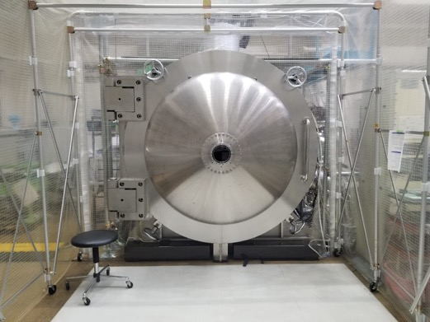

Figure 2 Space Chamber at CeNT

## Test Setup

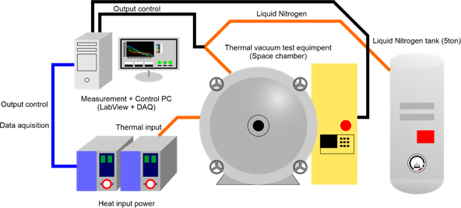

Figure 3 Overall test setup



Figure 4 Connection from COM-UHF transceiver boards to GS equipment

## Thermal Cycle Profile

* The test is planned to be conducted for 4 cycles (4 cold and 4 hot) as shown in Figure 5.
* At the extreme cold temperature and at the extreme hot temperature of each cycle, soaking time would be two hours with one hour for functional testing per satellite.
* There are total 8 temperature measurement points for the satellite, including the six on the external panel points.
* The monitoring/control temperature is average of six external panels.
* The worst hot condition for the external panel was +30°C.
* The battery heater of the satellite thermal subsystem would be activated at 8°C and less.
* The battery temperature was controlled to go close to 0°C.

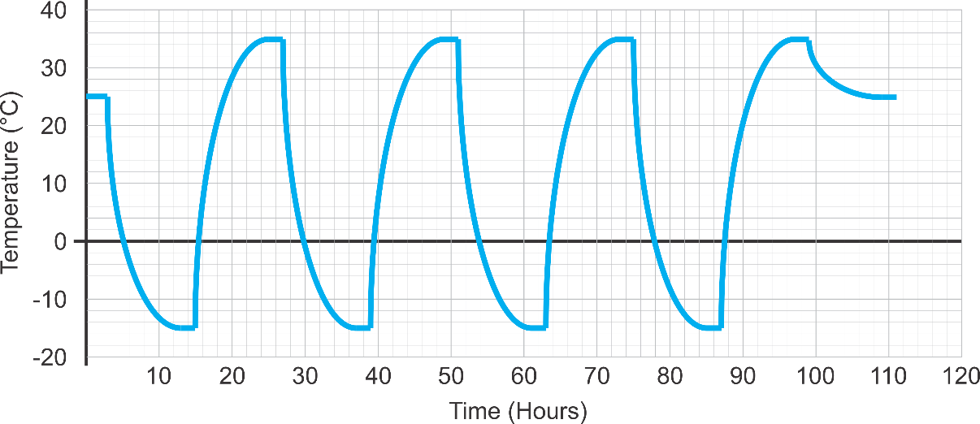

Figure 5 Planned Thermal cycle profile.

## Heater positions

The next table provides the sheet heater parameters such as position, size, resistance, and maximum power that can be used for the test.

Table 5 Heaters resistance and power supply assigned

|  |  |  |  |
| --- | --- | --- | --- |
| Heater Number | Position | Resistance (Ohm) | Power supply number |
| 1 | Front | 20.7 | 1 |
| 2 | Right | 15.2 | 2 |
| 3 | Back | 21.2 | 3 |
| 4 | Left | 15.7 | 4 |
| 5 | Bottom | 16.5 | 5 |
| 6 | Top | 14.9 | 6 |

## Thermocouple positions

The thermocouple positions are summarized in the following table.

Table 6 Positions of Thermocouples

|  |  |  |  |
| --- | --- | --- | --- |
| TC No. | Position | TC name in PC | Measurement point |
| 1 | PY_Battery Box (outside) | Bat_Box | Refer to Table 7 |
| 2 | PY_Reaction Wheel Assembly | Reaction_Wheel |
| 3 | PY_Positive X External Panel | Pos_X_Panel |
| 4 | PY_Negative X External Panel | Neg_X_Panel |
| 5 | PY_Positive Y External Panel | Pos_Y_Panel |
| 6 | PY_Negative Y External Panel | Neg_Y_Panel |
| 7 | PY_Positive Z External Panel | Pos_Z_Panel |
| 8 | PY_Negative Z External Panel | Neg_Z_Panel |
| 9 | PH_Battery Box (outside) | Bat_Box |
| 10 | PH_Reaction Wheel Assembly | Reaction_Wheel |
| 11 | PH_Positive X External Panel | Pos_X_Panel |
| 12 | PH_Negative X External Panel | Neg_X_Panel |
| 13 | PH_Positive Y External Panel | Pos_Y_Panel |
| 14 | PH_Negative Y External Panel | Neg_Y_Panel |
| 15 | PH_Positive Z External Panel | Pos_Z_Panel |
| 16 | PH_Negative Z External Panel | Neg_Z_Panel |
| 17 | JP_Battery Box (outside) | Bat_Box |
| 18 | JP_Reaction Wheel Assembly | Reaction_Wheel |
| 19 | JP_Positive X External Panel | Pos_X_Panel |
| 20 | JP_Negative X External Panel | Neg_X_Panel |
| 21 | JP_Positive Y External Panel | Pos_Y_Panel |
| 22 | JP_Negative Y External Panel | Neg_Y_Panel |
| 23 | JP_Positive Z External Panel | Pos_Z_Panel |
| 24 | JP_Negative Z External Panel | Neg_Z_Panel |
| 25 | Cylinder Shroud |  |  |
| 26 | Front wall |  |  |
| 27 | Back wall |  |  |
| 28 | Heater1 |  |  |
| 29 | Heater2 |  |  |
| 30 | Heater3 |  |  |
| 31 | Heater4 |  |  |
| 32 | Heater5 |  |  |
| 33 | Heater6 |  |  |

Table 7 Measurement Points

|  |  |  |  |
| --- | --- | --- | --- |
| **External Panels** | | | |
|  |  | |  |
| Positive Z External Panel | Positive Y External Panel | | Positive X External Panel |
|  |  | |  |
| Negative Z External Panel | Negative Y External Panel | | Negative X External Panel |
| **Internal Components** | | | |
| Y axis Magnetic Coil | | Z axis Magnetic Coil | |
|  | |  | |
| Battery Box | | Reaction Wheel Assembly | |

## Attachment of Thermocouples

The next figure shows the steps of attaching the thermocouples to satellite surfaces and components.

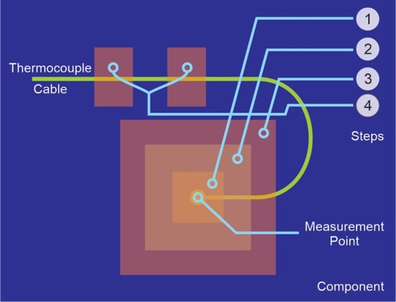

Figure 6 Thermocouple attachment

* Step 1: Cover thermocouple tips by a small piece of polyimide tape.
* Step 2: Fix the thermocouple terminal using aluminum tape.
* Step 3: Cover the aluminum tape by polyimide tape.
* Step 4: Fix the thermocouple wire by polyimide tapes.

## Placement of satellite inside the chamber

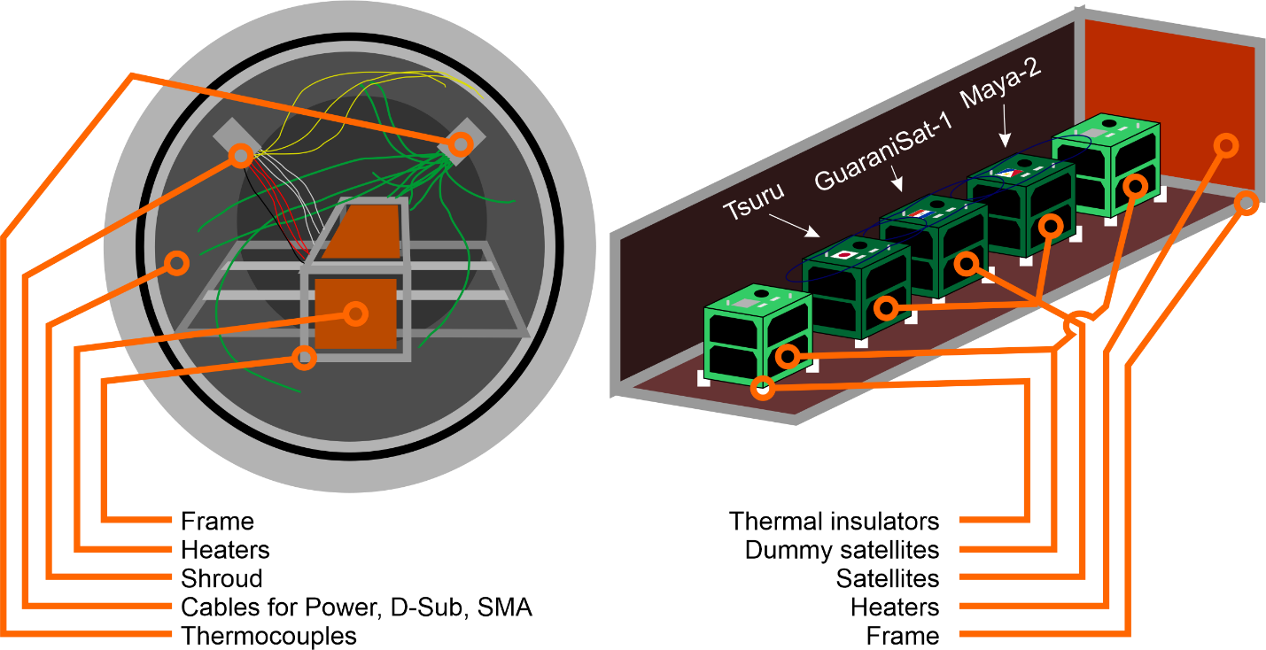

Figure 7 Placement of Satellite inside the chamber

## Equipment and Measuring Instruments

Table 8 Equipment and measuring instruments details

|  |  |  |  |  |
| --- | --- | --- | --- | --- |
| **No** | **Equipment** | **Quantity** | **Model** | **Comments** |
| 1 | Thermocouples | 33 | Type-K | -180 to +1300 °C |
| 2 | Data Acquisition PC | 1 | N/A | For chamber control |
| 3 | DAQ-mx | 2 | NI 9213 | 24-bit ADC |
| 4 | Power Supplies | 2 |  | 0-320V |
| 5 | Transceiver | 1 | IC-9100 | For functional test |
| 6 | Attenuator | 3 |  | For functional test |
| 7 | Functional Test PC | 2 | N/A | For functional test |
| 8 | Terminal Node Controller | 1 | KPC-9612+ | For functional test |
| 9 | Sheet heaters |  |  |  |

# Test Schedule

The test schedule is shown in Table 9 below, the schedule is tentative and can be changed base on the actual test conditions.

Table 9 Test schedule

|  |  |  |  |  |  |  |  |  |  |
| --- | --- | --- | --- | --- | --- | --- | --- | --- | --- |
| PROCEDURE | Jan  4 | Jan  5 | Jan  6 | Jan  7 | Jan  8 | Jan  9 | Jan  10 | Jan  11 | Jan  12 |
| Preparation of the satellite, thermocouples (TCs), sheet heaters, connectors, GS setup and other materials to be used for the test |  |  |  |  |  |  |  |  |  |
| Attachment of TCs to the satellite and checking the response |  |  |  |  |  |  |  |  |  |
| Satellite assembly |  |  |  |  |  |  |  |  |  |
| Checking of satellite functionality in normal laboratory setup (in Room condition) |  |  |  |  |  |  |  |  |  |
| Installation of the satellite, TCs, and connectors inside the vacuum chamber and checking connectivity and responses |  |  |  |  |  |  |  |  |  |
| Checking the satellite functionality inside the vacuum chamber before closing (atmospheric condition) |  |  |  |  |  |  |  |  |  |
| Vacuuming |  |  |  |  |  |  |  |  |  |
| Inject LN2 |  |  |  |  |  |  |  |  |  |
| Thermal Cycle |  |  |  |  |  |  |  |  |  |
| De-vacuuming, setup recovery and removing the satellite from the vacuum chamber |  |  |  |  |  |  |  |  |  |

# Detailed Test Procedure

The detail test procedures shown in Table 10 with tasks need to be done before, during and after the test, the person in charge of each task should check the task once it is finished.

|  |  |  |
| --- | --- | --- |
| Verification | | |
| Preparation and checking the satellite and chamber | | |
| (Cold Cycle) | Make vacuum and conduct the thermal test and functional test | (Hot Cycle) |
| Stop the test, clean up and check the satellite | | |

Table 10 Detailed test procedure

|  |  |  |  |  |  |
| --- | --- | --- | --- | --- | --- |
| **No** | **Procedure** | **Date** | **Time** | **Responsible** | **Comments** |
| 1 | Verify all satellite functionalities and operation (preliminary, in Clean Room) | Jan, 7 | --- |  | --- |
| 2 | Prepare and check thermocouples | Jan, 4 | --- | AM | --- |
| 3 | Check chamber's thermocouple connections | Jan, 8 | --- | AM | --- |
| 4 | Check chamber's D-Sub and RF port connections | Jan, 5 | --- |  | --- |
| 5 | Disassemble structure and center box | Jan, 5 | --- | AM, YC | --- |
| 6 | Attach thermocouples to Satellite | Jan, 5 | --- | AM, YC, MS | --- |
| 7 | Take photos and note the TCs’ positions | Jan, 5 | --- | AM, MS | --- |
| 8 | Reassemble satellite and check thermocouples and heaters connection | Jan, 5 | --- | AM, YC | --- |
| 9 | Check satellite functionalities | Jan, 7 | --- | IZ, AJ | --- |
| 10 | Move satellite to the chamber | Jan, 7 | --- | IZ, AM, AJ, MS | --- |
| 11 | Install the satellite in the chamber | Jan, 7 | --- | AM | --- |
| 12 | Check again all heaters’ and TCs’ response on the PC | Jan, 8 | --- | AM | --- |
| 13 | Check satellite functionalities | Jan, 8 | --- | IZ, AJ | --- |
| 14 | Chamber closing, start of rough vacuum | Jan, 9 | 02:13 | AM | --- |
| 15 | Finish rough vacuum | Jan, 9 | 04:33 | AM | --- |
| 16 | Start high vacuum | Jan, 9 | 04:33 | AM | --- |
| 17 | High vacuum reached | Jan, 9 | 08:50 | AM | --- |
| 18 | Start Functional test | Jan, 9 | --- | IZ, AJ | --- |
| 19 | Finish Functional test | Jan, 9 | --- | IZ, AJ | --- |
| 20 | Inject LN2 | Jan, 9 | 12:00 | AM | --- |
| 21 | Start cold ramp #1C | Jan, 9 | 12:00 | AM | --- |
| 22 | Temp stabilization reached (cold) #1C | Jan, 9 | 19:30 | AM | --- |
| 23 | Start Functional test #1C | Jan, 9 | 20:30 | IZ, AJ, Hisa | --- |
| 24 | Finish Functional test #1C | Jan, 10 | 01:30 | IZ, AJ, Hisa | --- |
| 25 | Start hot ramp #1C | Jan, 10 | 01:30 | AM | --- |
| 26 | Temp stabilization reached (hot) #1C | Jan, 10 | 04:40 | AM | --- |
| 27 | Start Functional test #1C | Jan, 10 | 05:40 | IZ, AJ, Hisa | --- |
| 28 | Finish Functional test #1C | Jan, 10 | 08:42 | IZ, AJ, Hisa | --- |
| 29 | Start cold ramp #2C | Jan, 10 | 08:42 | MS, HA | --- |
| 30 | Temp stabilization reached (cold) #2C | Jan, 10 | 15:10 | HA, AM | --- |
| 31 | Start Functional test #2C | Jan, 10 | 16:10 | IZ, AJ, Hisa | --- |
| 32 | Finish Functional test #2C | Jan, 10 | 19:10 | IZ, AJ, Hisa | --- |
| 33 | Start hot ramp #2C | Jan, 10 | 19:10 | AM | --- |
| 34 | Temp stabilization reached (hot) #2C | Jan, 10 | 23:00 | AM | --- |
| 35 | Start Functional test #2C | Jan, 11 | 00:00 | IZ, AJ, Hisa | --- |
| 36 | Finish Functional test #2C | Jan, 11 | 02:44 | IZ, AJ, Hisa | --- |
| 37 | Start cold ramp #3C | Jan, 11 | 02:44 | AM | --- |
| 38 | Temp stabilization reached (cold) #3C | Jan, 11 | 08:00 | AM | --- |
| 39 | Start Functional test #3C | Jan, 11 | 13:00 | IZ, AJ | --- |
| 40 | Finish Functional test #3C | Jan, 11 | 15:50 | IZ, AJ | --- |
| 41 | Stop LN2 injection | Jan, 11 | 15:50 | AM | --- |
| 42 | Get to room temperature | Jan, 11 | 15:50 | AM | Turn on chamber heater to increase chamber temperature |
| 43 | Room temperature reached | Jan, 11 | --- | AM | --- |
| 44 | Start Functional test | Jan, 12 | --- | IZ, AJ | --- |
| 45 | Finish functional test | Jan, 12 | --- | IZ, AJ | --- |
| 46 | De-vacuuming and recovery | Jan, 12 | --- | AM | --- |
| 47 | Do fit check with satellite | Jan, 12 | --- | AM | --- |
| 48 | Remove TCs | Jan, 12 | --- | AM | --- |

# Test Output

## Data analysis strategy

Table 11 below show the operating temperature range for the satellite. The temperature of each component during the test should be inside of operating temperature range.

Table 11 Components operating temperature range

|  |  |  |
| --- | --- | --- |
| Component | Operating Temperature Range (°C) | |
| Lowest | Highest |
| Battery Box Assembly | 0 | +40 |
| Reaction Wheel | -40 | +60 |
| Plus X Panel | -40 | +85 |
| Minus X Panel | -40 | +85 |
| Plus Y Panel | -40 | +85 |
| Minus Y Panel | -40 | +85 |
| Plus Z Panel | -40 | +85 |
| Minus Z Panel | -40 | +85 |

|  |  |  |  |  |  |  |
| --- | --- | --- | --- | --- | --- | --- |
| Component | Recorded Temperature Range during Test (°C) | | | | | |
| Paraguay | | Philippines | | Japan | |
| Lowest | Highest | Lowest | Highest | Lowest | Highest |
| Battery Box Assembly | 0.37 | 40.59 | 2.59 | 40.24 | -0.46 | 40.63 |
| Reaction Wheel | -9.79 | 39.62 | -11.69 | 38.83 | -9.39 | 40.55 |
| Plus X Panel | -18.60 | 34.66 | -22.99 | 31.51 | -17.14 | 36.81 |
| Minus X Panel | -15.86 | 38.00 | -21.44 | 35.12 | -19.87 | 34.77 |
| Plus Y Panel | -19.58 | 36.19 | --- | --- | -15.34 | 40.07 |
| Minus Y Panel | -16.95 | 37.81 | -18.63 | 37.59 | -17.82 | 39.32 |
| Plus Z Panel | --- | --- | -20.75 | 34.59 | -21.58 | 32.70 |
| Minus Z Panel | -20.02 | 34.09 | -22.41 | 32.19 | -19.49 | 37.03 |

## Test report

Temperature profile of all measurement points during the test.

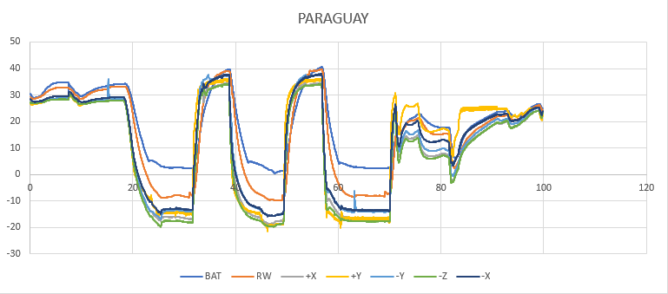

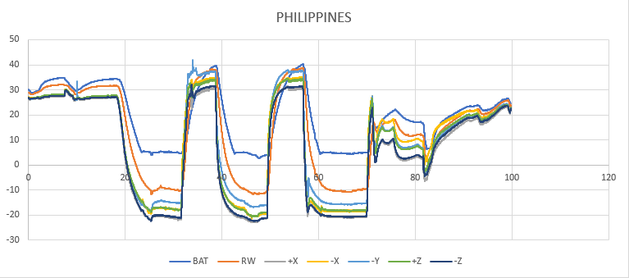

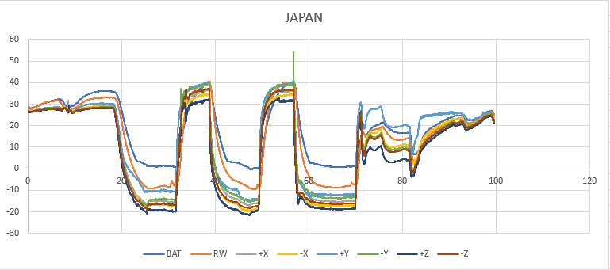

Since the tests subjects have same hardware as the EM model of the satellite, which has subjected to temperatures from -30 to +70 degrees Celsius on its thermal vacuum test, FM TVT external panels worst hot and cold conditions were set to -20 to +40 degrees Celsius as a less severe test, reason why internal temperature readings from battery box and reaction wheel were unable to go below -11.69 degrees. 4 thermocouples readings were faulty during the test, so they were omitted.

|  |
| --- |
|  |

On the FM TVT, +2 hours of hot and cold soak were done during every cycle before performing functional test.

# Quality Insurance

Temperature [oC]: 20 ± 5

Humidity [%]: 70 ± 10

Atmosphere: 10^-5 Pa

# Personnel Assignment

Table 12 show the personnel assignment for the thermal vacuum test.

Table 12 Personnel Assignment During Setup Preparation

|  |  |
| --- | --- |
| **Task** | **Responsible Person** |
| Ground Station Equipment | NAKAYAMA, MARLOUN |
| Preparation and installation of heaters and thermocouples | ANIBAL, YIGIT |
| D-sub Connector Preparation | IZ |
| Battery Charging Setup | HARI |
| Antenna preparation and deployment test trial | YUMA |
| Documentation | ANIBAL, ADOLFO, IZ, YIGIT |
| Support | ADOLFO, MARLOUN |
| TVT lead | ANIBAL |
| Team management | IZ |

# Conclusion

Thermal Vacuum Test was performed on all 3 satellites of BIRDS4. The hardware and components showed to work properly on the conditions stated in the procedure, passing this test.