Kyushu Institute of Technology

Department of Applied Science for Integrated System Engineering



**BIRDS-4 Project**

**Vibration Test Plan for FM**

Laboratory of Lean Satellite Enterprises and In-orbit Experiments



|  |  |  |  |
| --- | --- | --- | --- |
| **Date** | **Version Number** | **Writer** | **Annotations** |
| 2019/11/13 | 0 | Yigit Cay | Draft |
| 2020/01/27 | 1 | Yigit Cay | Satellite weights are added. |
| 2020/08/10 | 2 | Yigit Cay | Level is changed to AT+MWL. |
|  |  |  |  |
|  |  |  |  |

**Contents**

LIST OF ACRONYMS AND ABBREVIATIONS 3

1. INTRODUCTION 4

2. REFERENCED DOCUMENTATION 4

3. TEST PURPOSE 4

3.1. Overall test description 4

3.2. Success Criteria 4

4. TEST FACILITY 5

4.1 Location 5

4.2 Test Facility Characteristics 5

4.3 Test Equipment 6

4.4 Test TOOLS 6

5. TEST DESCRIPTION 7

5.1. Test flow 7

5.2. Test article(s) 7

5.3. Test set-up 8

5.4. Supporting analyses 11

5.5. Test input data 11

5.6. Test output data 14

5.7. Test Schedule 14

6. DETAILED PROCEDURAL CHECKLIST 15

Test checklist 15

7. SAFETY MANAGEMENT 15

8. TEST PERSONNEL 16

9. EMERGENCY PROCEDURE 16

**List of Acronyms and Abbreviations**

|  |  |  |  |  |
| --- | --- | --- | --- | --- |
| **A** |  |  | **P** |  |
| AMP | Charge Amplifier |  | PC | Personal Computer |
| AT | Acceptance Test |  |  |  |
| ATV | Automatic Transfer Vehicle |  | **R** |  |
| **B** |  |  | RAS | Requirement Allocation Sheet |
| BAT | Battery |  |  |  |
| **C** |  |  | **S** |  |
| CH | Channel |  | STM | Structure and Thermal model |
| CAM | Camera |  |  |  |
| C.P. | Control Point |  | STR | Structure team |
| **D** |  |  | SVBL | Satellite Venture Business Laboratory |
| DAQ | Data Acquisition System |  | SpX | Space X |
| DR | Design Requirements |  |  |  |
| Dir | Direction |  |  |  |
|  |  |  |  |  |
| **F** |  |  | | |
| FFT | Fast Fourier Transform |  | | |
| FM | Flight Model |  | | |
|  |  |  | | |
| **G** |  |  | | |
| Go-p | G zero to peak |  | | |
| Grms | G Root mean square |  | | |
|  |  |  | | |
| **H** |  |  | | |
| HTV | HII Transfer Vehicle |  | | |
|  |  |  | | |
| **J** |  |  | | |
| JEM | Japan Experimental Module |  | | |
|  |  |  | | |

1. **Introduction**

This document highlights mechanical tests (vibration) to be carried out on the BIRDS-4 CubeSat. The aim of the test is to demonstrate that the test article can withstand mechanical vibration when excited with acceleration levels induced by launch vehicles which includes HTV-X, Dragon and Cygnus by adding the minimum workmanship level (MWL). Excitations of the test article will be done within a range of 20 Hz to 2,000 Hz to comply with JAXA requirements.

The vibration test types include:

* Modal survey
* Random vibration test (AT level)

By successfully completing these tests, we can show that the structure design has enough strength and rigidity with sufficient safety margin to withstand the environmental stress induced by ground handling and launch vehicle induced loads.

1. **Referenced Documentation**

**Table 1 Reference documents**

|  |  |  |  |
| --- | --- | --- | --- |
| **No.** | **Document number** | **Document description** | **Revision level or Release date** |
| 1 | JX-ESPC-101132-D | JEM Payload Accommodation Handbook; Small Satellite Deployment Interface Control Document | Vol 8. May, 2020 |
| 2 | Torque Chart | Maryland Metrics Torque Chart | Retrieved May, 2016  <https://mdmetric.com/tech/torqcht1a.pdf> |
| 3 | 18_  BIRDS4-AP-01 | Torque Management | Revision 1 |
| 4 | SSP52005 | Payload Flight Equipment Requirements and Guidelines for  Safety-Critical Structures | Rev. C. December, 2002 |
| 5 | NASA-STD-7001 | Payload Vibroacoustic Test Criteria | November, 2017 |

1. **Test Purpose**

**3.1. Overall test description**

The purpose of this test is to evaluate the impact of vibration by launch vehicle on BIRDS-4 CubeSat Structure.

Functional tests of the different subsystems will be carried out before and after each vibration test. Modal survey will be done to determine the natural frequencies of structure. After Modal survey, Random vibration will be done to excite the structure within the qualification levels of the launch vehicles indicated in JEM Payload Accommodation Handbook referred to in Table 1. above.

After each Random vibration, Modal survey will be conducted to evaluate any changes in the vibration response of the structure. The vibration response data will be used as a benchmark in verifying the integrity of the design workmanship as well as determining if the design and configuration satisfies minimum launch provider requirements for strength and stiffness.

**3.2. Success Criteria**

The success of the vibration test will be determined based on the following criteria;

* Shift in Natural Frequency: A significant shift in natural frequency indicates *workmanship failure* (loose components on/in the structure). Any broken parts in the primary structure shall be judged as a *failure in design.*
* Torque Mark Shift: When observed visually, there should be no shift in torque marks on the screws on the test article after each test. Any shift in torque mark shows a *workmanship failure* in setting the required torque before testing
* Fracture Critical Parts:

1. All external fasteners and fasteners holding the main structure shall not be loosened after vibration.
2. Glass components (including solar cells and camera lens) shall not be broken after vibration.

* Deployable Components

The deployable UHF and VHF dipole antennas shall not deploy during vibration.

* Radio Interference

Satellite shall not broadcast radio (CW) during vibration.

* Satellite Function

Satellite functional test shall be conducted before and after vibration tests. Satellite function after vibration tests should be the same as before tests.

1. **Test Facility**
   1. **Location**

Center for Nanosatellite Testing (CeNT)

Laboratory of Lean Satellite Enterprises and In-orbit Experiments

Kyushu Institute of Technology

1-1 Sensui, Tobata, Kitakyushu, 804-8550 Fukuoka, Japan

* 1. **Test Facility Characteristics**

The vibration testing system specifications are shown in Table 2 and an illustration of CeNT’s vibration test machine is shown in Figure 1.

**Table 2 Vibration testing system specification**

|  |  |  |  |  |
| --- | --- | --- | --- | --- |
| **No.** | **Items** | **Specification** | | |
| 1 | Type | F-35000BD/LA36AP(made by EMIC) | | |
| 2 | Exciting Force | Sine | | 35.0 kN |
|  | Random | | 28.0 kN |
|  | Shock | | 87.5 kN |
| 3 | No-load maximum acceleration | Vertical | Sine | 1060.0 m/s2 |
|  | Shock | 1470.0 m/s2 (0-p) |
|  | Horizontal | Sine | 460.5 m/s2 |
|  | Shock | 1151.3 m/s2 (0-p) |
| 4 | Maximum loading mass | Vertical | | 400 kg |
|  | Horizontal | | 500 kg |
| 5 | Horizontal vibration table size | 50cm×50 cm | | |
| 6 | Power | 49.0 kVA | | |

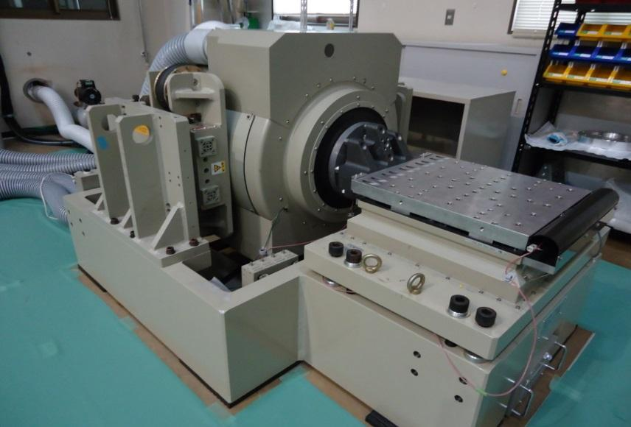

**Figure 1 Vibration Test Machine**

* 1. **Test Equipment**

The list of equipment to be used during BIRDS-4 FM vibration test is described in Table 3.

**Table 3 Test equipment**

|  |  |  |  |  |
| --- | --- | --- | --- | --- |
| **No.** | **Equipment name** | **Model number** | **Manufacturer** | **Quantity** |
| 1 | Vibration test machine | EMIC F-35000BD/LA36AP | EMIC | 1 |
| 2 | Vibration control machine | DS-98000MJ | EMIC | 1 |
| 3 | Data acquisition PC |  |  | 1 |
| 4 | Accelerometers |  |  | 7 |
| 5 | 16 bit DAQ(-10 - +10V) | NI cDAQ 9178  NI 9125 | National Instruments(TI) | Max 24 channels |
| 6 | Charge Amplifier | Control (EMC 504-CB/TKS-4/214) | EMIC | 4 ch |
| 7 | Accelerometer checker |  |  | 1 |

* 1. **Test tools**

The list of tools necessary to carry on BIRDS-4 FM vibration test is given in Table 4.

**Table 4 Test tools**

|  |  |  |  |  |
| --- | --- | --- | --- | --- |
| **No.** | **Designation** | **Kyutech Number** | **Memo** | **Quantity** |
| 1 | Torque driver 1 | TW-1 | 2~6 Nm | 1 |
| 2 | Torque driver 2 | TD-1 | 20~120 cNm | 1 |
| 3 | Torque driver 3 | - | M2, 31.5 cNm | 1 |
| 4 | Torque driver 4 | - | M1.6, 15.6 cNm | 1 |
| 5 | Torque wrench 1 | 20 | 9.2 Nm | 1 |
| 6 | Torque wrench 2 | 3 | 30 Nm | 1 |
| 7 | Torque wrench 3 | 2 | 120 Nm | 1 |
| 8 | Allen key set | 22 | - | 1 |
| 9 | Hammer | 18 | Accelerometer check | 1 |
| 10 | Alcohol | - | Cleaning | 1 |
| 11 | Kim wipes | - | Cleaning | 1 |
| 12 | Super glue | - | Accelerometer fixation | 1 |
| 13 | Electrical tape | - | Routing | 1 |
| 14 | Gloves | - | KitMaap manipulation | 1 pair/person |
| 15 | Water level | - | - | 1 |
| 16 | permanent marker |  | Torque mark | 1 |
| 17 | Sand paper |  | Accelerometer cleaning | 1 |
| 18 | Polyimide tape |  |  | 1 |
| 19 | Video camera |  | SONY HDR-CX550V | 1 |

1. **Test Description**
   1. **Test flow**

BIRDS-4 FM vibration test is described in Figure 2.

|  |  |  |  |  |  |  |  |  |  |  |
| --- | --- | --- | --- | --- | --- | --- | --- | --- | --- | --- |
|  | **01 Functional Test\*** |  |  |  |  |  |  |  |  |  |
|  | **↓** |  |  |  |  |  |  |  |  |  |
|  | **02 Preparation** |  |  |  | **06 Axis change** |  |  |  | **10 Axis change** |  |
|  | **↓** |  |  |  | **↓** |  |  |  | **↓** |  |
| **Z axis** | |  |  | **X axis** | |  |  | **Y axis** | |  |
|  | **03 Modal** |  | → |  | **07 Modal** |  | → |  | **11 Modal** |  |
|  | **↓** |  |  |  | **↓** |  |  |  | **↓** |  |
|  | **04 Random AT+MWL** |  |  |  | **08 Random AT+MWL** |  |  |  | **12 Random AT+MWL** |  |
|  | **↓** |  |  |  | **↓** |  |  |  | **↓** |  |
|  | **05 Modal** |  |  |  | **09 Modal** |  |  |  | **13 Modal** |  |
|  |  |  |  |  |  |  |  |  |  |  |
|  |  |  |  |  |  |  |  |  | **↓** |  |
|  |  |  |  |  |  |  |  |  | **14 Clean up** |  |
|  |  |  |  |  |  |  |  |  | **↓** |  |
|  |  |  |  |  |  |  |  |  | **15 Functional Test\*** |  |

**Figure 2 BIRDS-4 FM vibration test flow**

* These functional tests are performed independently of the vibration test.

* 1. **Test article(s)**

The test articles to undergo AT level vibration test are the 3 BIRDS-4 FM CubeSats, and a 3U pod. Each test article specifications are described in Table 5 and Figure 3.

**Table 5. Test articles**

|  |  |  |  |  |  |
| --- | --- | --- | --- | --- | --- |
|  | **Article name** | **Number** | **Manufacturer** | **Mass (kg)** | **Dimension (mm)** |
| **1** | BIRDS-4 FM / 001J (TSURU) | 1 | HMD | 1.30 | 100 (L) × 100 (W) × 113.5 (H) |
| **2** | BIRDS-4 FM / 001P (MAYA-2) | 1 | HMD | 1.30 | 100 (L) × 100 (W) × 113.5 (H) |
| **3** | BIRDS-4 FM / 001A (GUARANISAT-1) | 1 | HMD | 1.31 | 100 (L) × 100 (W) × 113.5 (H) |
| **4** | 3U Pod | 1 |  | 4.62 |  |

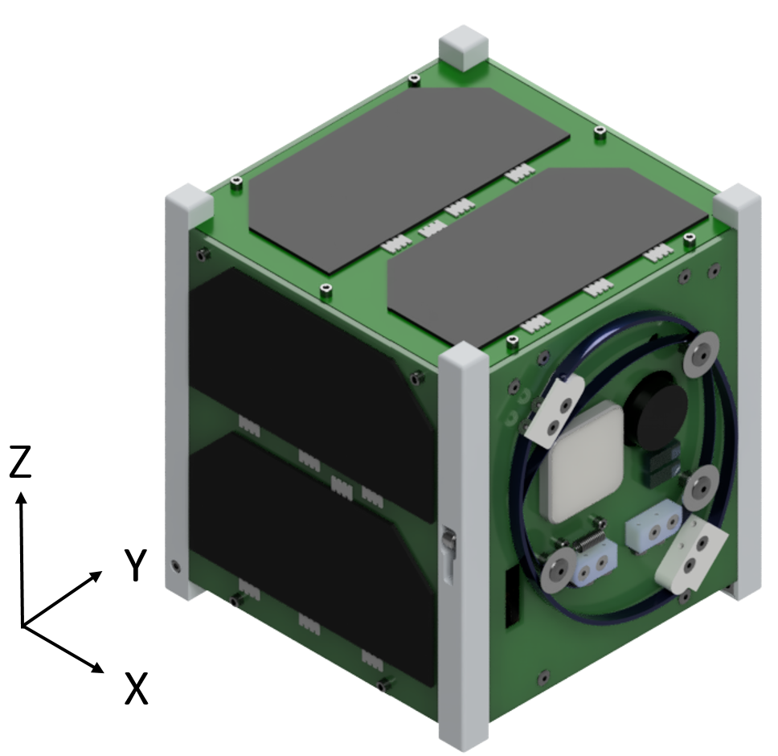 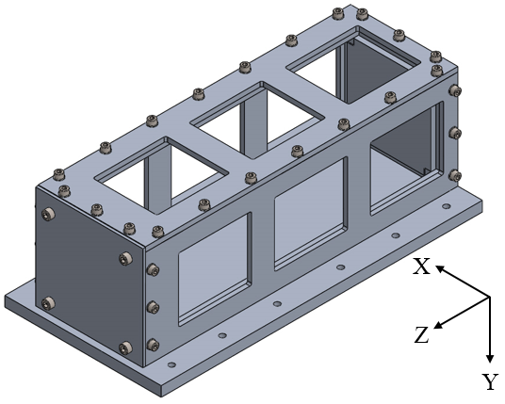

(a) (b)

113.6±0.05 m

**Figure 3. Test Articles: (a) BIRDS-4 FM and (b) 3U POD.**

* 1. **Test set-up**

BIRDS-4 FM set-up into the POD is shown in Figure 4 and the accelerometers location is described in Figures 5, 6. For the monitoring of the 3U POD and BIRDS-4, one triple-axis accelerometer are mounted at X axis of POD to monitor systems’ response along X, Y, and Z-axis. Moreover, four single-axis accelerometer are mounted to jig at four different locations. Two of them are used for jig control, while the other two are used for jig monitoring.

Each accelerometer is connected to a charge amplifier (AMP) and the data are taken through DAQ to a PC using a USB cable. Data from the analog signal channels are taken simultaneously and converted to digital signal using 16 bit DAQ (10,000 samples) and Fast Fourier Transform (FFT) is applied using LabView program. The accelerometer description is presented in Table 6 and the description of the test set-up for the different vibration types is shown in Table 7.

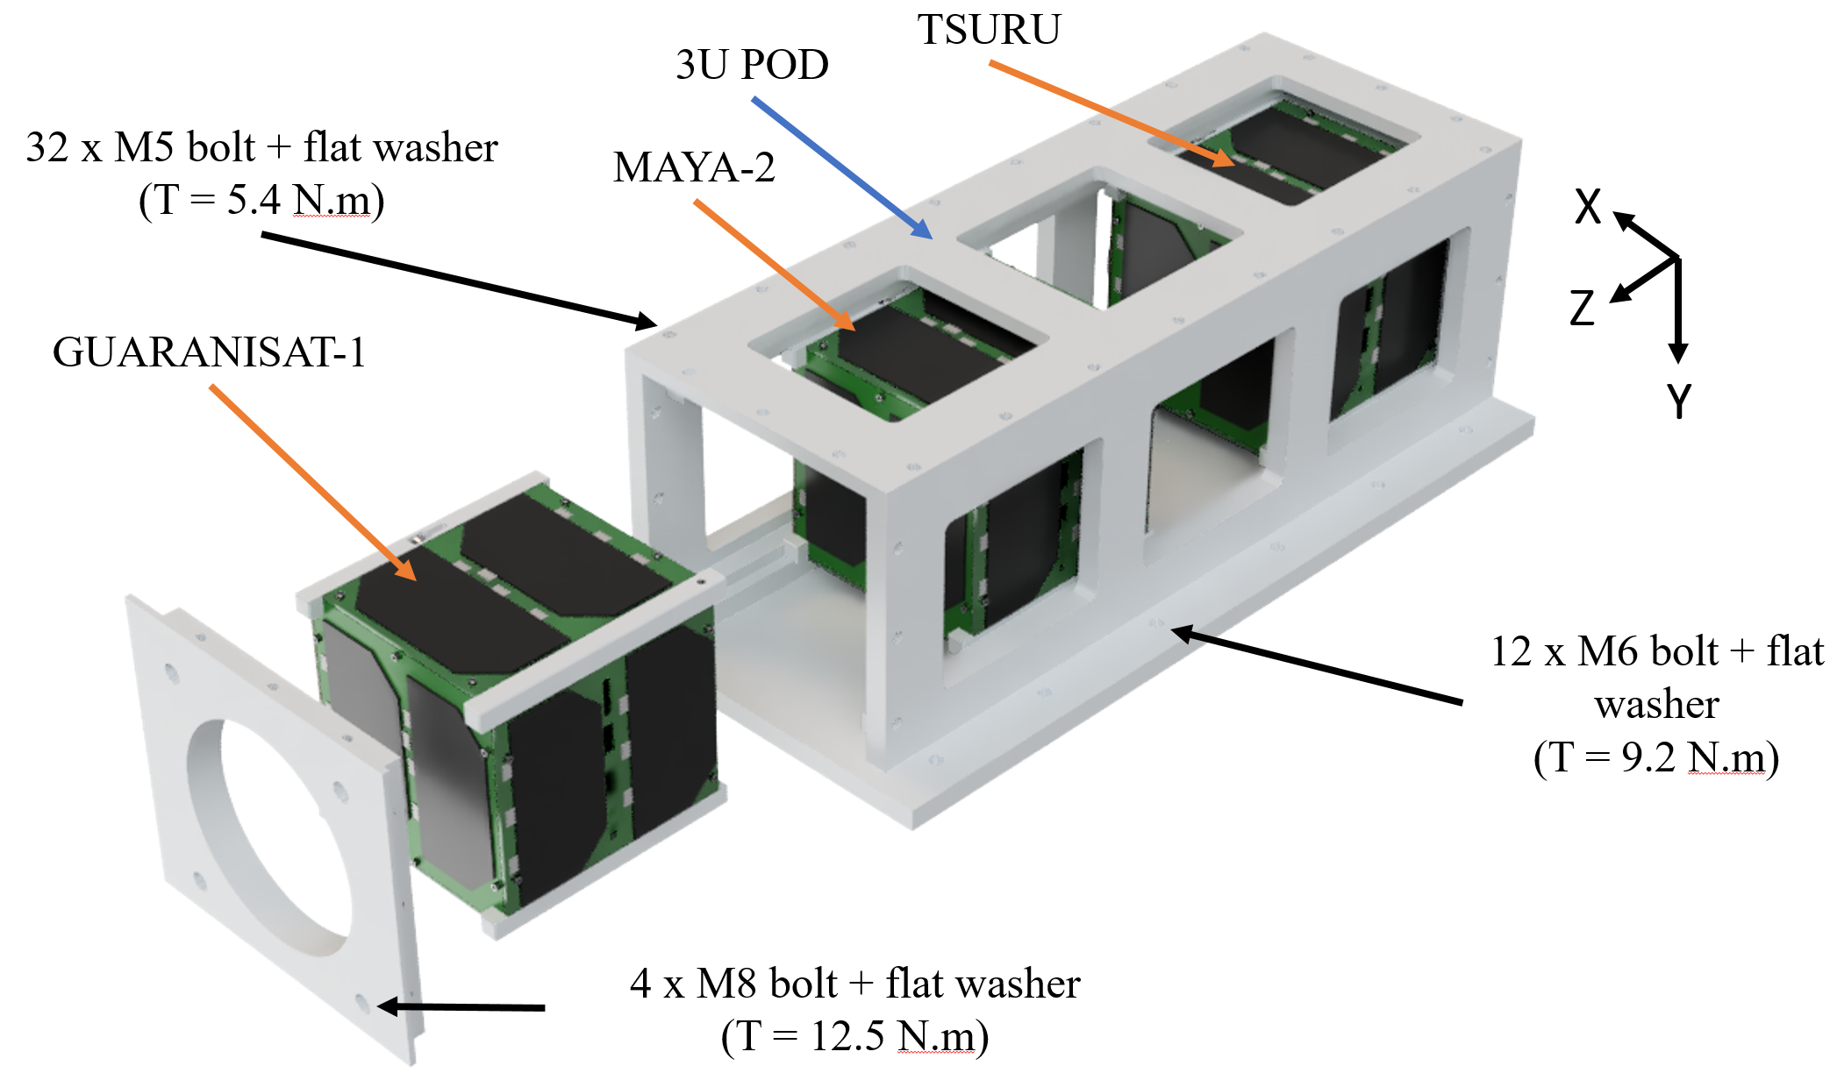

**Figure 4. BIRDS-4 set-up into 3U POD**

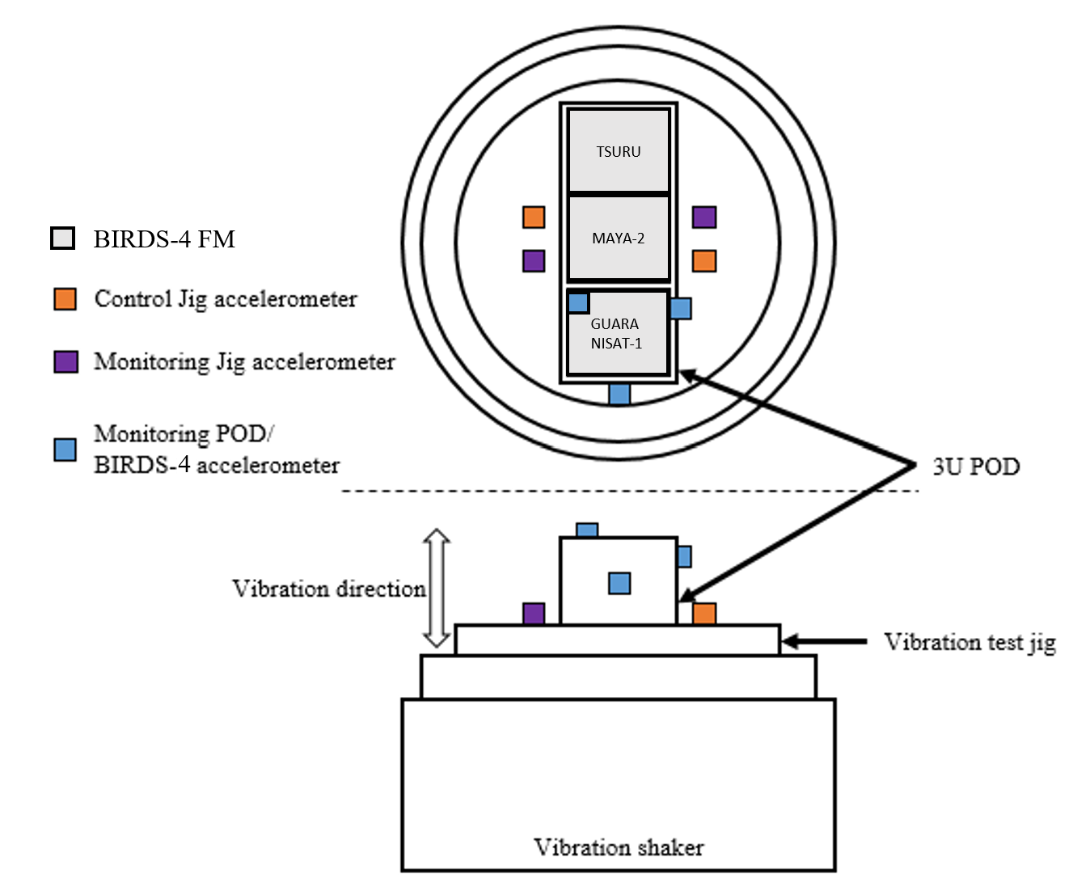

**Figure 5. Accelerometers configuration for acceleration in Y-direction**

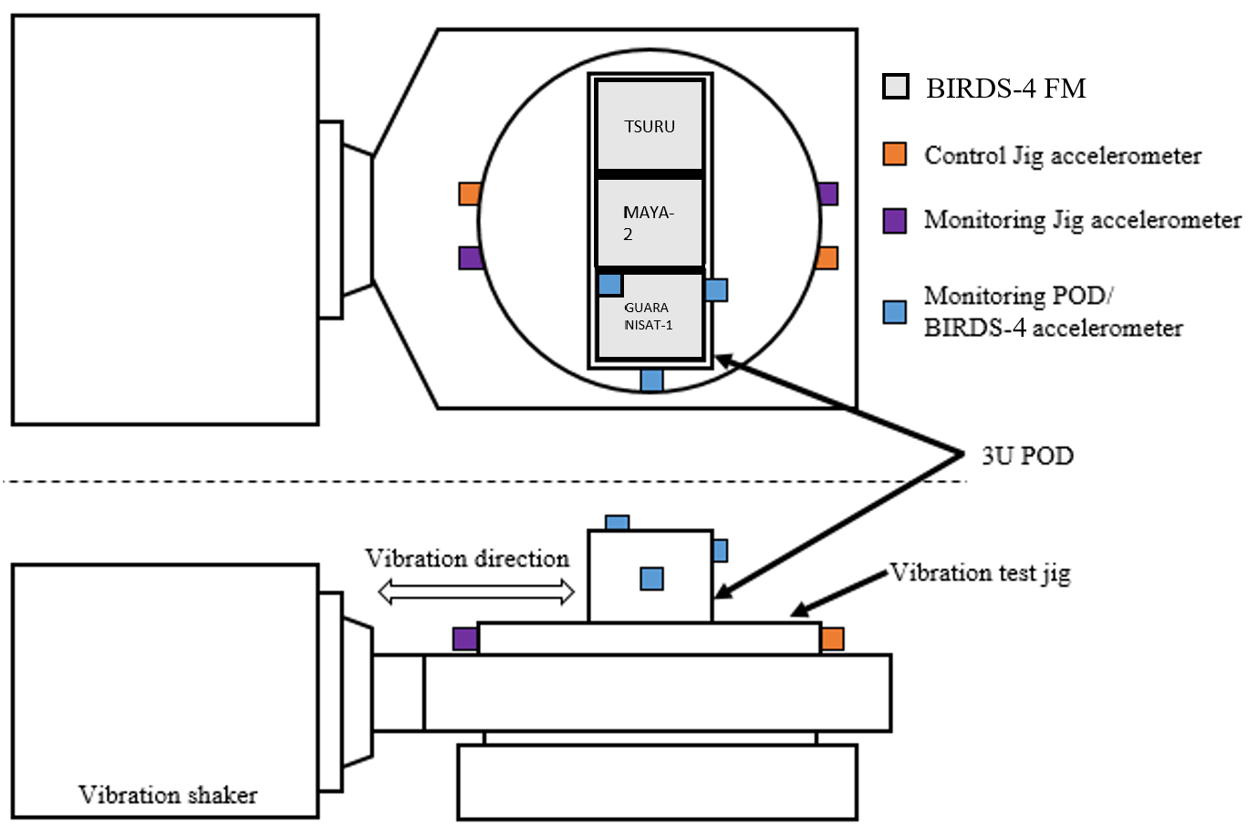

**Figure 6. Accelerometers configuration for acceleration in X and Z-direction**

**Table 6. Accelerometer Channel Number Designation and Charge Amplifier settings**

|  |  |  |  |  |  |  |
| --- | --- | --- | --- | --- | --- | --- |
| **Channel No** | **Axis** | **Mounting position** | **Accelerometer number** | pC/G | G/V range  Of Modal survey | G/V range  Of Random |
| 6 | X | X Axis (3U POD) |  |  |  |  |
| 5 | Y |  |  |  |  |
| 7 | Z |  |  |  |  |
| 1 | - | Jig |  |  |  |  |
| 2 | - | Jig |  |  |  |  |
| Controller | - | Jig |  |  |  |  |
| Controller | - | Jig |  |  |  |  |

**Table 7. Setting on the PC for control, PC for measurement, Vibration machine control and AMP**

|  |  |  |  |
| --- | --- | --- | --- |
| **Vibration test type** | | **Modal survey** | **Random** |
| Vibration Profile | | Random | Random |
| Vibration parameters  On LabView | Test type | Modal | Random |
| Frequency band [Hz]:  Min [Hz] | 20 | 20 |
| Frequency band [Hz]:  Max [Hz] | 2000 | 2000 |
| Setting of measuring:  Number of channels | 8 | 8 |
| Setting of measuring:  Measuring time [sec] | 50 | 50 |
| Setting of measuring:  Sampling rate [sample/sec] | 10,000 | 10,000 |
| Setting of analysis:  Number of FFT point | 16,384 | 16,384 |
| Setting of analysis:  G/V | 31.6 | 31.6 |
| Monitor (OSC)  Display time (Sec) | 0.2 | 0.2 |
| Monitor (OSC)  Max value of voltage (V) | 0.5 | 2 |
| Vibration Machine control | Switch: Sine - Random | Random | Random |
| External level | Half | Max |
| AMP | G/V range of single sensor | 3.16 | 3.16 |
| G/V range of control sensor | 31.6 | 31.6 |

* 1. **Supporting analyses**

Preliminary structural analysis was done using Fusion360. The natural frequency from analysis is shown in Table 8.

**Table 8. Natural Frequency of Satellite from Structural Analysis**

|  |  |
| --- | --- |
| **Axis** | **Natural Frequency (Hz)** |
| X | 263 |
| Y | 310 |
| Z | 483 |

* 1. **Test input data**
* Modal survey

Modal survey test parameters are descried in Table 9.

**Table 9. Modal survey test table**

|  |  |  |  |
| --- | --- | --- | --- |
| **MODAL SURVEY** | | | |
| **Direction** | **Frequency [Hz]** | **Acceleration [Grms]** | **Time [min]** |
| Z, X, Y | 5~2000 | 0.5 (White Noise) | 1 |

* Random vibration (AT level + MWL)

The Random Acceleration Profile for the Test is as shown in Figure 8 and Table 10. The profile is derived using Maximum PSD values of Cygnus, Dragon and HTV-X by adding the MWL (Figure 7. and Table 10).

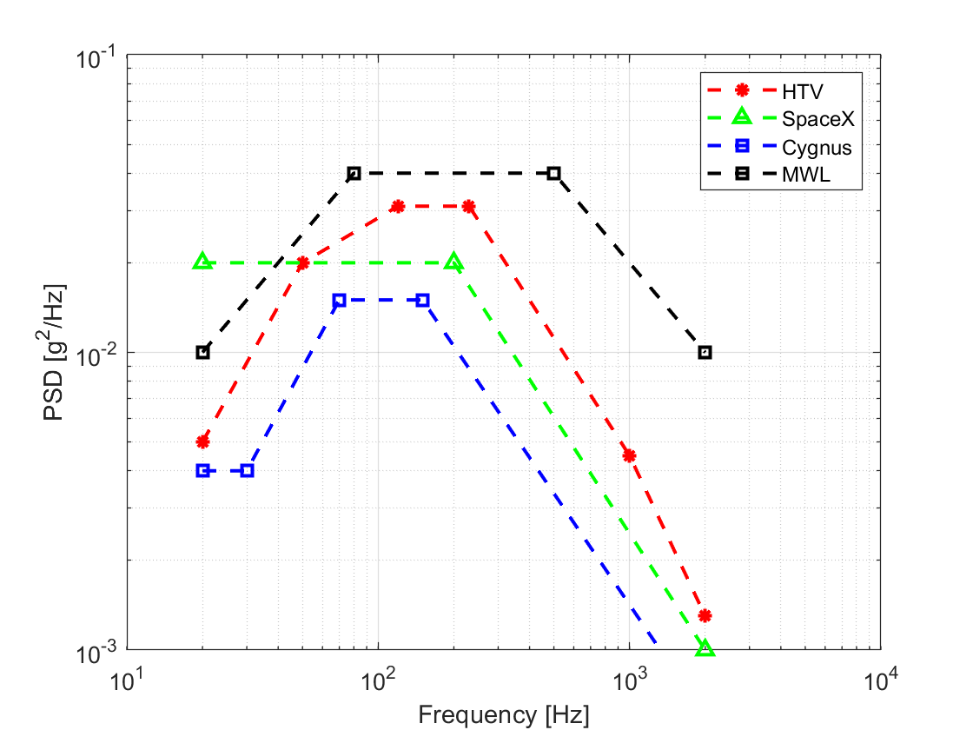

**Figure 7. AT Random vibration profiles for HTV-X, Dragon and Cygnus with MWL (Ref. JX-ESPC-101132D and NASA-STD-7001 for MWL)**

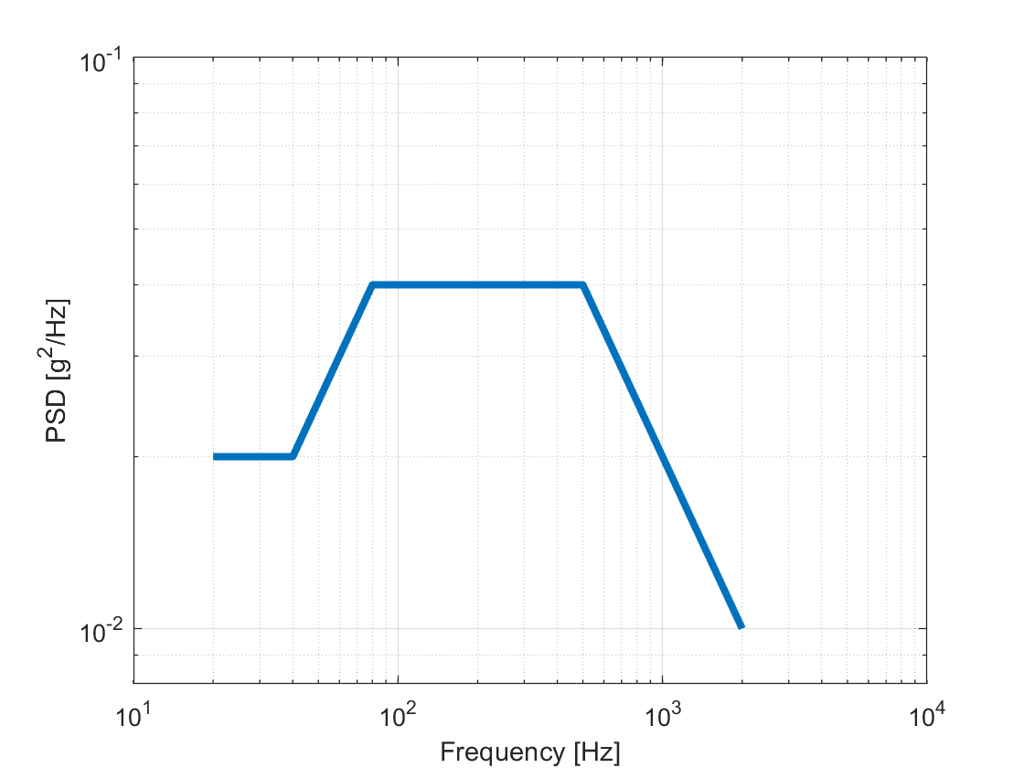

**Figure 8. Acceptance Test random vibration profile (PSD envelope)**

**Table 10. Random Vibration (AT) of Each Launch Vehicle, MWL and Max PSD (HTV-X, Dragon and Cygnus)**

|  |  |  |  |  |  |  |
| --- | --- | --- | --- | --- | --- | --- |
| **HTV-X** | | **Dragon** | |  | **AT Envelope (+MWL)** | |
| Freq. (Hz) | PSD (g2/Hz) | Freq. (Hz) | PSD (g2/Hz) |  | Freq. (Hz) | PSD (g2/Hz) |
| 20 | 0.005 | 20 | 0.02 |  | 20 | 0.02 |
| 50 | 0.02 | 200 | 0.02 |  | 40 | 0.02 |
|  |  |  |  |  | 80 | 0.04 |
|  |  |  |  |  | 500 | 0.04 |
| 120 | 0.031 |  |  |  | 2000 | 0.01 |
| 230 | 0.031 |  |  |  |  |  |
| 1000 | 0.0045 |  |  |  |  |  |
| 2000 | 0.0013 | 2000 | 0.001 |  |  |  |
| Overall (Grms) | 4.05 | Overall (Grms) | 3.20 |  |  |  |
| Duration(s) | 60 | Duration (s) | 60 |  | Overall (Grms) | 6.79 |
| **Cygnus** | | **MWL** | |  | Duration (s) | 60 |
| Freq. (Hz) | PSD (g2/Hz) | Freq. (Hz) | PSD (g2/Hz) |  |  |  |
| 20 | 0.004 | 20 | 0.01 |  |  |  |
| 30 | 0.004 | 80 | 0.04 |  |  |  |
| 70 | 0.015 |  |  |  |  |  |
| 150 | 0.015 |  |  |  |  |  |
|  |  | 500 | 0.04 |  |  |  |
| 2000 | 0.0006 | 2000 | 0.01 |  |  |  |
| Overall (Grms) | 2.44 | Overall (Grms) | 6.78 |  |  |  |
| Duration (s) | 60 | Duration (s) | 60 |  |  |  |

**Table 11. Random vibration test table**

|  |  |  |  |
| --- | --- | --- | --- |
| **RANDOM VIBRATION TEST** | | | |
| **Direction** | **Frequency [Hz]** | **Overall Acceleration [Grms]** | **Time [min]** |
| X, Y, Z | 20~2000 | 6.79 | 1 |

* 1. **Test output data**
* Raw vibration data from LabView
* Vibration Testing pictures
* Vibration Test Report
* Vibration Testing Video
* Functional Test Report
* Antenna Deployment Video

* 1. **Test Schedule**

The test schedule is detailed in Table 12.

**Table 12. Test schedule**

|  |  |  |
| --- | --- | --- |
| **Date** | **Time** | **Task** |
| 2020/08/11 | 9:00 | Functional Test |
| 10:30 | Preparation of Vibration test |
| 13:00 | Z axis Vibration |
| 15:00 | X axis Vibration |
| 17:00 | Change the vibration test machine axis |
| 18:00 | Y axis Vibration |
| 19:00 | Clean up |
| 20:00 | Functional Test |

1. **Detailed Procedural Checklist**

This section provides step-by-step instructions for setting up and conducting test activities.

**Table 13. Test checklist**

|  |  |  |  |  |  |  |  |
| --- | --- | --- | --- | --- | --- | --- | --- |
| **No.** | **Dir** | **Test** | **Check Torque marks** | **Picture and video** | **Check**  **parameters** | **Check**  **Pickup condition** | **Remarks**  **(Relevant information or comments)** |
| 01 | Functional Test | |  | | | |  |
| 02 | Preparation | |  |  |  |  |  |
| 03 | Z | Modal | N/A | N/A |  |  | Hz |
| 04 | Z | Random AT |  |  |  |  |  |
| 05 | Z | Modal | N/A | N/A |  |  | Hz  % change |
| 06 | Axis Change | |  | N/A | N/A |  |  |
| 07 | X | Modal | N/A | N/A |  |  | Hz |
| 08 | X | Random AT |  |  |  |  |  |
| 09 | X | Modal | N/A | N/A |  |  | Hz  % change |
| 10 | Axis Change | |  | N/A | N/A |  |  |
| 11 | Y | Modal | N/A | N/A |  |  | Hz |
| 12 | Y | Random AT |  |  |  |  |  |
| 13 | Y | Modal | N/A | N/A |  |  | Hz  % change |
| 14 | Clean up | |  | N/A | N/A |  |  |
| 15 | Functional Test | |  | | | |  |

1. **Safety management**

During the test period, work safety shall be taken into consideration and the following items shall be strictly observed and worked.

(1) During the test period, the person responsible for conducting the test supervises the work and acts on the safety of the work.

(2) The place to use in this test is always organized.

(3) When handling this satellite, carry out work with Kualatek gloves attached.

1. **Test Personnel**

The following personnel are expected to participate in the test:

**Table 12. Test personnel**

|  |  |  |  |
| --- | --- | --- | --- |
| **No** | **Work** | **Person in charge** | **Remarks** |
| 1 | Test plan | Yigit Cay |  |
| 2 | Operate the test machine controller PC |  |  |
| 3 | Operate the measurement PC |  |  |
| 4 | Observe the test articles |  |  |
| 5 | Record the test (camera, document) |  |  |
| 6 | Assistance |  |  |
| 7 | Report | Yigit Cay |  |

1. **Emergency Procedure**

The emergency procedure is shown in Table 10-1 (compliant with Kyushu Institute of Technology emergency contact network)

|  |
| --- |
| Accident occurred |

|  |
| --- |
| Are there any injured people? |

Yes No

|  |
| --- |
| Is it serious? |

Yes No

|  |
| --- |
| Ambulance　119  Police　110 |

|  |
| --- |
| Contact the main gate or the west gate (Induction of ambulance)  The main gate：093-884-3032  The west gate：093-884-3033 |

|  |
| --- |
| Kyushu Institute of Technology Insurance Center  093-884-3228 |

|  |
| --- |
| Contact staff / students  Hirokazu Masui：093-884-3295  Manager engagement：093-884-3049 |

**Figure 9. Emergency contact network**