Rationale for application of MUA codes

The “DRAGONFLY” is a small satellite to be deployed from the JEMRMS using the JEM Small Satellite Orbital Deployer (J-SSOD). Overview of DRAGONFLY and J-SSOD are shown in Fig.1 and Fig. 2 respectively.

The satellite will be installed in the dedicated deployer or launch case on the ground and this deployer or the case will be packed in the Cargo Transfer Bag (CTB) for the launch.

After being unpacked onboard, if the satellite is packed in the launch case, the satellite will move from the case to the dedicated deployer on board. Then the deployer will be attached on the Multi-Purpose Experiment Platform (MPEP) to be grappled by the JEMRMS with other J-SSOD components on the JEM Airlock Slide Table. After the installation, the deployer will be transferred out through the JEM A/L.

Lastly, the satellite will be deployed from the deployer after the JEMRMS will detach the MPEP and maneuver to the pre-defined potion.

In nominal scenario, the satellite will be in the deployer with unpowered from the launch until the actual deployment.

This is implemented by three Deployment Switches to inhibit unintentional activation in the Deployer until the satellites will be deployed into space.

The rail of a satellite is made of hard-anodized Aluminum Alloy A6061-T6. The main structure other than the rails is treated with alodine. The screw holes are also coated with the same coating.

Since the “DRAGONFLY” will be developed using COTS (Commercial Off-the Shelfs), the satellite itself is a black-box and there is no rating for the Thermal Vacuum Stability (TVS), Stress Corrosion Cracking (SCC) and Corrosion.

[TVS] Rationale Code: 410

* The satellite is stowed inside the Deployer before its deployment. There is no ISS hardware that is sensitive to contamination in the sight of the satellite deployment direction since it faces to the open space towards 45 degree in the aft and nadir direction for the deployment as shown in Fig.3. Duration of JEMRMS maneuver of the Deployer from JEM Airlock to the satellite deployment position takes within three hours in nominal case after the JEM Air Lock Slide Table is extended out. The duration of the period is minimized where the outgas from the satellites may affect the nearby components.

[SCC] Rationale Code: 505、507

* The rail of a satellite is made of hard-anodized Aluminum Alloy A6061-T6. The main structure other than the rails is treated with alodine. The screw holes are also coated with the same coating.
* Tensile stress of the main structure due to limit loads is no greater than 30% of its ultimate strength. In addition, tensile force for the secondary structures and other metallic materials is negligibly small.

[Corrosion] Rationale Code: 604、611

* The rail of a satellite is made of hard-anodized Aluminum Alloy A6061-T6. The main structure other than the rails is treated with alodine. The screw holes are also coated with the same coating.
* The cabin environment is not severe for the corrosion of the main structures and other metallic materials in the satellite.
* The satellite will not be stayed in the cabin longer than one year.
* The antenna element is made of SK85, which is tempered to form an oxide film on its surface to prevent corrosion.

2U CubeSat

Size: 100x100x227mm

Mass: less than 2.66kg

Main Structure: Aluminum Alloy A6061-T6

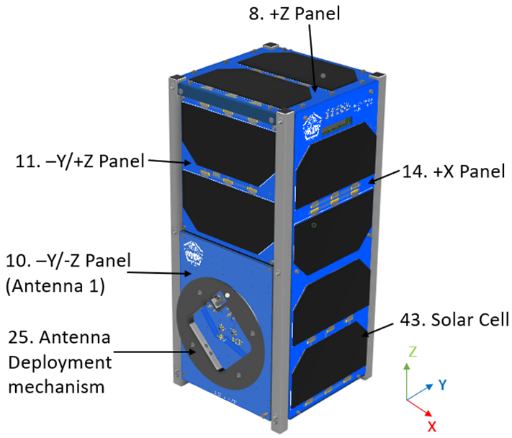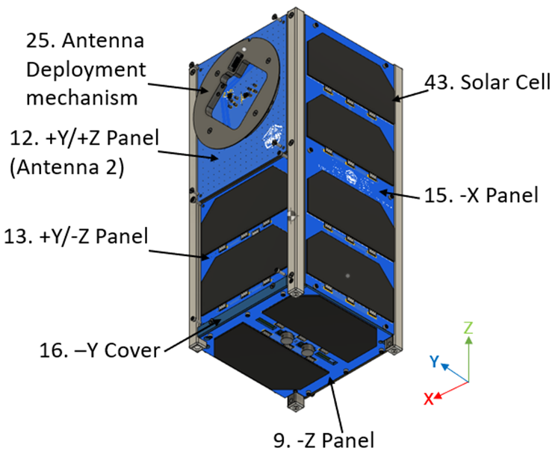

Fig. 1-1 Overview of DRAGONFLY (antenna stowed configuration)

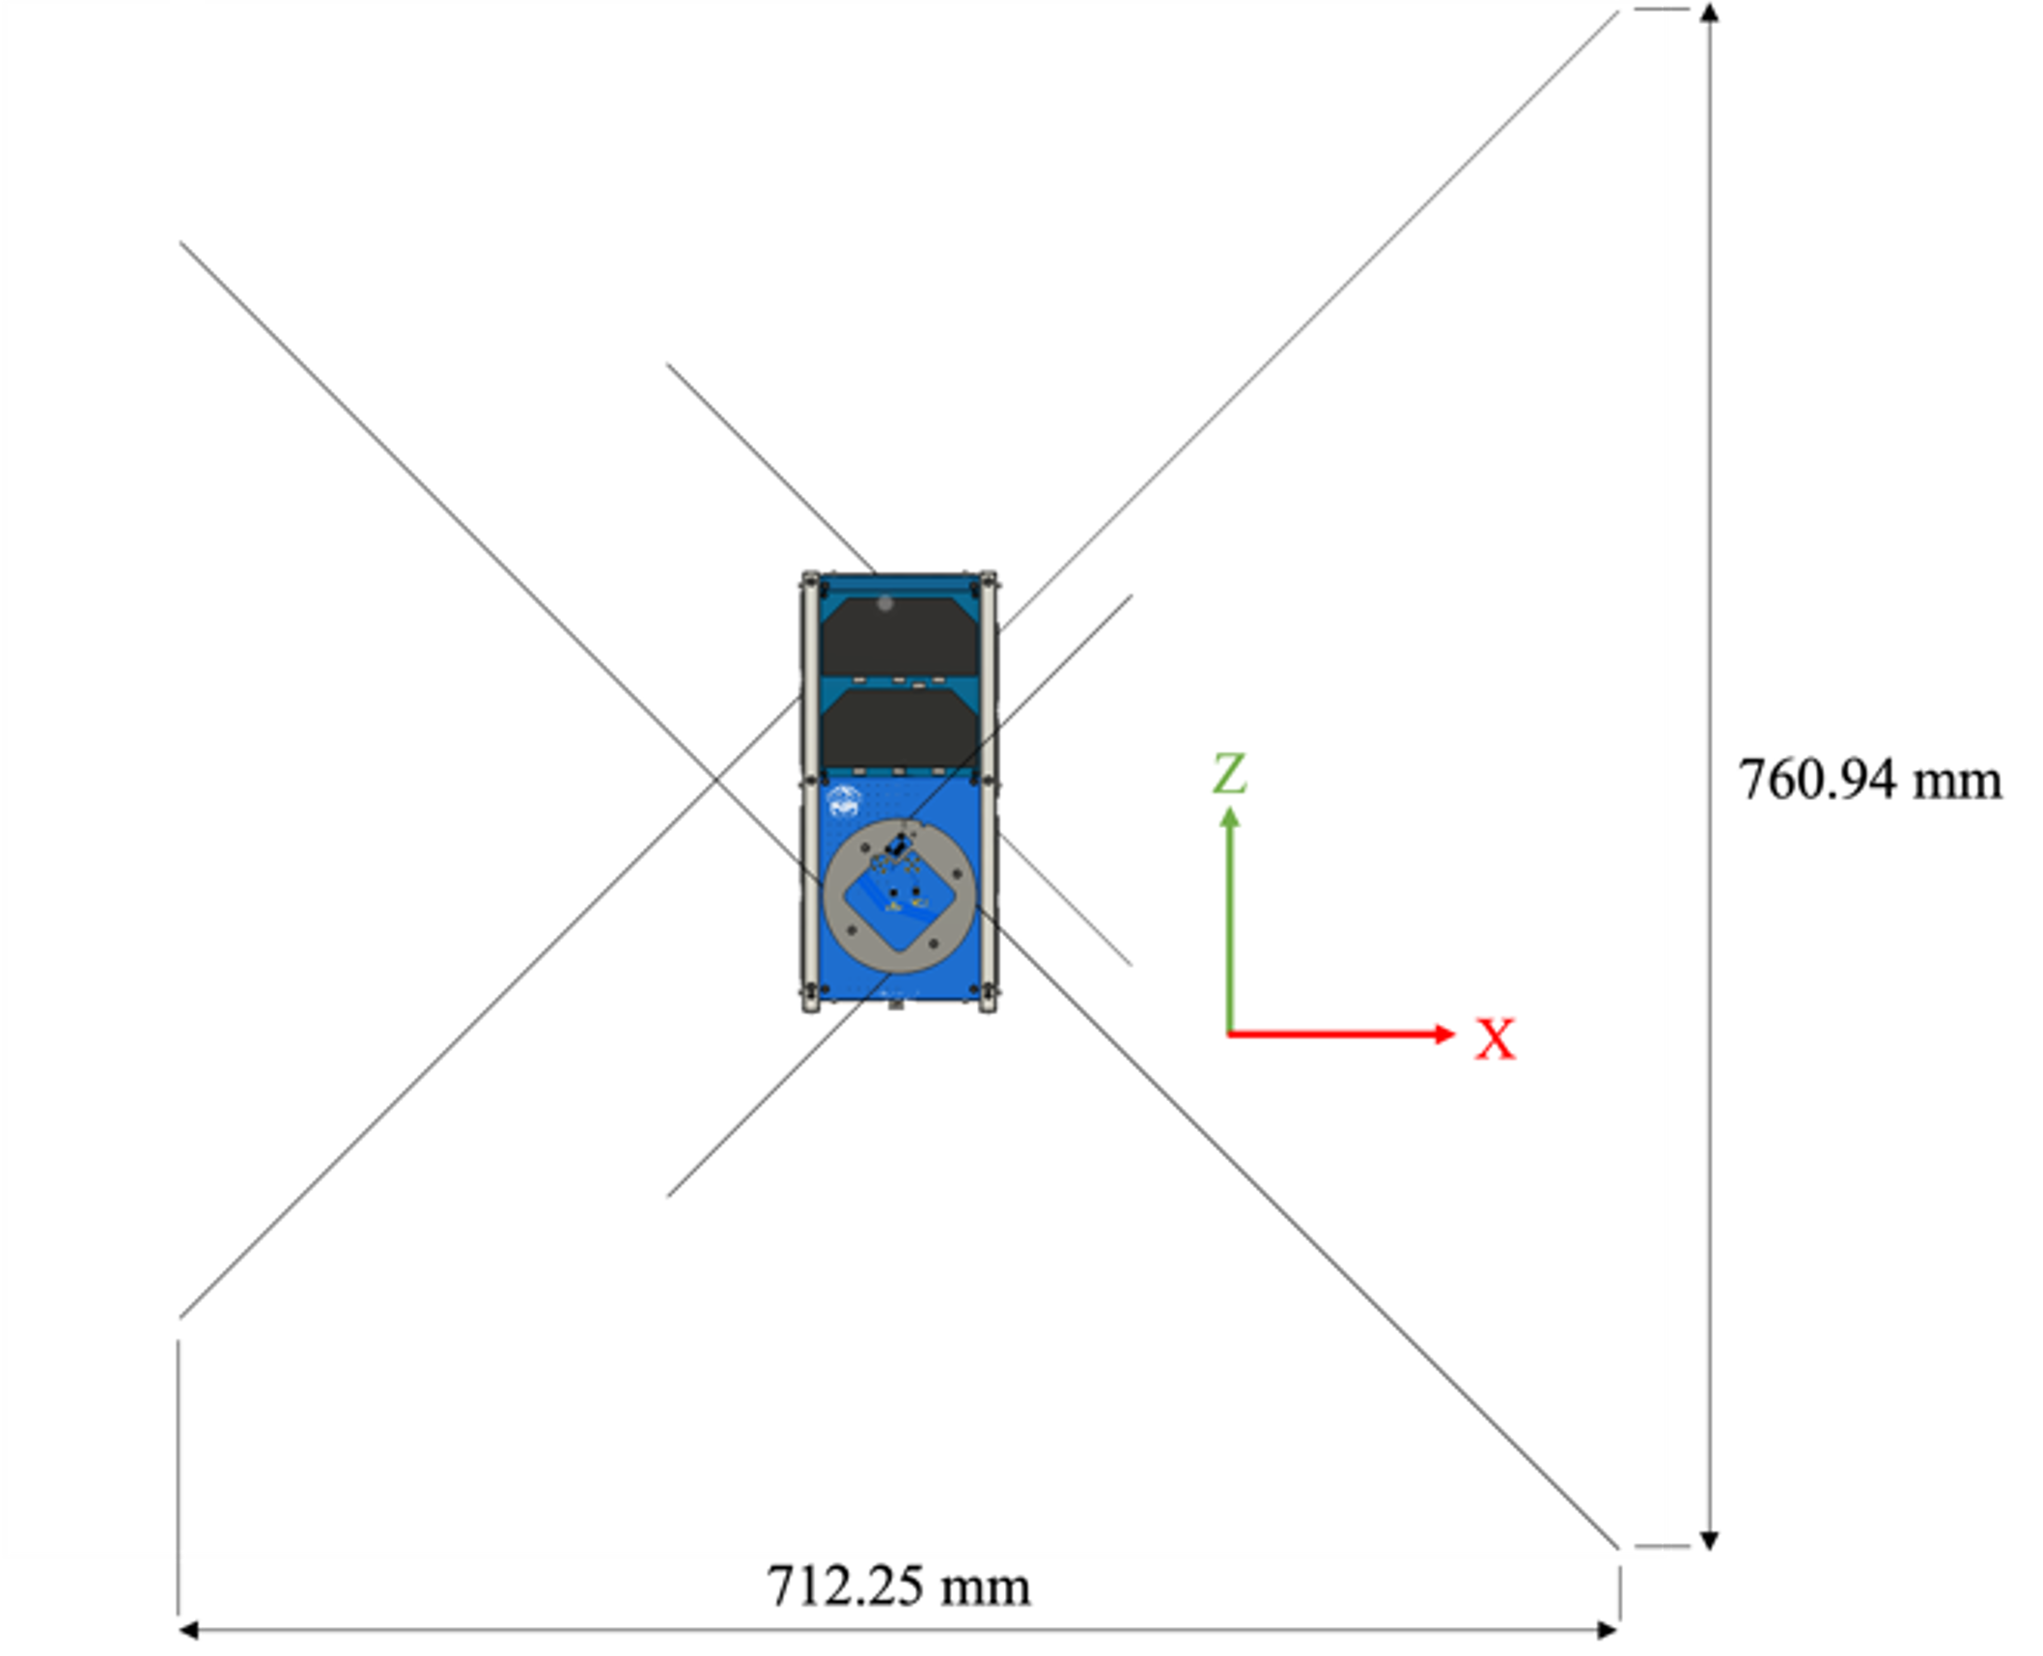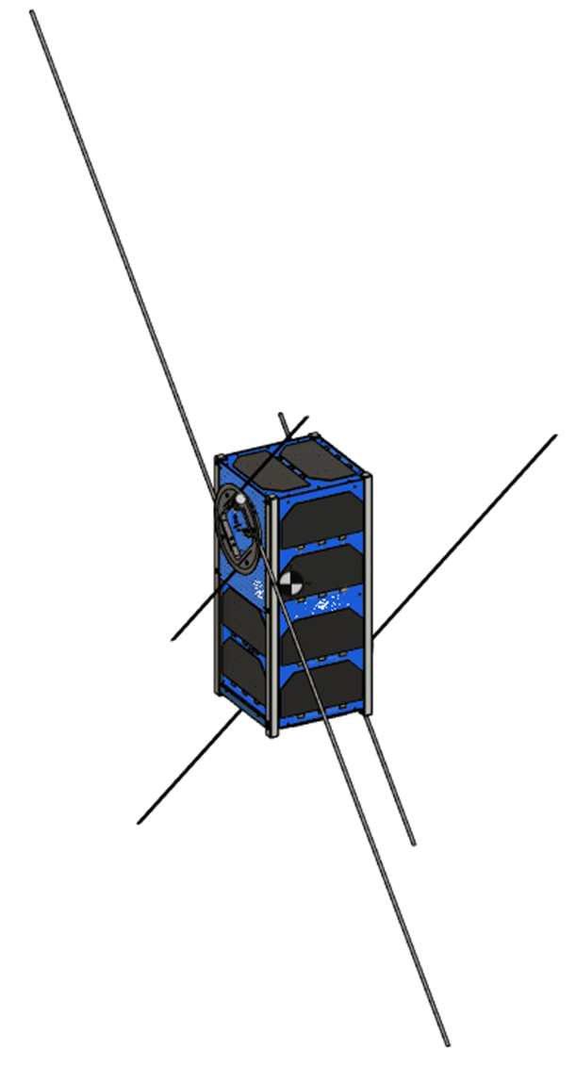

Fig. 1-2 Overview of DRAGONFLY (antenna deployed configuration)

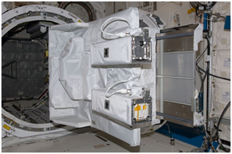

JEM Small Satellite Orbital Deployer

Fig.2 J-SSOD Deployer

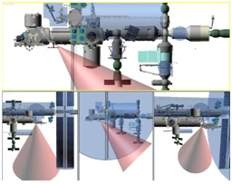

Fig.3 Satellite Deployment Direction