There is likelihood to activate FET and transistor under radiated electric field in ISS. But, since all FETs and transistors involved in the inhibit activate at more than 0.1 Volts, there is no chance of malfunction.

Figure 1 shows the inhibit circuit diagram. The red boxes indicate the FETs and transistors involved in the inhibit.

The specifications for these are shown.

The DCDC converter used as an inhibit uses four FETs inside.

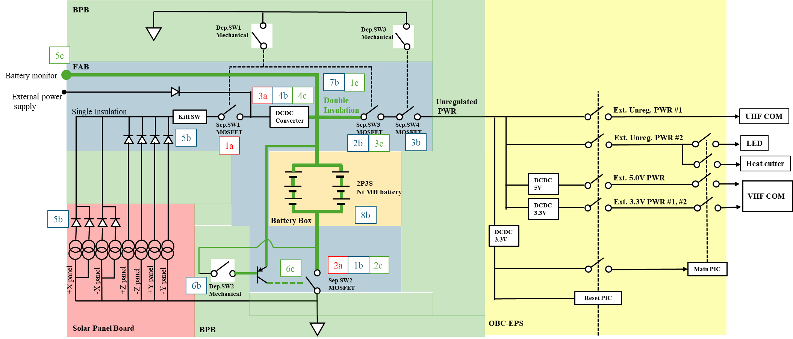These FETs are controlled by a logic circuit inside the DCDC converter, and the lines connecting them to the gates are extremely short. Therefore, no evaluation is required.

**Figure 1 EPS diagram**

Transistor: PDTA144E

SepSW1, 3, 4:SiA447DJ

SepSW2:Si7232DN

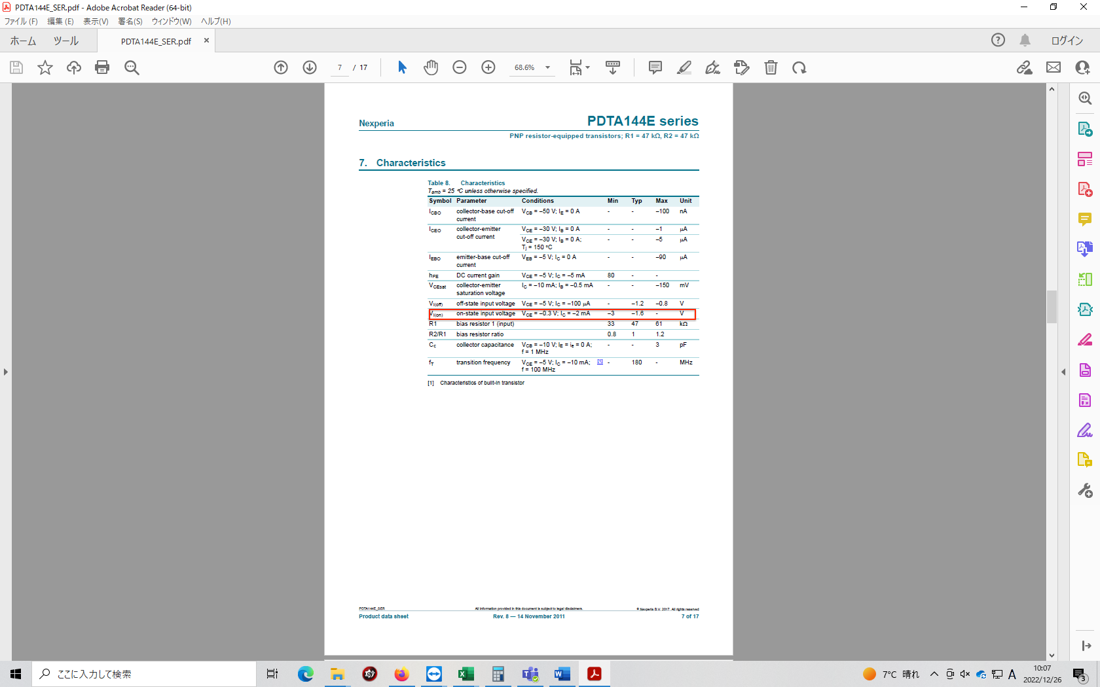

 

**Block Diagram of DCDC convertor**