|  |  |  |  |  |  |  |  |
| --- | --- | --- | --- | --- | --- | --- | --- |
| **System:** | DRAGONFLY | | | **Sub-Subsystem:** | | Mechanical | |
| **Flight/Increment Applicability:** | | | | **Mission Phases:** | | | |
| HTV-X / Cygnus / Dragon  Inc.(TBD) and subsequent stages. | | | | **Launch Processing:** **Launch:** **Rendezvous / Docking:**  **Deployment:** **Orbital Assembly & Checkout:** **On-orbit Operation:**  **On-orbit Maintenance:** **Descent / Landing:** | | | |
| **Scope:** | | | | **Interfaces:** | | | |
| **Payload:** **JEM - PM:**  **JEM - EF:**  **Other( ):** | | | | **JEM-PM** **JEM-EF** **JEM-AIRLOCK** **JEMRMS**  **Other( ):** | | | |
| **Hazardous Condition Description:** | | | | | | | |
| Inadvertent deployment of antenna inside J-SSOD will potentially cause collision with ISS structure due to sticking of the CubeSat antenna into any gap of the J-SSOD inner surface or adjacent satellites. Also, inappropriate design and/or manufacturing of the satellite may lead to inappropriate satellite deployment from J-SSOD. | | | | | | | |
| **Cause Summary:** | | | | | | | |
| Cause 1. Inadvertently Deployed of the CubeSat deployment | | | | | | | |
| **Remarks:** | |  | | | | | |
| **Submittal Concurrence:** | | | | | **Safety Review Panel Approval** | | |
| **Signature** | | | **Date** | | **Signature** | | **Date** |

|  |  |  |
| --- | --- | --- |
| **Cause Number:** | **Cause Title:** | |
| 1 | Inadvertently Deployed of the CubeSat deployment | |
| **Hazard Cause Description:** | | |
| * 1. Sticking due to inadvertent deployment inside J-SSOD.   2. Inappropriate design or manufacturing of the satellite.   [Note 1]. Unintentional deployment of the antennas is controlled by three deployment switches. These three deployment switches are released after deploying the CubeSat from the Satellite Install Case, then the CubeSat activates, and the deployment items are deployed after 30 minutes.  [Note 2]: Regarding the power supply from the solar cell, the amount of light in the ISS is about 1,400Lm / m2 (= 2.1W / m2). The solar cells used on the outer surface of CubeSat, and are attached a total of 16 solar cells. The area of the solar cell is 0.003mm2, and the total energy that can be generate is about 67.5 mW. The minimum power required to operate the Reset PIC, which controls the power supply to the OBC and the antenna deployment mechanism, is 380 mW. Therefore, Reset PIC cannot be started with the power from the solar cell. | | |
| **Severity:** | | **Likelihood:** |
| **I (Catastrophic)** **II (Critical)** | | **A (Probable)** **B (Infrequent)** **C (Remote)** **D (Improbable)** |
| **Controls:** | | **Verification Method and Status:** |
| 1.1-1 Protection devices are equipped to deactivate deployment mechanism before deployment. The protection devices are three separation switches (SepSW2, SepSW3 and SepSW4) and proper insulation.  1.1-2 The CubeSat shall be implemented according to JAXA approved structure verification and control plan (JMX-2011303E), of which scope covers JBX-97160C, JEM Payload Fracture Control Plan.  1.2 Design and Manufacture the satellite in accordance with the JX-ESPC-101132E(Japanese) / 101133E(English) dimension and mass requirements. | | 1.1-1(1) Perform function test of the protection devices.  [Status] Open: BIRDSX-IFTR-01, BIRDS-X Inhibit Function Test report (To be closed at Phase3)  1.1-1(2) Inspection of the proper insulation.  [Status] Open: BIRDSX-IFTR-01, BIRDS-X Inhibit Function Test report (To be closed at Phase3)  1.1-2 Fracture Control Evaluation Form is submitted to and approved by JAXA.  [Status] Closed: BIRDSX-FCE-01, BIRDS-X Fracture Control Evaluation Form for Phase 0/I/II (2024/01/29)  [Status] Open: BIRDSX-FCE-02, BIRDS-X Fracture Control Evaluation Form for Phase III (To be closed at Phase3)  1.2 Inspection of as-built hardware.  [Status] Closed: BIRDSX-AD-01, BIRDS-X FM Assembly Drawing  (2024/01/26)  [Status] Closed: BIRDSX-AP-01, BIRDS-X Assembly Procedure  (2024/01/29)  [Status] Open: BIRDSX-AR-01, BIRDS-X Assembly Record  (To be closed at Phase3) |
| **Safety Requirements:** | | |
| SSP51721, ISS Safety Requirements Document  JX-ESPC-101132 E (Japanese) / 101133E (English), JEM Payload Accommodation Handbook Vol.8 | | |
| **Detection and Warning Methods:** | | **Additional Safety Features:** |
| － | | － |
| **Cause Remarks:** | | |
| － | | |
| **Mission Phases:** | | **Point of Contact** |
| **Launch Processing:** **Launch:** **Rendezvous / Docking:**  **Deployment:** **Orbital Assembly & Checkout:** **On-orbit Operation:**  **On-orbit Maintenance:** **Descent / Landing:** | |  |

**Attachment-1 of BIRDSX-UNQ-04 (1/3)**

When at least one of the three deployment switches are pushed in, current from battery to the heat cutter is cut by disconnecting circuit.

Furthermore, a sufficient power is not expected to be generated by solar panels to deploy the antenna since they are covered by J-SSOD’s outer structure.



**Figure 1. Inhibit Schematic with Deployment System**

**Attachment-1 of BIRDSX-UNQ-04 (2/3)**

**Figure 2 Stowed Antenna Configuration**

**Attachment-1 of BIRDSX-UNQ-04 (3/3)**

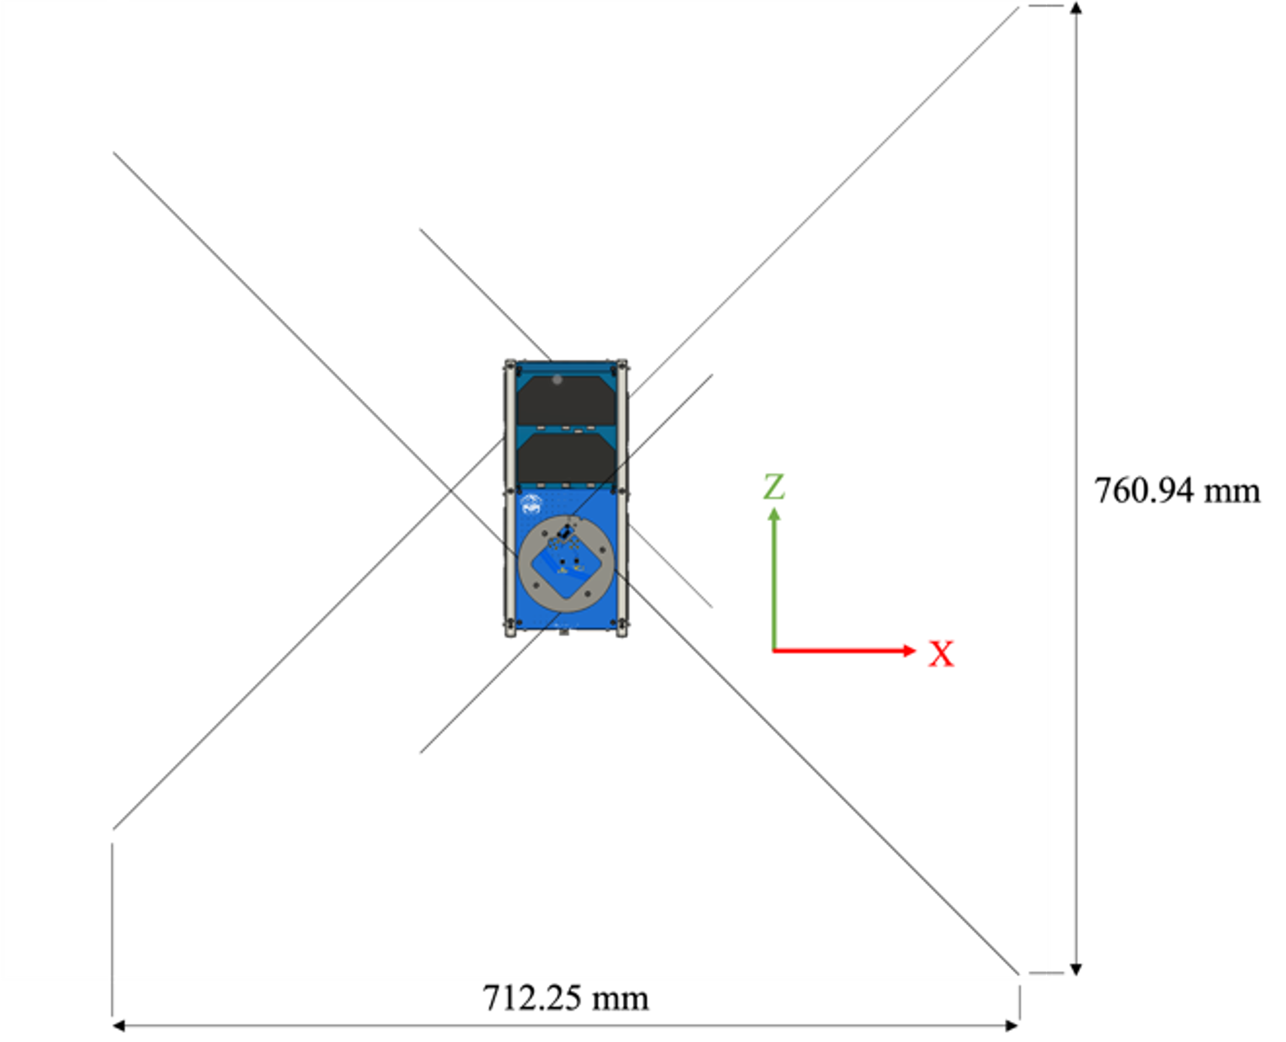

Antenna thickness = 0.3 mm

Antenna width = 3 mm

**Figure 3 Deployed Antenna Configuration**