|  |
| --- |
|  |

**BIRDS-X Project**

**DRAGONFLY**

**Antenna Deployment and RF Transmission Test Report**

|  |  |  |  |
| --- | --- | --- | --- |
| **Date** | **Version Number** | **Writer** | **Annotation** |
| 2022/02/15 | NC | Edgar MUJUNI | Initial Release |
| 2024/03/30 | A | Merisa Kosiyakul | Add results |
| 2024/08/23 | B | Yudai Etsunaga | Applicable Documents Fixes |

Contents

1. Purpose 3

2. Applicable Document and Requirements 3

3. Design for the Circuit of Antenna Deployment and RF transmissions 3

4. Test Method 4

4.1 30-minute timer test 4

4.2 Reset function test 5

5. Test Results 5

5.1 30-minute timer test 5

5.2 Reset function test 9

6. Conclusion 11

# **Purpose**

This document summarizes the results of antenna deployment and RF transmissions test for BIRDS-X satellites, DRAGONFLY, which will be deployed from JEM Small Satellites Orbital Deployer (J-SSOD-R). The antennae of the DRAGONFLY will be deployed 30 minutes after being released from the J-SSOD-R. DRAGONFLY will transmit its CW beacon (437.375 MHz) after the antennae are deployed.

# **Applicable Document and Requirements**

1. JX-ESPC-101132-E JEM Payload Accommodation Handbook-Vol.8-

Small Satellite Deployment Interface Control Document

**Section 2.3. Operational Requirements**

(4) All deployable such as booms, antennas, and solar panels shall wait to deploy for 30 minutes at minimum after the deployment switches are activated at ejection of the satellite from the J-SSOD-R. Whenever either of two deployment switches is re-depressed, the timer shall be reset.

(5) RF transmissions shall wait to transmit for 30 minutes at minimum after the deployment switches are activated at ejection of the satellite from the J-SSOD-R. Whenever either of two deployment switches is re-depressed, the timer shall be reset.

1. 16_DRAGONFLY-SAR-02 Flight Safety Assessment Report for Phase III

# **Design for the Circuit of Antenna Deployment and RF transmissions**

All deployable antennas shall wait to deploy, and RF transmissions shall wait to transmit for 30 minutes at minimum after the deployment switches are activated at the deployment of the satellite from the J-SSOD-R. Two signals are necessary to activate the heat cutter of DRAGONFLY. The 3V3 signal from OBC and the unregulated lines from the EPS. Upon release to space, only the 3V3 signal turns ON. After 30 minutes, the whole electrical system of the satellite turns ON, therefore, activating the unregulated lines. This causes the heat cutter circuit to activate hence cutting the wires stowing the antennae. The unregulated line turned off after 1 minute. The transmission of the CW beacon of DRAGONFLY starts 1 minute and 2 minutes after the antennae are deployed, respectively.

**Figure 3-1 Antenna Deployment Mechanism (Nichrome wire as the heat cutter)**

# **Test Method**

## 

## **4.1 30-minute timer test**

Figure 4-1 shows a test flow of the Antenna Deployment and RF transmissions test.

1. The battery is charged until the planned voltage at launch.
2. Press one deployment switch to reset the satellite.
3. Release the deployment switch of the pressed satellite and start the stopwatch.
4. All deployment switches are released, and then the satellite is activated.
5. The -Y antenna is deployed after 31 minutes (1860 seconds) and the +Y antenna after 40 minutes (2400 seconds) after the deployment switch is added or removed. After +Y deployment, confirm that the RF signal is transmitted. A picture of configuration after deployment is taken, and record time of deployment and starting RF transmission.

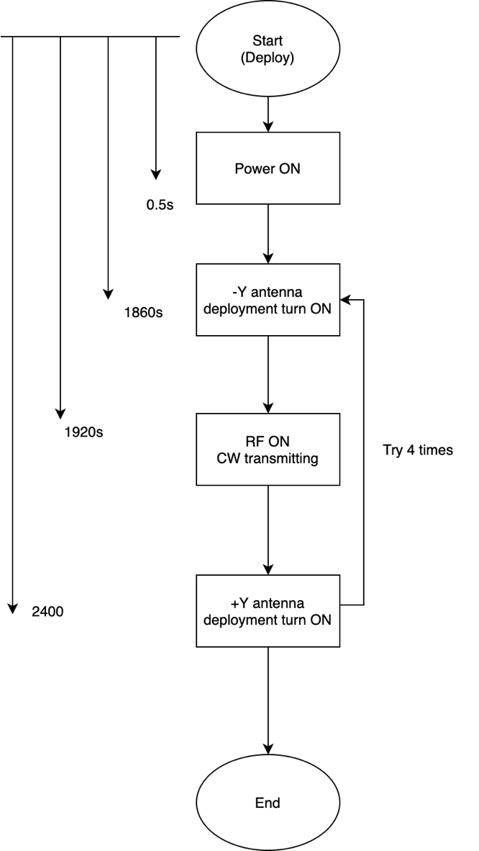

**Figure 4-1 Test sequence**

## **4.2 Reset function test**

After the 30-minute timer test, the satellite reset function is inspected.

1. Press one deployment switch to reset the satellite.
2. Release the deployment switch of the pressed satellite and start the stopwatch.
3. All deployment switches are released, and then the satellite is activated.
4. 30 minutes after releasing the last deployment switch, confirm that the RF signal is transmitted. Record the time of starting RF transmission. Compare the RF emission start times before and after the reset and verify that the 30 timers have been reset.

**Table 4-1 Test objectives**

|  |  |  |  |
| --- | --- | --- | --- |
|  | Objectives | Quantity | Remarks |
| 1 | DRAGONFLY | 1 | - |
| 2 | Stopwatch | 1 | - |
| 3 | Video Camera | 1 | - |
| 4 | Ground Station PC | 1 | - |
| 5 | Ground Station Transceiver | 1 | RTL SDR |
| 6 | Ground Station Antenna | 1 | Monopole antenna |

# **Test Results**

Date of test: 2024/03/07

Place of test: Center for Nanosatellite Testing (CeNT)

Laboratory of Lean Satellite Enterprises and In-Orbit Experiments

Kyushu Institute of Technology

1-1, Sensui, Tobata, Kitakyushu, 804-8550 Fukuoka, Japan

## **5.1 30-minute timer test**

Figures 5-1 to 5-5 and Table 5-1 show the result of the Antenna Deployment and RF transmissions test. The deployment of antennas on the -Y panel and transmission of CW beacons were conducted over 31 minutes after releasing the deployment switches. After 40 minutes, the second antennas on the +Y panel are deployed.

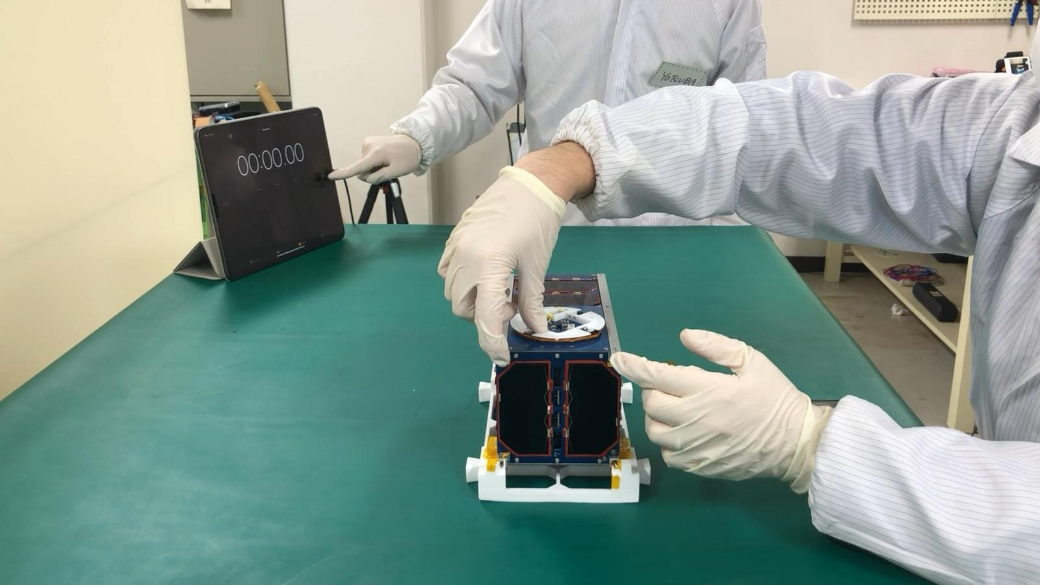

**Figure 5-1 Start of the test**

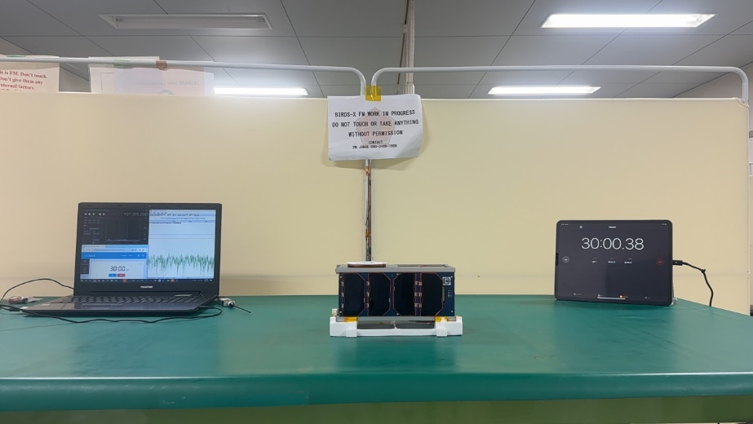

**Figure 5-2 Past 30 minutes after the satellite activation**

机の上にあるコンピューターのスクリーンショット

**Figure 5-3 -Y antennas deployed after satellite activation (after 31min 16sec)**

**机の上にあるコンピューターのスクリーンショット

**

**Figure 5-4 Started transmitting CW beacons (after 33min 1sec)**

**Figure 5-5 +Y antenna deployed after satellite activation (after 40min 6sec)**

**Table 5-1 Result of activation sequence**

|  |  |  |  |
| --- | --- | --- | --- |
|  | Action | Requirement | Recorded time |
| 1 | Release all deployment switches | - | 00:00:00 |
| 2 | -Y Antennas of DRAGONFLY are deployed | Over 30 min from releasing all switches | 00:31:16 |
| 3 | Start transmitting CW beacons | Over 30 min from releasing all switches | 00:33:01 |
| 4 | +Y Antennas of DRAGONFLY are deployed | Over 30 min from releasing all switches | 00:40:06 |

## **5.2 Reset function test**

Figures 5-6 to 5-8 and Table 5-2 show the result of the reset function test. No matter which of the three switches was pressed, the CW was emitted when the same amount of time had passed since the deployment switch was released. So, the satellite's timer reset function was functioning normally.

**Figure** **5-7 Received CW Beacon from DRAGONFLY after** **resetting by DepSW1**

**(after 33 min 6 sec)**

**Figure 5-8 Received CW Beacon from DRAGONFLY after resetting by DepSW2**

**(after 33 min 1 sec)**

**Figure 5-9 Received CW Beacon from DRAGONFLY after resetting by DepSW3**

**(after 32 min 38 sec)**

**Table 5-2 Result of reset function test**

|  |  |  |  |
| --- | --- | --- | --- |
|  | Satellite | Action | Recorded time |
| 1 | DRAGONFLY | The satellite starts transmitting its CW beacon after resetting by DepSW1 | 00:33:06 |
| 2 | The satellite starts transmitting its CW beacon after resetting by DepSW2 | 00:33:01 |
| 3 | The satellite starts transmitting its CW beacon after resetting by DepSW3 | 00:32:38 |

# **Conclusion**

The results of the test show that the antenna deployment and beacon transmission of DRAGONFLY only occurred after the 30-minutes wait time from release of deployment switches. We also confirmed that the reset function of the satellite timer is working.