Kyushu Institute of Technology

Department of Applied Science for Integrated System Engineering

BIRDS-X Project

DRAGONFLY

Sharp Edge Inspection Report

V3: 23/08/2024

Revision History

|  |  |  |  |
| --- | --- | --- | --- |
| Version | Date | Writer | Annotations |
| 1 | 04/03/2024 | Jorge Casir | Initial Release |
| 2 | 16/03/2024 | Jorge Casir | Added results |
| 3 | 23/08/2024 | Yudai Etsunaga | Applicable Documents Fixes |
|  |  |  |  |
|  |  |  |  |

Contents

**1.** **Purpose** 1

**2.** **Applicable Document** 1

**3.** **Inspection method** 1

**4.** **Inspection result** 1

**4.2. DRAGONFLY** 1

**5.** **Conclusion** 5

# **Purpose**

This document summarizes the result of sharp edge inspection for [DRAGONFLY] which will be deployed from JEM Small Satellites Orbital Deployer (J-SSOD-R).

# **Applicable Document**

1. JX-ESPC-101132-E JEM Payload Accommodation Handbook-Vol.8-

Small Satellite Deployment Interface Control Document

1. 16_DRAGONFLY-SAR-02 Flight Safety Assessment Report for phase III

# **Inspection method**

The satellite was inspected by touching the surface of the satellite at several points to confirm there is no sharp edge. The satellite was also inspected by observing the external appearance.

# **Inspection result**

Date of inspection： [2024/03/04]

Place of inspection： [Kyushu Institute of Technology Clean room]

## **4.2. DRAGONFLY**

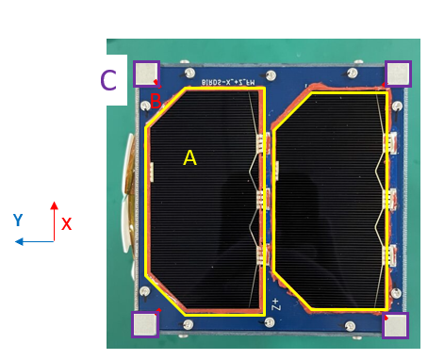

**Figure 4.2-1.　 Photo of +Z surface**

|  |  |
| --- | --- |
|  |  |

**Figure 4.2-2. Satellite Sharp Edge Touching Inspection for edge of solar cells (A) (+Z panel)**

|  |  |
| --- | --- |
|  |  |

**Figure 4.2-3. Satellite Sharp Edge Touching Inspection for rail edges of inside rail (B) (+Z panel)**

|  |
| --- |
|  |

**Figure 4.2-4. Satellite Sharp Edge Touching Inspection for rail edges (C) (Z panel)**

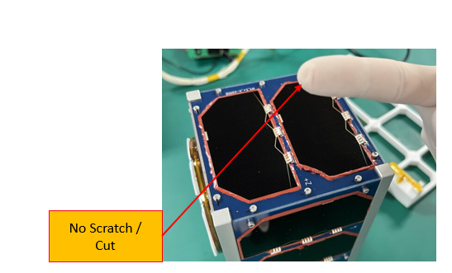

**Figure 4.2-5. After Satellite Sharp Edge Touching Inspection**

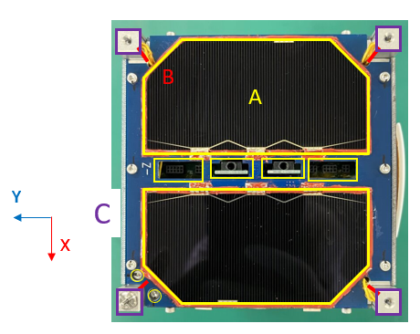

**Figure 4.2-6.　 Photo of -Z surface**

|  |  |
| --- | --- |
|  |  |

**Figure 4.2-7. Satellite Sharp Edge Touching Inspection for edge of solar cells (A) (-Z panel)**

|  |  |
| --- | --- |
|  |  |

**Figure 4.2-8. Satellite Sharp Edge Touching Inspection for rail edges of inside rail (B) (-Z panel)**

|  |  |
| --- | --- |
|  |  |

**Figure 4.2-9. Satellite Sharp Edge Touching Inspection for rail edges (C) (-Z panel)**

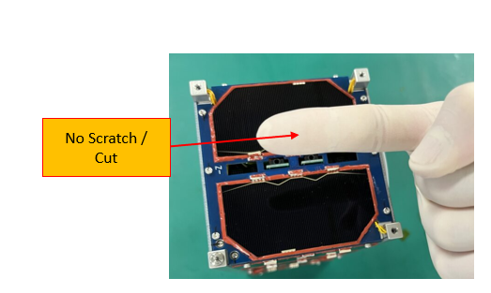

**Figure 4.2-10. After Satellite Sharp Edge Touching Inspection**

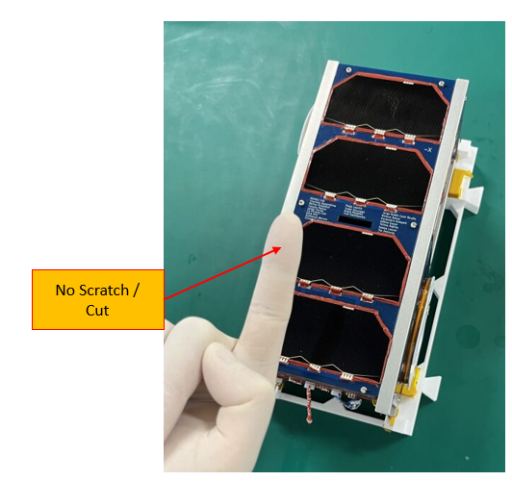

**Figure 4.3-1. After Satellite Sharp Edge Touching Inspection**

# **Conclusion**

No sharp edge on the satellite body was detected by visual and touch inspections.