Getting Started

The landing page
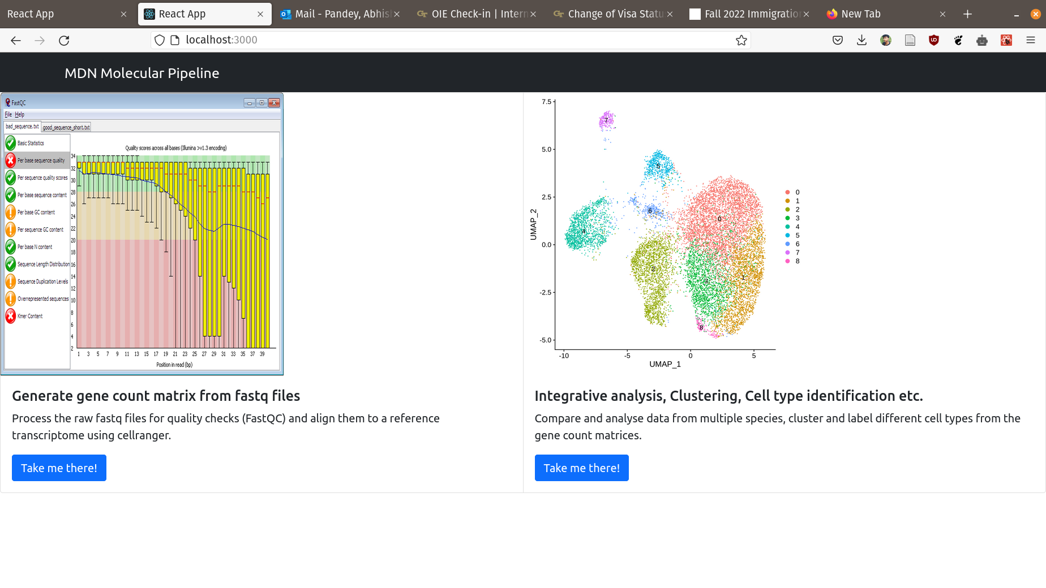
Above picture shows the landing page of the MDN portal. There are two options for the user to choose from:
1. Generate gene count matrix from fastq files.
2. Analyze previously obtained gene count matrices for different species.
The user can pick a appropriate function based on their requirement using the buttons below.

Alignment Portal
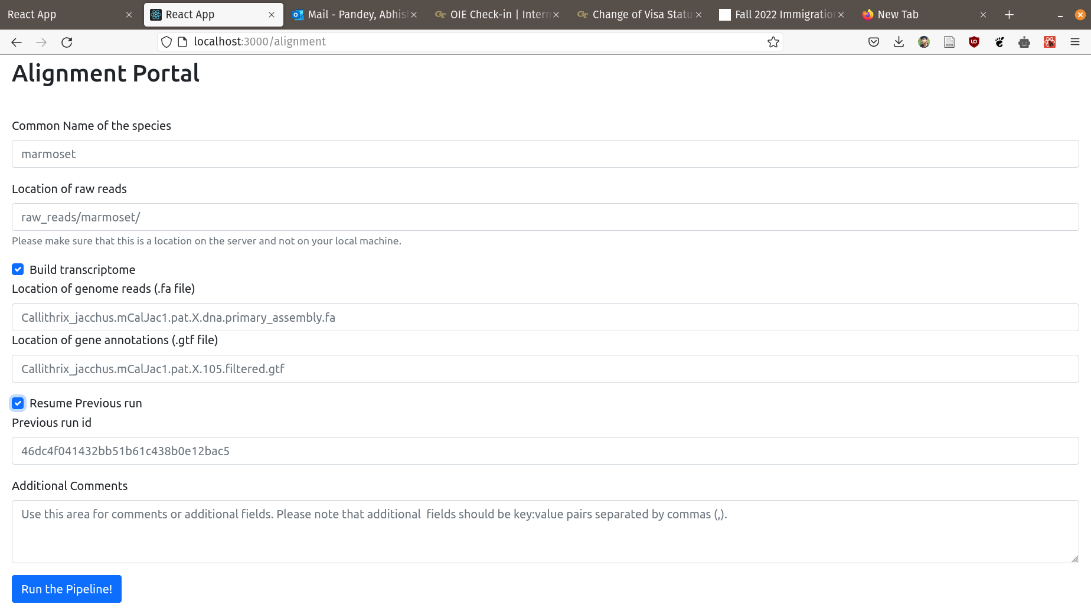
The alignment portal allows the user to align the raw fastq reads to a reference trnascriptome and find out what genes are present in that particular raw file. There are some reference transcriptomes that are already available on the server. You’ll find those species in the dropdown menu in the first textbox (Common name of the species). For others, you’ll have to build a reference transcriptome from the .fa and .gtf files obtained either from the Ensembl or NCBI portal (Note that the data over Ensembl is relatively clean and should be preferred over data from NCBI).

The user is also provided with an option to resume any previous runs which may have been aborted midway because of some issues as well as adding some comments or additional IDs that they may want to keep a track of.

- Common name of the species: What the name says, however there might be many variations in the common name of a species, so later versions will include a dropdown for the species for which a transcriptome is available. For the ones that don’t have one, you can include them by adding a custom species and building the transcriptome.
- Location of raw reads: Location of the fastq files on the server, both absolute path and paths relative to the snakemake directory will work.
- Build Transcriptome : Build a transcriptome from genome reads and annotations if it’s not already present for the species that you’re interested in.
  - Location of genome reads:
  - Location of genome annotations:
- Resume Previous run:
- Comments:

