# Technido Autonomous Guided Vehicle

Table of Contents

Technido Autonomous Guided Vehicle 1

1. Automated guided vehicle (AGV): - 3

2. Why Automated Guided Vehicle? 4

3. Deep Dive in AGV: - 5

Centralize system: - 5

4. Architecture: - 7

5. Product Details: - 8

Automated Guided Vehicle

## Automated guided vehicle (AGV): -

* 1. What is an AGV: -

AGV is a material handling system that uses independently operated, self-propelled vehicles guided along defined pathways. Automated Guided Vehicle (AGV) is a portable robot that follows markers or wires in the floor, or uses vision, magnets, or lasers for navigation. They are most often used in industrial applications to move materials around a manufacturing facility or warehouse.

* 1. Application of AVG: -
* Transport from receiving to production / warehouse
* Transport between production areas / work-in-process buffers
* Transport between production areas and warehouse areas
* Stacking and storing applications in warehouses (very narrow aisle, wide aisle & drive in racking, deep stacking, block storage, etc.)
* Roll handling
* End-of-line automation (packing machines, palletizers, stretch wrappers, etc.)
* Transport in consolidation and dispatch areas.
  1. Types of AGVs: -
* Towing
* Pallet Trucks
* Fork Trucks
* Unit Load
* Light Load
* Assembly Line
  1. Features of AGV: -
* High dynamic operation
* Robust design
* CAN Bus system communication
* Speed control separately for each wheel
  1. Basic Functions: -

**Navigation & Guidance** allows the vehicle to follow a predetermined route which is optimized for the material flow pattern of a given application

Routing is the vehicle’s ability to make decisions along the guidance path in order to select optimum routes to specific destinations

Steering Control is also an important part

**Traffic Management** is a system or vehicle ability to avoid collisions with other vehicles while at the same time maximizing vehicle flow and therefore load movement throughout the system.

**Load Transfer** is the pickup and delivery method for an AGVS system, which may be simple or integrated with other subsystems.

**System Management** is the method of system control used to dictate system operation.

The proper method selection for each function and its ability to work with the other functions determines in great measure the degree of success of a given system.

* 1. Benefits of AGV: -
* Reduced operating costs and higher efficiency
* Reduced manpower
* No product damages
* Increased safety
* Improved product traceability
* Easy and fast installation
* Better use of space
* Low maintenance.

## Why Automated Guided Vehicle?

Automated guided vehicles are predominantly used for materials handling purposes. This can include a range of tasks from on time delivery of parts to the production line, to round the clock transit. If the vehicle is equipped with a clamping mechanism, positioning fixtures and tool attachments, it can perform a range of functions.

Depending on the application and requirements, AGVs can function in isolation or in fleets. This makes the use of AGVs scalable according to need, so a plant manager can make a specific decision on the number of vehicles in a facility.

AGVs can be equipped with sensors for traceability, so that the plant manager can monitor the position of each individual vehicle and therefore track the movement of materials around a facility.

Pick-up, transit and delivery of items can be time stamped as part of this process to further improve tracking. This information can be integrated into the company’s enterprise resource planning (ERP) or materials resource planning (MRP) systems.

Depending on the application, there are different types of vehicle navigation methods. A plant manager can opt for a very simple system, similar to the earliest AGVs, or can choose more advanced navigation methods.

## Deep Dive in AGV: -

### Centralize system: -

The whole system had been commanded by centralize server.

* 1. Design Type: Unit Load Truck capacity – 2000lbs.

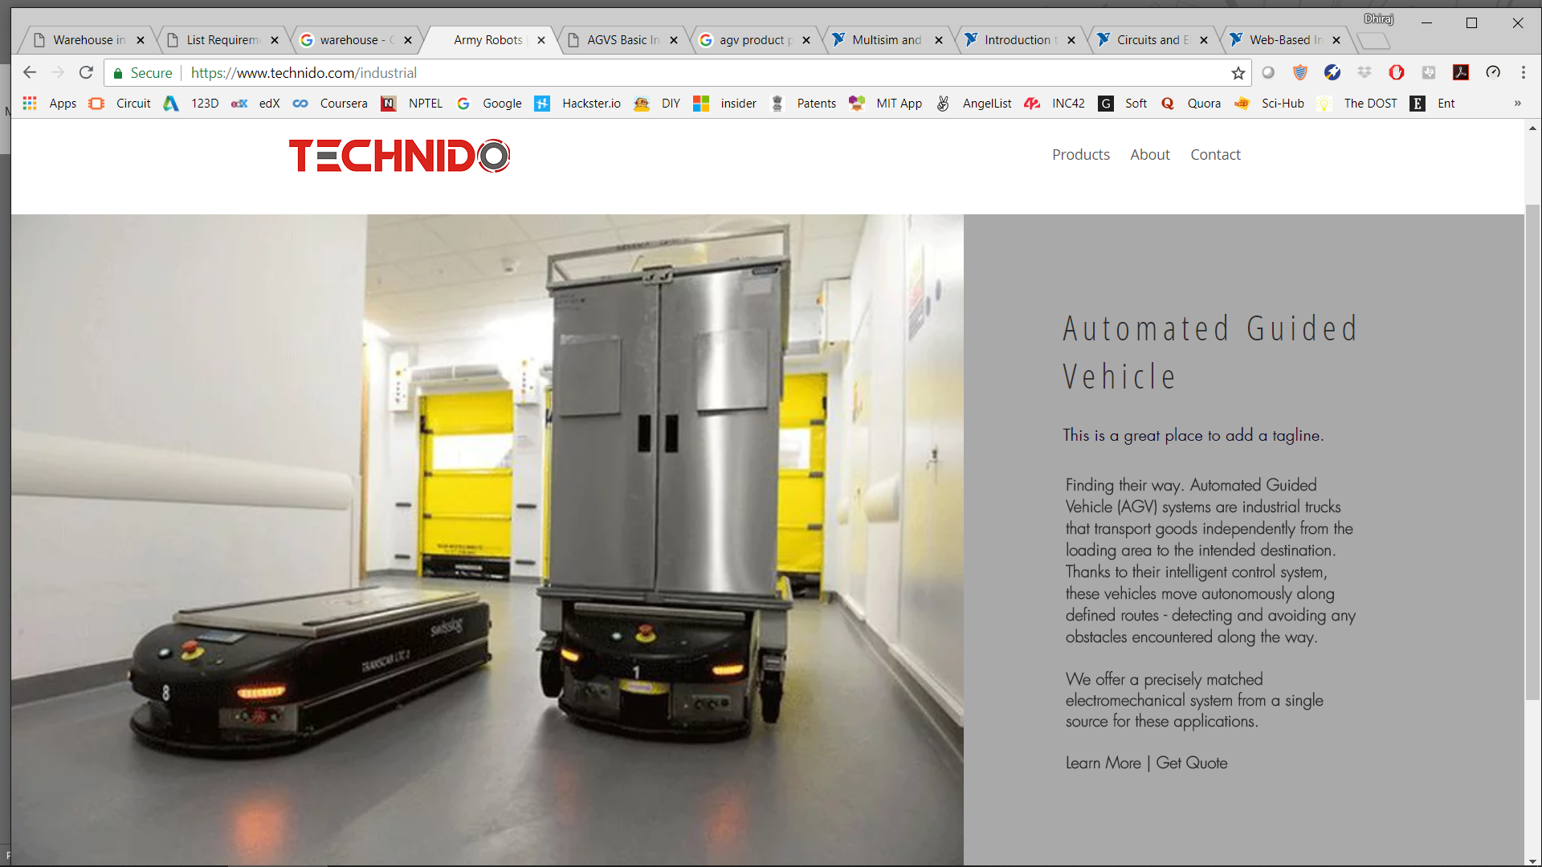

*Fig. Proposed AGV design*

* 1. Navigation System : -

Magnetic Tap and Sensor Type :-

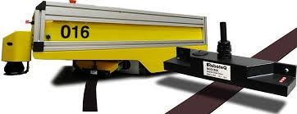

*Fig. Magnetic Tap with Sensor*

The AGC’S is fitted with the appropriate guide sensors to follow the path of the tape. It is considered a “passive” system since it does not require the guide medium to be energized.\

* 1. Guidance Type: -

Skid Steering system will be installed: -

Skid-steer locomotion is commonly used on tracked vehicles such as tanks and bulldozers, but is also used on some four- and six-wheeled vehicles. On these vehicles, the wheels (or tracks) on each side can be driven at various speeds in forward and reverse (all wheels on a side are driven at the same rate). There is no explicit steering mechanism--as the name implies steering is accomplished by actuating each side at a different rate or in a different direction, causing the wheels or tracks to slip, or skid, on the ground

**

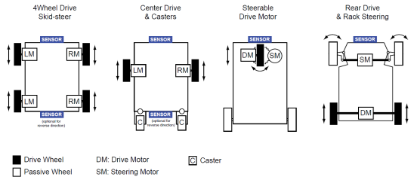

*Fig. Free Body Diagram Fig. Skid Steering system*

* 1. Traffic Management Control: -

This is done by the server and make the decision in the server itself and then it will pass the command.

## Architecture: -

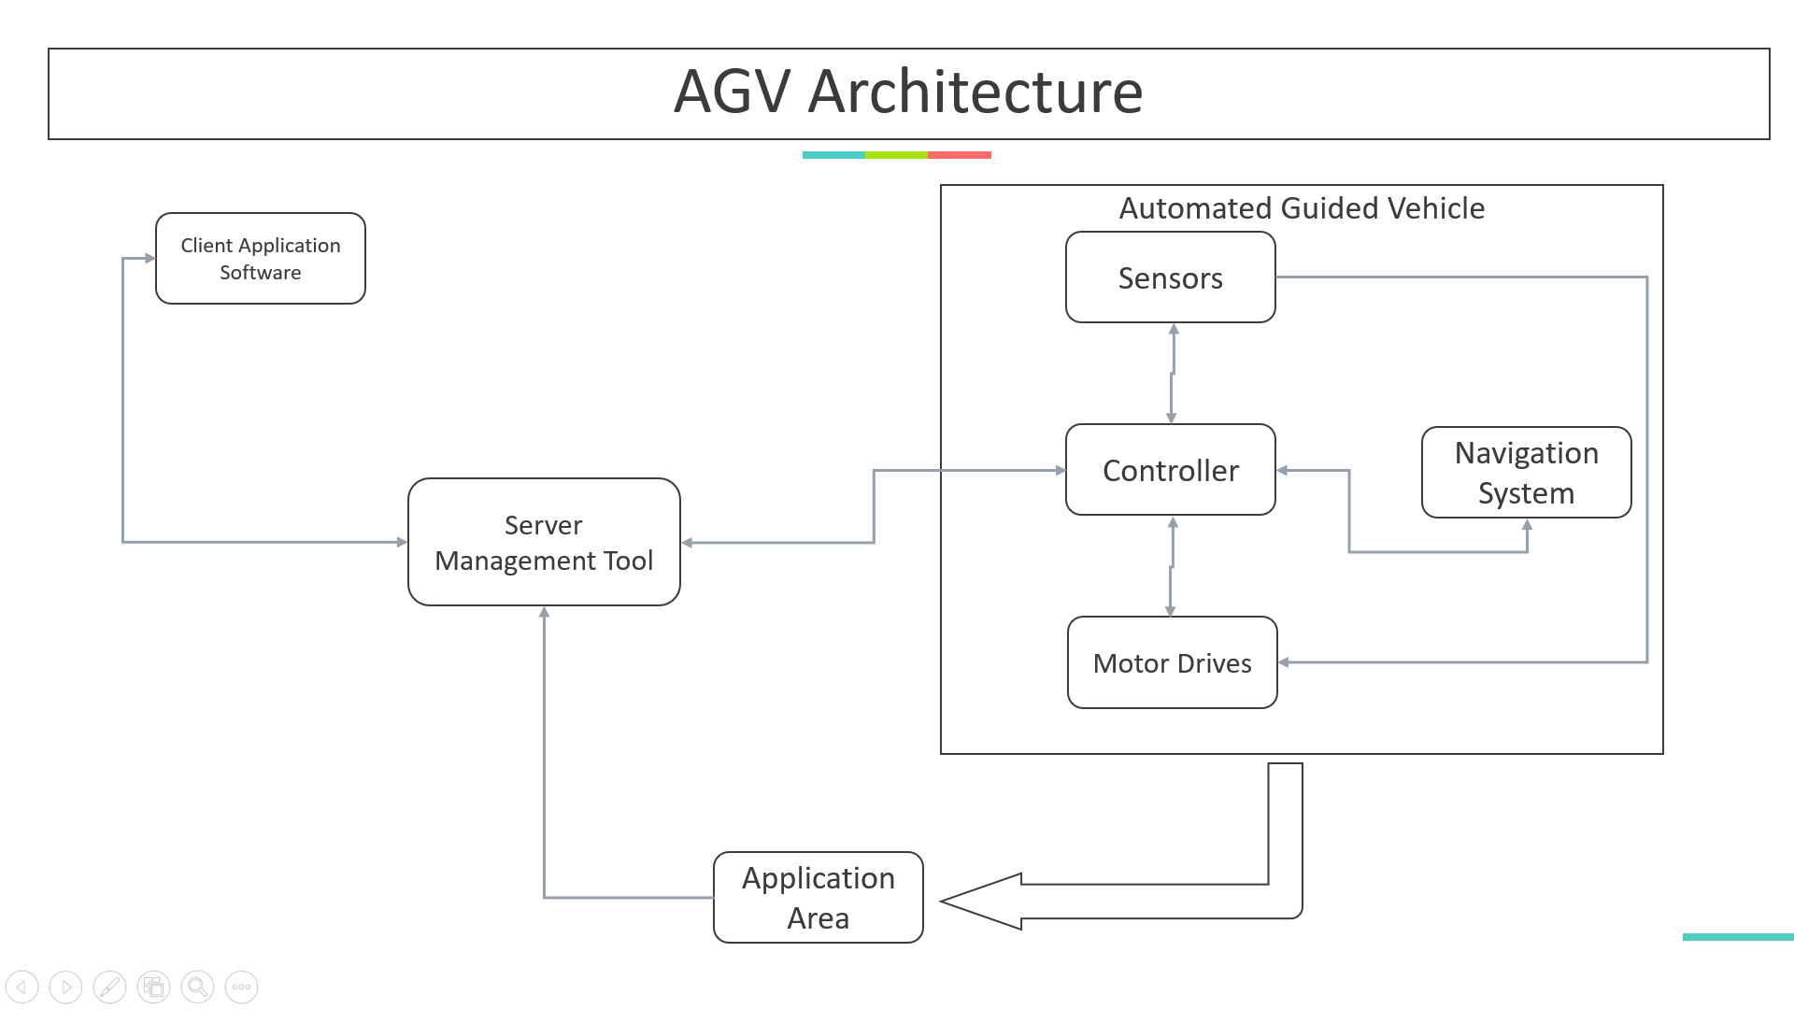

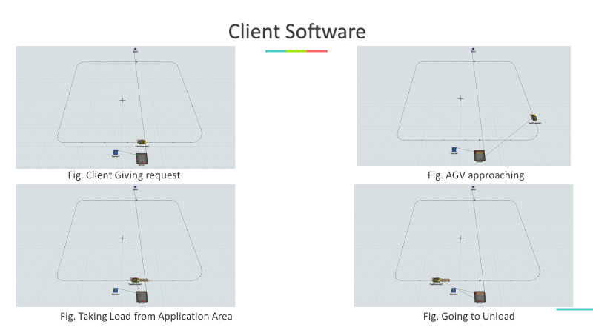

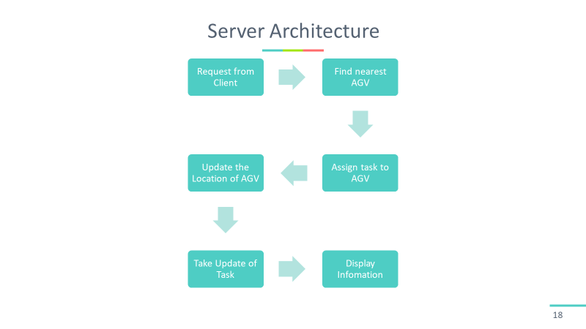

## Product Details: -

* Client Software: - Connected to Server via ethernet.
* Server End: Consist of High configuration system and Communication protocol to communicate with AGV, and it will keep all the database,

Algorithm to allocate the nearest AGV is also in the Server, GUI interface to show the availability and status of AGV.

* AGV sensors: - LiDAR – for Obstacles detection, IR – At all four side, Speed sensor.
* AGV control System: -

Microcontroller: The function of microcontroller will be to communicate with the server and update the location to the server in every 10 ms (100Mhz). and the priority interrupt will be the safety sensors: LiDAR & IR.

* AGV Motor control: Skid Steering (4 wheel), Motor driver for speed control.
* Navigation System: Magnetic Sensor, Magnetic Tap…