**COURSEWORK SUBMISSION FORM**

| **STUDENT USE** | | **STAFF USE** | |
| --- | --- | --- | --- |
| Module Name | Web Applications Development | First Marker’s  (acts as signature) |  |
| Module Code | 5COSC017C | Second Marker’s  (acts as signature) |  |
| Lecturer Name | Isomiddin Abdunabiev | Agreed Mark |  |
| UoW Student IDs | 18150193/1 | **For Registrar’s office use only (hard copy submission)** | |
| WIUT Student IDs | 00010989 |
| Deadline date | 14/03/2023 |
| Assignment Type | 🗌Group🗌Individual |

**SUBMISSION INSTRUCTIONS**

**COURSEWORKS *must* be submitted in *both* HARD COPY (to the Registrar’s Office) *and* ELECTRONIC unless instructed otherwise.**

For hardcopy submission instructions refer to: <http://intranet.wiut.uz/Shared%20Documents/Forms/AllItems.aspx> - Coursework hard copy submission instructions.doc

For online submission instructions refer to: <http://intranet.wiut.uz/Shared%20Documents/Forms/AllItems.aspx> - Coursework online submission instructions.doc

| **MARKERS FEEDBACK (Continued on the next page)** |
| --- |
|  |

**From Creational Design Pattern I will use:**

**Singleton**

**This is my own code example:**

<https://docs.google.com/document/d/1v1p596ox2aPhKWXn46uH1nga0xjNmXZMsJUdV6WShRo/edit?usp=sharing>

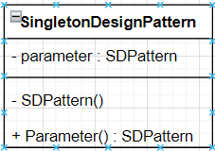

*If image is not visible please make it bigger

**Builder**

**This is my own code example:**

<https://docs.google.com/document/d/165vK71Zlr2cVGc27mMExIhR7IsVrCzi-p2u15p8YTUE/edit?usp=sharing>

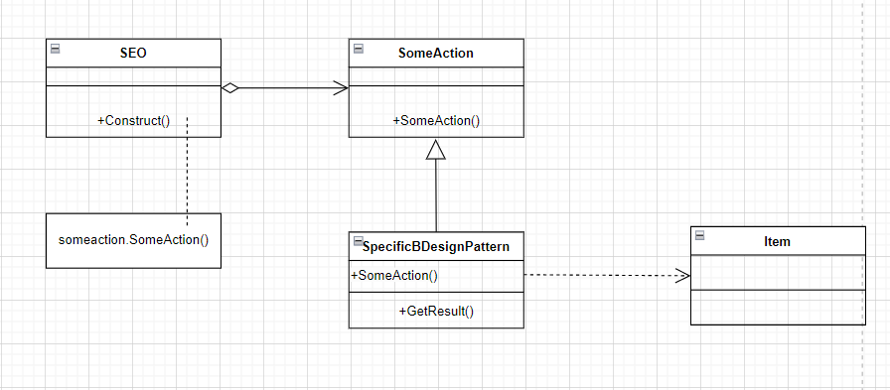

*If image is not visible please make it bigger

**From Structural Design Pattern I will use:**

**Adapter**

**This is my own code example:**

<https://docs.google.com/document/d/1BM98ylOH8J5WV-5DBRYHxZ_lPFkzFme1wP4eWnow4Dk/edit?usp=sharing>

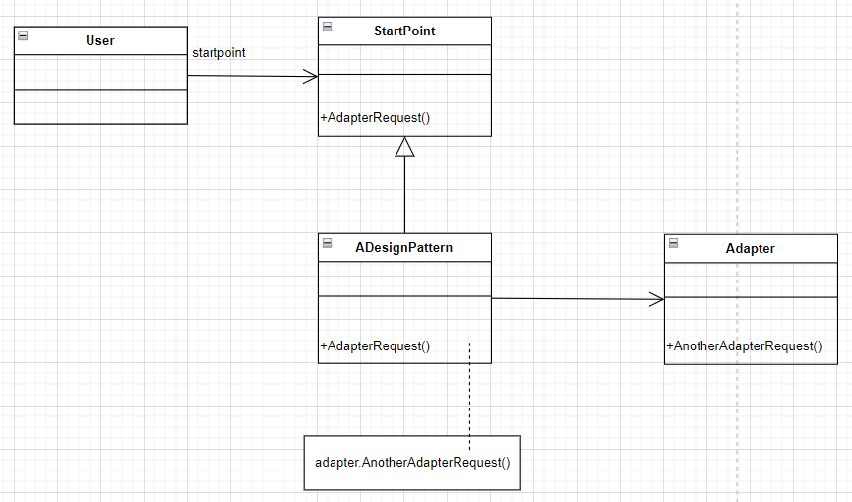

*If image is not visible please make it bigger

**Decorator**

**This is my own code example:**

<https://docs.google.com/document/d/1GWSOwkq-hwZeN2w9OhvLXfjCQgQ1mMsbXnHV-BpPuCg/edit?usp=sharing>

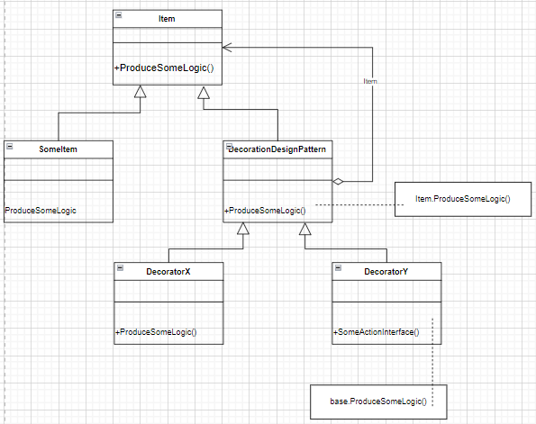

*If image is not visible please make it bigger

**Facade**

**This is my own code example:**

<https://docs.google.com/document/d/1lDP_KYZyzfauQNsQR5ZejHYANiDlGDhCrOWLkk8FII8/edit?usp=sharing>

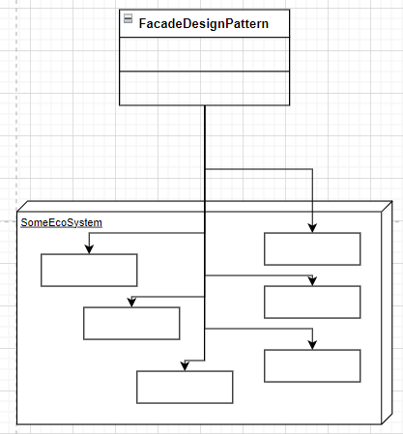

*If image is not visible please make it bigger

**From Behavioural Design Pattern I will use:**

**Chain of Responsibility**

**This is my own code example:**

<https://docs.google.com/document/d/16iwmlnlecFWxNZahXw9oJa9qgAVjZLXmfE08jGljEDo/edit?usp=sharing>

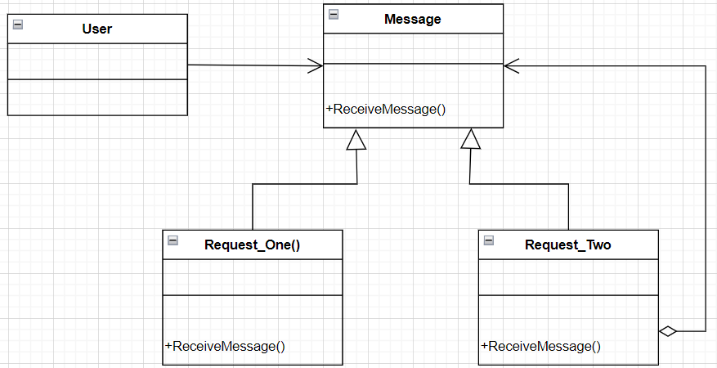

*If image is not visible please make it bigger

**Template method**

**This is my own code example:**

[**https://docs.google.com/document/d/1Kf8e_zyxNnfh05NXHB2IPwqQwpGtixDT5n0xyZI-R7Q/edit**?**usp=sharing**](https://docs.google.com/document/d/1Kf8e_zyxNnfh05NXHB2IPwqQwpGtixDT5n0xyZI-R7Q/edit?usp=sharing)

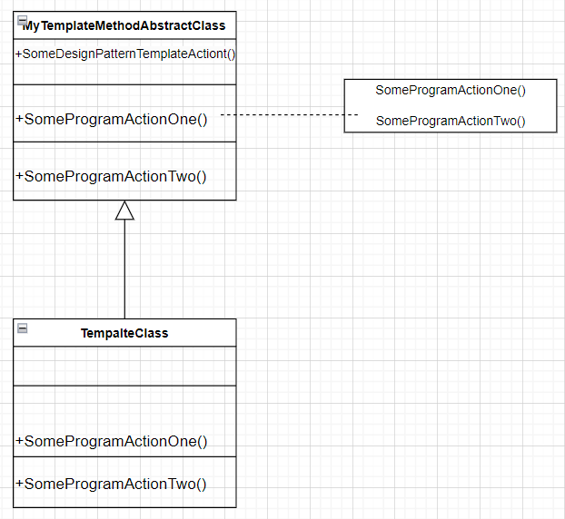

*If image is not visible please make it bigger

**Strategy**

**This is my own code example:**

<https://docs.google.com/document/d/15MMURuNYEDY4tDh_s-2wDeimqpxj1_XkfnMKFk1uPhQ/edit?usp=sharing>

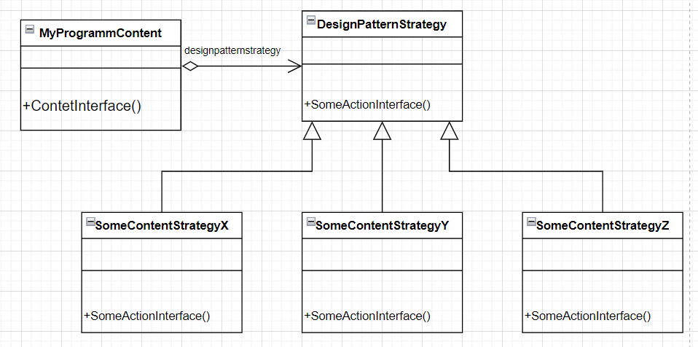

*If image is not visible please make it bigger