General Instructions:

- All are requested to follow all the instructions, without which the submission will not be granted.

- Submit your document removing this general instruction page.

- Font type, size, orientation of Chapters, Sections, Subsections, Headings, Subheadings, figures, tables are already given. Add or remove as per requirements.

- The font size is maintained as follows: Font Size of Chapter = 16, Heading= 14, Subheading=12, Content=10, Table Heading=8, Figure Heading=8.

- All content must be in Times New Roman Format.

- Remove the heading ‘project title’ and provide yours.

- Do not make any changes in font type, size and orientation in the project title page, certificate page, approval page and acknowledgement page. You are only about to modify the content to add your student details and supervisor details accordingly.

- Only all the headings should be in bold.

- Overlapping of contents of different sections/subsections in the same page should be avoided.

- All figures, tables, diagrams, charts, graphs must be labelled and numbered sequentially.

FAKE NEWS DETECTION USING MACHINE LEARNING ENSEMBLE METHODS
Submitted by,

Name | Roll No. | Registration No.
SOURAV SAHA | CSE2018/006 | 11700118034
BISHAL RAJAK | CSE2018/031 | 11700118098
MANILAL GORAI | CSE2018/046 | 11700118081
SUSHMITA SAHA | CSE2019/L07 | 11700119115

Under the guidance of

Mr./Ms./Mrs./Dr…………. ANIRBAN DEY ……………………

Dept. of Computer Science & Engineering

RCC Institute of Information Technology

PROJECT REPORT SUBMITTED IN PARTIAL FULFILLMENT OF THE REQUIREMENTS FOR THE DEGREE OF BACHELOR OF TECHNOLOGY IN COMPUTER SCIENCE AND ENGINEERING RCC INSTITUTE OF INFORMATION TECHNOLOGY


DEPARTMENT OF COMPUTER SCIENCE AND ENGINEERING

RCC INSTITUTE OF INFORMATION TECHNOLOGY [Affiliated to West Bengal University of Technology] CANAL SOUTH ROAD, BELIAGHATA, KOLKATA-700015

DEPARTMENT OF COMPUTER SCIENCE AND ENGINEERING

RCC INSTITUTE OF INFORMATION TECHNOLOGY

TO WHOM IT MAY CONCERN

I hereby recommend that the Project entitled
“FAKE NEWS DETECTION USING MACHINE LEARNING ENSEMBLE METHODS”
prepared under my supervision by SOURAV SAHA (11700118034), BISHAL RAJAK (11700118098), MANILAL GORAI (11700118081), SUSHMITA SAHA (11700119115), of B. Tech (8th Semester), may be accepted in partial fulfilment for the degree of Bachelor of Technology in Computer Science & Engineering under Maulana Abul Kalam Azad University of Technology (MAKUT).

…………………………………………

Project Supervisor

Department of Computer Science and Engineering

RCC Institute of Information Technology

Countersigned:

………………………………………

Head

Department of Computer Sc. & Engg.,

RCC Institute of Information Technology

Kolkata – 700015


CERTIFICATE OF APPROVAL

The foregoing Project is hereby accepted as a credible study of an engineering subject carried out and presented in a manner satisfactory to warrant its acceptance as a prerequisite to the degree for which it has been submitted. It is understood that by this approval the undersigned do not necessarily endorse or approve any statement made, opinion expressed or conclusion drawn therein, but approve the project only for the purpose for which it is submitted.

FINAL EXAMINATION FOR

EVALUATION OF PROJECT

1.

2.

3.

(Signature of Examiners)

I
ACKNOWLEDGEMENT

We acknowledge our overwhelming gratitude & immense respect to our revered guide, Mr./Ms./Mrs./Dr.

ANIRBAN DEY (Assistant Professor, RCC Institute of Information Technology) under whose scholarly guideline, constant encouragement & untiring patience; we have proud privilege to accomplish this entire project work. We feel enriched with the knowledge & sense of responsible approach we inherited from our guide & shall remain a treasure in our life.

Name: Sourav Saha

Roll No: CSE2018/006

Name: Bishal Rajak

Roll No: CSE2018/031

Name: Manilal Gorai

Roll No: CSE2018/046

Name: Sushmita Saha

Roll No: CSE2019/L07

II

ABSTRACT

(Importance, Standard methods of implementations with accuracy, Approach made or followed, Accuracy level achieved and cases being considered) (Within 150 words)

III

 |  |  | CONTENTS
CERTIFICATE OF APPROVAL ........................................................................................................................... |  |  |  |  | I
ACKNOWLEDGEMENT ..................................................................................................................................... |  |  |  |  | II
ABSTRACT ............................................................................................................................................................ |  |  |  |  | III
CONTENTS ............................................................................................................................................................ |  |  |  |  | IV
LIST OF SYMBOLS .............................................................................................................................................. |  |  |  |  | V
LIST OF ABBREVIATIONS ................................................................................................................................ |  |  |  |  | VI
LIST OF FIGURES .............................................................................................................................................. |  |  |  |  | VII
LIST OF TABLES ............................................................................................................................................... |  |  |  |  | VIII
CHAPTER-1 |  |  |  |  | Page No
1.1 INTRODUCTION………………………………………………………………………….
1.2 LITERATURE REVIEW……………………………………………………………………
CHAPTER-2
2.1 WORK FLOW……………………………………………………………………………….
2.2 METHODOLOGIES OF IMPLEMENTATION………………………………………..
2.3 SOFTWARE & HARDWARE REQUIREMENTS………………………………………
2.4 PROPOSED WORK……………………………………………………………………….
CHAPTER-3
3.1 TEST CASES & SYSTEM VALIDATION……………………………………………..
3.2 OBSERVED OUTPUT……………………………………………………………………
3.3 PERFORMANCE ANALYSIS…………………………………………………………...
CHAPTER-4
4.1 CONCLUSION………………………………………………………………………….
4.2 CHALLENGES………………………………………………………………………….
4.3 FUTURE SCOPE………………………………………………………………………..

REFERENCES………………………………………………………………………………

IV

LIST OF SYMBOLS

Page No.

V

LIST OF ABBREVIATIONS

Abbreviation

Full Form / Meaning

VI

Fig. No.
LIST OF FIGURES

Description | Page No.

VII

LIST OF TABLES

Table No.

Description

Page No.

VIII

CHAPTER 1

  - Introduction

The advent of the World Wide Web and the rapid adoption of social media platforms (such as Facebook and Twitter) paved the way for information dissemination that has never been witnessed in the human history before. Besides other use cases, news outlets benefitted from the widespread use of social media platforms by providing updated news in near real time to its subscribers. The news media evolved from newspapers, tabloids, and magazines to a digital form such as online news platforms, blogs, social media feeds, and other digital media formats [1]. It became easier for consumers to acquire the latest news at their fingertips. Facebook referrals account for 70% of traffic to news websites [2]. These social media platforms in their current state are extremely powerful and useful for their ability to allow users to discuss and share ideas and debate over issues such as democracy, education, and health. However, such platforms are also used with a negative perspective by certain entities commonly for monetary gain [3, 4] and in other cases for creating biased opinions, manipulating mindsets, and spreading satire or absurdity. The phenomenon is commonly known as fake news.
There has been a rapid increase in the spread of fake news in the last decade, most prominently observed in the 2016 US elections [5]. Such proliferation of sharing articles online that do not conform to facts has led to many problems not just limited to politics but covering various other domains such as sports, health, and also science [3]. One such area affected by fake news is the financial markets [6], where a rumor can have disastrous consequences and may bring the market to a halt.
Our ability to take a decision relies mostly on the type of information we consume; our world view is shaped on the basis of information we digest. There is increasing evidence that consumers have reacted absurdly to news that later proved to be fake [7, 8]. One recent case is the spread of novel corona virus, where fake reports spread over the Internet about the origin, nature, and behavior of the virus [9]. The situation worsened as more people read about the fake contents online. Identifying such news online is a daunting task.
Fortunately, there are a number of computational techniques that can be used to mark certain articles as fake on the basis of their textual content [10]. Majority of these techniques use fact checking websites such as “PolitiFact” and “Snopes.” There are a number of repositories maintained by researchers that contain lists of websites that are identified as ambiguous and fake [11]. However, the problem with these resources is that human expertise is required to identify articles/websites as fake. More importantly, the fact checking websites contain articles from particular domains such as politics and are not generalized to identify fake news articles from multiple domains such as entertainment, sports, and technology.
The World Wide Web contains data in diverse formats such as documents, videos, and audios. News published online in an unstructured format (such as news, articles, videos, and audios) is relatively difficult to detect and classify as this strictly requires human expertise. However, computational techniques such as natural language processing (NLP) can be used to detect anomalies that separate a text article that is deceptive in nature from articles that are based on facts [12]. Other techniques involve the analysis of propagation of fake news in contrast with real news [13]. More specifically, the approach analyzes how a fake news article propagates differently on a network relative to a true article. The response that an article gets can be differentiated at a theoretical level to classify the article as real or fake. A more hybrid approach can also be used to analyze the social response of an article along with exploring the textual features to examine whether an article is deceptive in nature or not.
A number of studies have primarily focused on detection and classification of fake news on social media platforms such as Facebook and Twitter [13, 14]. At conceptual level, fake news has been classified into different types; the knowledge is then expanded to generalize machine learning (ML) models for multiple domains [10, 15, 16]. The study by Ahmed et al. [17] included extracting linguistic features such as n-grams from textual articles and training multiple ML models including K-nearest neighbor (KNN), support vector machine (SVM), logistic regression (LR), linear support vector machine (LSVM), decision tree (DT), and stochastic gradient descent (SGD), achieving the highest accuracy (92%) with SVM and logistic regression. According to the research, as the number of increased in -grams calculated for a particular article, the overall accuracy decreased. The phenomenon has been observed for learning models that are used for classification. Shu et al. [12] achieved better accuracies with different models by combining textual features with auxiliary information such as user social engagements on social media. The authors also discussed the social and psychological theories and how they can be used to detect false information online. Further, the authors discussed different data mining algorithms for model constructions and techniques shared for features extraction. These models are based on knowledge such as writing style, and social context such as stance and propagation.
A different approach is followed by Wang [18]. The author used textual features and metadata for training various ML models. The author focused mainly on using convolutional neural network (CNN). A convolutional layer is used to capture the dependency between the metadata vectors, followed by a bidirectional LSTM layer. The max-pooled text representations were concatenated with the metadata representation from the bidirectional LSTM, which was fed to fully connected layer with a softmax activation function to generate the final prediction. The research is conducted on a dataset from political domain which contains statements from two different parties. Along with that, some metadata such as subject, speaker, job, state, party, context, and history are also included as a feature set. Accuracy of 27.7% was achieved with combination of features such as text and speaker, whereas 27.4% accuracy was achieved by combining all the different metadata elements with text. A competitive solution is provided by Riedel et al. [19], which is a stance detection system that assigns one of four labels to an article, “agree,” “disagree,” “discuss,” or “unrelated,” depending on the conformity of article headline with article text. The authors used linguistic properties of text such as term frequency (TF) and term frequency-inverse document frequency (TF-IDF) as a feature set, and a multilayer perceptron (MLP) classifier is used with one hidden layer and a softmax function on the output of the final layer. The dataset contained articles with a headline, body, and label. The system’s accuracy on the “disagree” label on test examples was poor, whereas it performs best with respect to the “agree” label. The authors used a simple MLP with some fine-tuned hyperparameters to achieve an overall accuracy of 88.46%. Shu et al. [12] also discussed several varieties of veracity assessment methods to detect fake news online. Two major categories of assessment methods are explored: one is linguistic cue approaches and the other is network analyses approaches. A combination of both creates a more robust hybrid approach for fake news detection online. Linguistic approaches involve deep syntax, rhetorical structure, and discourse analysis. These linguistic approaches are used to train classifiers such as SVM or naïve Bayes models. Network-based approaches included analyzing and processing social network behavior and linked data. A unique approach is followed by Vosoughi et al. [13] to explore the properties of news spread on social media; i.e., the authors discussed the spread of news (rumors) on social media such as Twitter and analyzed how the spread of fake news differs from real news in terms of its diffusion on Twitter. Multiple analysis techniques are discussed in the paper to explore the spread of fake news online, such as the depth, the size, the maximum breadth, the structural virality, the mean breadth of true and false rumor cascades at various depths, the number of unique Twitter users reached at any depth, and the number of minutes it takes for true and false rumor cascades to reach depth and number of Twitter users.

Our Contributions
In the current fake news corpus, there have been multiple instances where both supervised and unsupervised learning algorithms are used to classify text [20, 21]. However, most of the literature focuses on specific datasets or domains, most prominently the politics domain [10, 19, 21]. Therefore, the algorithm trained works best on a particular type of article’s domain and does not achieve optimal results when exposed to articles from other domains. Since articles from different domains have a unique textual structure, it is difficult to train a generic algorithm that works best on all particular news domains. In this paper, we propose a solution to the fake news detection problem using the machine learning ensemble approach. Our study explores different textual properties that could be used to distinguish fake contents from real. By using those properties, we train a combination of different machine learning algorithms using various ensemble methods that are not thoroughly explored in the current literature. The ensemble learners have proven to be useful in a wide variety of applications, as the learning models have the tendency to reduce error rate by using techniques such as bagging and boosting [22]. These techniques facilitate the training of different machine learning algorithms in an effective and efficient manner. We also conducted extensive experiments on real world publicly available datasets. The results validate the improved performance of our proposed technique using the 4 commonly used performance metrics (namely, accuracy, precision, recall, and F-1 score).

1.2 Literature Review

3

CHAPTER 2

2.1 Work Flow

Brief`Description….

Input: - News Content
Output: -
Step 1: - Convert text to lowercase
Step 2: - Remove punctuation, digits, stop words from text
Step 3: - calculate count vector for it
append the count vector to count_feature vector
Step 4: - Calculate the TF-IDF vector for it
append the count vector to tfidf_feature vector
Step 5: - calculate the spacy vector for it
append the spacy vector to spacy_feature vector
Step 6: - Parse count_feature vector, tfidf_feature vector and spacy_feature vector
into classifier
Step 7: - Return feature vector gives us highest accuracy
Step 8: - Build model with the feature_vector

The fake news model detection is built using steps like Text collection, Text preprocessing, Feature Extraction and then finally classification using different classifiers.

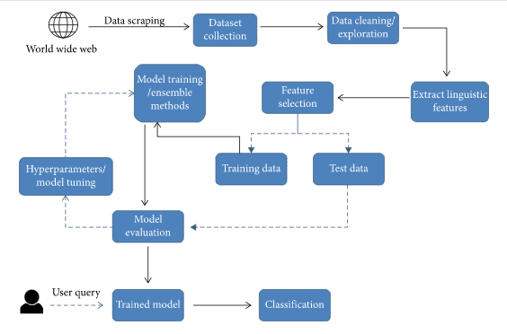
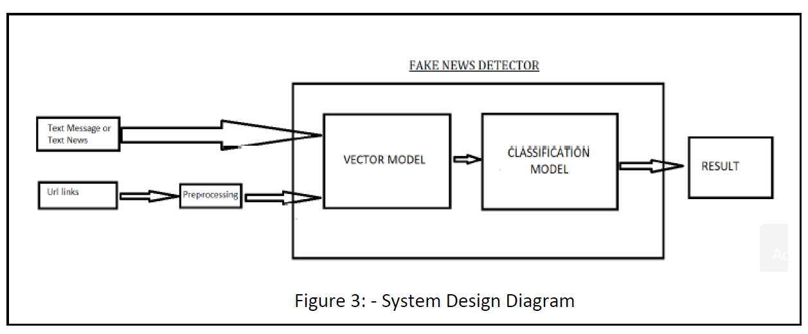

Fig 2.1: Work Flow Diagram

4

2.2 Methodologies of Implementation

(Detailed study of the techniques used in each step of implementation (what+why+how), formulations/ equations, metrices, constraints, architecture, model, cases etc.)

- Text Pre-Processing: - Text data must be preprocessed before being input into machine learning and deep learning models, by employing NLP methods such as stop word removal, tokenization, sentence segmentation, and punctuation removal.

- Following the acquisition of content, pre-processing is performed.
  - All of the letters in the documents are converted to lowercase.
  - Numbers are removed.
  - Punctuation and accent marks are removed.
  - White spaces are removed.
  - Stop words are removed.
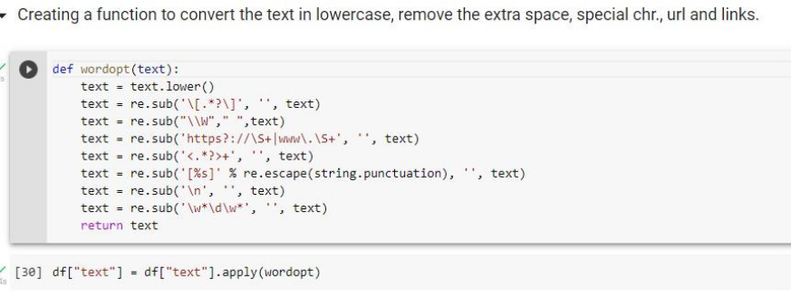

Fig 4: - text pre-processing code snippet
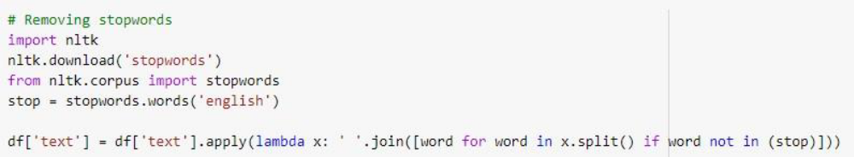

Fig 5: - Removing stopwords code snippet
- Textual data: Text written by the author in a news, pre-processed by the following operations:

  - Cleaning: eliminating stop words and special characters.
  - Stemming: transforming the useful words into roots.
  - Encoding: transforming all the words into a numerical vector. This needs the application of the TF-IDF method on the result
- Categorical data: Source of the news- TV channel, newspaper or magazine; its author. The pre-treatment of these data is performed through two steps:
- Cleaning: eliminating special characters and transforming letters into lowercase.
- Encoding: for sources we used a label encoding. For authors, the names were encoded into numeric. A list containing two fields was created, the first for the source and the second for its authors, then we replaced each author by its index number.
- Numerical data: The date of posting and the sentiment given by the text. Split the date into three unique values: day, month and year. For the sentiment given by the text, we calculate the sum of the sentiment degrees of the words.

5
2.3 Software & Hardware Requirements

2.3.1 Software Specifications

Language: Python
Web Server: Jupyter notebook (Anaconda3)
Operating System: Windows 10 32 or 64 Bit

2.3.2 Hardware Specifications

Main Processor : 2GHz

Ram : 512 MB (min)

Hard Disk : 80 GB

6

2.4 Proposed Work

(Detailed Description about the Modification made to any existing model/ architecture/protocol/ technique or new idea/ model/architecture/protocol/technique implemented)

In our proposed framework, as illustrated in Figure , we are expanding on the current literature by introducing ensemble techniques with feature sets to classify news articles from multiple domains as true or fake.

The fake news detection using machine learning is built using the following steps:

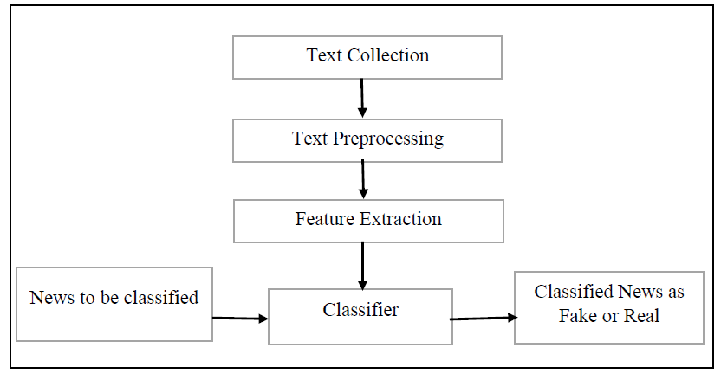

Algorithms
We used the following learning algorithms in conjunction with our proposed methodology to evaluate the performance of fake news detection classifiers.

1. Logistic Regression
As we are classifying text on the basis of a wide feature set, with a binary output (true/false or true article/fake article), a logistic regression (LR) model is used, since it provides the intuitive equation to classify problems into binary or multiple classes [27]. We performed hyperparameters tuning to get the best result for all individual datasets, while multiple parameters are tested before acquiring the maximum accuracies from LR model. Mathematically, the logistic regression hypothesis function can be defined as follows [27]:
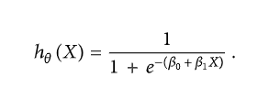
Logistic regression uses a sigmoid function to transform the output to a probability value; the objective is to minimize the cost function to achieve an optimal probability. The cost function is calculated as shown in
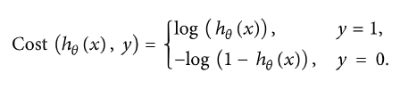
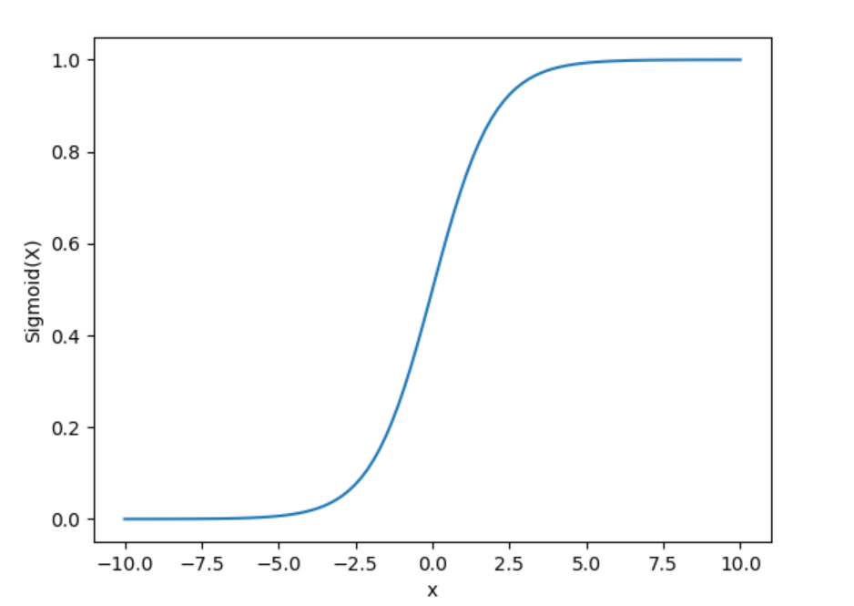

2. Decision Tree Classifier
Decision Tree is a supervised learning technique that can be used for both classification and Regression problems, but mostly it is preferred for solving Classification problems. It is a tree-structured classifier, where internal nodes represent the features of a dataset, branches represent the decision rules and each leaf node represents the outcome.
Decision tree is the most powerful and popular tool for classification and prediction. A Decision tree is a flowchart like tree structure, where each internal node denotes a test on an attribute, each branch represents an outcome of the test, and each leaf node (terminal node) holds a class label. Decision trees classify instances by sorting them down the tree from the root to some leaf node, which provides the classification of the instance. An instance is classified by starting at the root node of the tree, testing the attribute specified by this node, then moving down the tree branch corresponding to the value of the attribute as shown in the above figure. This process is then repeated for the subtree rooted at the new node.

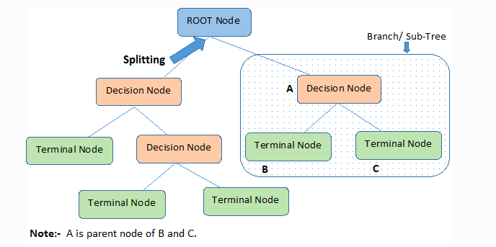

3. Support Vector Machine
Support vector machine creates a hyperplane to isolate and group features. Support vectors are created on either side of the hyperplane in order to calculate the optimal hyperplane with each vector maximising the distance between them. The greater the vector distance around the hyperplane results in a more accurate decision boundary between the category features [25]. The data points are classified into distinct classes dependent on their position on the hyperplane. The key motive is to maximise the gaps that exist between the hyperplane and data points. The margin is maximised by the loss function. The hyperplane is defined by
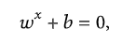

where is the weight vector and b is the bias.
One reasonable choice as the best hyperplane is the one that represents the largest separation or margin between the two classes.
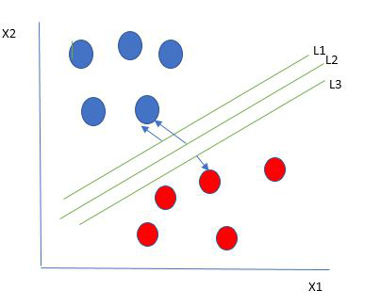
So we choose the hyperplane whose distance from it to the nearest data point on each side is maximized. If such a hyperplane exists it is known as the maximum-margin hyperplane/hard margin. So from the above figure, we choose L2.

4. Ensemble Learners
We proposed using existing ensemble techniques along with textual characteristics as feature input to improve the overall accuracy for the purpose of classification between a truthful and a false article. Ensemble learners tend to have higher accuracies, as more than one model is trained using a particular technique to reduce the overall error rate and improve the performance of the model. The intuition behind the ensemble modeling is synonymous to the one we are already used to in our daily life such as requesting opinions of multiple experts before taking a particular decision in order to minimize the chance of a bad decision or an undesirable outcome. For example, a classification algorithm can be trained on a particular dataset with a unique set of parameters that can produce a decision boundary which fits the data to some extent. The outcome of that particular algorithm depends not only on the parameters that were provided to train the model, but also on the type of training data. If the training data contains less variance or uniform data, then the model might overfit and produce biased results over unseen data. Therefore, approaches like cross validation are used to minimize the risk of overfitting. A number of models can be trained on different set of parameters to create multiple decision boundaries on randomly chosen data points as training data. Hence, using ensemble learning techniques, these problems can be addressed and mitigated by training multiple algorithms, and their results can be combined for near optimum outcome. One such technique is using voting classifiers where the final classification depends on the major votes provided by all algorithms [32]. However, there are other ensemble techniques as well that can be used in different scenarios such as the following.

4.1. Random Forest (RF)
Random forest (RF) is an advanced form of decision trees (DT) which is also a supervised learning model. RF consists of large number of decision trees working individually to predict an outcome of a class where the final prediction is based on a class that received majority votes. The error rate is low in random forest as compared to other models, due to low correlation among trees [33]. Our random forest model was trained using different parameters; i.e., different numbers of estimators were used in a grid search to produce the best model that can predict the outcome with high accuracy.

Working of Random Forest Algorithm
We can understand the working of Random Forest algorithm with the help of following steps −
- Step 1 − First, start with the selection of random samples from a given dataset.
- Step 2 − Next, this algorithm will construct a decision tree for every sample. Then it will get the prediction result from every decision tree.
- Step 3 − In this step, voting will be performed for every predicted result.
- Step 4 − At last, select the most voted prediction result as the final prediction result.

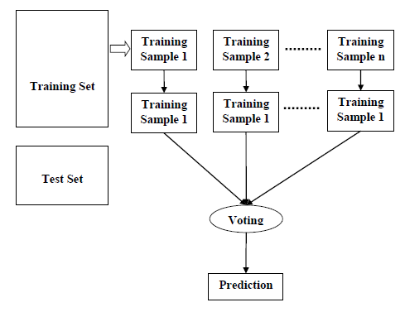
News

4.2. Boosting Ensemble Classifiers
Boosting is another widely used ensemble method to train weak models to become strong learners. For that purpose, a forest of randomized trees is trained, and the final prediction is based on the majority vote outcome from each tree. This method allows weak learners to correctly classify data points in an incremental approach that are usually misclassified. Initially equal weighted coefficients are used for all data points to classify a given problem. In the successive rounds, the weighted coefficients are decreased for data points that are correctly classified and are increased for data points that are misclassified [35]. Each subsequent tree formed in each round learns to reduce the errors from the preceding round and to increase the overall accuracy by correctly classifying data points that were misclassified in previous rounds. One major problem with boosting ensemble is that it might overfit to the training data which may lead to incorrect predictions for unseen instances [36]. There are multiple boosting algorithms available that can be used for both the purposes of classification and regression. In our experiments we used XGBoost [37] and AdaBoost [38] algorithms for classification purpose.
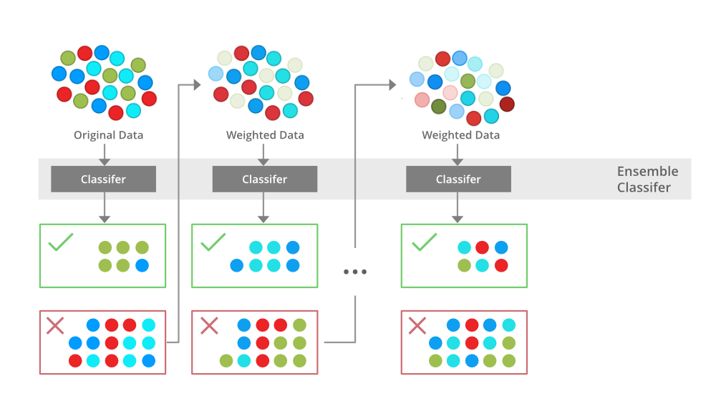

7

CHAPTER 3

3.1 Test Cases & System Validation

(Link and description about the data set used, output of possible cases of input variations, noise, error etc.)

For implementation and better result purpose we created a dataset a CSV file as True.csv and Fake.csv we made it by using web scraping method we scraped the news articles for authentic news web sites and created a dataset having more than 20,000 news here below is the screenshot of the result of making the dataset using web scraping[9] [10]. Further, a Jupyter Notebook was created to implement the ML program. We have used Logistic Regression, Gradient Boosting, Support Vector Machine, Decision Tree, and Random Forest. After TF-IDF vectorization and cleaning the data, we train and test them according to these classifiers we got the accuracy for Logistic Regression as 85.04%, Decision Tree as 78.11%, Gradient Boosting as 77.44%, Random Forest as 84.50%, Support Vector Machine Classifier as 80.20%

The columns of Table 1 are defined as follows

• Classifiers: Models that are used to train and test data are known as classifiers.
• Accuracy: How often a data point is correctly classified by the algorithm.
• Precision: The number of accurately predicted positive observations divided by the total number of predicted positive observations.
• Recall: The percentage of accurately anticipated positive observations to the total number of observations in a class is known as recall.
• F1 Score: The F1 Score is the weighted average of Precision and Recall.

Confusion Matrix provides the values needed to calculate the F1 score, Recall, and Precision. It is a table that demonstrates how well a classification model (or a classifier) performs on a set of test data with known True values [8]. Figure 2: User-Interface. These prediction values are calculated for all classifiers and then the average of all these prediction values will be taken as the final percentage. Based on these values we are setting a range that will help to find the percentage of the truthness of the news. The webserver we created is displaying the result followed by the news. To catch the attention of users we used some emoticons as a symbol to show the results more effectively. The created web server is platform-independent. It means that all of the arrangements of the webserver will be independent of devices. Bootstrap helped us to make our web server device-independent. The final output is in the form of a message which is different according to different percentage values. It is displayed as shown in figure 2.

8

3.2 Observed Output

(Snapshot of each individual output observed for valid inputs and outputs for 3.1)

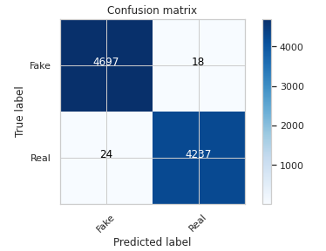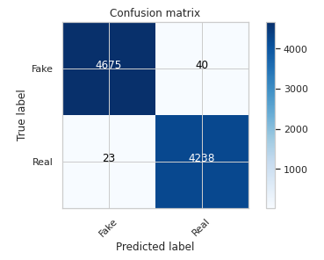

Fig : Confusion matrix of Decision Tree Classifier Fig : Confusion matrix of Random Forrest Classifier

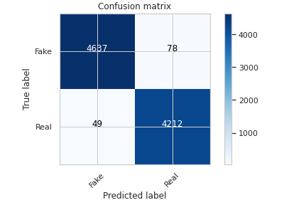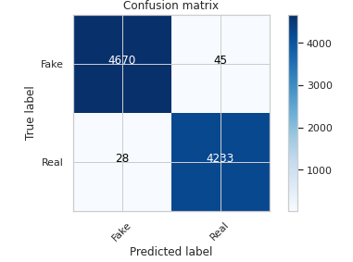

Fig : Confusion matrix of Logistic Regression Fig : Confusion matrix of Gradient Boosting Classifier

Fig : Confusion matrix of SVM

Accuracy from different Classifiers :-

Accuracy of Logistic Regression : 98.59%

Accuracy of Decision Tree : 98.53%

Accuracy of Random Forest : 99.30%

Accuracy of SVM : 99.19 %

Accuracy of Gradient Boosting : 99.50%

Comparison of Different Classification Methods:-

Line Plot:
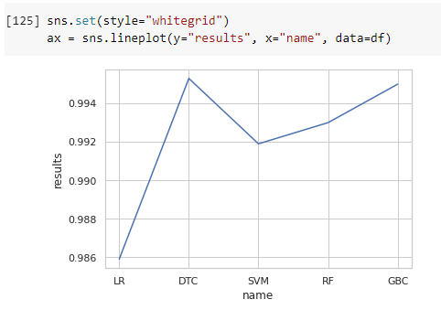
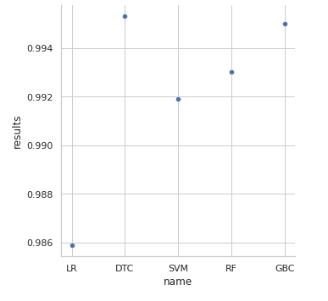

Relplot:

Boxplot

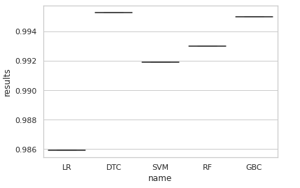

3.3 Performance Analysis

(Graphical and tabular analysis of the outcomes of different cases, comparison with standard methods)

10

CHAPTER4

4.1 Conclusion

(Conclusion/ remarks/ comments against overall performance and accuracy)

Our goal is to detect fake news using Machine Learning. In the process of archiving our goal, we have well defined the problem statement and Methodology. We reviewed the Literature. In the process of implementing, we have collected the data set and did the pre-processing of the data. We did cleaning, stemming and encoded the words into numerical vectors using TF-IDF method. For numerical data like date of posting we split into three unique values: day, month and year. Further we will do the binary classification of the data using SVM, Logistic Regression, Random Forest and Decision tree classifier. And a variety of evaluation measures will be utilized to evaluate the algorithms classification accuracy in detecting fake news. Some measures will be Precision, Recall and Accuracy.

In the 21st century, the majority of the tasks are done online. Newspapers that were earlier preferred as hard-copies are now being substituted by applications like Facebook, Twitter, and news articles to be read online. Whatsapp’s forwards are also a major source. The growing problem of fake news only makes things more complicated and tries to change or hamper the opinion and attitude of peopltowards use of digital technology. When a person is deceived by the real news two possible things happen- People start believing that their perceptions about a particular topic are true as assumed. Thus, in order to curb the phenomenon, we have developed our Fake news Detection system that takes input from the user and classify it to be true or fake. To implement this, various NLP and Machine Learning Techniques have to be used. The model is trained using an appropriate dataset and performance evaluation is also done using various performance measures. The best model, i.e. the model with highest accuracy is used to classify the news headlines or articles.

11

4.2 Challenges

(The conditions/constraints/challenges faced during implementations)

Together with societal challenges, there is a dramatic and inconspicuous situation happening in the media landscape, the public sphere and journalism industry that requires debate and examination, pointing out two main aspects 2 . The first one relies on the fact that news publishers have lost control over the distribution of news, which are presented to Internet users by obscure and unpredictable algorithms.

In this system paper we present our contribution to the Constraint 2022 Fake News Detection Using Machine Learning Using Ensemble method, which poses the challenge of classifying NEWS related social media posts as either fake or real. In our system, we address this challenge by applying classical machine learning algorithms together with several linguistic features, such as logistic regression, decision tree, support vector machine, gradient boosting classifier and random forest classifier. In terms of pre-processing, we experiment with various steps like stop word removal, stemming/lemmatization, link removal and more. We find our best performing system to be based on a Decision tree classifier, which obtains a weighted average F1 score of 99.67% on test data, which lands a place in the middle of the leaderboard.

In the article published by Kai Shu, Amy Sliva, Suhang Wang, Jiliang Tang, and Huan Liu [2], they explored the fake news problem by reviewing existing literature in two phases: characterization and detection. In the characterization phase, they introduced the basic concepts and principles of fake news in both traditional media and social media. In the detection phase, they reviewed existing fake news detection approaches from a data mining perspective, including feature extraction and model construction.

12

4.3 Future Scope

(The application of the implementation and the scope of modifications)

The good news is that in near future artificial intelligence or to be more specific machine learning-based models will help a user to check whether the news is real or fake. Even though the research in this area is going on, but the researchers claim that there’s still a lot more to be solved. This particular area of research comes under the hierarchy of machine learning known as natural language processing (NLP). This area is receiving a lot of attention from researchers, scholars, and academicians across the globe. The number of users of online media is growing therefore automated detection of fake news seems to be the only way to tackle such a problem. So far there have been text-based detection approaches of fake news which did not yield better results. Almost all the machine learning models use hand-crafted features extracted from input textual content. In the future, we will witness a context-based approach in detecting fake news. In 2016, some researchers found that the traffic taken by Facebook is almost 50 percent fake and hyperpartisan, while at the same time news agencies depend on Facebook for 20 percent of their traffic.

The future will witness deep learning models to have a great prospect in fake news detection. Such models will be able to classify between fake news and legitimate news. Decades of deception detection have shown how well we humans can detect lies in the text. The findings show that we are not so good at it. In reality just 4 percent better than chance, based on a meta-analysis of more than 200 experiments. The viral spread of fake news hurts the behaviors, beliefs, and attitudes of the public which can seriously endanger the democratic processes. Early detection of such false information and extensive spread presents the main challenge for researchers today.

This project can be further enhanced to provide greater flexibility and performance with certain modification whenever necessary.
Deep fake learning which can be help to detect fake image.
Deep learning machine learning to get more accurate result.

13

References

[Reference No]. Reference Details (author name, paper name, conference/journal name, and year

- Gilda S., "Evaluating machine learning algorithms for fake news detection", 2017.
- Yang Y., "TI-CNN: Convolutional Neural Networks for Fake News Detection", 2018.
- Mykhailo G. V. M., "Fake News Detection Using Naive Bayes Classifier", 2017.
- Priyanka S, "Detection of Fake Profiles on Twitter using Random Forest & Deep Convolutional Neural Network", 2019.
- Gentzkow H., "Social media and fake news in the 2016 election", 2017.
- Gilda S., "Evaluating Machine Learning Algorithms for the Detection of the Fake News", 2017.
- Chandra Mouli Madhav Kotteti, Na Li, "Fake News Detection Enhancement with Data Imputation", 2018.
- Arjun R., Asif Ekbal, Pushpak Bhattacharyya, "A Deep Ensemble Framework for Fake News Detection and Classification", 2018.

- M. Granik and V. Mesyura, "Fake news detection using naive Bayes classifier," 2017 IEEE First Ukraine Conference on Electrical and Computer Engineering (UKRCON), Kiev, 2017, pp. 900-903.
- Fake news websites. (n.d.) Wikipedia. [Online]. Available: https://en.wikipedia.org/wiki/Fake_news_website. Accessed Feb. 6, 2017

- Kai Shu, Amy Sliva, Suhang Wang, Jiliang Tang, and Huan Liu, “Fake News Detection on Social Media: A Data Mining Perspective”
- arXiv:1708.01967v3 [cs.SI], 3 Sep 2017
- Aayush Ranjan, “ Fake News Detection Using Machine Learning”, Department Of Computer Science & Engineering Delhi Technological University, July 2018.
- N. Smitha and R. Bharat, “Performance Comparison of Machine Learning Classifiers for Fake News Detection,” 2020 Second International Conference on Inventive Research in Computing Applications (ICIRCA), 2020, pp. 696-700.
- K. Poddar, G. B. Amali D. and K. S. Umadevi, “Comparison of Various Machine Learning Models for Accurate Detection of Fake News, “2019 Innovation in Power and Advanced Computing Technologies (i-PACT), 2019, pp. 1-5.

14

