NATIONAL INSTITUTE OF TECHNOLOGY SURATHKAL

IT-254 WTA Lab

Assignment-1

Submitted By-
Akshay B Bistagond
191EC203

CASCADING STYLE SHEETS (CSS3)

Practice the Basic syntax of CSS, Inline, internal and external stylesheets, <link> tag, CSS selectors, CSS Box model, styling various HTML elements for the problems done as part of the HTML4 Practice Exercises.

Added Styling to Sidebar :
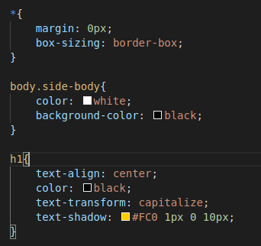

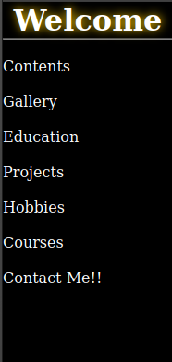
Made the contents section flexbox and aligned it horizontally:
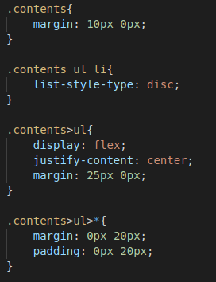

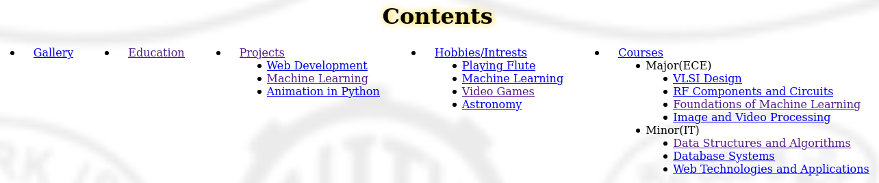
Aligned the Content in the body :
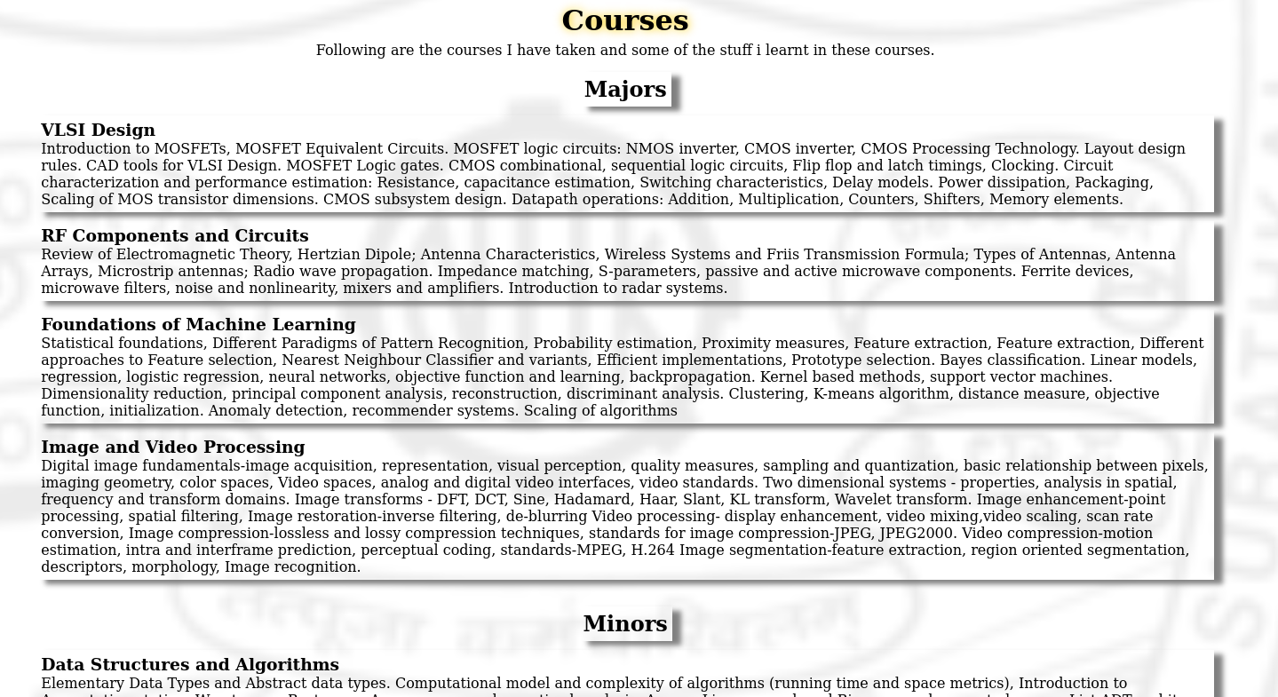
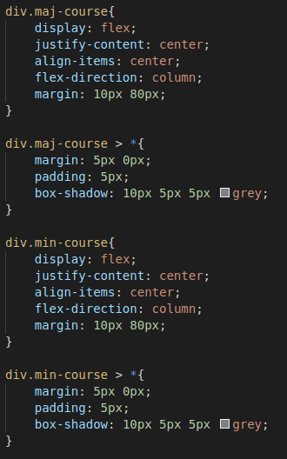

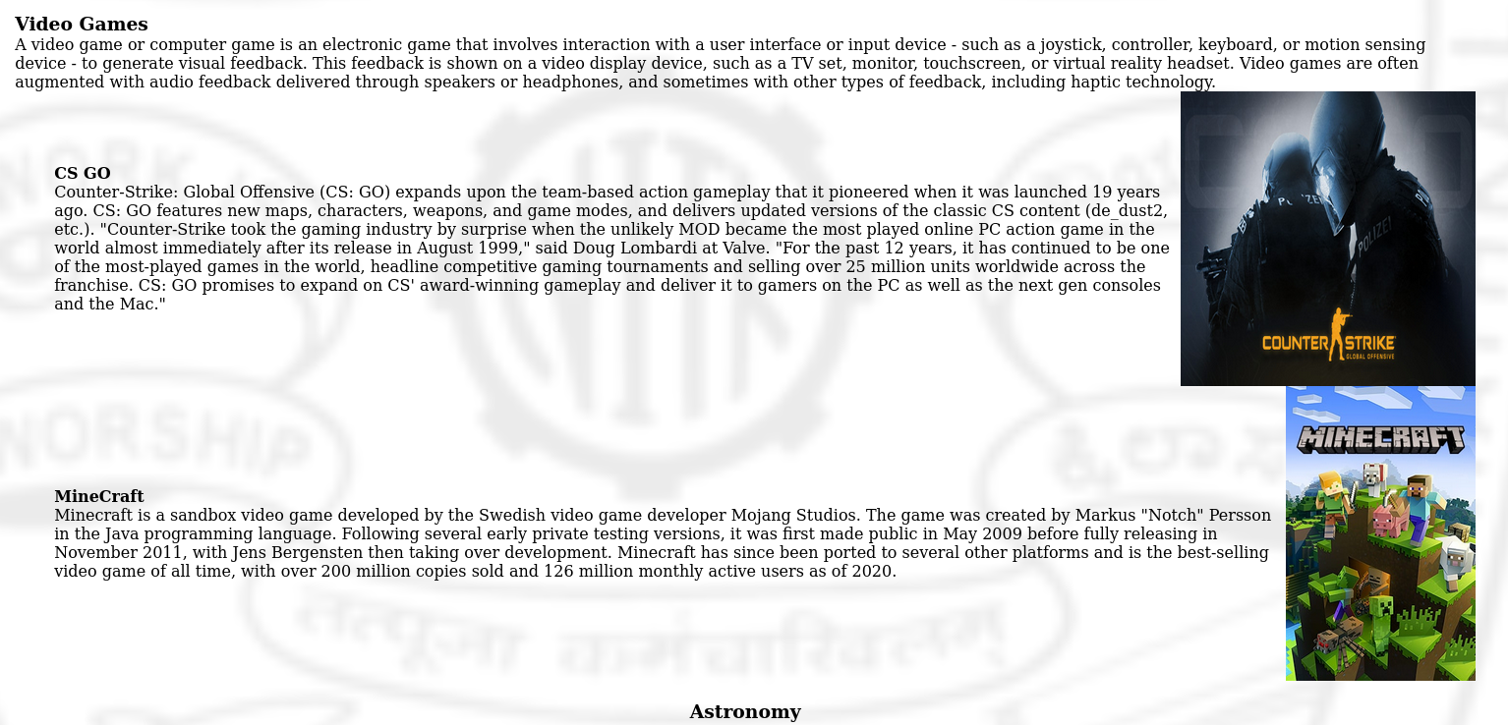

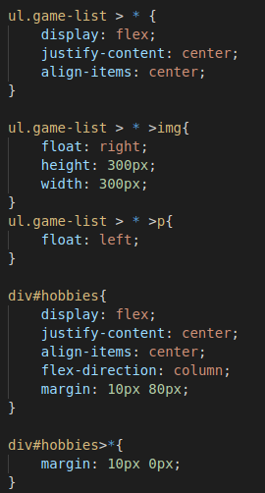

Added a basic animation:



