NATIONAL INSTITUTE OF TECHNOLOGY SURATHKAL

IT-254 WTA Lab

Assignment-1

Submitted By-
Akshay B Bistagond
191EC203
1.Create a gallery of clickable images of yourself, your projects, campus etc that lead to individual pages giving suitable description/details for each image. Demonstrate the use of basic HTML elements and content-based tags like <h1...h6>, <p>, <b>, etc., in your work.
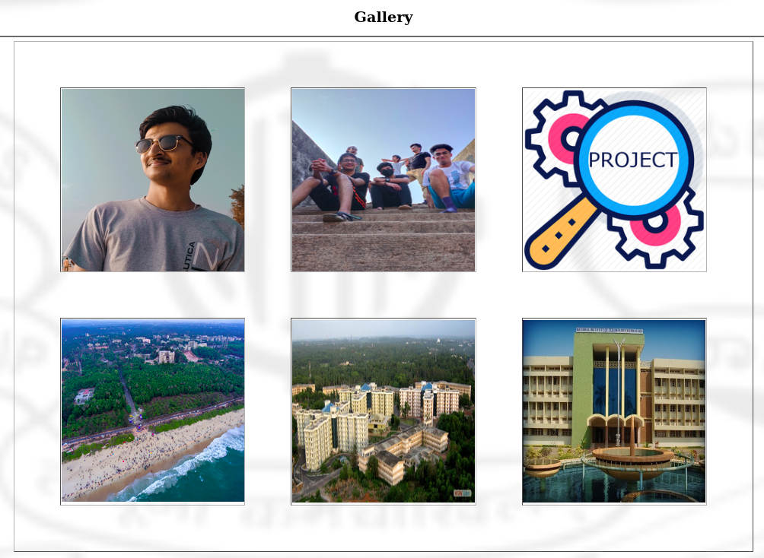
Code:-
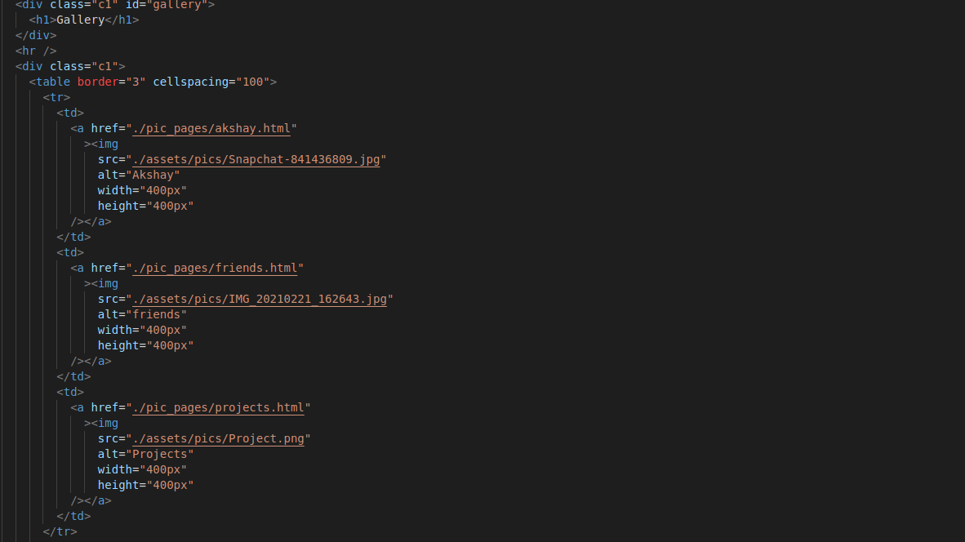
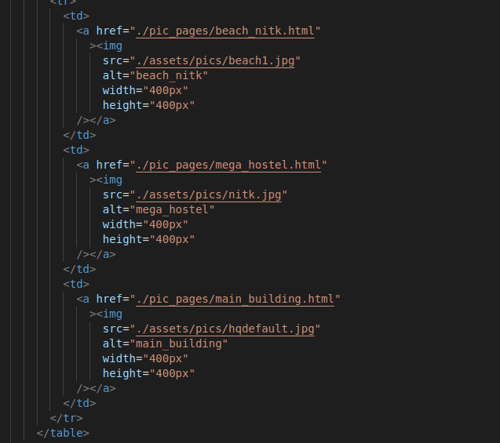
2. Create a nested list of all your projects/hobbies/interests/courses. Include a contents section at the beginning of the page, and more information about each of the projects/hobbies/ interests/courses
later in the page.

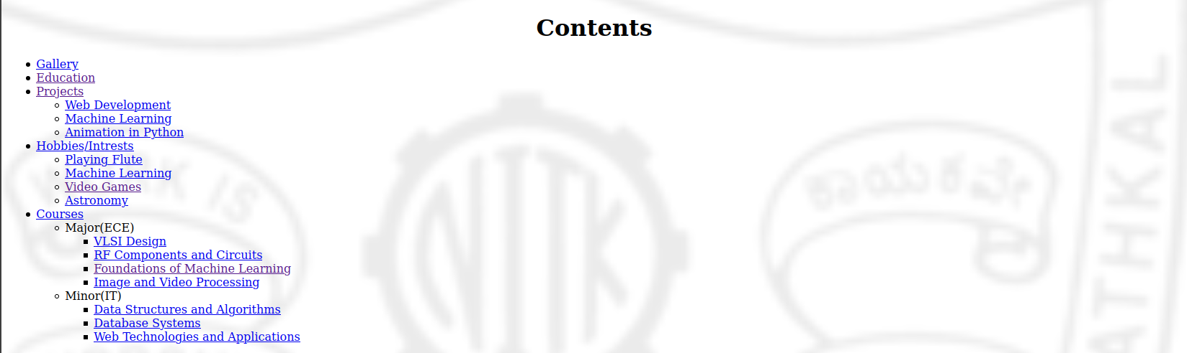

Code:-
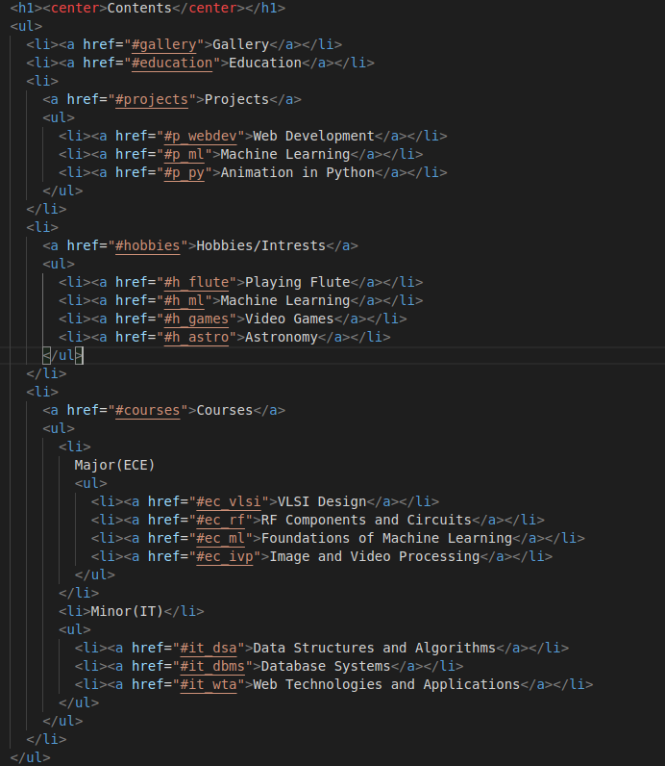
3. Create a table for your page similar to the sample shown below and populate with relevant content.

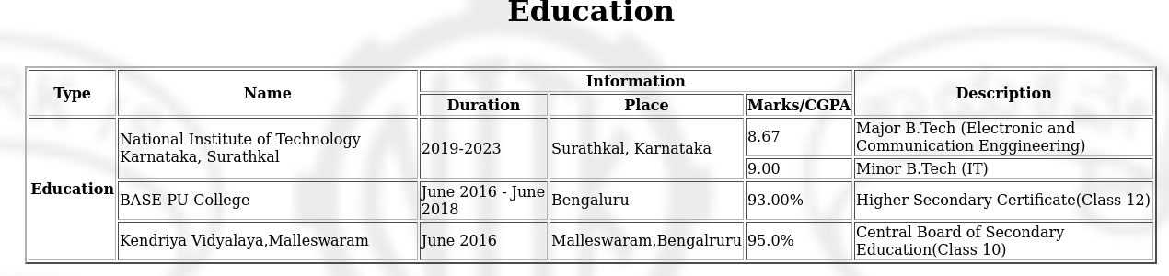
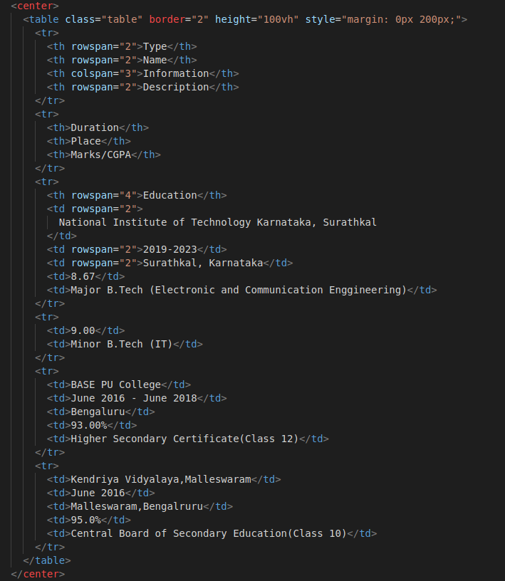
Code:-
4. Create an XHTML form customized to your webpage, similar to the sample shown on Page 2.

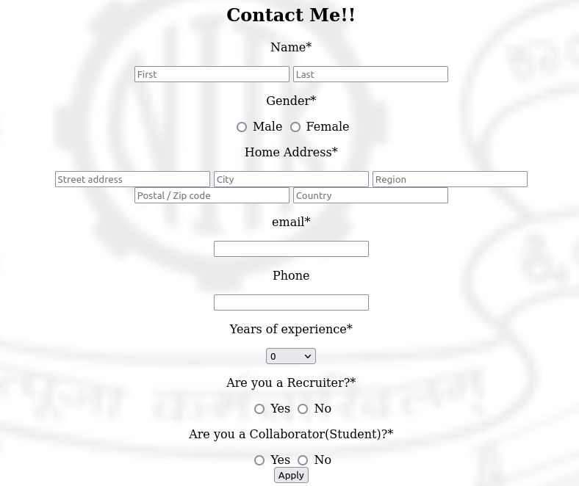

code:-
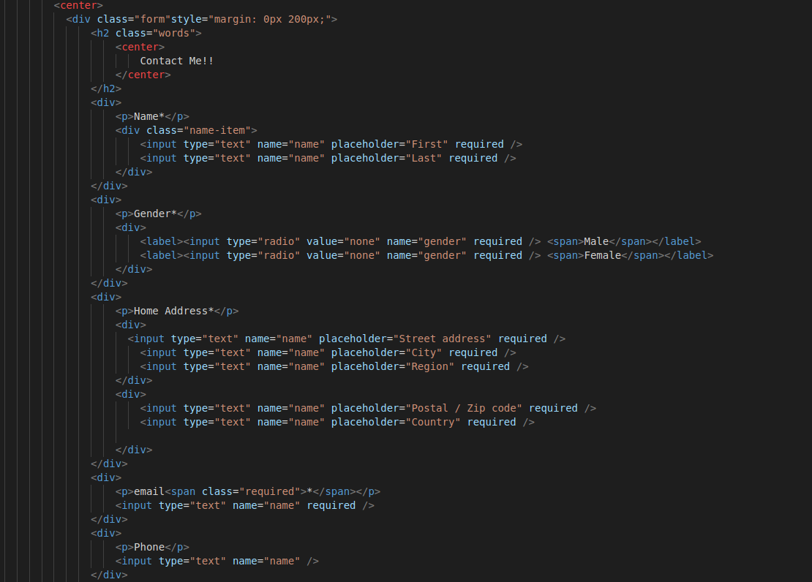
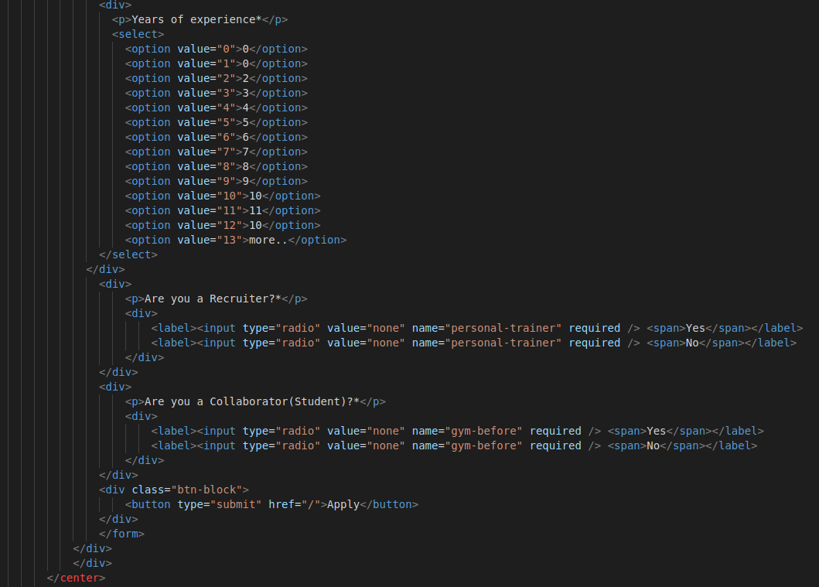

5. Use nested frames to make your webpage appear similar to the display sample shown on Page 2. Create other related pages for yourself, that are displayed in each of the other frames. The
hypertext links when clicked, should open in the frame named “Menu”

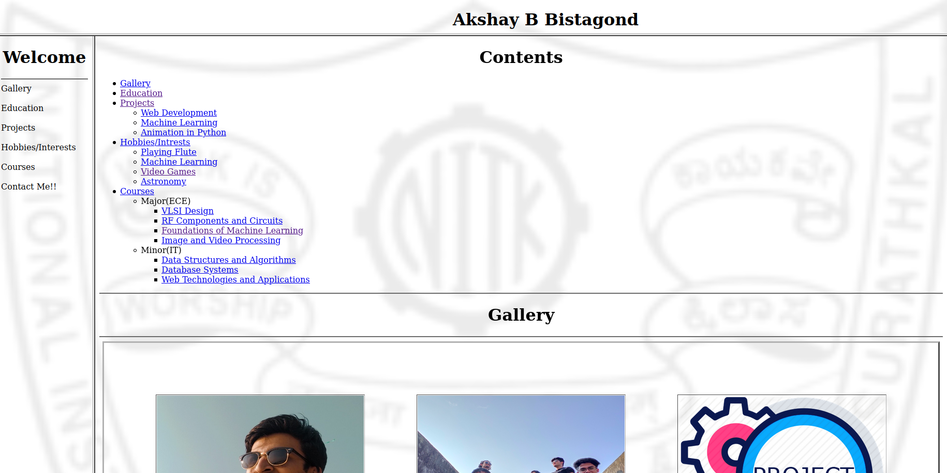
Code:-
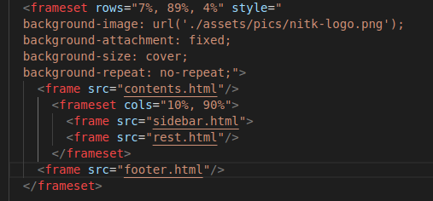

ERRORS AND VALIDATION
All the above Errors are taken care of in the code.

