NATIONAL INSTITUTE OF TECHNOLOGY SURATHKAL

IT-254 WTA Lab

Assignment-3a

Submitted By-
Akshay B Bistagond
191EC203

JAVASCRIPT BASIC

1a. Display the various parts of the current date with appropriate messages.
Output :-
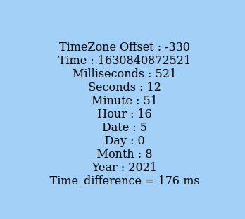

Code :-
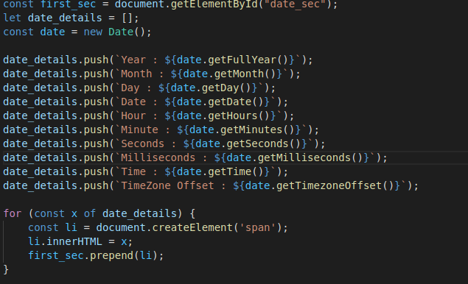
1b. Compute the time needed to complete a computation involving a for loop, using the Date object.

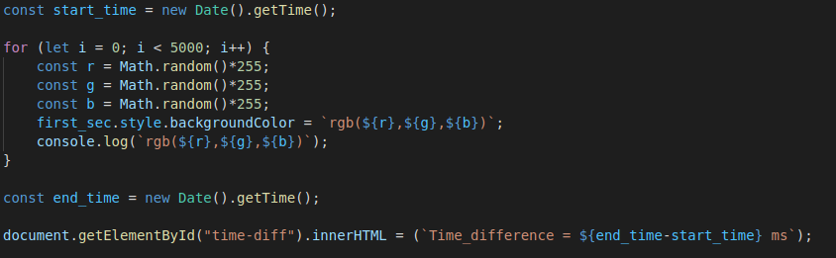
Code :-

2. Display some content about your favourite movies/books/food/places etc. Include a button which announces to visitors to click on it for starting an image slideshow. Once clicked, users are able to view another page with links for viewing next image and prev image, based on which the image is displayed.

Output:-

1) Button on main page :-


2)image slideshow :-
Code:-
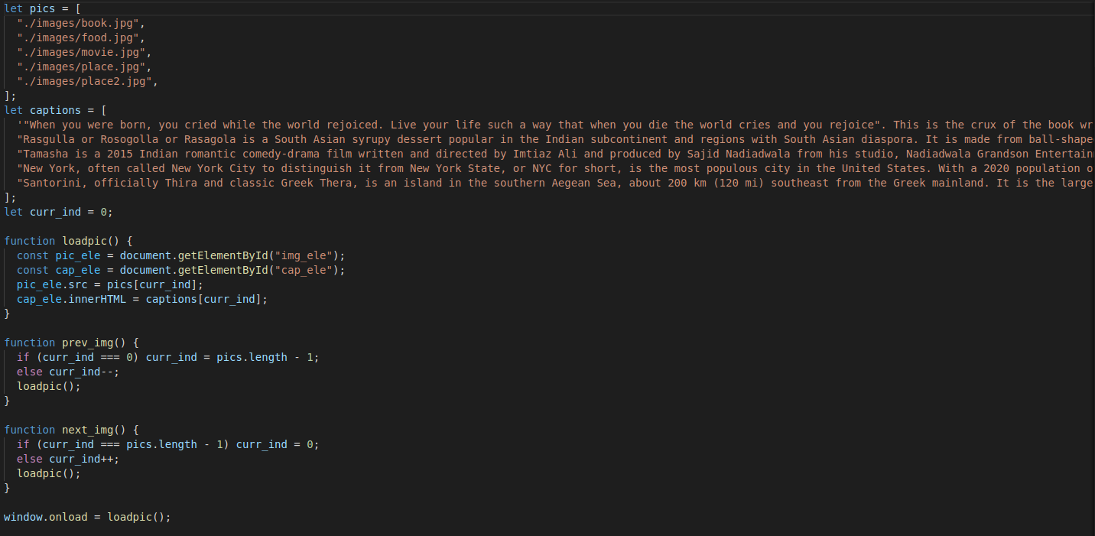
3. Use JavaScript to access the webpage’s DOM tree. Try the different DOM methods and properties to understand their usage. Also use different event handlers with XHTML tags to observe how events
are handled.
Ans :- Various event handlers lik ‘click’, ‘blur’ etc have been used and also the various parts of the DOM tree are accessed using Javascript(getElementById, getElementByName etc.)

4.Create an XHTML form that collects the user’s feedback regarding site services. The form contains the following fields - Name, City, Email, Comments.

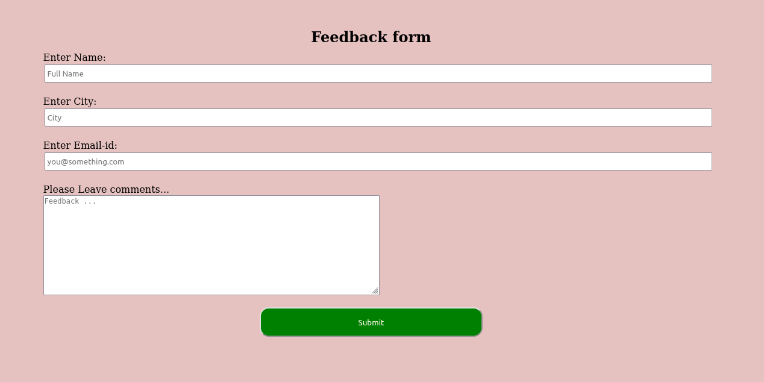
Form :-

Code :-
HTML -
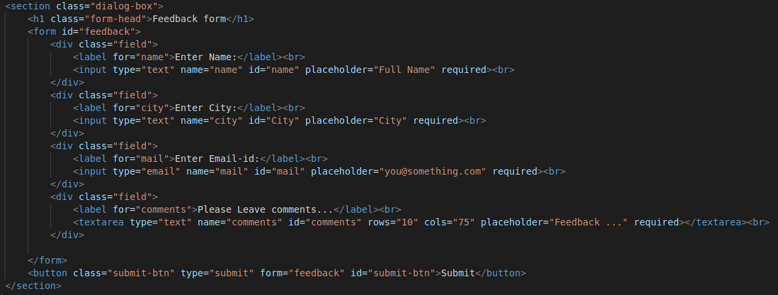
Javascript -
